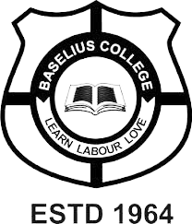

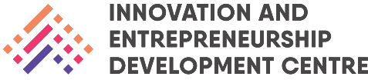
Innovation & Entrepreneurship Development Centre
An initiative of Kerala Startup Mission
24-25

Certificate

This is to certify that the following is a bonafide record of activities and achievements of Innovation & Entrepreneurship Development Centre (IEDC) for the academic year 2023-24. Necessary supporting documents have been attached wherever possible.

Teacher-in-charge
Dr. Aparna Thankappan

Verified by
IQAC Coordinator

Countersigned by
Dr. Biju Thomas
Principal

Innovation & Entrepreneurship Development Centre
An initiative of Kerala Startup Mission

- Name of Event | : KSUM- Empowering Innovation and Entrepreneurship
- Name of Institute | : Baselius College
- Name of Nodal Officer | : Dr Aparna Thankappan
- Email Address | : aparnathankappan@baselius.ac.in
- Contact Number | : 9747620918
- Event participant type | : participants only from the institution
- Total number of participants | : 27
- Total number of women participants | : 14
- Track of Event | : Entrepreneurship
- Event category | : Entrepreneurship - Sessions - IPR, Incubation & acceleration, Angel & VC Funding etc.
- Sector | :other-entrepreneurship
- Date from | : 6.6.24
- Date to | :6.6.241
- Total number of hours | : 1.5 hrs
- Details of IEDCs Collaborated | : IIC, Department of mathematics
- Details of Communities or Clubs collaborated with | : IIC, Department of mathematics
- Detailed report of the event (Min 200 words) | : On June 6, 2024, at 2:15 PM, the Innovation and Entrepreneurship Development Cell (IEDC) and Institution's Innovation Council (IIC) in collaboration with the Department of Mathematics organized a session titled "KSUM - Empowering Innovation and Entrepreneurship." The session was conducted by Dr. Sheeba Joseph from the Department of Commerce. This event aimed to create awareness among students about the various financial support options available to them through the Kerala Startup Mission (KSUM). Dr. Sheeba Joseph provided valuable insights into several initiatives including financial support for student internships, idea grants, the Idea Fest, the Leap Fund, and the WhyHack program.  The session saw an enthusiastic participation of 27 students who were keen to explore the avenues for innovation and entrepreneurship supported by KSUM. Dr. Sheeba Joseph's presentation was both informative and engaging, highlighting the importance of these financial aids in fostering a culture of innovation among students. The session concluded with an interactive Q&A segment, where students had the opportunity to clarify their doubts and gain deeper insights into leveraging these financial supports effectively.
18. Creatives created for the event (Max 10nos)
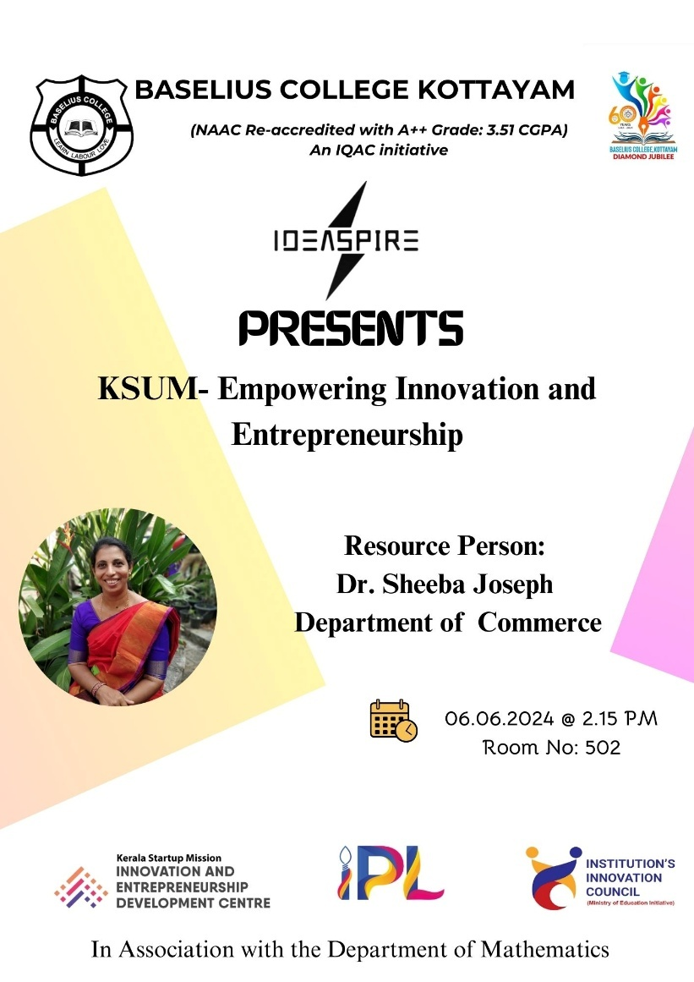

- Photograph of the event - Stage

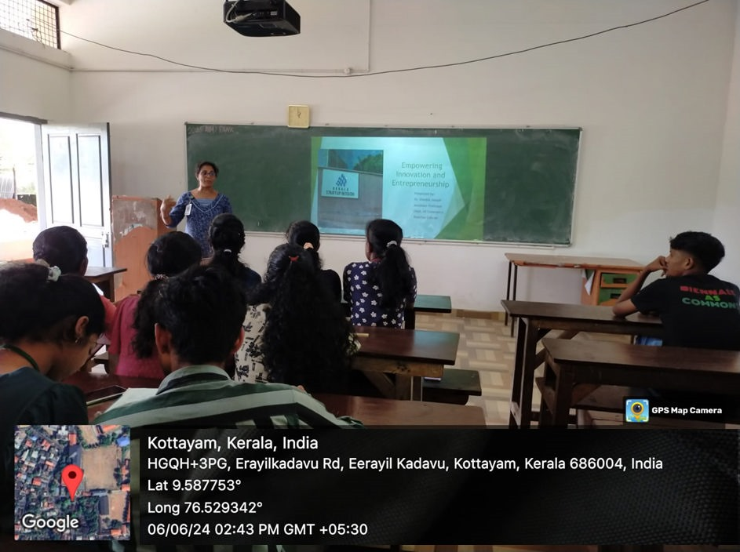
- Photograph of the event - Audience
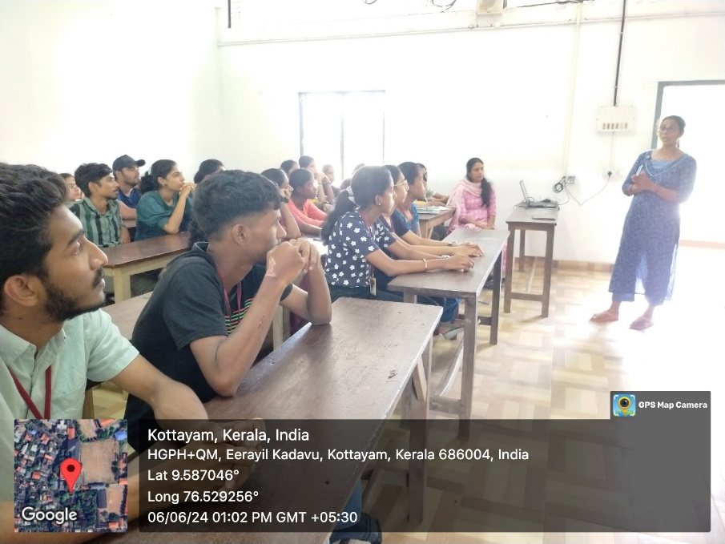

- Photograph of the event - Group Photo

- Other photographs if any

- Other Documents if any (Schedule, Resource Person Details, ..)

Resource Person: Dr. Sheeba Joseph, Department of Commerce

Innovation & Entrepreneurship Development Centre
An initiative of Kerala Startup Mission

- Name of Event | Creative Writing Techniques
- Name of Institute | : Baselius College
- Name of Nodal Officer | : Dr Aparna Thankappan
- Email Address | : aparnathankappan@baselius.ac.in
- Contact Number | : 9747620918
- Event participant type | : participants only from the institution
- Total number of participants | : 18
- Total number of women participants | : 8
- Track of Event | Innovation
- Event category | Mentoring programme
- Sector | Media & Entertainment
- Date from | 7.6.24
- Date to | 7.6.24
- Total number of hours | :1
- Details of IEDCs Collaborated | : IIC, Department of Physics
- Details of Communities or Clubs collaborated with | : IIC, Department of Physics
- Detailed report of the event (Min 200 words) | On June 7, 2024, at 2:15 PM, the Institution's Innovation Council (IIC) and the Innovation and Entrepreneurship Development Cell (IEDC), in collaboration with the Postgraduate Department of Physics and Research Centre, organized a session on "Creative Writing Techniques." The session was conducted by Dr. Thomas Kuruvilla from the Department of Malayalam. The event aimed to raise awareness about content writing across various mediums such as movies, journals, and news. Dr. Kuruvilla shared his extensive experience and insights into the art of writing, emphasizing the importance of creativity and technique in crafting compelling content.  Eighteen students participated in the session, demonstrating a keen interest in enhancing their writing skills. Dr. Kuruvilla's presentation was both inspiring and educational, covering key aspects of creative writing and offering practical tips for aspiring writers. He discussed the nuances of writing for different platforms and audiences, highlighting how to adapt one's style to suit various contexts. The session concluded with an interactive discussion, allowing students to ask questions and engage with Dr. Kuruvilla's experiences. This event successfully provided participants with a deeper understanding of creative writing and its applications, inspiring them to pursue their own writing endeavors with renewed enthusiasm.
- Creatives created for the event (Max 10nos)
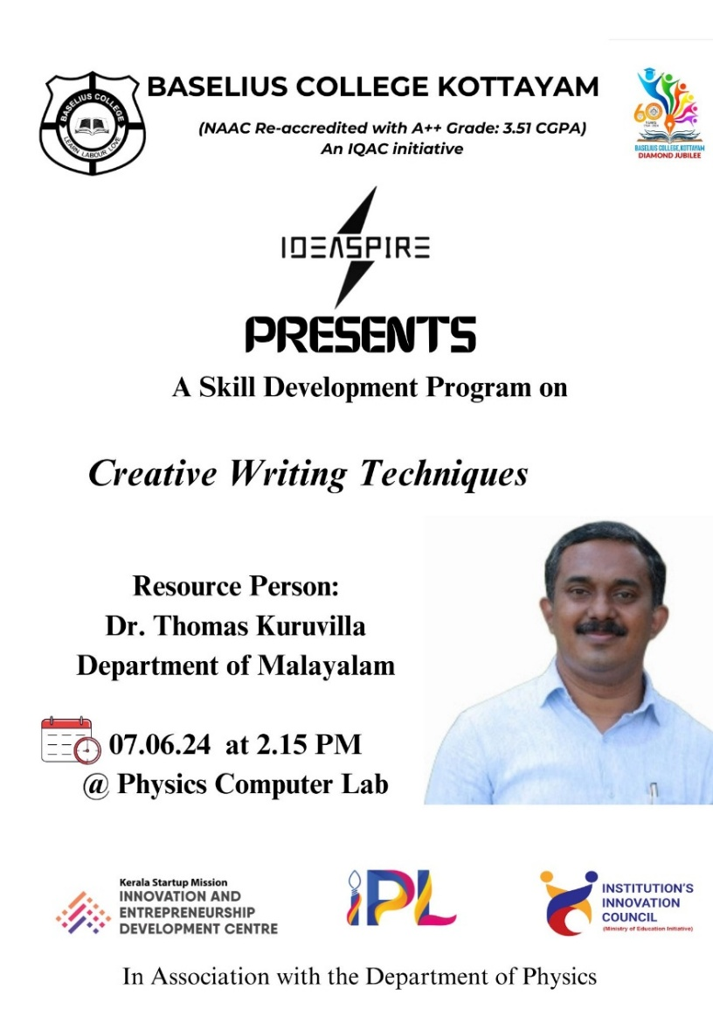

- Photograph of the event - Stage

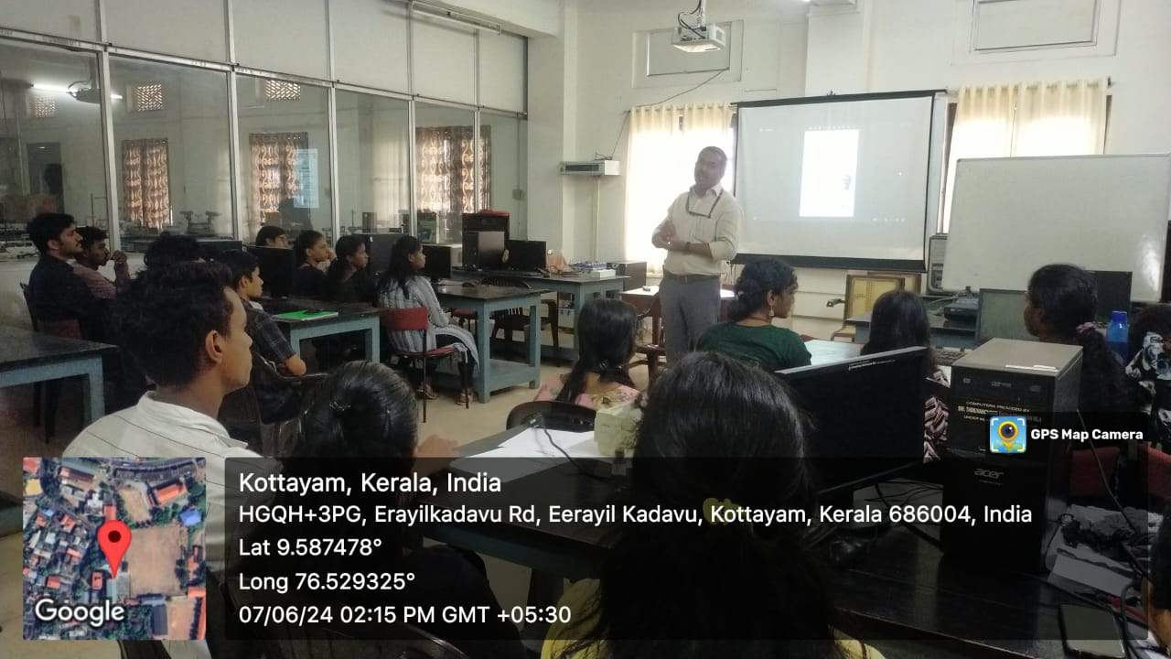

- Photograph of the event - Audience

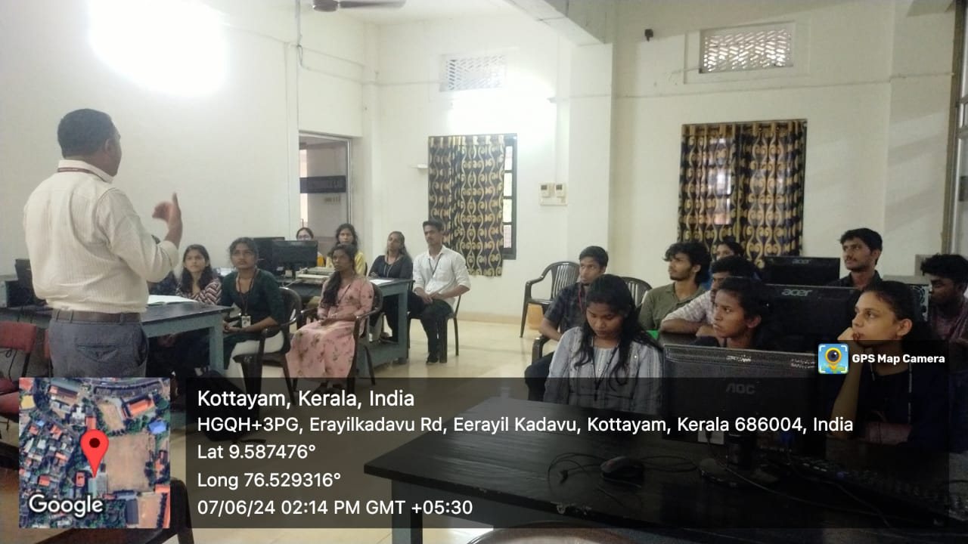
- Photograph of the event - Group Photo

- Other photographs if any
- Other Documents if any (Schedule, Resource Person Details, ..)
Dr. Thomas Kuruvilla, Department of Malayalam

Innovation & Entrepreneurship Development Centre
An initiative of Kerala Startup Mission

- Name of Event | FROM CHEMINFORMATICS TO DRUG DISCOVERY: THE ROLE OF MOLECULAR DOCKING
- Name of Institute | : Baselius College
- Name of Nodal Officer | : Dr Aparna Thankappan
- Email Address | : aparnathankappan@baselius.ac.in
- Contact Number | : 9747620918
- Event participant type | : participants only from the institution
- Total number of participants | : 17
- Total number of women participants | : 12
- Track of Event | Technology
- Event category | Technology - Boot Camp/Hands-On Workshop - AR/VR, Mobile/Web Development, Artificial Intelligence, Hardware, Other Future Technologies etc.
- Sector | Chemicals & BIoTech
- Date from | 11.6.24
- Date to | 1.6.24
- Total number of hours | 1.5 hrs
- Details of IEDCs Collaborated | -
- Details of Communities or Clubs collaborated with | IEDC,IIC, ED,Placement cell,Department of Botany and Zoology
- Detailed report of the event (Min 200 words) | On June 11, 2024, the IEDC, IIC,RINK,ED and placement cell collaborated with the Departments of Botany and Zoology to organize an insightful session titled "From Cheminformatics to Drug Discovery: The Role of Molecular Docking." The session was conducted by Dr. Anju Linda Varghese from the Department of Chemistry & Centre for Research. A group of 17 enthusiastic students participated, gaining valuable knowledge about the integration of computational techniques in drug discovery.  Dr. Varghese's presentation delved into the fundamental concepts of molecular docking and its significance in modern pharmacology. She explained how molecular docking serves as a predictive tool for understanding the interactions between drug candidates and biological targets. This technique, as she highlighted, is crucial for identifying promising compounds and optimizing their efficacy and safety profiles. The session covered the workflow of molecular docking, including the preparation of target proteins and ligands, simulation processes, and analysis of results. Students were particularly engaged with the practical examples and case studies that demonstrated the real-world applications of molecular docking in drug discovery.  The collaborative effort of IEDC, IIC, and the academic departments underscored the interdisciplinary nature of this field, fostering a deeper appreciation among students for the role of computational methods in biological research. The session not only broadened the participants' understanding of cheminformatics and molecular docking but also inspired them to consider the potential of these techniques in their future research endeavors.

- Creatives created for the event (Max 10nos)

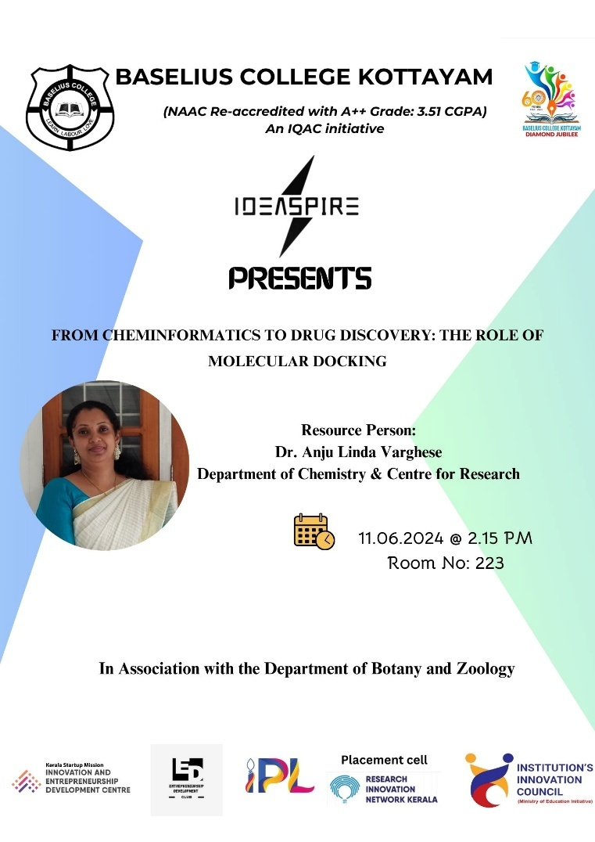

- Photograph of the event - Stage

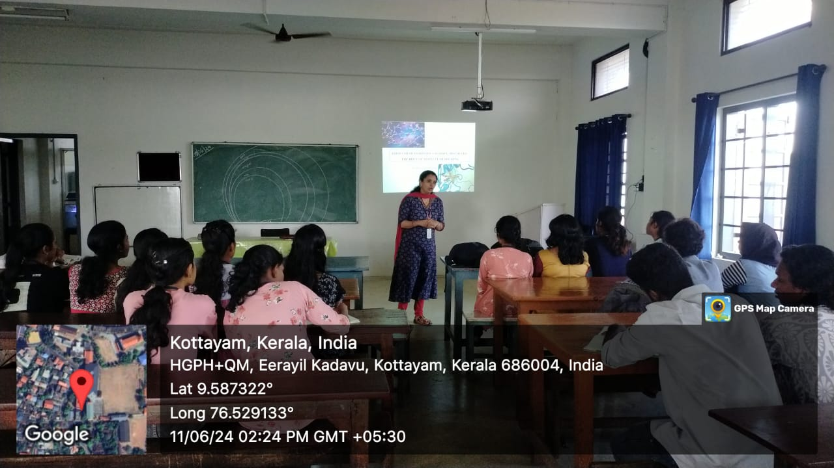
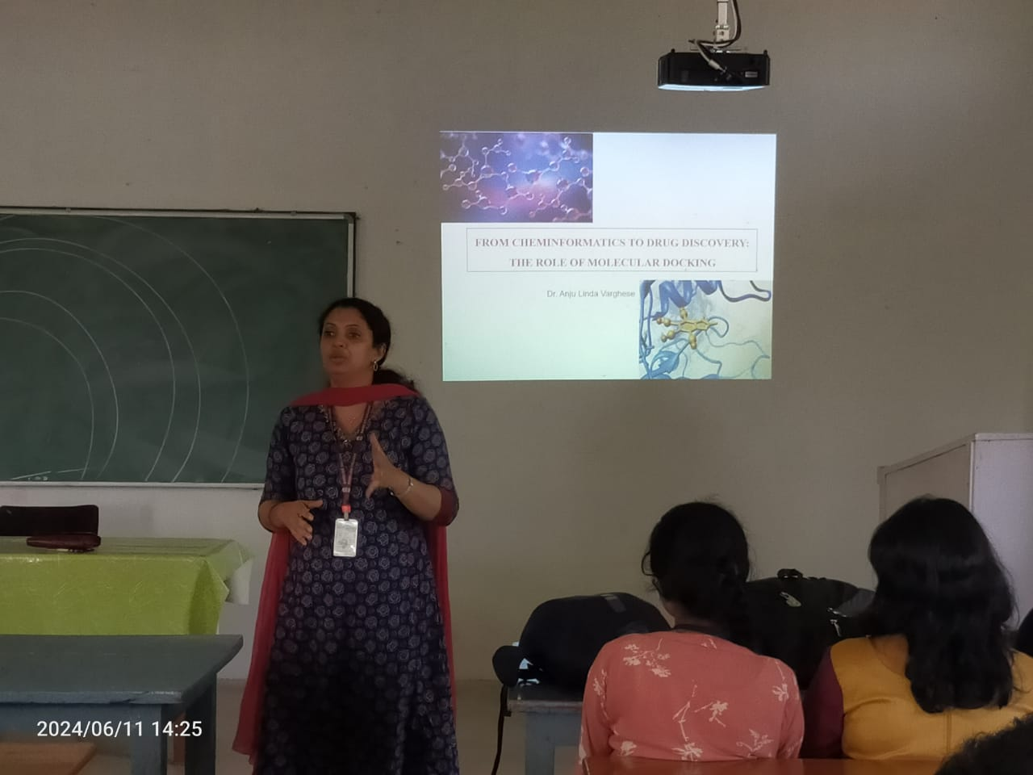

- Photograph of the event - Audience

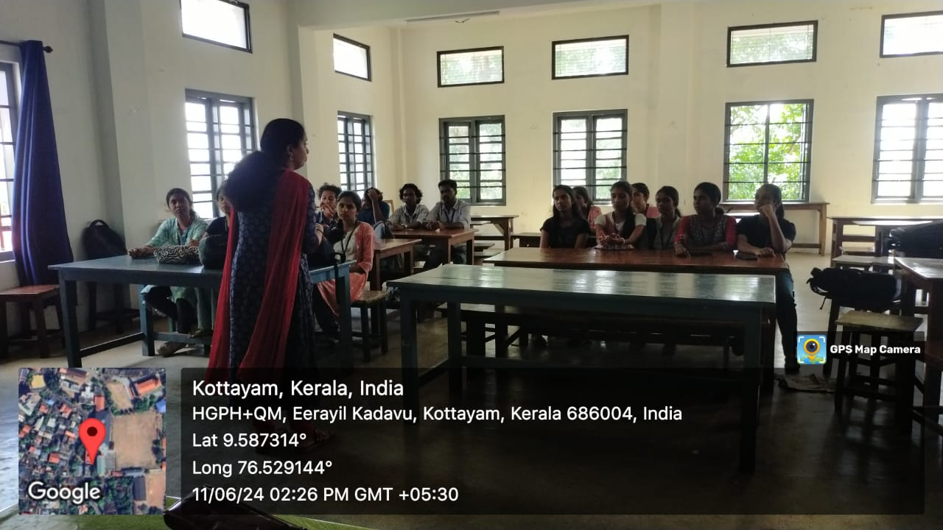

- Photograph of the event - Group Photo

- Other photographs if any
- Other Documents if any (Schedule, Resource Person Details, ..)

Resource Person: Dr. Anju Linda Varghese Department of Chemistry & Centre for Research

Innovation & Entrepreneurship Development Centre
An initiative of Kerala Startup Mission

- Name of Event | A Professional Development Course on Human Resource Management
- Name of Institute | : Baselius College
- Name of Nodal Officer | : Dr Aparna Thankappan
- Email Address | : aparnathankappan@baselius.ac.in
- Contact Number | : 9747620918
- Event participant type | : participants only from the institution
- Total number of participants | : 10
- Total number of women participants | : 1
- Track of Event | Entrepreneurship
- Event category | Other entrepreneurship related events
- Sector | HRTech & Smart Workforce
- Date from | 12.6.24
- Date to | 12.6.24
- Total number of hours | 1.5 hrs
- Details of IEDCs Collaborated | -
- Details of Communities or Clubs collaborated with | IIC,RINK, ED, Placement cell and department of economics
- Detailed report of the event (Min 200 words) | On June 12, 2024, a professional development course on Human Resource Management was conducted by Dr. John K. Babu from the Department of Business Administration (BBA). The session, held at 2:15 PM in Room No. 610, was organized by the Innovation and Entrepreneurship Development Centre (IEDC) in collaboration with the Institution's Innovation Council (IIC), the RINK, the Entrepreneurship Development (ED) cell, the Placement Cell, and the Department of Economics. The course attracted the participation of 10 students, all eager to enhance their understanding of HR management. Dr. Babu's lecture provided a comprehensive overview of the key principles and practices of human resource management. He emphasized the strategic role of HR in organizational success, covering essential topics such as talent acquisition, employee development, performance management, and labor relations. The session also addressed contemporary challenges in HR, including managing diversity, fostering inclusive work environments, and leveraging technology for HR functions. Dr. Babu's engaging teaching style and real-world examples helped students grasp complex concepts and their practical applications. The collaborative efforts of the various departments and cells highlighted the importance of interdisciplinary learning and professional development. The session not only equipped students with valuable HR management skills but also encouraged them to consider careers in this vital field. Overall, the course was a significant step towards preparing students for the dynamic demands of the modern workforce, underscoring the institution's commitment to providing holistic and industry-relevant education.
- Creatives created for the event (Max 10nos)
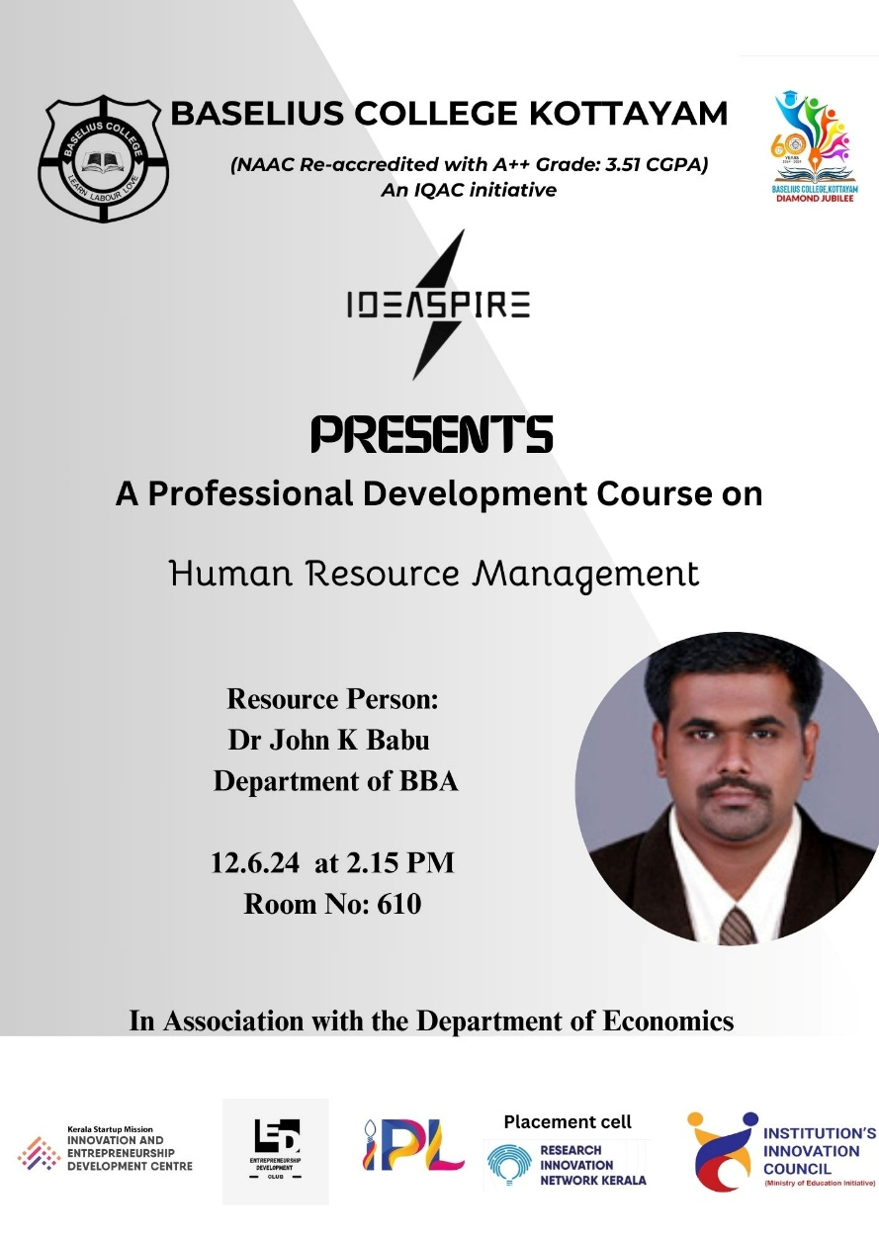

- Photograph of the event - Stage
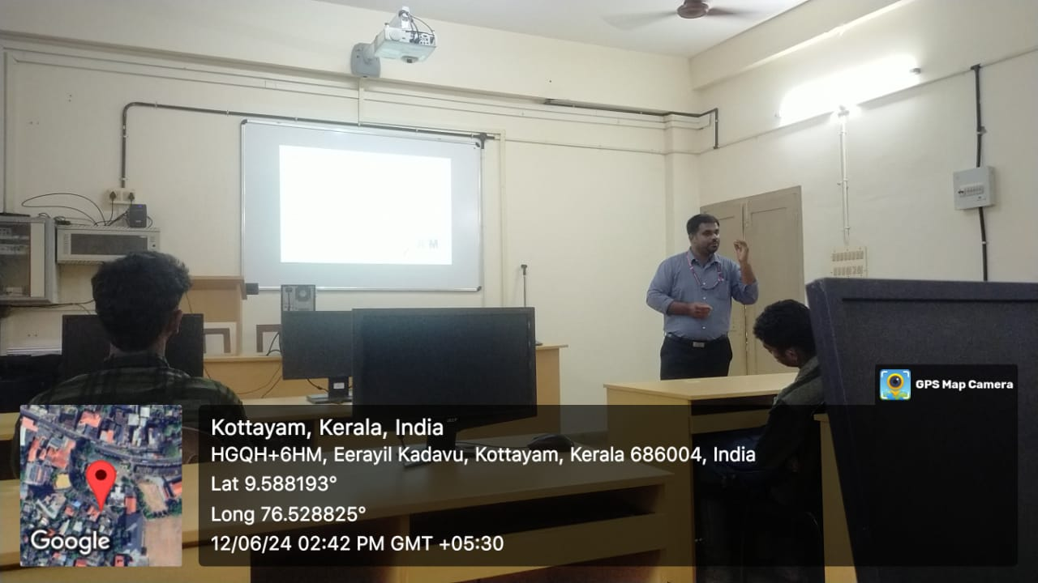

- Photograph of the event - Audience

- Photograph of the event - Group Photo

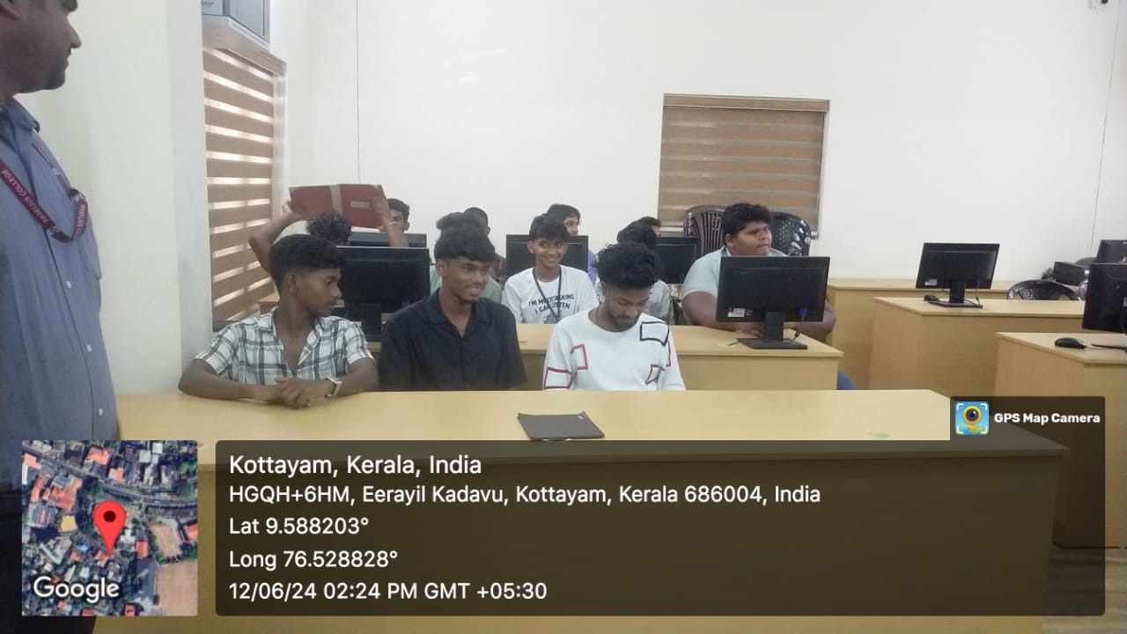
- Other photographs if any
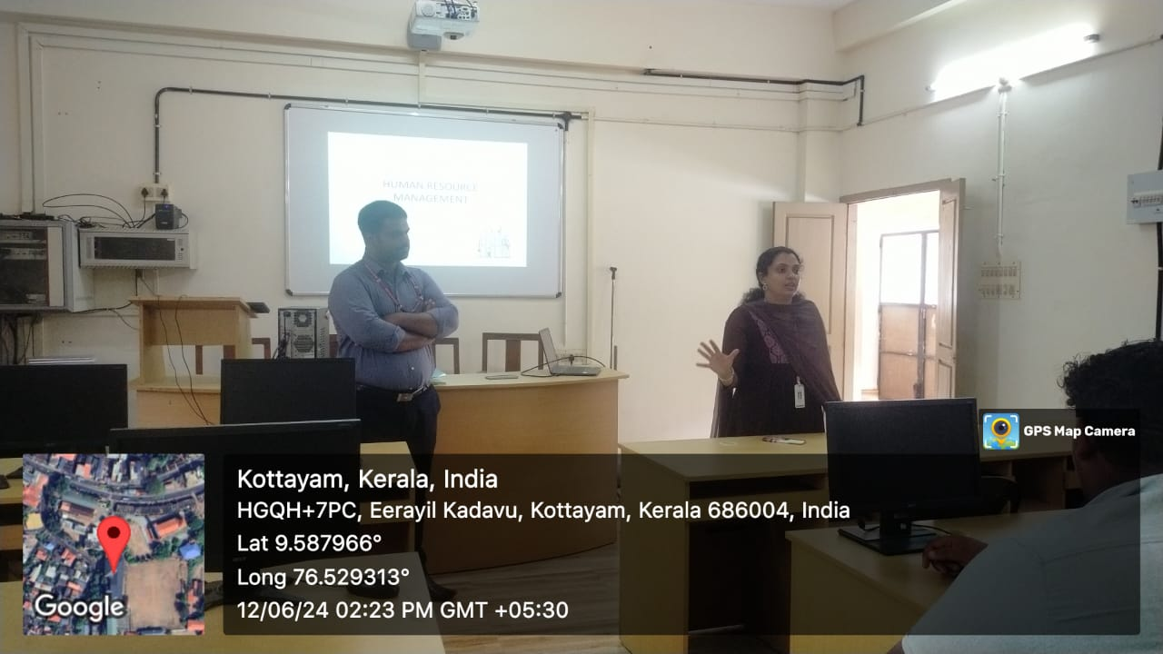
- Other Documents if any (Schedule, Resource Person Details, ..)

Resource Person: Dr John K Babu Department of BBA

Innovation & Entrepreneurship Development Centre
An initiative of Kerala Startup Mission

- Name of Event | Hands-On Workshop  Creating Distance Measurement Tools Using Arduino
- Name of Institute | : Baselius College
- Name of Nodal Officer | : Dr Aparna Thankappan
- Email Address | : aparnathankappan@baselius.ac.in
- Contact Number | : 9747620918
- Event participant type | : participants only from the institution
- Total number of participants | : 12
- Total number of women participants | : 12
- Track of Event | Technology
- Event category | Technology - Boot Camp/Hands-On Workshop - AR/VR, Mobile/Web Development, Artificial Intelligence, Hardware, Other Future Technologies etc.
- Sector | SaaS, Software & IT/ITES
- Date from | 6.7.24
- Date to | 6.7.24
- Total number of hours | 2 hrs
- Details of IEDCs Collaborated | -
- Details of Communities or Clubs collaborated with | IEDC,IIC,RINK,ED, Placement cell
- Detailed report of the event (Min 200 words) | On July 6th, 2024, a hands-on workshop titled "Creating Distance Measurement Tools Using Arduino" was conducted at the Physics Computer Lab. Organized collaboratively by the IEDC, IIC, RINK, ED, and Placement Cell, the workshop was led by Ms. Neha P R, an Assistant Professor from the Department of Physics. Aimed at providing students with practical experience in developing distance measurement tools using Arduino technology, the workshop saw the participation of 12 students. It ensured personalised attention and in-depth guidance from the resource person, fostering a conducive learning environment.  Ms. Neha P R commenced the workshop by introducing the fundamental concepts of Arduino, an open-source electronics platform based on easy-to-use hardware and software. She detailed the Arduino board's pin diagram, explaining each pin's function and how they connect to various sensors and components. The discussion emphasized the importance of Arduino in modern electronics, highlighting its versatility and applications in various projects and industries. Following this, she delved into the core topic of the workshop – measuring distance using Arduino. She explained the working principle of ultrasonic sensors, the key component in distance measurement projects, and demonstrated how to integrate them with Arduino to create a functional distance measurement tool.  The workshop was highly interactive, with students actively participating in hands-on activities. They were guided through the process of writing and uploading Arduino code, setting up circuits, and calibrating sensors to ensure accurate measurements. Ms. Neha P R provided continuous support and troubleshooting assistance, addressing individual queries and challenges faced by the students. This practical approach not only enhanced their technical skills but also encouraged critical thinking and problem-solving. The feedback from the participants was overwhelmingly positive, with many expressing appreciation for the opportunity to gain practical experience and insights from an experienced instructor. The success of this workshop underscored the effectiveness of the organizing bodies in providing valuable educational experiences and fostering a culture of innovation and learning.

- Creatives created for the event (Max 10nos)

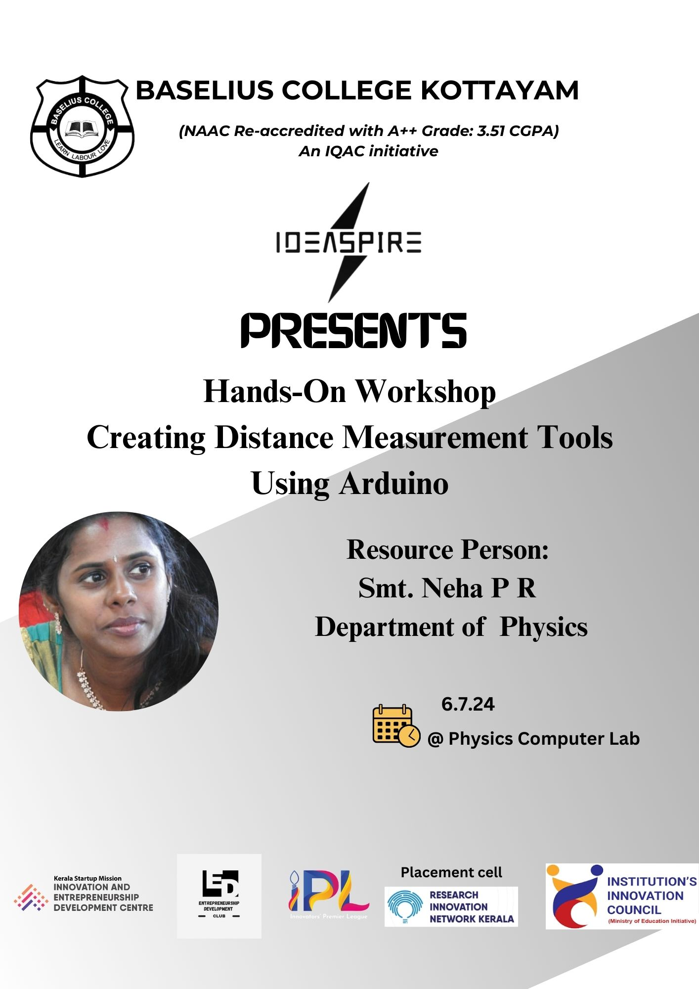

- Photograph of the event - Stage

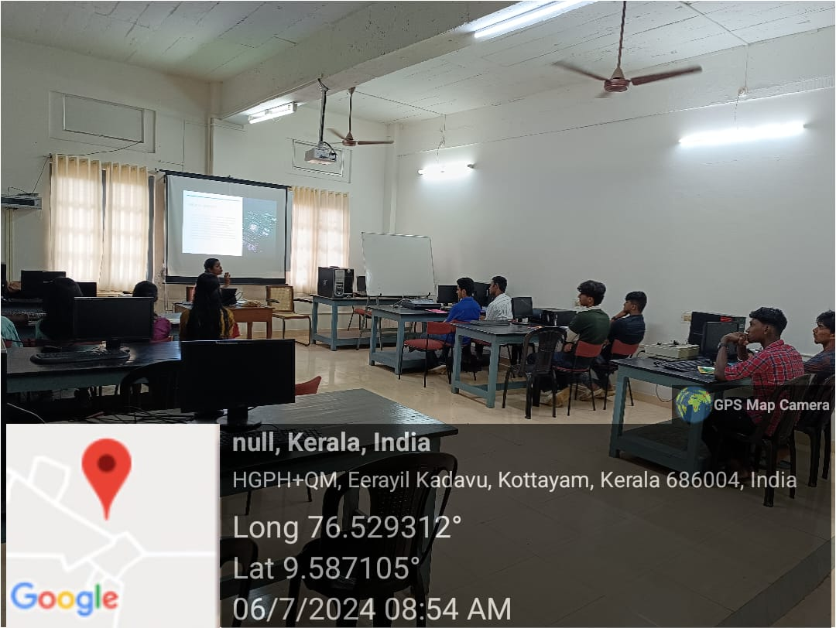

- Photograph of the event - Audience

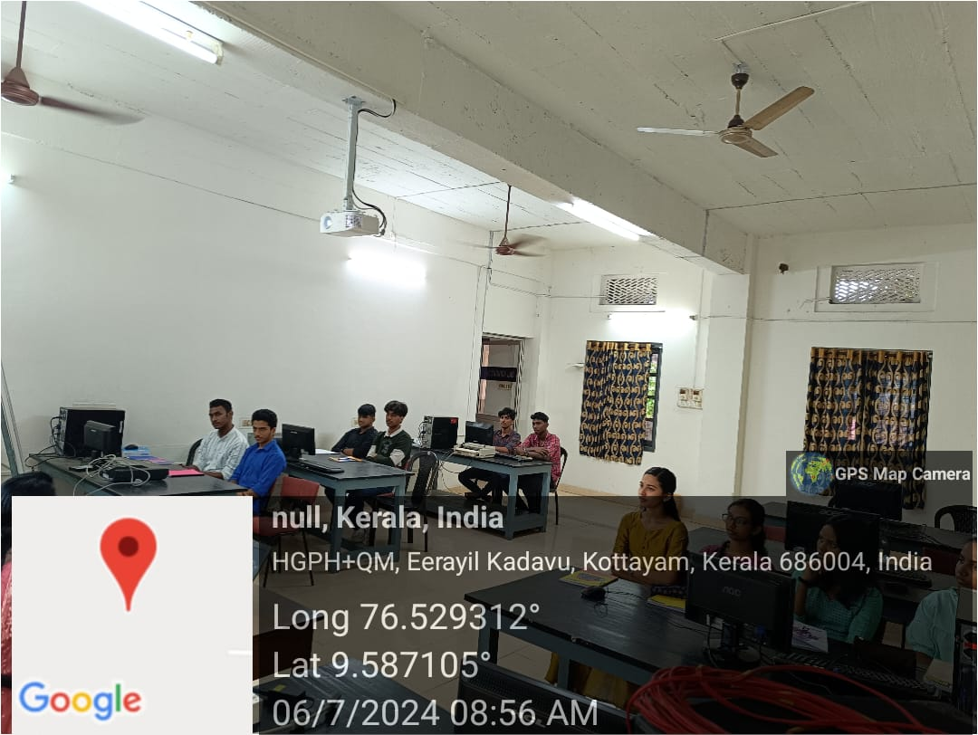

- Photograph of the event - Group Photo

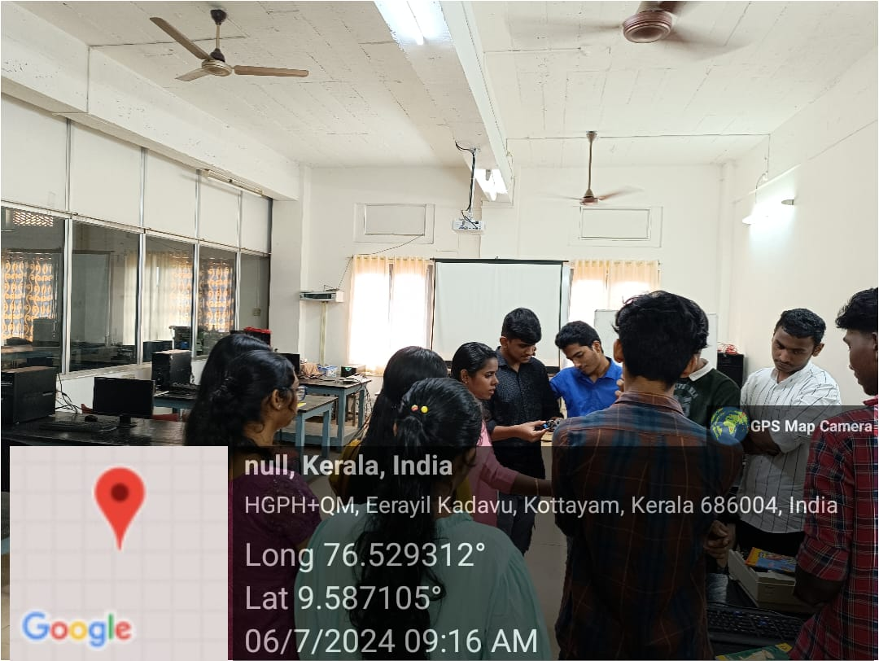

- Other photographs if any
- Other Documents if any (Schedule, Resource Person Details, ..)

Resource Person: Smt. Neha P R Department of Physics

Innovation & Entrepreneurship Development Centre
An initiative of Kerala Startup Mission

- Name of Event | Precision in Practice: Circuit Component Analysis
- Name of Institute | : Baselius College
- Name of Nodal Officer | : Dr Aparna Thankappan
- Email Address | : aparnathankappan@baselius.ac.in
- Contact Number | : 9747620918
- Event participant type | : participants only from the institution
- Total number of participants | : 12
- Total number of women participants | : 3
- Track of Event | Technology
- Event category | Technology - Super FabLab/FabLab/Mini FabLab Visit
- Sector | Other-lab visit
- Date from | 6.7.2024
- Date to | 6.7.2024
- Total number of hours | 2
- Details of IEDCs Collaborated | -
- Details of Communities or Clubs collaborated with | IEDC,IIC
- Detailed report of the event (Min 200 words) | The "Precision in Practice: Circuit Component Analysis" program, organized by the Innovation and Entrepreneurship Development Center (IEDC) and the Institution’s Innovation Council (IIC) at Baselius College, was a highly impactful event held on 6th July at 10 AM. It aimed to bridge the gap between theoretical knowledge and practical application in electronics. The program featured technical sessions and hands-on workshops where students engaged in activities such as vernier calliper and screw gauge measurements, as well as determining resistance values using colour codes. Participants also utilized diagnostic tools like multimeters and oscilloscopes to measure and analyze circuit parameters, gaining valuable practical experience. The event successfully enhanced students' practical skills, and confidence in using tools and software, and fostered collaboration and innovation among participants.  The comprehensive approach of combining theoretical knowledge with hands-on practice effectively promoted innovation and practical understanding among students. Overall, the program achieved its objectives of enhancing technical skills and fostering problem-solving abilities, paving the way for future initiatives by IEDC and IIC to further support the innovative capabilities of Baselius College students.
- Creatives created for the event (Max 10nos)
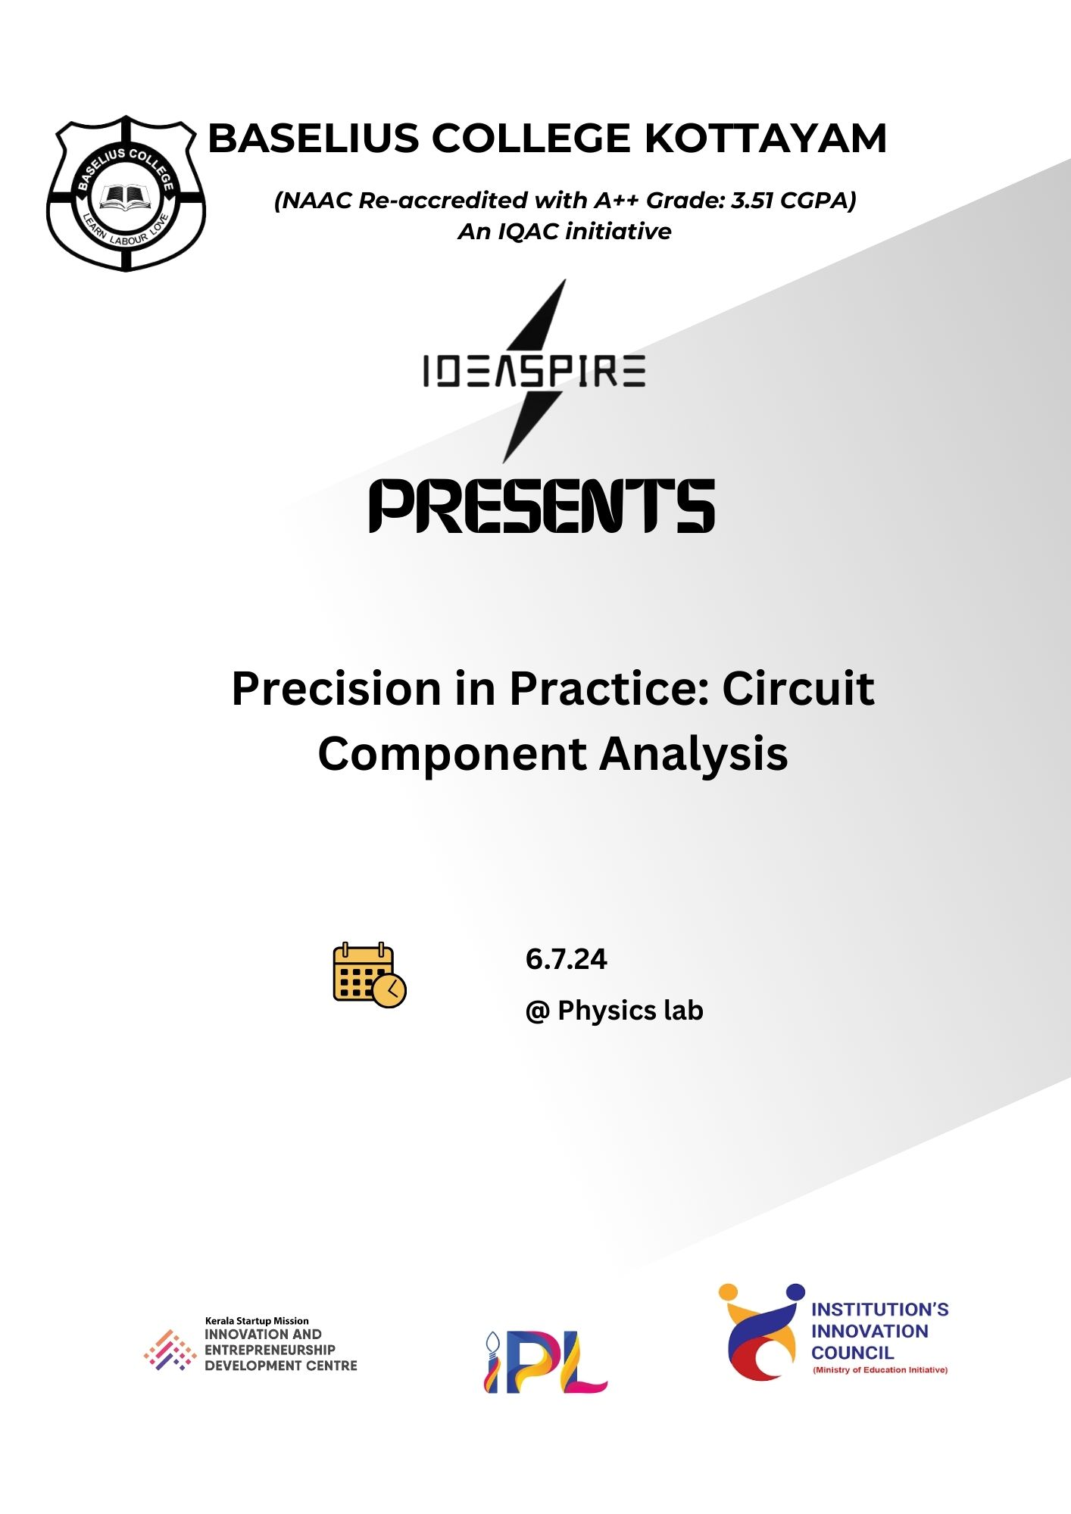

- Photograph of the event - Stage

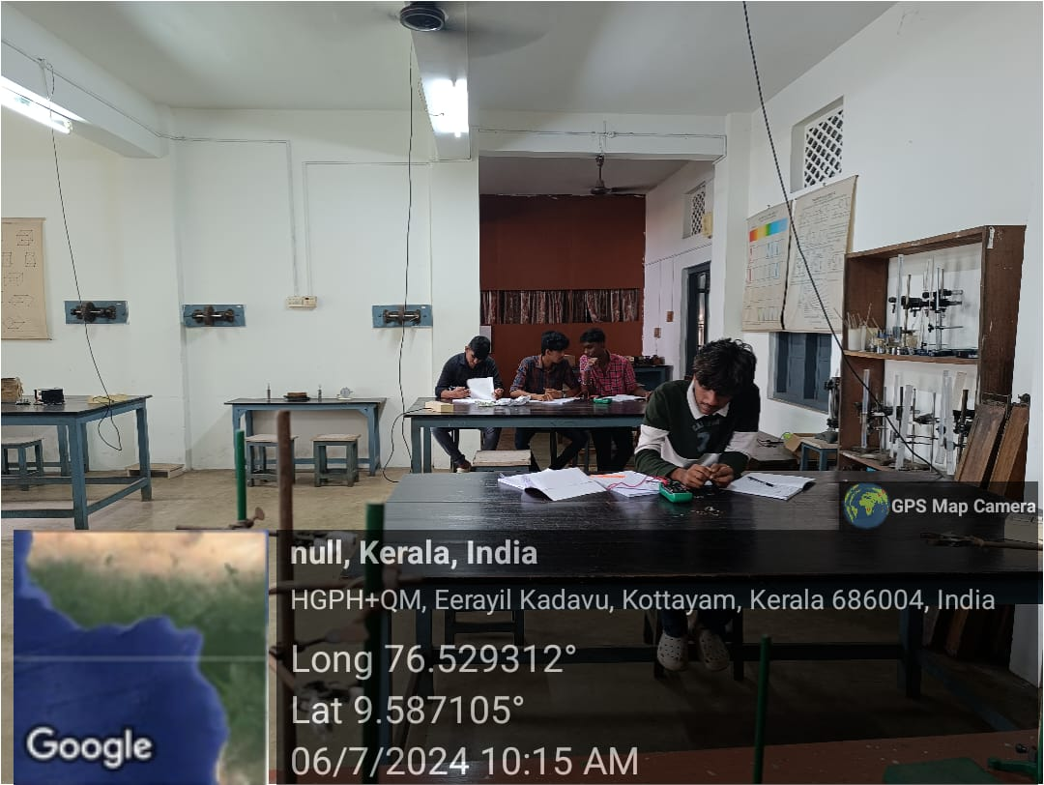

- Photograph of the event - Audience

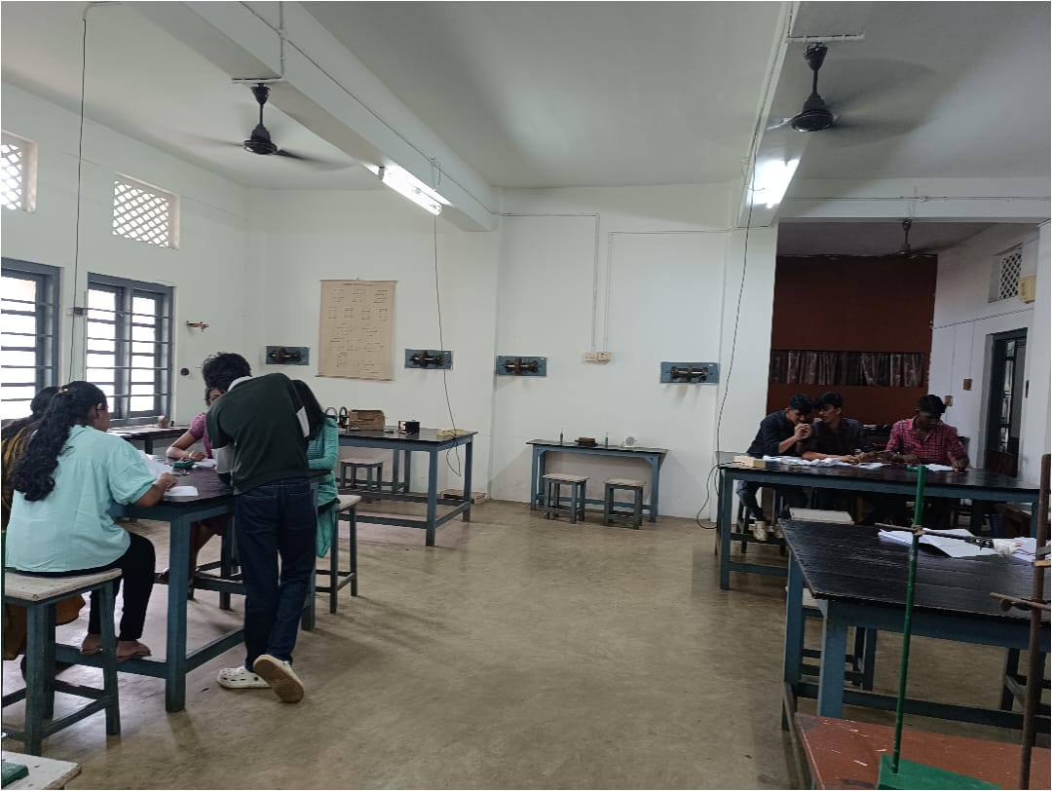

- Photograph of the event - Group Photo

- Other photographs if any
- Other Documents if any (Schedule, Resource Person Details, ..)

Innovation & Entrepreneurship Development Centre
An initiative of Kerala Startup Mission

- Name of Event | IDEATHONE
- Name of Institute | : Baselius College
- Name of Nodal Officer | : Dr Aparna Thankappan
- Email Address | : aparnathankappan@baselius.ac.in
- Contact Number | : 9747620918
- Event participant type | : participants only from the institution
- Total number of participants | : 22
- Total number of women participants | : 9
- Track of Event | Innovation
- Event category | Innovation - Workshops - Innovation Orientation, Ideation etc.
- Sector | Other ideathone
- Date from | 10.7.24
- Date to | 10.7.24
- Total number of hours | 2
- Details of IEDCs Collaborated | -
- Details of Communities or Clubs collaborated with | IEDC,IIC
- Detailed report of the event (Min 200 words) | The Ideathone event for BBA students, organized by the Innovation and Entrepreneurship Development Cell (IEDC) and the Institution's Innovation Council (IIC) at Baselius College, was held on July 10, 2024, starting at 10:45 am. This event provided a platform for BBA students to present their innovative ideas and entrepreneurial concepts.  The primary objective of the Ideathone was to encourage creativity, innovation, and critical thinking among the students. Participants had the opportunity to showcase their original ideas, which could range from business plans to technological innovations, and receive constructive feedback.  Dr. Aparna Thankappan, the IEDC Nodal Officer, evaluated the presentations. With her extensive experience and expertise in innovation and entrepreneurship, Dr. Thankappan provided valuable insights and guidance to the students. Her evaluation focused on the feasibility, originality, and potential impact of the presented ideas.  The event was not only a competition but also a learning experience, helping students refine their ideas and understand the practical aspects of turning concepts into viable projects. The Ideathone fostered a spirit of innovation and entrepreneurship within the BBA program, aligning with the broader goals of IEDC and IIC to promote an entrepreneurial culture at Baselius College.

- Creatives created for the event (Max 10nos)
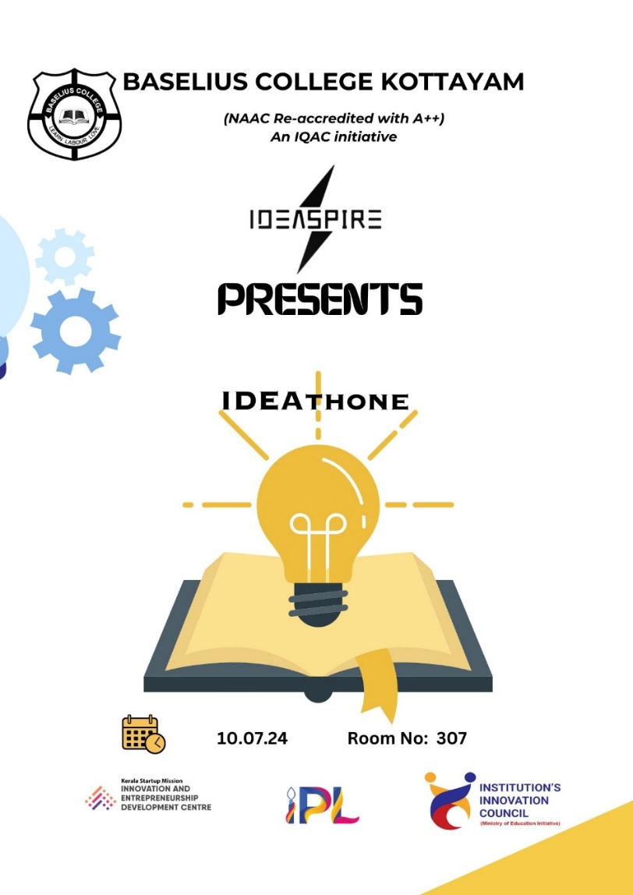

- Photograph of the event - Stage
- 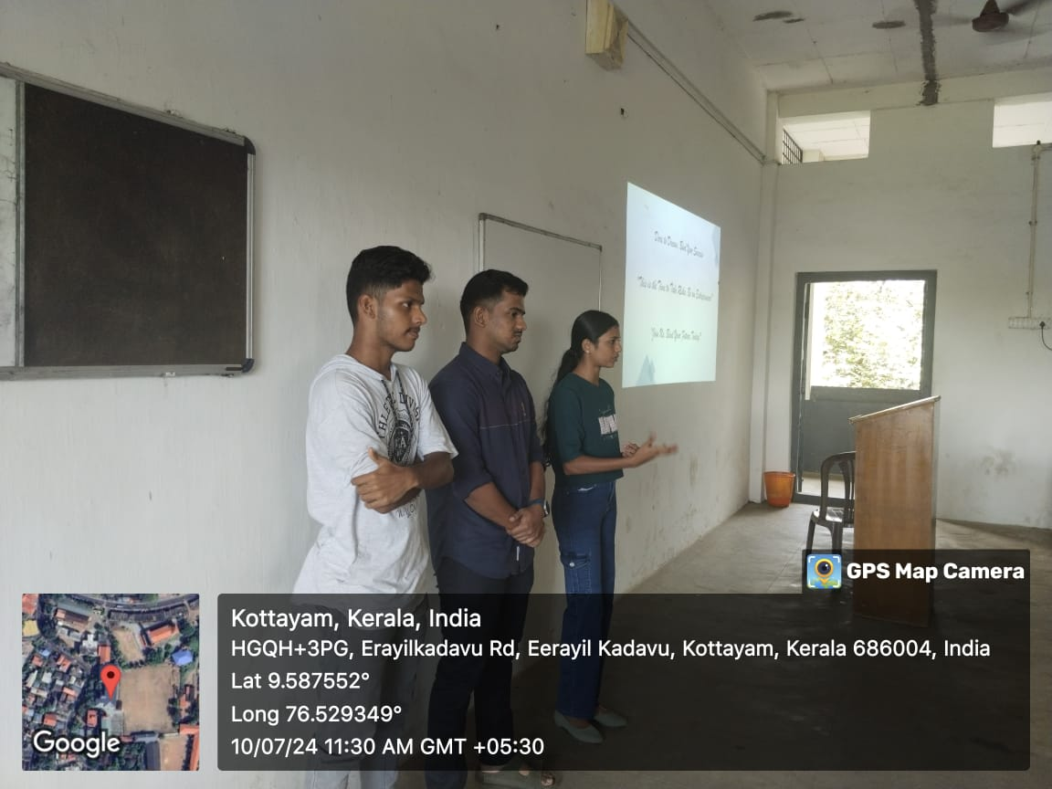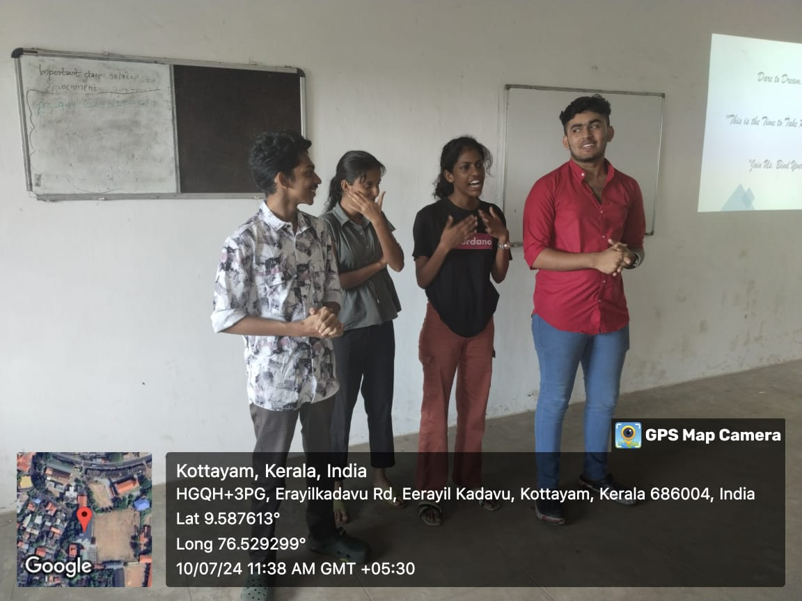

- Photograph of the event - Audience
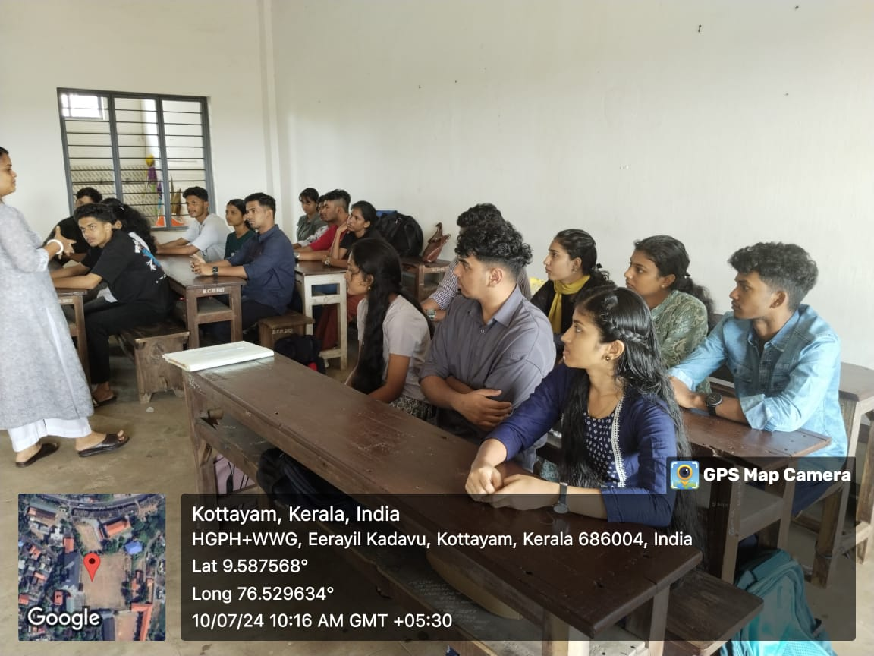

- Photograph of the event - Group Photo

- Other photographs if any
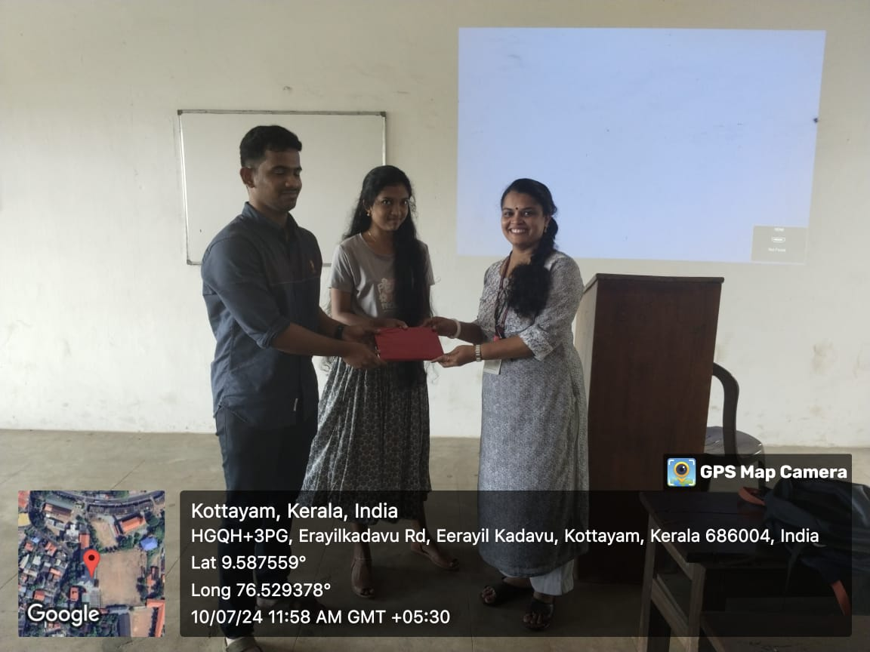
- Other Documents if any (Schedule, Resource Person Details, ..)
Dr Aparna Thankappan, IEDC Nodal Officer

Innovation & Entrepreneurship Development Centre
An initiative of Kerala Startup Mission

- Name of Event | Ideathone
- Name of Institute | : Baselius College
- Name of Nodal Officer | : Dr Aparna Thankappan
- Email Address | : aparnathankappan@baselius.ac.in
- Contact Number | : 9747620918
- Event participant type | : participants only from the institution
- Total number of participants | : 12
- Total number of women participants | : 5
- Track of Event | Innovation
- Event category | Innovation - Workshops - Innovation Orientation, Ideation etc.
- Sector | Other- ideathone
- Date from | 9.7.2024
- Date to | 9.7.2024
- Total number of hours | 3
- Details of IEDCs Collaborated | -
- Details of Communities or Clubs collaborated with | IEDC ,IIC
- Detailed report of the event (Min 200 words) | The Ideathone event for the Department of Physics, organized by the Innovation and Entrepreneurship Development Cell (IEDC) and the Institution's Innovation Council (IIC) at Baselius College, took place on July 9, 2024. The event began at 11.30 am and saw the participation of 12 enthusiastic physics students.  This Ideathone aimed to foster innovation and entrepreneurial thinking among the physics students. Participants were encouraged to present their unique ideas, which could encompass scientific research, technological advancements, or practical applications of physics principles. The event served as a platform for students to demonstrate their creativity and problem-solving abilities.  Dr. Aparna Thankappan, the IEDC Nodal Officer, evaluated the presentations. Her role was crucial in providing an expert assessment of the ideas based on criteria such as originality, feasibility, scientific rigor, and potential impact. Dr. Thankappan's feedback was instrumental in helping students refine their ideas and gain a deeper understanding of how to translate theoretical knowledge into practical solutions.  The Ideathone was designed not just as a competitive event but as a comprehensive learning experience. Students received constructive criticism and guidance, enabling them to enhance their projects. The event highlighted the importance of interdisciplinary thinking and innovation in the field of physics, aligning with the mission of IEDC and IIC to nurture an entrepreneurial mindset among students.  Overall, the Ideathone for the Department of Physics was a successful initiative that inspired students to think beyond traditional academic boundaries and explore the potential of their ideas in real-world applications.

- Creatives created for the event (Max 10nos)
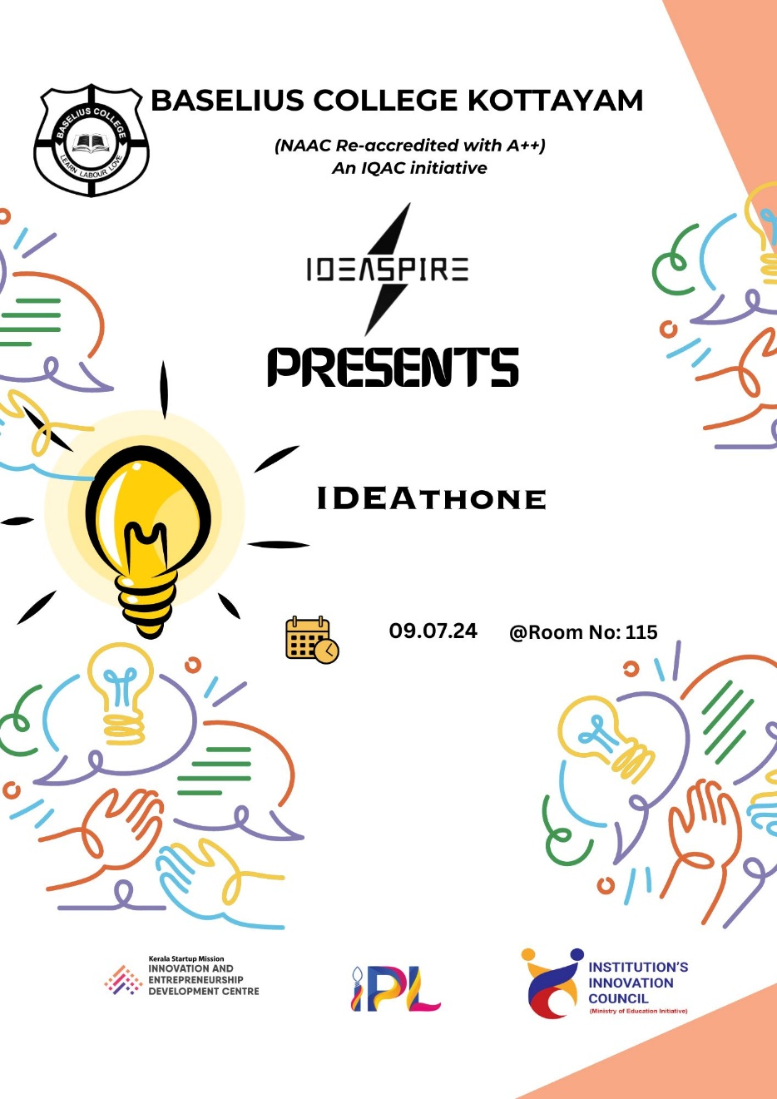

- Photograph of the event - Stage

- Photograph of the event - Audience

- Photograph of the event - Group Photo
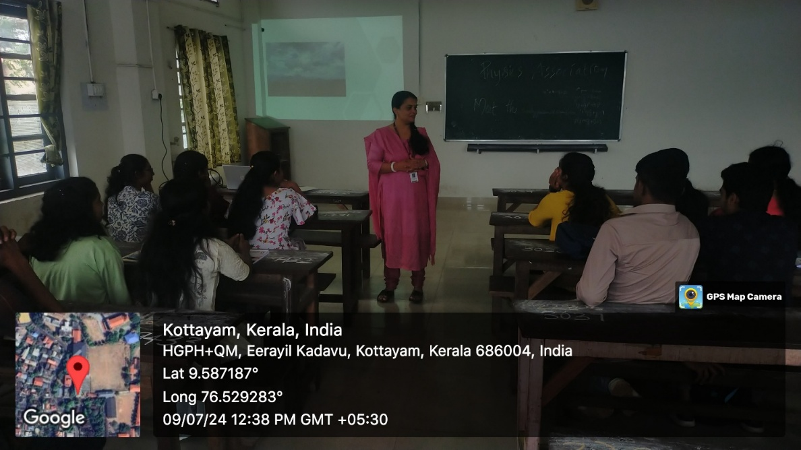

- Other photographs if any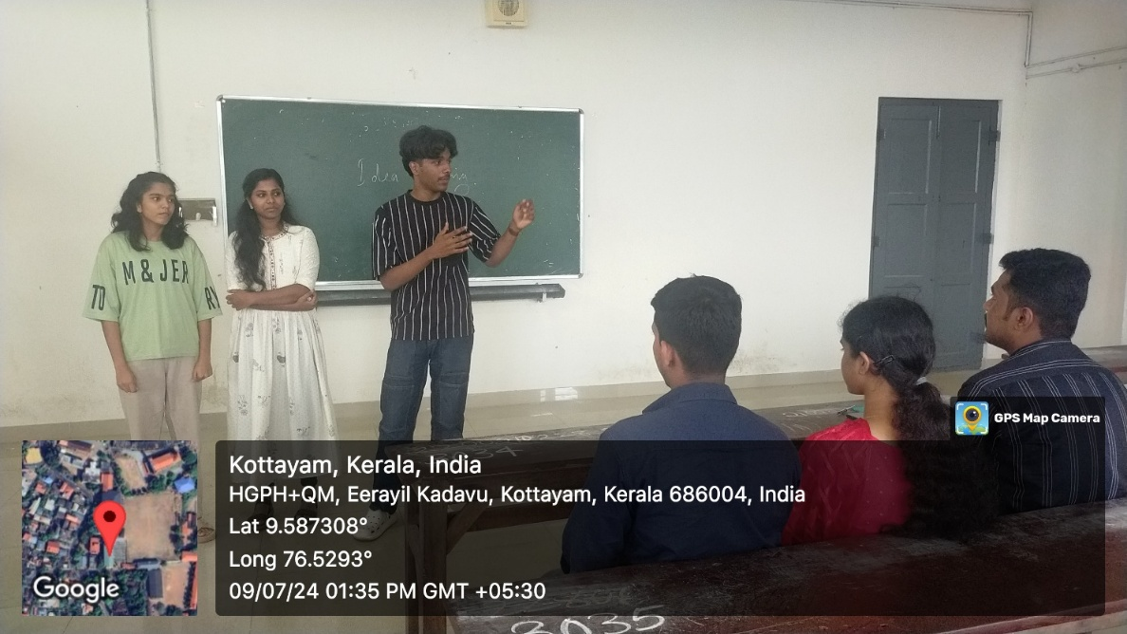
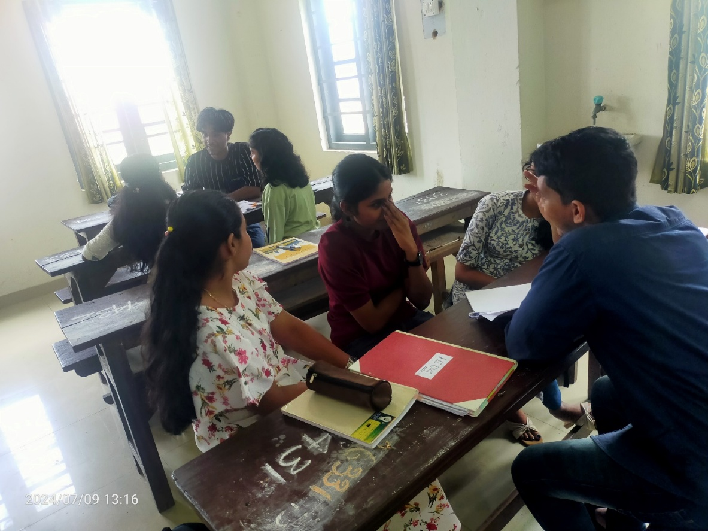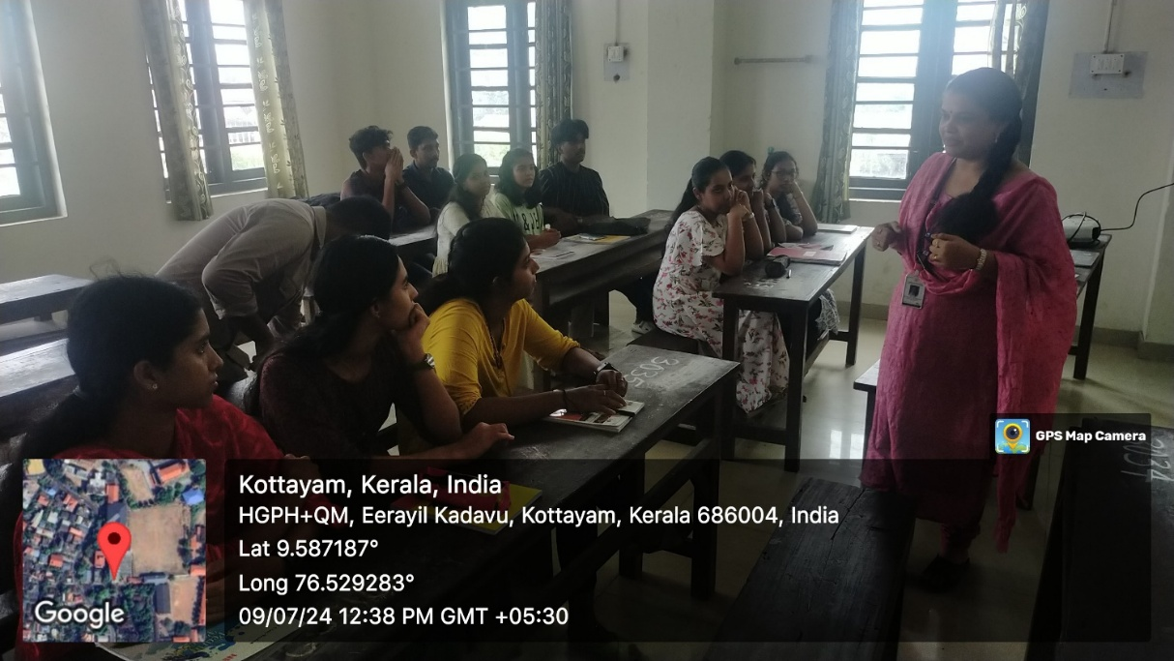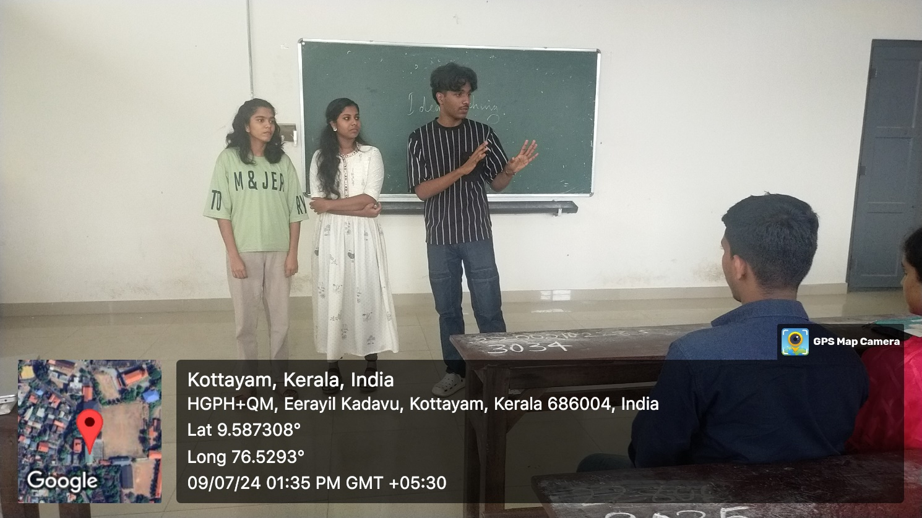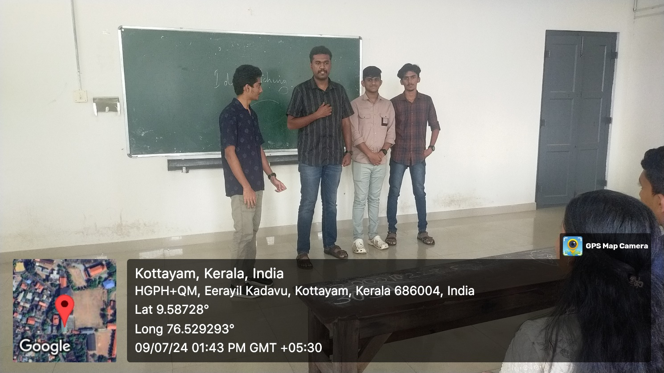
- Other Documents if any (Schedule, Resource Person Details, ..)

Dr Aparna Thankappan,IEDC Nodal Officer
- Participant list in prescribed format
Innovation & Entrepreneurship Development Centre
An initiative of Kerala Startup Mission

- Name of Event | Orientation: Dare to Dream
- Name of Institute | : Baselius College
- Name of Nodal Officer | : Dr Aparna Thankappan
- Email Address | : aparnathankappan@baselius.ac.in
- Contact Number | : 9747620918
- Event participant type | : participants only from the institution
- Total number of participants | : 22
- Total number of women participants | : 8
- Track of Event | innovation
- Event category | Innovation - Workshops - Innovation Orientation, Ideation etc.
- Sector | orientation
- Date from | 10.7.2024
- Date to | 10.7.2024
- Total number of hours | 2
- Details of IEDCs Collaborated | -
- Details of Communities or Clubs collaborated with | IEDC,IIC
- Detailed report of the event (Min 200 words) | On July10, 2024, an orientation session for BBA students was conducted by Dr. Aparna Thankappan, the IEDC Nodal Officer, at Baselius College. The purpose of this session was to introduce BBA students to the Innovation and Entrepreneurship Development Cell (IEDC) and inform them about the various opportunities available for fostering innovation and entrepreneurship.  Dr. Aparna Thankappan led the session with a focus on the following key areas:  - Introduction to IEDC: Dr. Thankappan provided an overview of the IEDC's mission, emphasizing its role in promoting a culture of innovation and entrepreneurship among students. She highlighted the importance of entrepreneurial skills in the modern business world and how the IEDC supports students in developing these skills.  - Programs and Initiatives: The session detailed various programs, workshops, and events organized by the IEDC that are specifically tailored for BBA students. Dr. Thankappan discussed how these initiatives can help students gain practical experience, enhance their business acumen, and develop innovative solutions to real-world problems.  - Resources and Support: Dr. Thankappan explained the resources and support systems available through the IEDC, including access to mentorship, funding opportunities, and collaborative spaces. She emphasized the importance of utilizing these resources to bring their entrepreneurial ideas to life.  - Success Stories: To inspire the students, Dr. Thankappan shared success stories of former students who had successfully launched their own startups or innovative projects through the support of the IEDC. These stories showcased the potential impact and benefits of active participation in the IEDC's activities.  - Q&A Session: The orientation included an interactive question-and-answer segment where students could engage with Dr. Thankappan, seek advice on their ideas, and clarify their doubts regarding the IEDC's offerings.  The orientation session was designed to be motivational and informative, aiming to ignite an entrepreneurial spark among BBA students. It encouraged them to think creatively, leverage the resources provided by the IEDC, and embark on their entrepreneurial journeys with confidence.

- Creatives created for the event (Max 10nos)
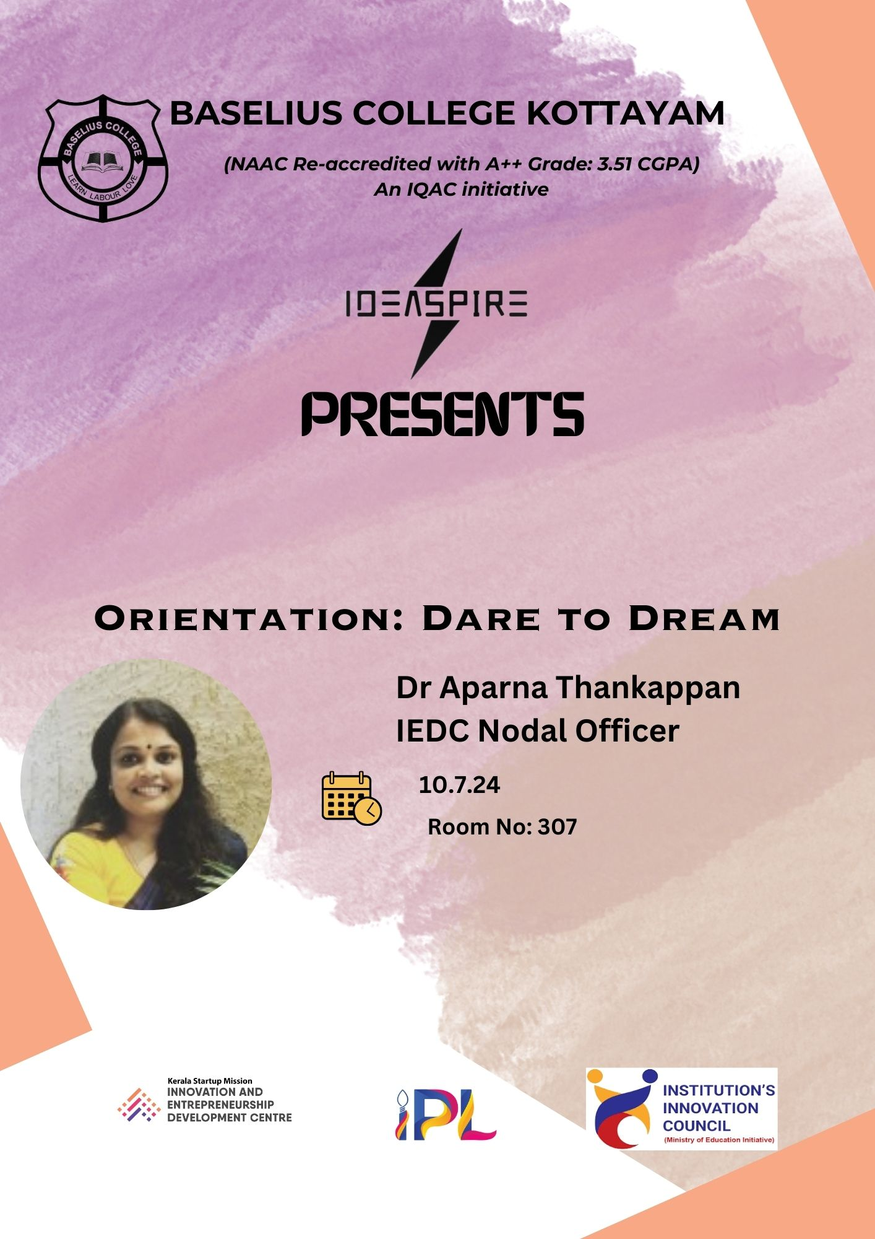
- Photograph of the event - Stage

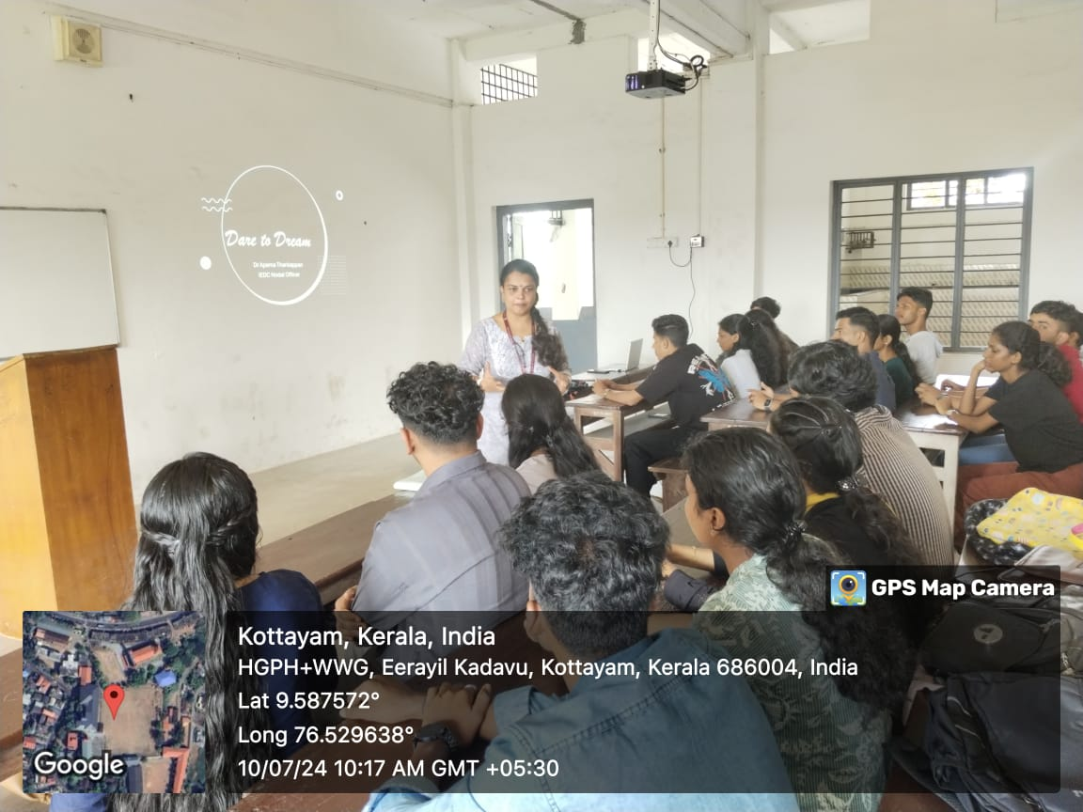

- Photograph of the event - Audience

- Photograph of the event - Group Photo

- Other photographs if any
- Other Documents if any (Schedule, Resource Person Details, ..)

Dr Aparna Thankappan
- Participant list in prescribed format
Innovation & Entrepreneurship Development Centre
An initiative of Kerala Startup Mission

- Name of Event | Orientation: Dream Big, Start Now
- Name of Institute | : Baselius College
- Name of Nodal Officer | : Dr Aparna Thankappan
- Email Address | : aparnathankappan@baselius.ac.in
- Contact Number | : 9747620918
- Event participant type | : participants only from the institution
- Total number of participants | : 12
- Total number of women participants | : 5
- Track of Event | Innovation
- Event category | Innovation - Workshops - Innovation Orientation, Ideation etc.
- Sector | Orientation-Innovation
- Date from | 9.7.24
- Date to | 9.7.24
- Total number of hours | 3
- Details of IEDCs Collaborated | -
- Details of Communities or Clubs collaborated with | IEDC,IIC
- Detailed report of the event (Min 200 words) | On July 9, 2024, an orientation session for Physics students was conducted by Dr. Aparna Thankappan, the IEDC Nodal Officer, at Baselius College. This session was organized to introduce the students to the Innovation and Entrepreneurship Development Cell (IEDC) and its various initiatives.  Dr. Aparna Thankappan, with her extensive knowledge and experience in fostering innovation and entrepreneurship, led the orientation. She provided a comprehensive overview of the IEDC's mission, objectives, and the opportunities it offers to students. The session aimed to inspire and motivate Physics students to engage in innovative projects and entrepreneurial activities.  Key highlights of the orientation included:  - Introduction to IEDC: Dr. Thankappan explained the role and significance of the IEDC in promoting a culture of innovation and entrepreneurship among students.  - Programs and Initiatives: She detailed various programs, workshops, and events organized by the IEDC that students could participate in to enhance their skills and knowledge.  - Resources and Support: Information about the resources, mentorship, and support available through the IEDC for students pursuing innovative projects was shared.  - Success Stories: Dr. Thankappan shared inspiring success stories of previous student projects and startups that emerged from the IEDC, demonstrating the potential and impact of student-led innovations.  The orientation session was interactive, with students having the opportunity to ask questions and discuss their ideas with Dr. Thankappan. It provided valuable insights into the possibilities and pathways available for Physics students to turn their innovative ideas into reality, fostering an entrepreneurial spirit within the department.

- Creatives created for the event (Max 10nos)

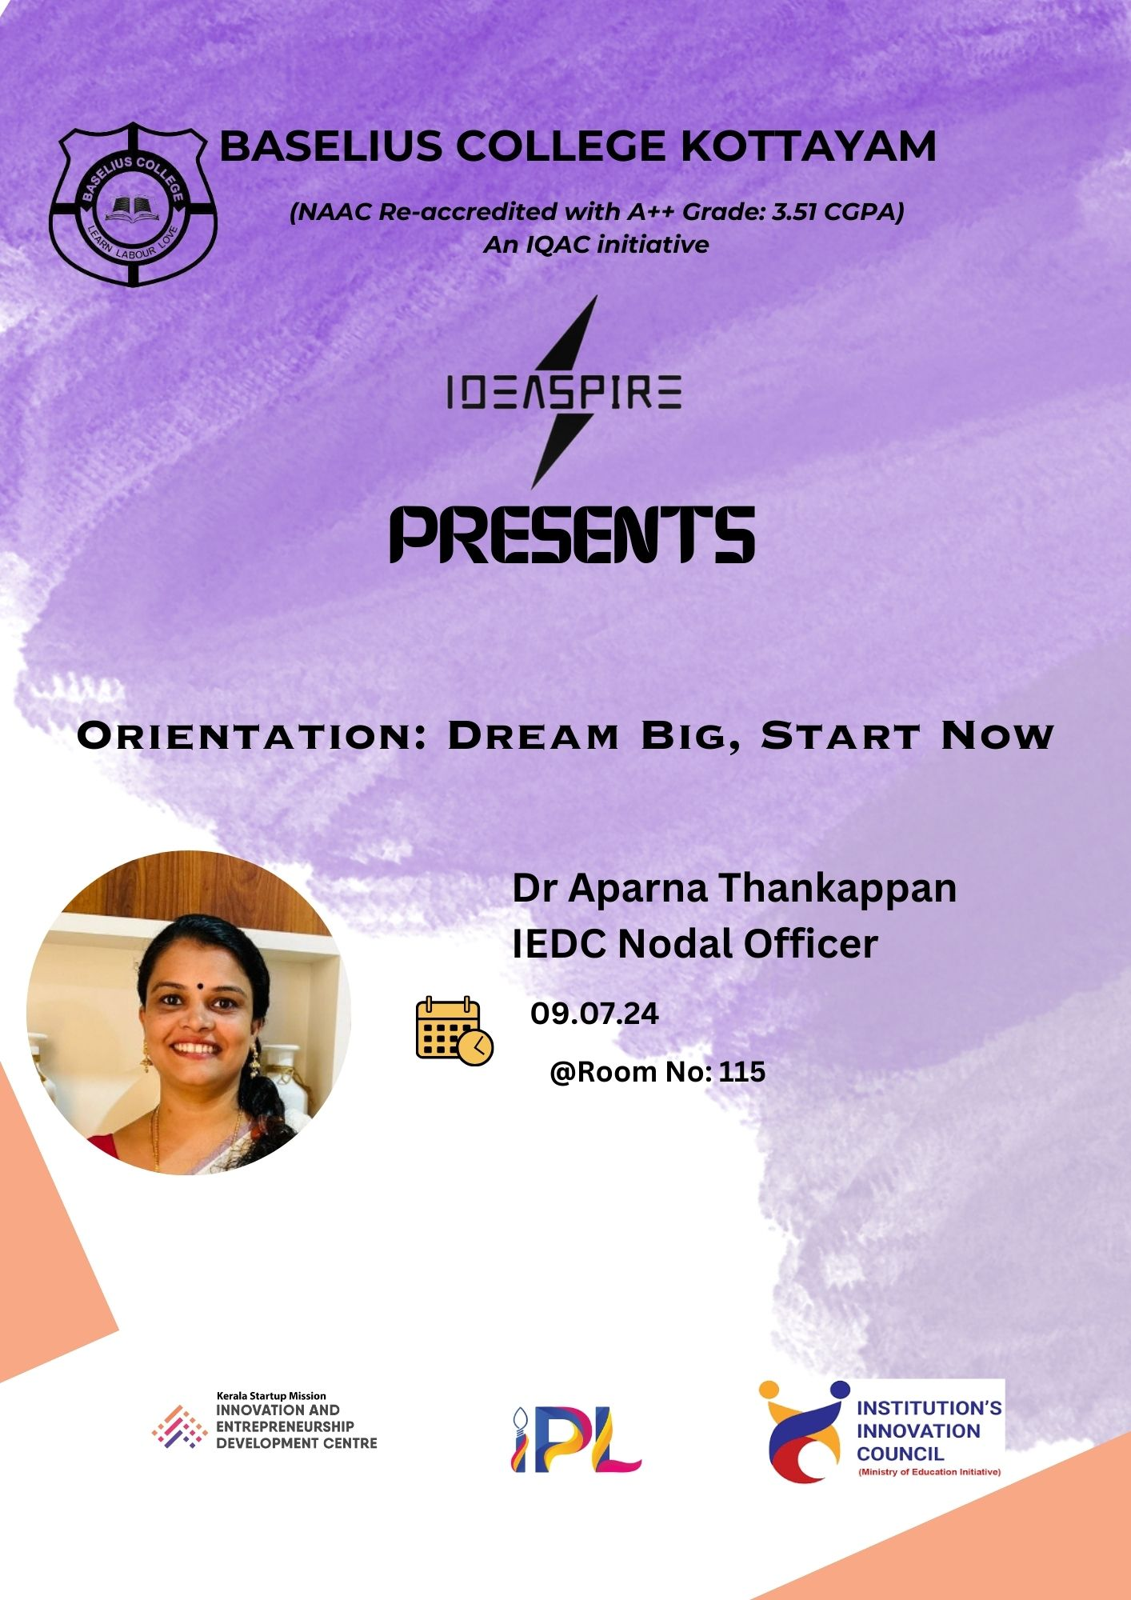
- Photograph of the event - Stage

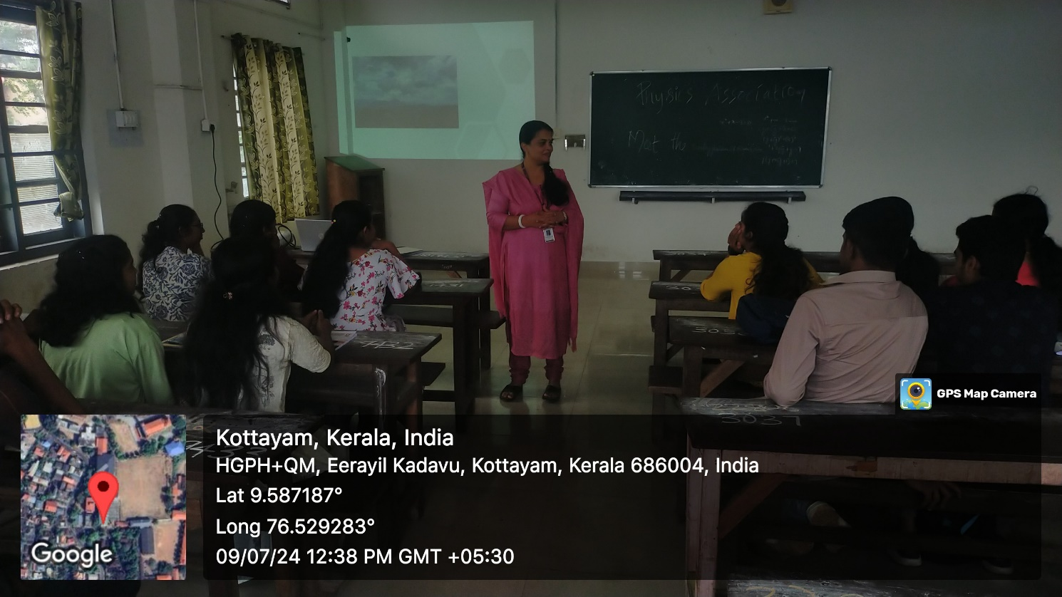

- Photograph of the event - Audience

- Photograph of the event - Group Photo

- Other photographs if any
- Other Documents if any (Schedule, Resource Person Details, ..)

Dr Aparna Thankappan,IEDC Nodal Officer
Participant list in prescribed format
Innovation & Entrepreneurship Development Centre
An initiative of Kerala Startup Mission

- Name of Event | Communicative Skill Bootcamp
- Name of Institute | : Baselius College
- Name of Nodal Officer | : Dr Aparna Thankappan
- Email Address | : aparnathankappan@baselius.ac.in
- Contact Number | : 9747620918
- Event participant type | : participants only from the institution
- Total number of participants | : 25
- Total number of women participants | : 16
- Track of Event | Entrepreneurship
- Event category | Entrepreneurship - Boot camps/Workshops - Business model Canvas Workshop, How to build a startup etc.
- Sector | Lifestyle, Personalcare & D2C
- Date from | 11.7.24
- Date to | 12.7.24
- Total number of hours | 4 hrs
- Details of IEDCs Collaborated | Nil
- Details of Communities or Clubs collaborated with | IEDC,IIC
- Detailed report of the event (Min 200 words) | The Communicative Skill Bootcamp, organized by the IEDC, IIC, and the Department of Physics at Baselius College, was held on July 11 and 12, 2024. This two-day event aimed to enhance the communication skills of 25 participating Physics students, equipping them to convey their innovative ideas and technological concepts effectively. The sessions were led by Dr. Kavitha Gopalakrishnan and Mr. Jithin John from the Department of English, along with Dr. Aparna Thankappan, IEDC Nodal Officer. The bootcamp included topics such as the fundamentals of effective communication, technical communication skills, pitching and persuasion techniques, and collaborative communication. Through interactive exercises, group activities, and role-playing, students gained practical experience and received constructive feedback, significantly improving their ability to articulate technical concepts and engage with diverse audiences.  The bootcamp successfully met its objectives, with participants reporting increased confidence and improved communication skills. The positive feedback from the students highlighted the bootcamp's interactive format and practical focus, emphasizing the importance of clear and effective communication in fostering innovation and entrepreneurship. This event showcased the commitment of Baselius College to provide its students with the essential tools for academic and professional success, reinforced by the expertise and guidance of resource persons Dr. Kavitha Gopalakrishnan and Mr. Jithin John. This interdisciplinary effort underscores the value of promoting a culture of innovation and collaboration within the college community.
- Creatives created for the event (Max 10nos)

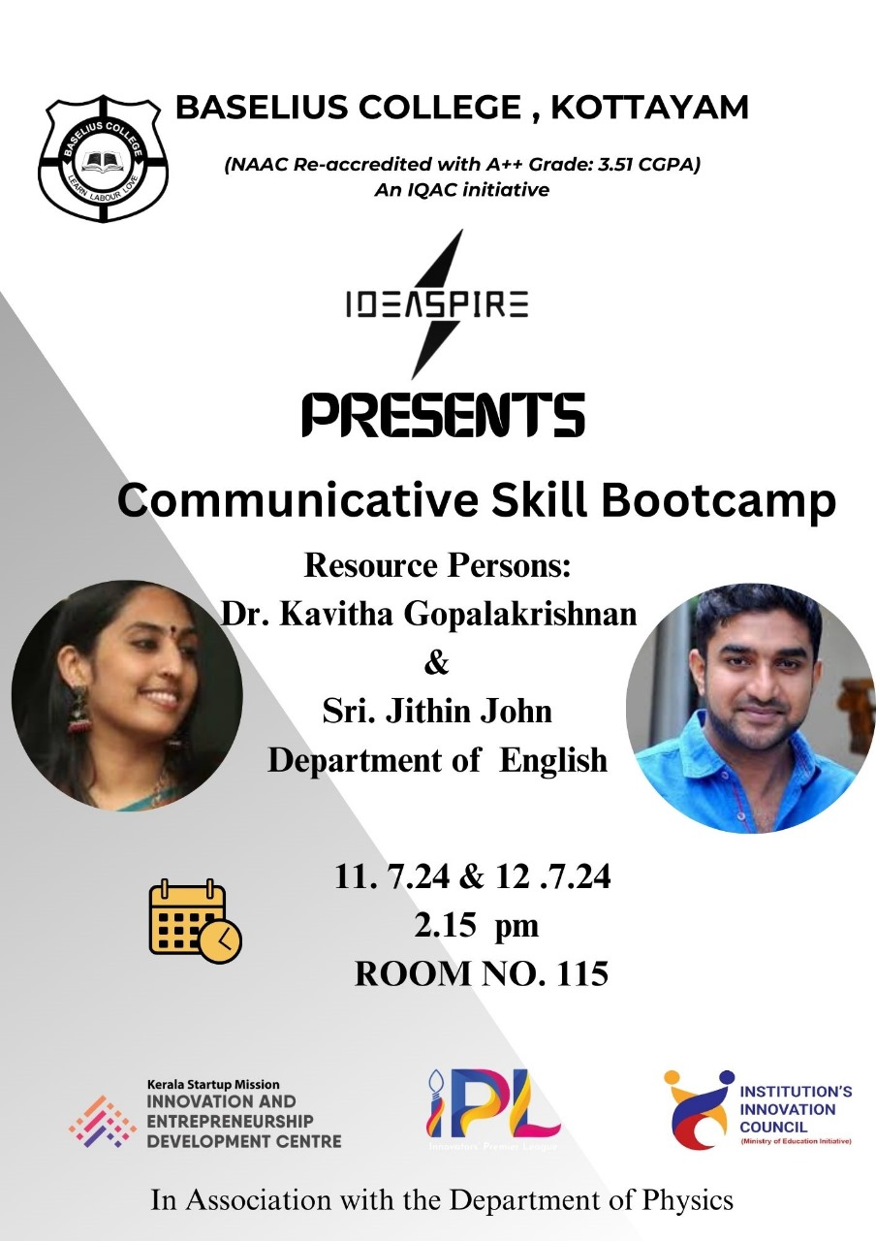
- Photograph of the event - Stage
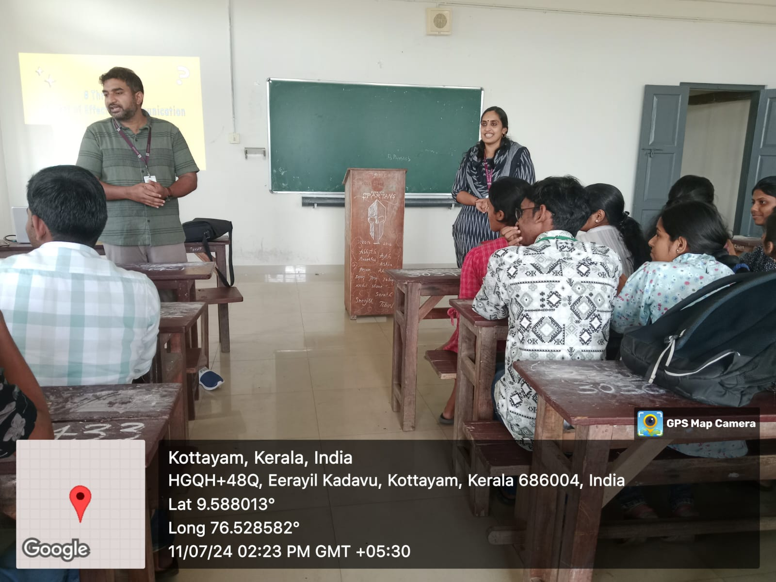

- Photograph of the event - Audience

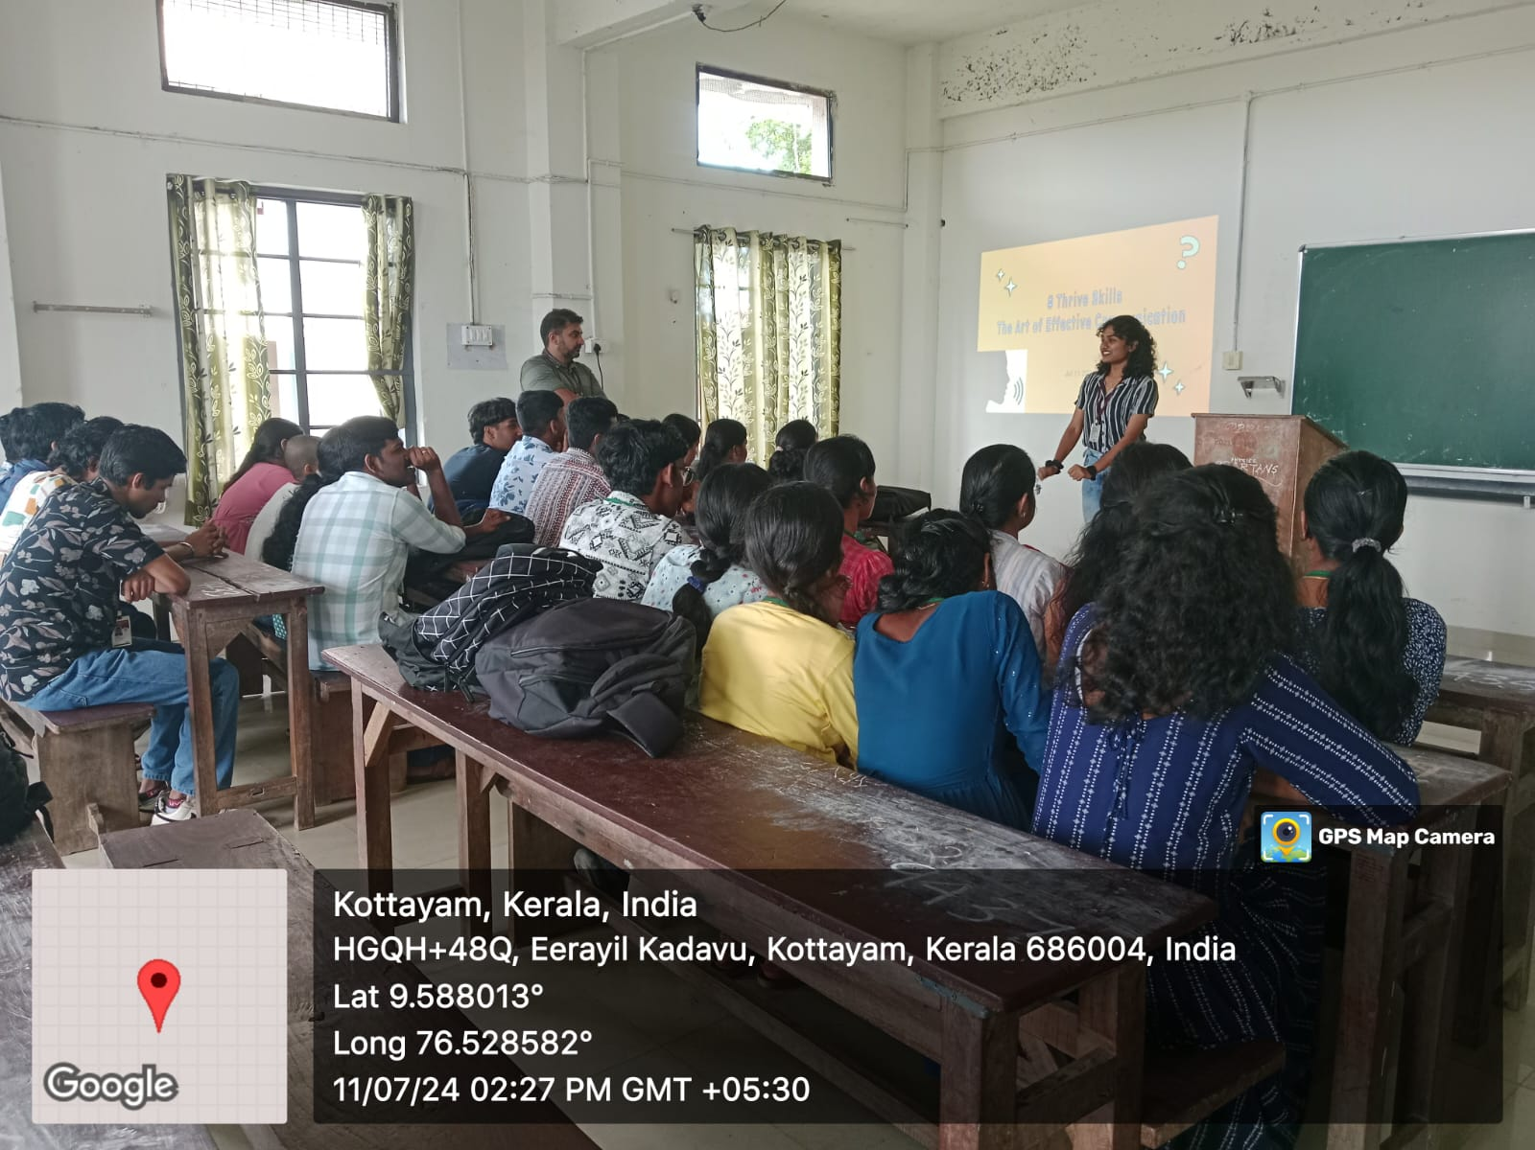

- Photograph of the event - Group Photo

- Other photographs if any
- Other Documents if any (Schedule, Resource Person Details, ..)
Dr Kavitha Gopalakrishnan, Mr. Jithin Jihn, Department of English

Innovation & Entrepreneurship Development Centre
An initiative of Kerala Startup Mission

- Name of Event | Environment and Literature: An Interdisciplinary approach
- Name of Institute | : Baselius College
- Name of Nodal Officer | : Dr Aparna Thankappan
- Email Address | : aparnathankappan@baselius.ac.in
- Contact Number | : 9747620918
- Event participant type | : participants only from the institution
- Total number of participants | : 20
- Total number of women participants | : 15
- Track of Event | Innovation
- Event category | Other Innovation related events
- Sector | Healthcare & Life Sciences
- Date from | 11.7.24
- Date to | 11.7.24
- Total number of hours | 2
- Details of IEDCs Collaborated | -
- Details of Communities or Clubs collaborated with | IEDC ,IIC, ED,Placement cell,RINK
- Detailed report of the event (Min 200 words) | On July 11, 2024, an insightful interdisciplinary session titled "Environment and Literature" was held at the Malayalam Reference Library, organized by the IEDC, IIC, ED, RINK, Placement cell, and the Department of Malayalam. The session, conducted by Dr. Arathi P, Assistant Professor of Botany from the Department of Botany, was attended by 20 enthusiastic participants. The event commenced at 2:17 pm and delved into the intricate connections between songs in movies and the environment, shedding light on how literary and cinematic expressions reflect and influence our ecological consciousness.  Dr. Arathi P eloquently explained how songs in movies often draw inspiration from nature, utilizing environmental elements to enhance emotional and narrative depth. She provided examples of how different environmental settings, such as forests, rivers, and mountains, are depicted in cinematic songs, creating a profound impact on the audience's perception of nature. This innovative approach allowed students to understand the interplay between environment and literature, opening up new perspectives on how art and nature intertwine.  The participants left the session with a wealth of innovative concepts, inspired by Dr. Arathi's engaging presentation. The event not only highlighted the importance of environmental awareness in literature and cinema but also encouraged students to explore creative ways to incorporate ecological themes into their own works. Overall, the session was a resounding success, fostering a deeper appreciation for the environment through the lens of literature and film.
- Creatives created for the event (Max 10nos)

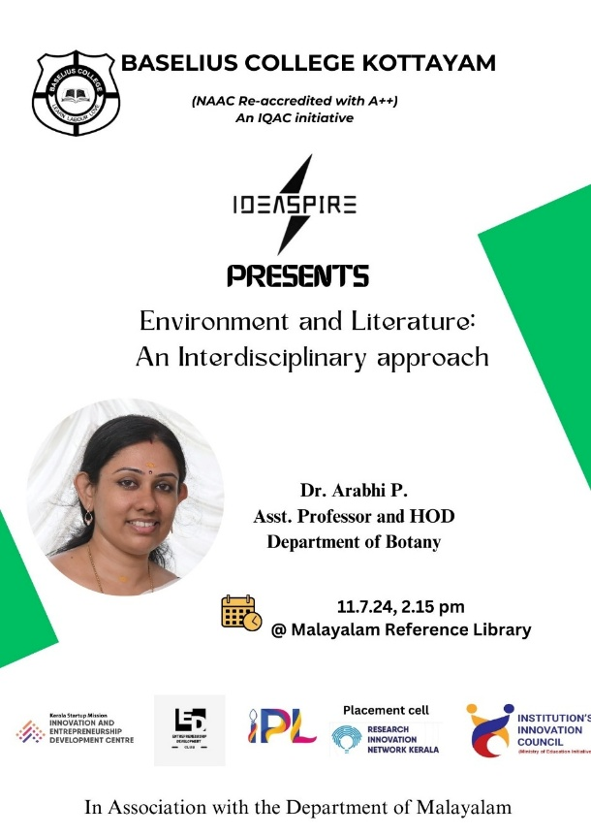
- Photograph of the event - Stage

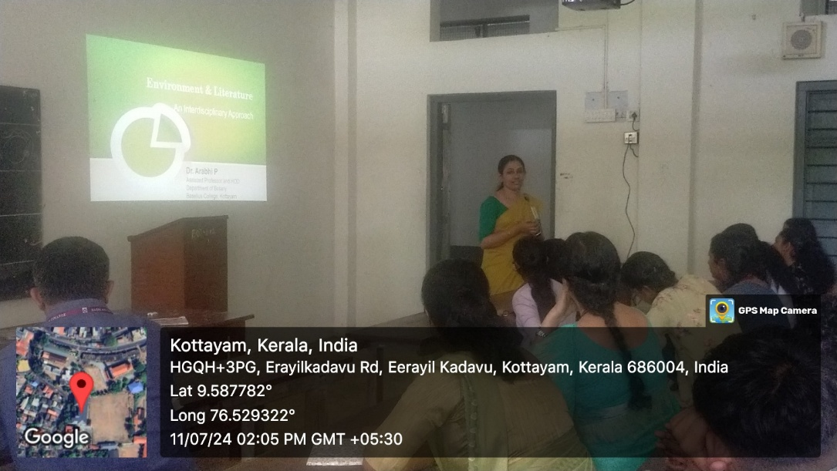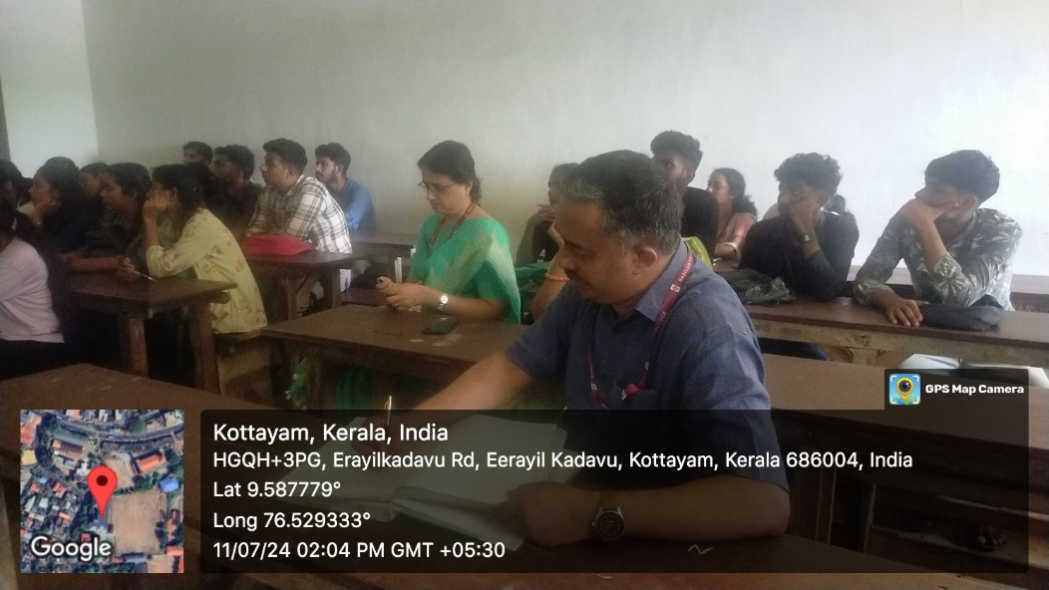

- Photograph of the event - Audience

- Photograph of the event - Group Photo

- Other photographs if any
- Other Documents if any (Schedule, Resource Person Details, ..)

Innovation & Entrepreneurship Development Centre
An initiative of Kerala Startup Mission

- Name of Event | Be the recycling Heros
- Name of Institute | : Baselius College
- Name of Nodal Officer | : Dr Aparna Thankappan
- Email Address | : aparnathankappan@baselius.ac.in
- Contact Number | : 9747620918
- Event participant type | : participants only from the institution
- Total number of participants | : 11
- Total number of women participants | : 7
- Track of Event | Entrepreneurship
- Event category | Other entrepreneurship related events
- Sector | Social Impact, Rural Livelihood & Sustainability
- Date from | 8.7.24
- Date to | 10.7.24
- Total number of hours | 4
- Details of IEDCs Collaborated | -
- Details of Communities or Clubs collaborated with | IEDC,IIC,ED,RINK and placement cell, YI chapter
- Detailed report of the event (Min 200 words) | From July 8 to July 10, 2024, the IEDC, ED , RINK, and Placement Cell, in collaboration with YI Kochi, organized an impactful electronic waste donation drive. This initiative provided a platform for students and teachers to responsibly dispose of their old electronic waste, contributing to environmental sustainability. The event saw active participation from both students and teachers, with 11 dedicated student volunteers spearheading the program.  The drive aimed to raise awareness about the importance of proper e-waste disposal and the environmental hazards posed by electronic waste. Over the three days, participants donated a variety of electronic items, including old mobile phones, laptops, chargers, and other electronic accessories. The collected e-waste was then handed over to YI Kochi for proper recycling and disposal.  The enthusiastic involvement of the college community highlighted the collective commitment towards environmental conservation. This collaboration not only provided a practical solution for e-waste management but also educated the participants on the significance of recycling electronic products. The event was a resounding success, showcasing the positive impact of collaborative efforts in addressing environmental issues.
- reatives created for the event (Max 10nos)

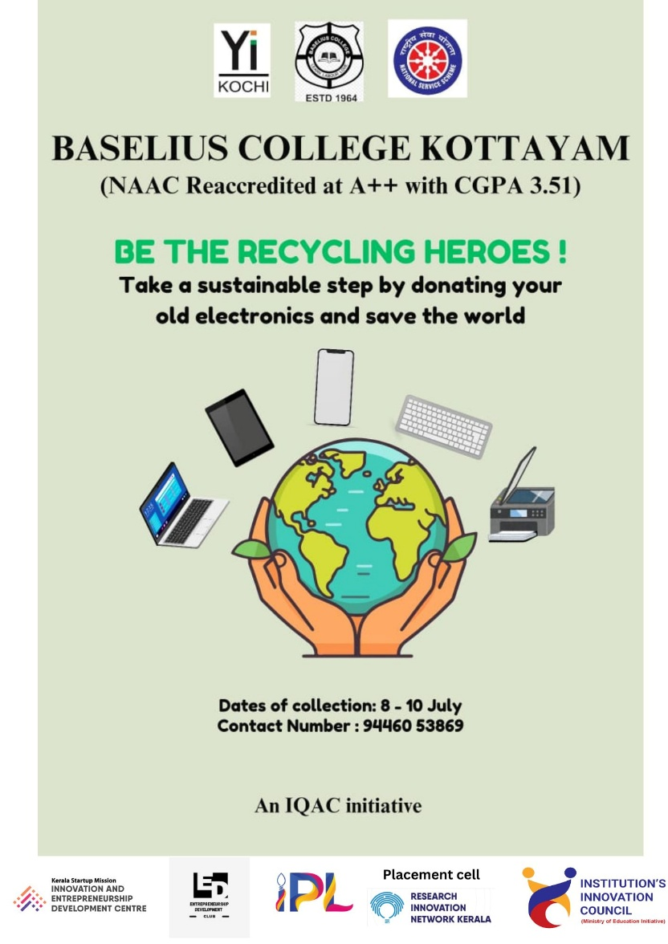
- Photograph of the event - Stage
- 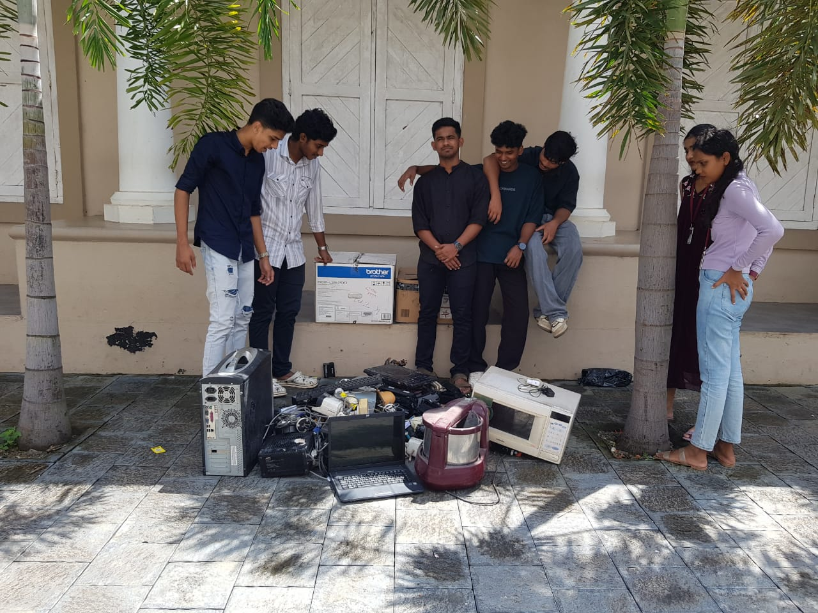

- Photograph of the event - Audience

- Photograph of the event - Group Photo

- Other photographs if any
- Other Documents if any (Schedule, Resource Person Details, ..)

-
Participant list in prescribed format
Innovation & Entrepreneurship Development Centre
An initiative of Kerala Startup Mission

- Name of Event | Meet the Entrepreneur: Success-Failure Friday
- Name of Institute | : Baselius College
- Name of Nodal Officer | : Dr Aparna Thankappan
- Email Address | : aparnathankappan@baselius.ac.in
- Contact Number | : 9747620918
- Event participant type | : participants only from the institution
- Total number of participants | : 19
- Total number of women participants | : 11
- Track of Event | Entrepreneurship
- Event category | Entrepreneurship - Sessions - IPR, Incubation & acceleration, Angel & VC Funding etc.
- Sector | MarketingTech & MICE
- Date from | 12/7/2024
- Date to | 12/7/24
- Total number of hours | 1
- Details of IEDCs Collaborated | -
- Details of Communities or Clubs collaborated with | IEDC,IIC,RINK,ED,Placement cell
- Detailed report of the event (Min 200 words) | On July 12, 2024, Baselius College hosted "Meet the Entrepreneur: Success-Failure Friday," featuring Dr. Geethalakshmi K, an esteemed faculty member from the Department of Botany and a successful woman entrepreneur. The session took place from 10:45 am to 11:45 am and was organized collaboratively by the IEDC, IIC, ED, Placement Cell, BBA, and RINK. Dr. Geethalakshmi shared her entrepreneurial journey, highlighting both her successes and the challenges she faced along the way. Her candid recounting of experiences provided valuable insights into the realities of entrepreneurship, particularly from a woman's perspective in academia.  Dr. Geethalakshmi's narrative resonated deeply with the attendees, comprising students and faculty members, who were inspired by her resilience and innovation. She discussed the importance of balancing academic responsibilities with entrepreneurial endeavors and emphasized the role of perseverance and adaptability in overcoming obstacles. The event concluded with an interactive Q&A session, where participants eagerly engaged with Dr. Geethalakshmi, seeking advice and gaining motivation to pursue their entrepreneurial aspirations. This initiative by the organizing bodies successfully fostered a spirit of innovation and enterprise within the Baselius College community.
- Creatives created for the event (Max 10nos)
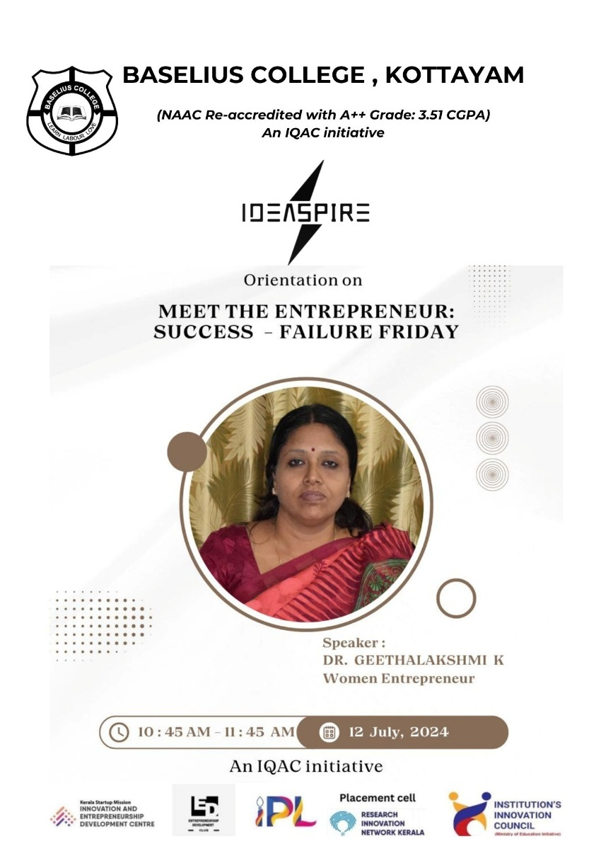

- Photograph of the event - Stage

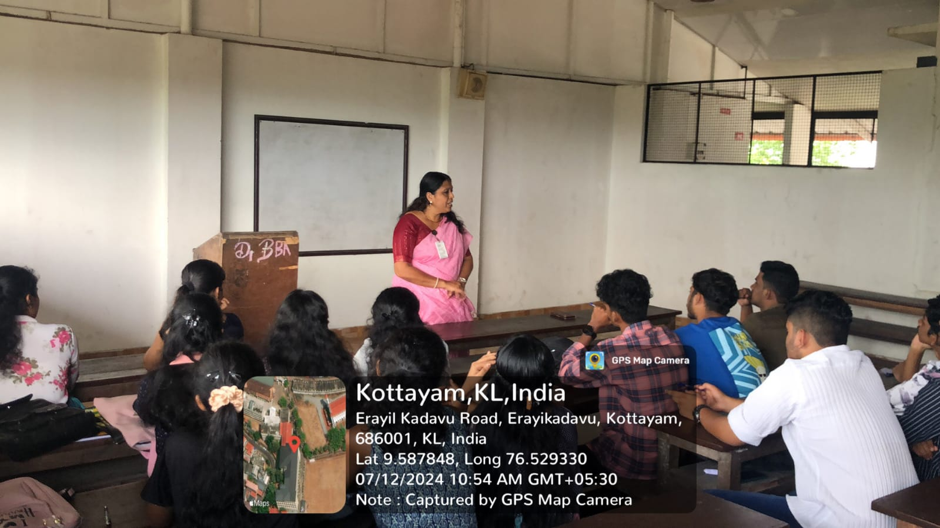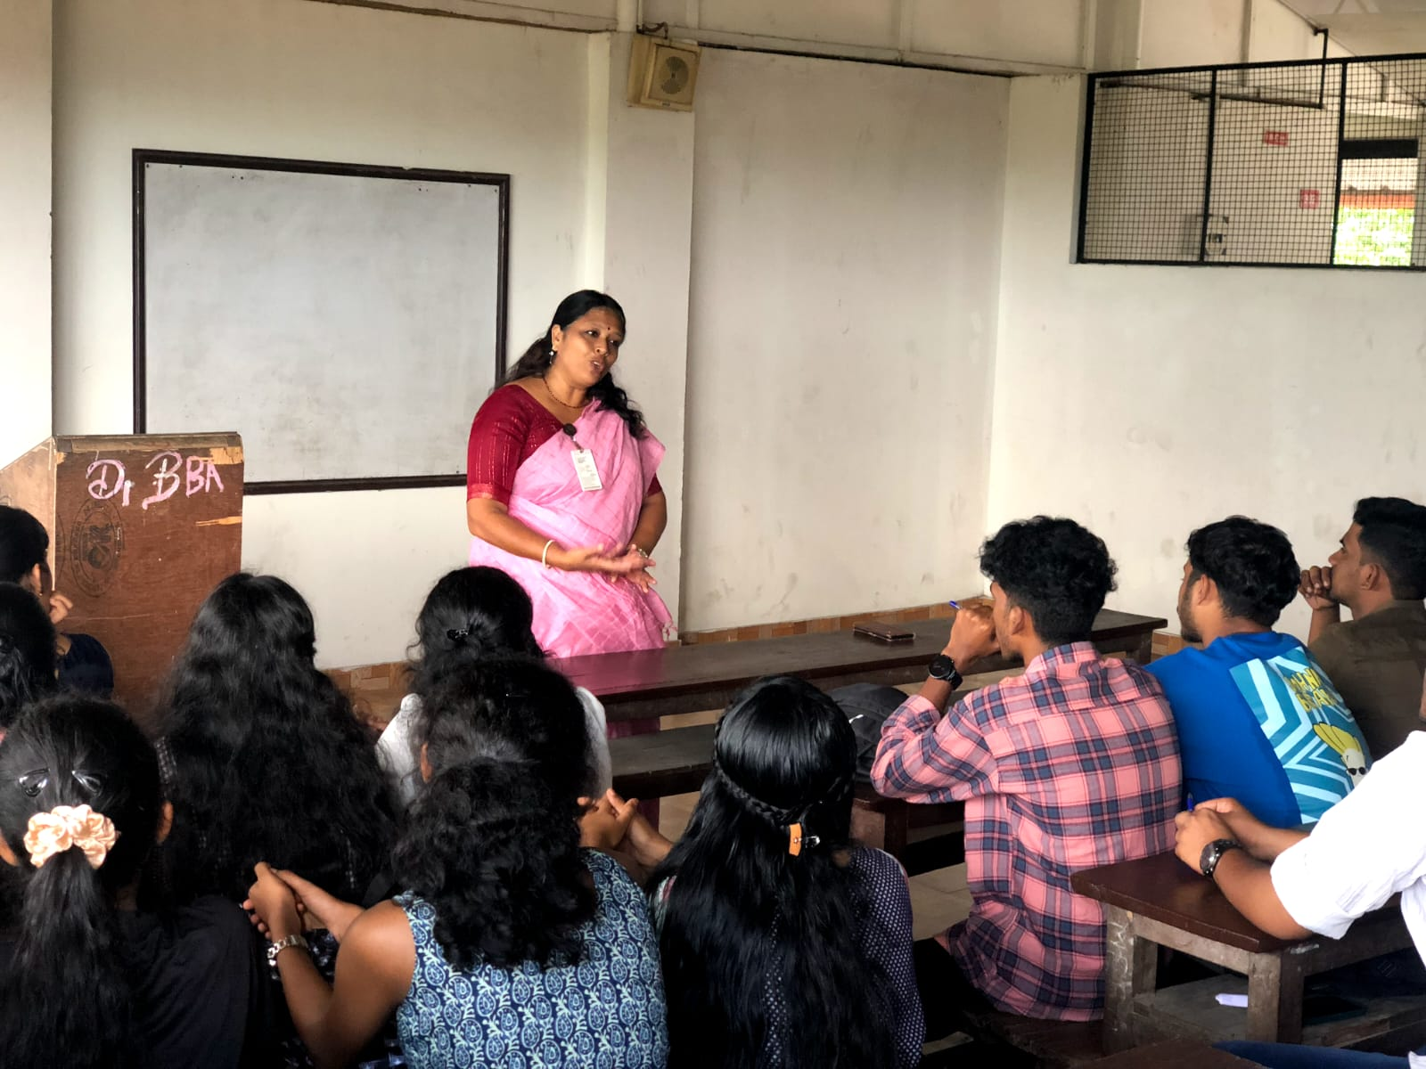
- Photograph of the event - Audience

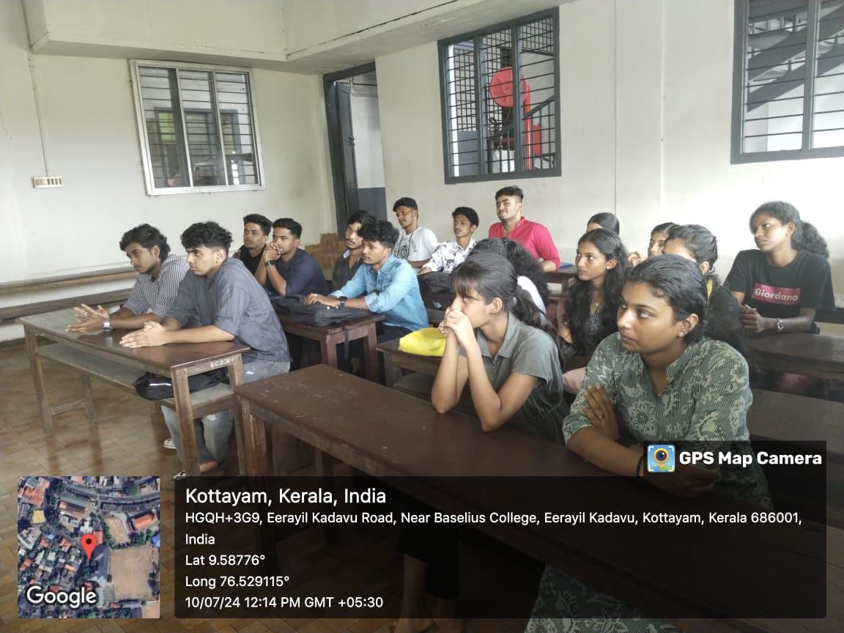

- Photograph of the event - Group Photo

- Other photographs if any
- Other Documents if any (Schedule, Resource Person Details, ..)
Dr. Geethalakshmi K
Department of Botany
Baselius College

Innovation & Entrepreneurship Development Centre
An initiative of Kerala Startup Mission

- Name of Event | Learn the art of saree draping
- Name of Institute | : Baselius College
- Name of Nodal Officer | : Dr Aparna Thankappan
- Email Address | : aparnathankappan@baselius.ac.in
- Contact Number | : 9747620918
- Event participant type | : participants only from the institution
- Total number of participants | : 5
- Total number of women participants | : 5
- Track of Event | Innovation
- Event category | Lifestyle, Personalcare & D2C
- Sector | Innovation
- Date from | 15.7.24
- Date to | 19.7.24
- Total number of hours | 5
- Details of IEDCs Collaborated | IEDC,IIC,ED
- Details of Communities or Clubs collaborated with | IEDC,IIC,ED & Department of English
- Detailed report of the event (Min 200 words) | From July 15 to July 19, 2024, a unique workshop titled "Learn the Art of Saree Draping" was conducted at Baselius College, offering students a chance to delve into the traditional art of saree draping. The workshop was organized by the Innovation and Entrepreneurship Development Centre (IEDC), Institution's Innovation Council (IIC), and the Entrepreneurship Development (ED) Club, aiming to preserve cultural heritage while fostering creativity among students.  Ms. Jani S Sreedhar, a talented second-year B.A. English student, served as the resource person for the workshop. With her passion for traditional attire and her skill in saree draping, she guided the participants through various styles and techniques, helping them appreciate the elegance and versatility of this timeless garment.  The workshop saw the enthusiastic participation of five students, who were eager to learn and perfect different saree draping styles. Over the course of five days, they were introduced to a variety of draping methods, including the classic Nivi style, the graceful Bengali drape, and the intricate Gujarati style, among others.  Ms. Jani's approachable teaching style and attention to detail ensured that each participant gained confidence in handling and draping a saree. The workshop also emphasized the cultural significance of the saree, highlighting its importance in Indian traditions and fashion.  The event was a resounding success, providing participants with not only practical skills but also a deeper connection to their cultural roots. The organizers expressed their satisfaction with the outcome and hope to continue offering such workshops that blend tradition with innovation in the future.
- Creatives created for the event (Max 10nos)
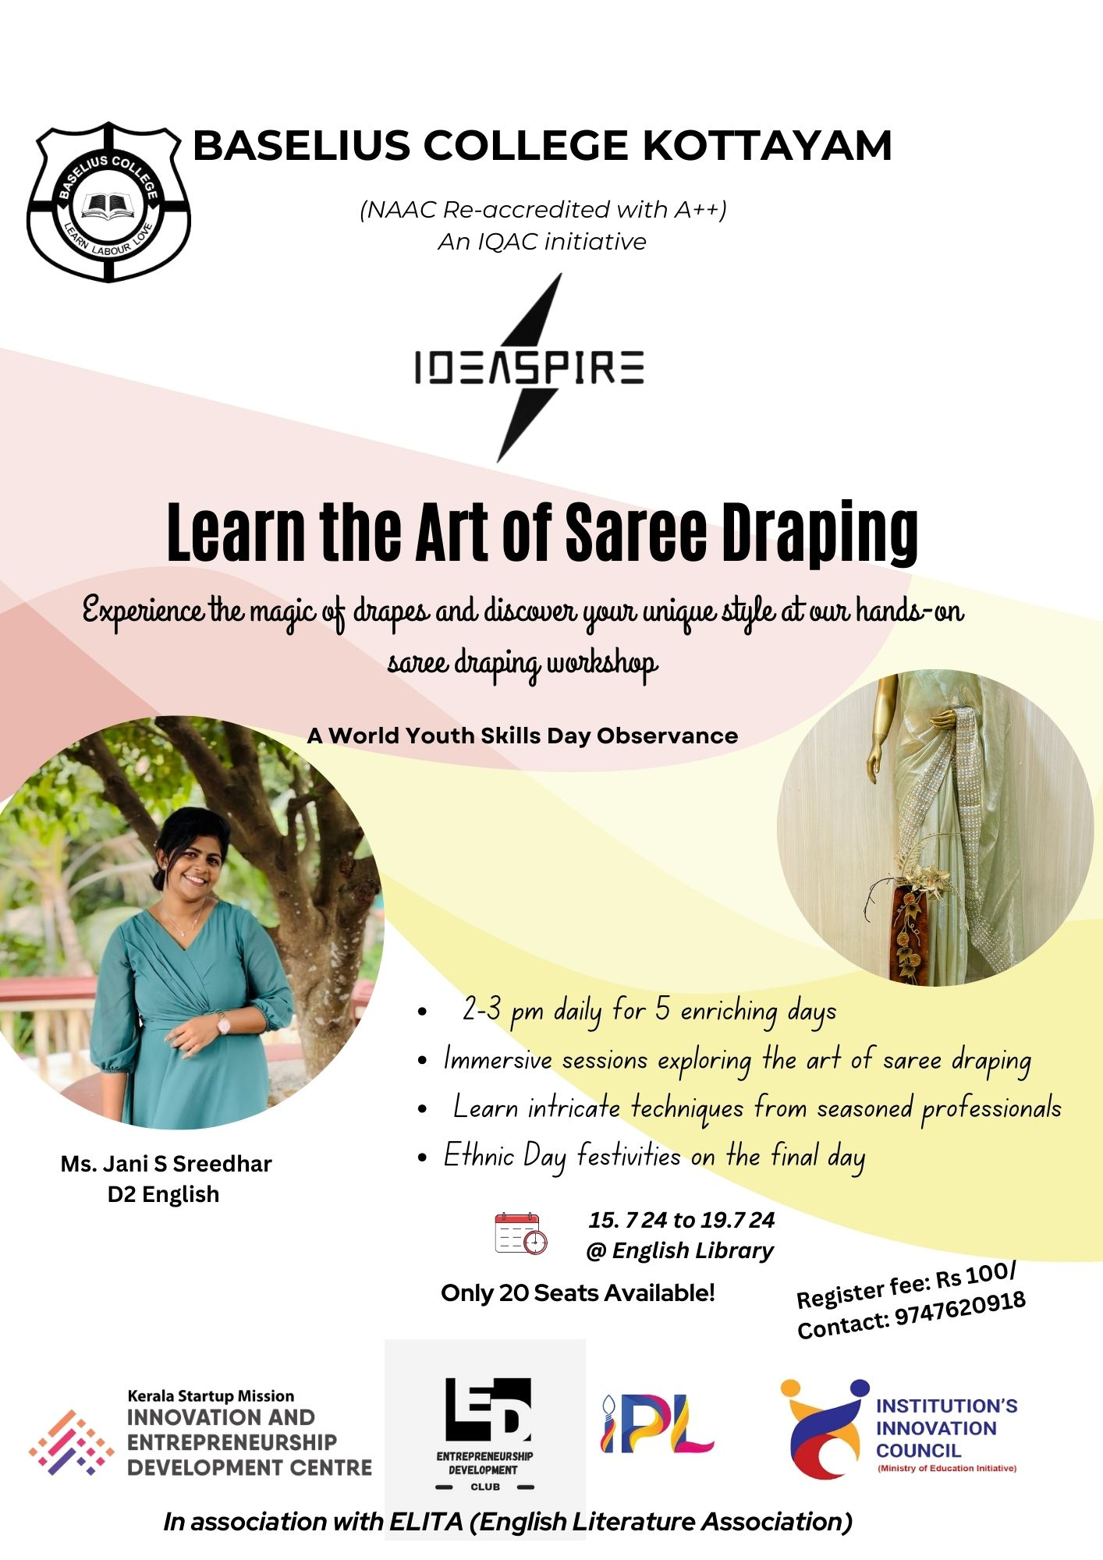

- Photograph of the event - Stage

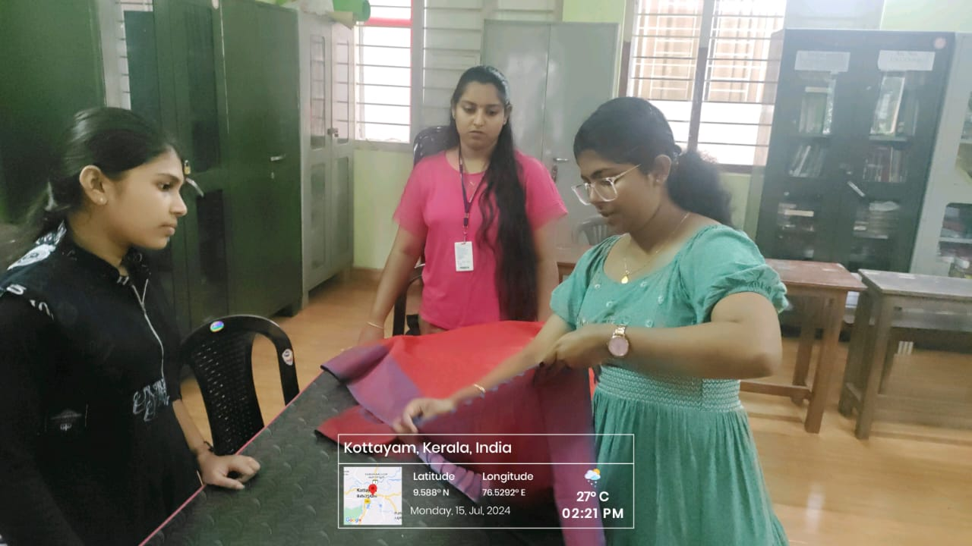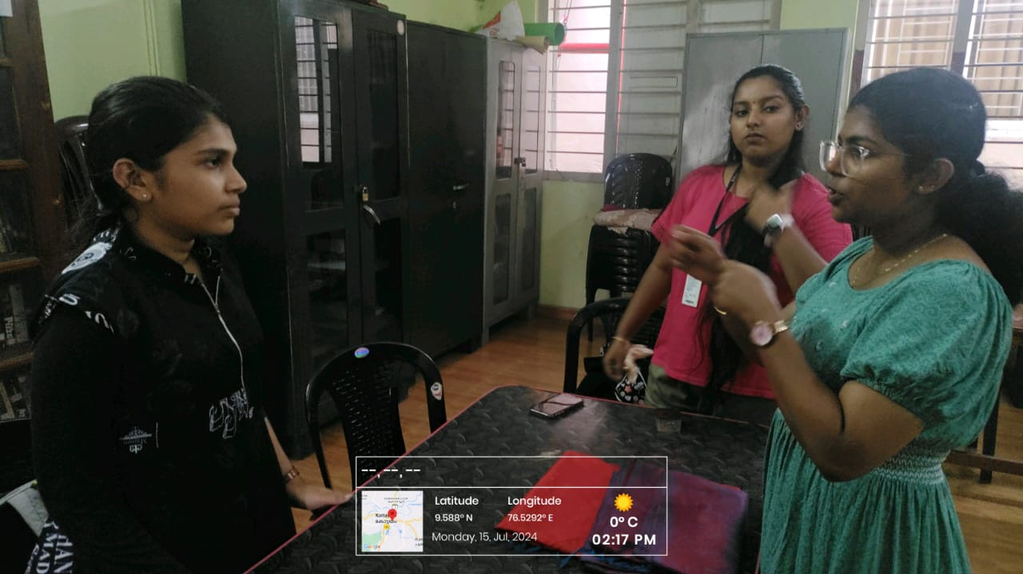

- Photograph of the event - Audience

- Photograph of the event - Group Photo

- Other photographs if any
- Other Documents if any (Schedule, Resource Person Details, ..)

Innovation & Entrepreneurship Development Centre
An initiative of Kerala Startup Mission

- Name of Event | Used books- collection drive: pages of book: Turning old pages into new beginning
- Name of Institute | : Baselius College
- Name of Nodal Officer | : Dr Aparna Thankappan
- Email Address | : aparnathankappan@baselius.ac.in
- Contact Number | : 9747620918
- Event participant type | : participants only from the institution
- Total number of participants | : 20
- Total number of women participants | : 16
- Track of Event | Innovation
- Event category | Other Innovation related events
- Sector | Social Impact, Rural Livelihood & Sustainability
- Date from | 13.7.24
- Date to | 17.7.24
- Total number of hours | 5
- Details of IEDCs Collaborated | -
- Details of Communities or Clubs collaborated with | IEDC, IIC,NSS,ED
- Detailed report of the event (Min 200 words) | From July 17, 2024, Baselius College successfully conducted a five-day used book collection drive titled "Pages of Hope: Turning Old Pages into New Beginnings." Organized by the Institution's Innovation Council (IEDC), Institution Innovation and Entrepreneurship Development Centre (IIC), Entrepreneurship Development (ED) Cell, and the National Service Scheme (NSS), the initiative aimed to gather used books from students, faculty, and the local community to support new educational and entrepreneurial projects. During the collection drive, students actively participated, demonstrating a strong sense of community and commitment to sustainability. They collected a diverse range of used books, including textbooks, novels, and reference materials, contributing to the IEDC's growing repository of resources. The drive concluded with a sense of accomplishment and optimism, as the organizers and participants reflected on the positive impact of their collective efforts. The success of this drive highlights the potential of collaborative initiatives in creating meaningful change and fostering a spirit of innovation and entrepreneurship at Baselius College.
- Creatives created for the event (Max 10nos)

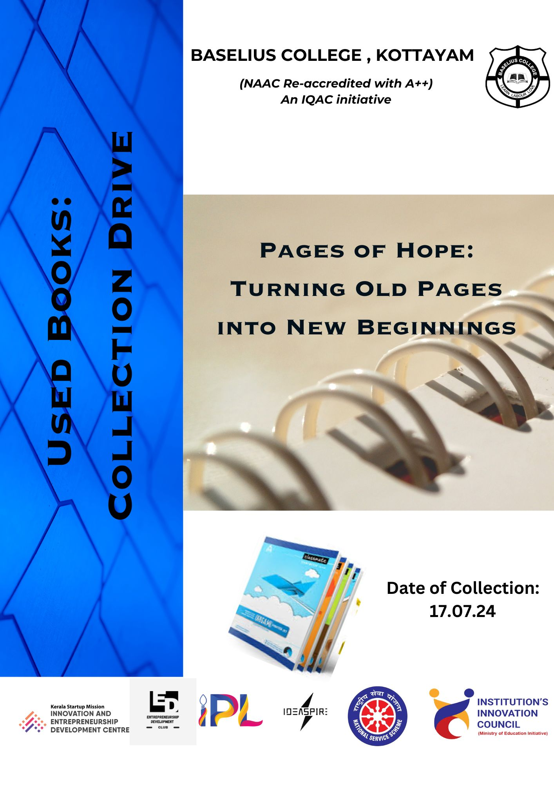

- Photograph of the event - Stage

- Photograph of the event - Audience

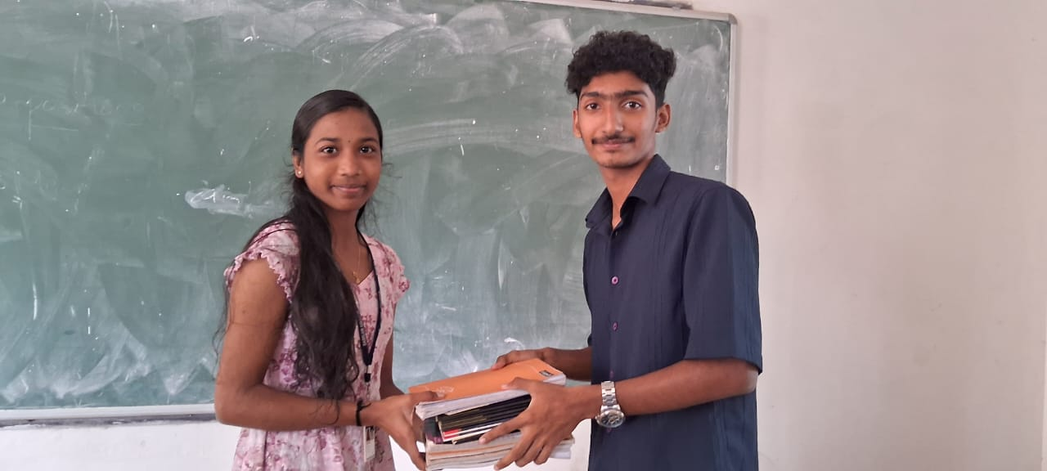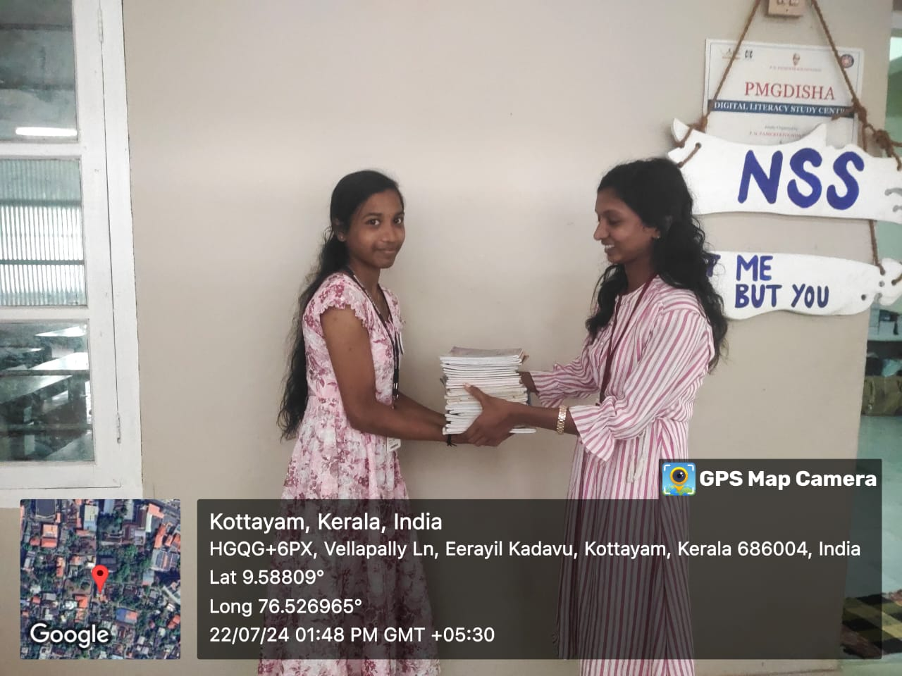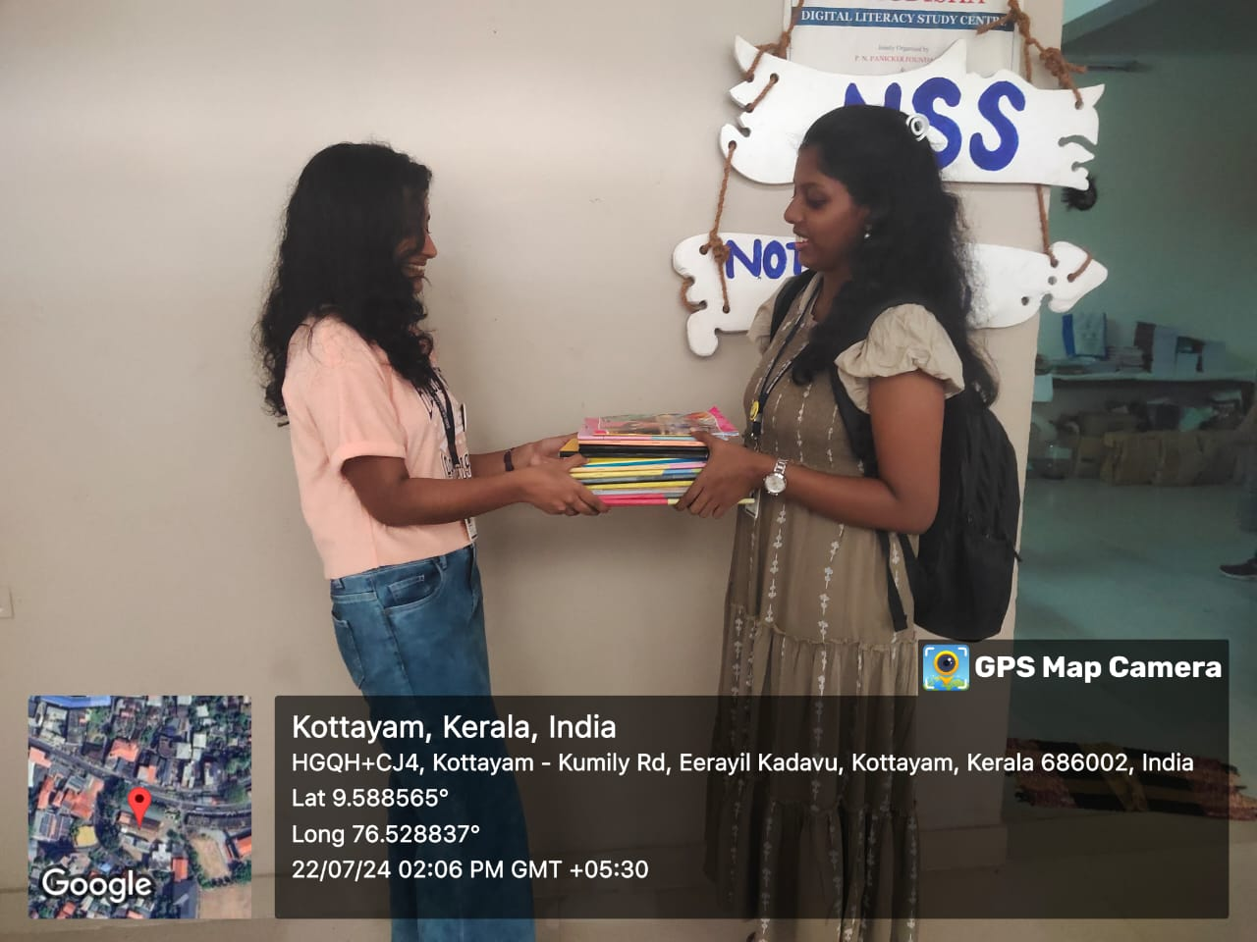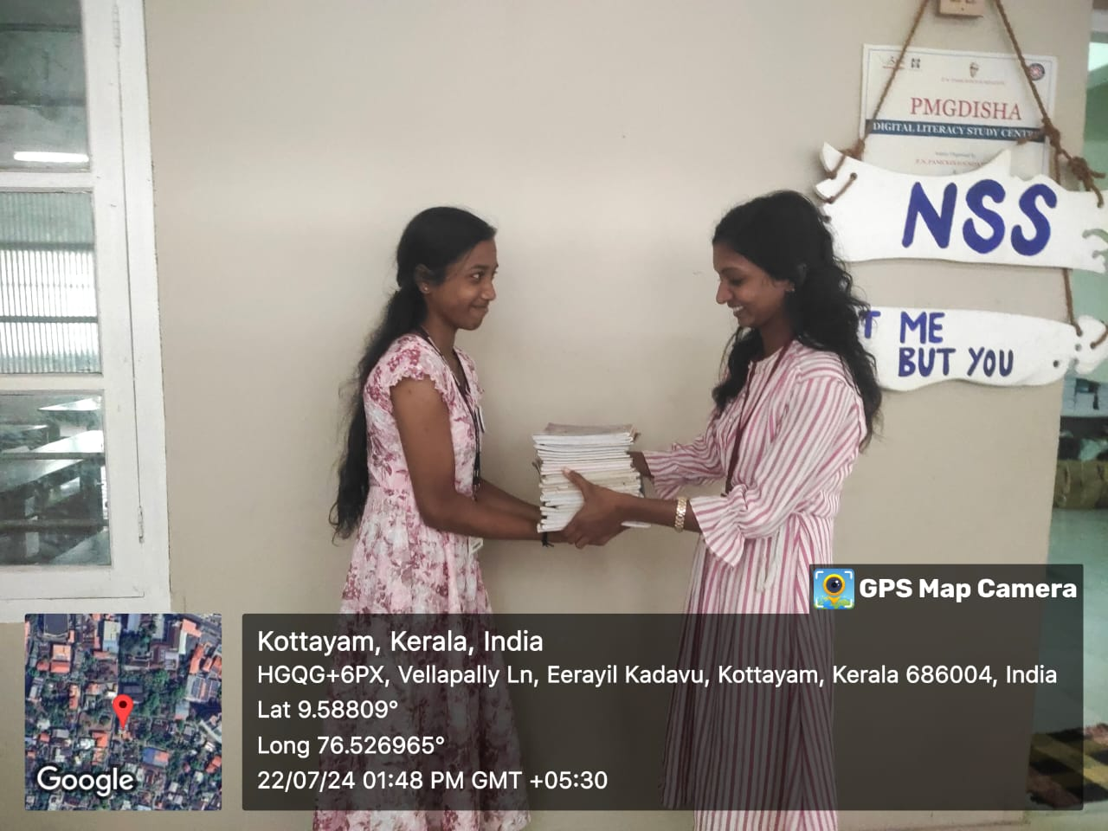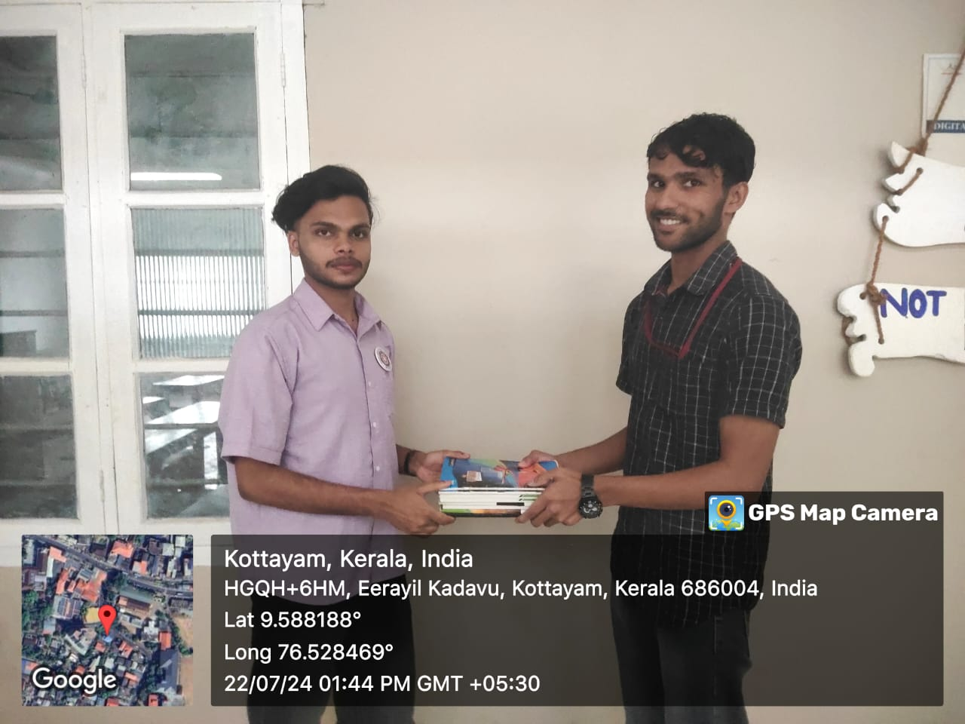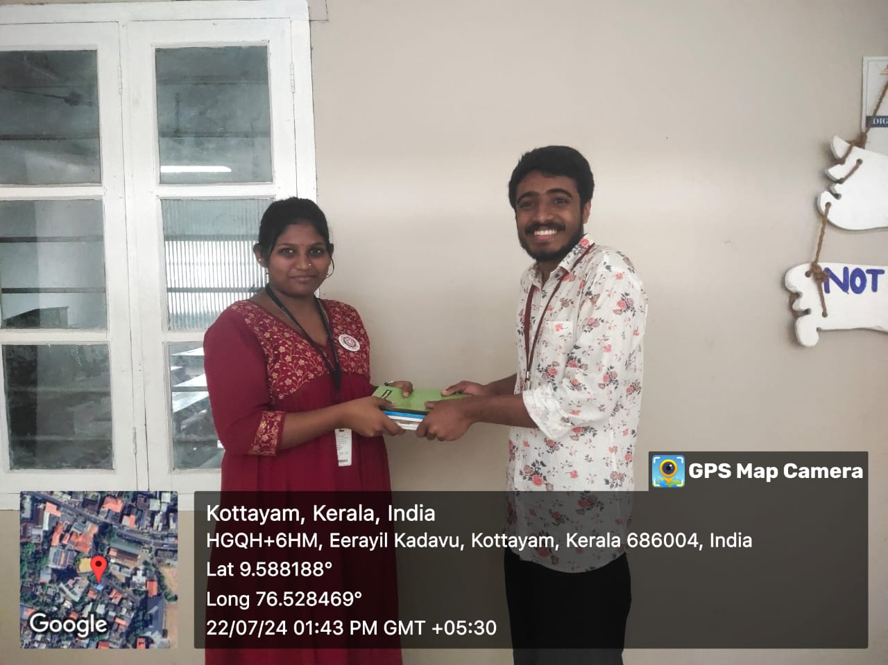
- Photograph of the event - Group Photo

- Other photographs if any
- Other Documents if any (Schedule, Resource Person Details, ..)

Innovation & Entrepreneurship Development Centre
An initiative of Kerala Startup Mission

- Name of Event | Pages of hope : Turning old pages into new beginnings
- Name of Institute | : Baselius College
- Name of Nodal Officer | : Dr Aparna Thankappan
- Email Address | : aparnathankappan@baselius.ac.in
- Contact Number | : 9747620918
- Event participant type | : participants only from the institution
- Total number of participants | : 8
- Total number of women participants | : 7
- Track of Event | Participants only from the institute
- Event category | Innovation - Workshops - Innovation Orientation, Ideation etc.
- Sector | Social Impact, Rural Livelihood & Sustainability
- Date from | 22.7.24
- Date to | 7.8.24
- Total number of hours | 5
- Details of IEDCs Collaborated | IEDC
- Details of Communities or Clubs collaborated with | IEDC,IIC, ED and NSS
- Detailed report of the event (Min 200 words) | From July 22, 2024, to August 7, 2024, Baselius College successfully conducted the "Pages of Hope" initiative, a collaborative effort by the Innovation and Entrepreneurship Development Center (IEDC), Institution's Innovation Council (IIC), Entrepreneurship Development (ED) cell, and the National Service Scheme (NSS). This unique initiative focused on establishing a bookbinding unit where students collected old, unused books from their peers and transformed them into new, usable ones. These refurbished books were then returned to the student community, reinforcing the values of sustainability and resourcefulness.  The initiative was guided by Ms. Sindhu S, an expert from the Anderi Book Binding Centre, Mannanam, who served as the resource person. Under her guidance, students acquired practical skills in bookbinding, working diligently for five hours daily after their class hours. The project not only provided an opportunity for students to engage in a hands-on learning experience but also aimed to extend its services beyond the college, with plans to take orders from the broader society in the future. The "Pages of Hope" initiative has laid the groundwork for fostering a culture of innovation, entrepreneurship, and community service among the students of Baselius College.
- Creatives created for the event (Max 10nos)
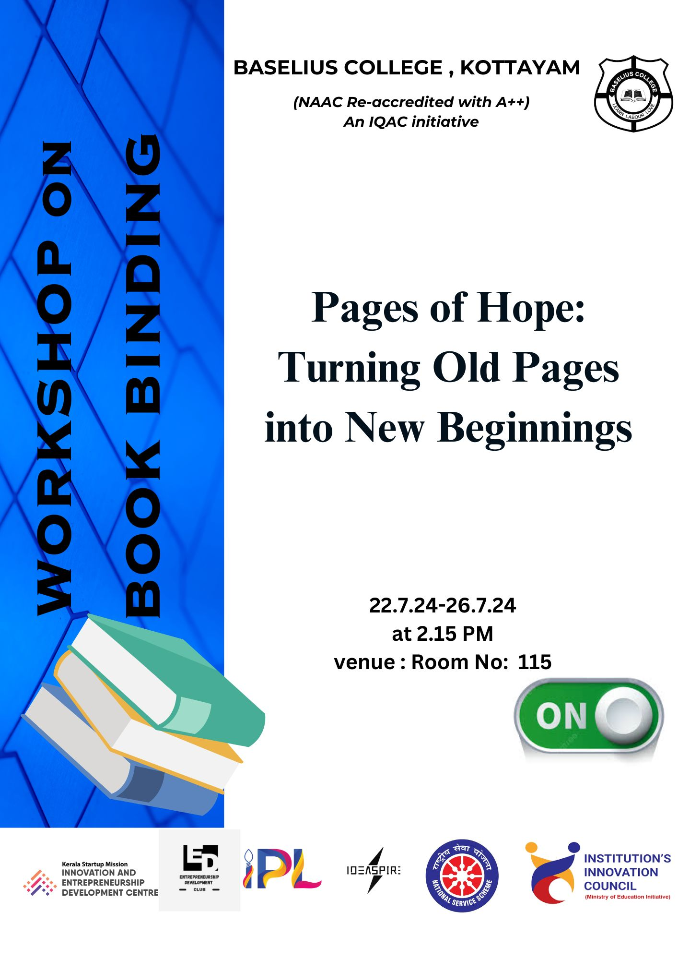

- Photograph of the event - Stage

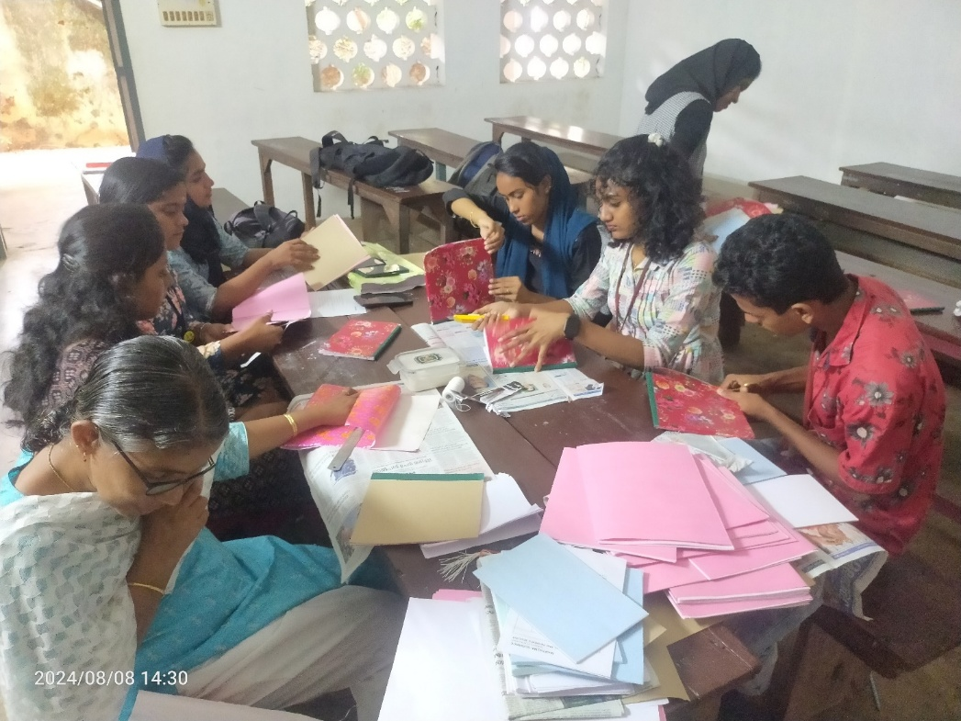

- Photograph of the event - Audience

- Photograph of the event - Group Photo

- Other photographs if any
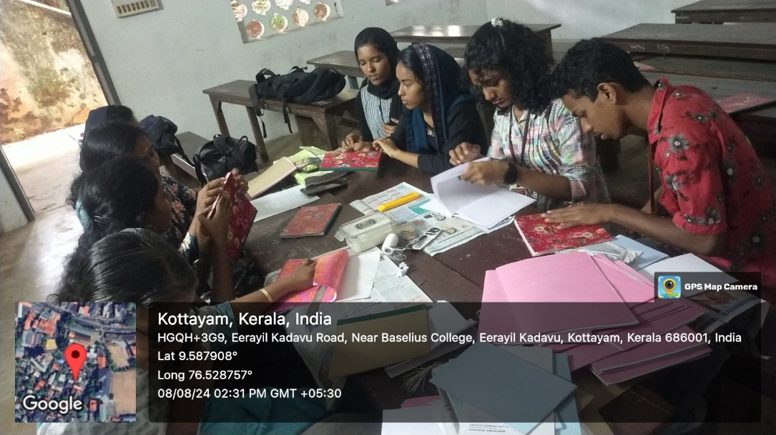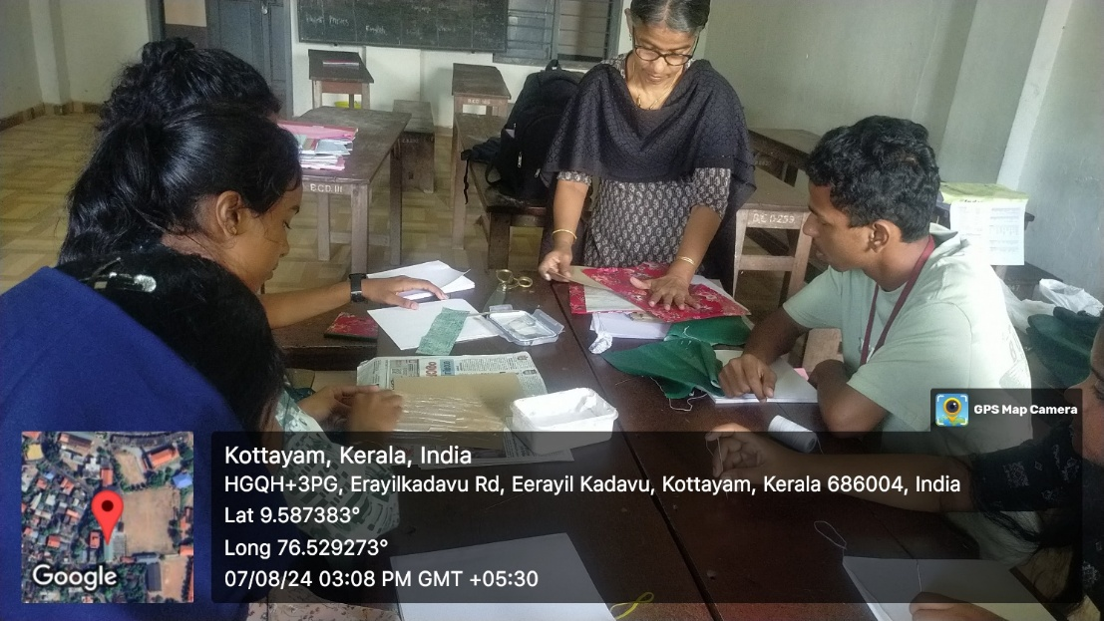
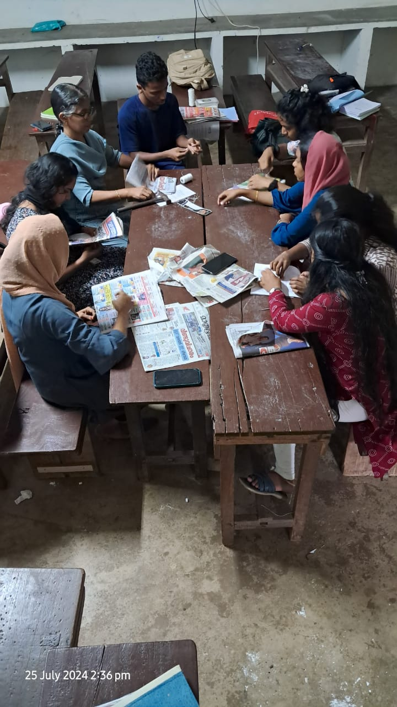
- Other Documents if any (Schedule, Resource Person Details, ..)

Ms. Sindhu S, Anderi Book Binding Centre, Mannanam
- Participant list in prescribed format
Innovation & Entrepreneurship Development Centre
An initiative of Kerala Startup Mission

- Name of Event | Alumni Interaction
- Name of Institute | : Baselius College
- Name of Nodal Officer | : Dr Aparna Thankappan
- Email Address | : aparnathankappan@baselius.ac.in
- Contact Number | : 9747620918
- Event participant type | : participants only from the institution
- Total number of participants | : 19
- Total number of women participants | : 11
- Track of Event | Entrepreneurship
- Event category | Alumni Engagement
- Sector | Other- capacity building program
- Date from | 10.7.24
- Date to | 10.7.24
- Total number of hours | 1
- Details of IEDCs Collaborated | -
- Details of Communities or Clubs collaborated with | IEDC,IIC,ED,RINK,placement cell and BBA
- Detailed report of the event (Min 200 words) | On July 10, 2024, an inspiring alumni interaction session was held at Baselius College from 11:45 am, featuring Mr. Jenin K S as the resource person. The event was organized by the Institution's Innovation Council (IEDC), Institution Innovation Council (IIC), Entrepreneurship Development (ED) Cell, RINK, Placement Cell, and the BBA Department.  Mr. Jenin K S, an accomplished alumnus of Baselius College, shared his entrepreneurial journey with the students. Nineteen students participated in the session, eager to learn from his experiences and insights. Mr. Jenin began by recounting his early days, the challenges he faced, and the pivotal moments that shaped his career. He emphasized the importance of resilience, adaptability, and continuous learning in the path to success.  Through his engaging storytelling, Mr. Jenin highlighted the crucial steps involved in developing a startup. He discussed ideation, market research, funding, and the significance of building a strong team. His real-life examples provided practical insights, making the entrepreneurial process more tangible and relatable for the students.  During the interaction, Mr. Jenin encouraged the students to believe in their ideas and pursue their entrepreneurial aspirations with confidence. He shared valuable tips on overcoming setbacks and staying motivated. His success story, marked by perseverance and innovative thinking, served as a powerful motivation for the attendees.  The interactive session allowed students to ask questions and seek advice on their startup ideas. Mr. Jenin's responses were insightful and encouraging, addressing the students' concerns and providing them with actionable guidance. The session concluded with a message of optimism, urging the students to take bold steps towards their entrepreneurial goals.
- Creatives created for the event (Max 10nos)

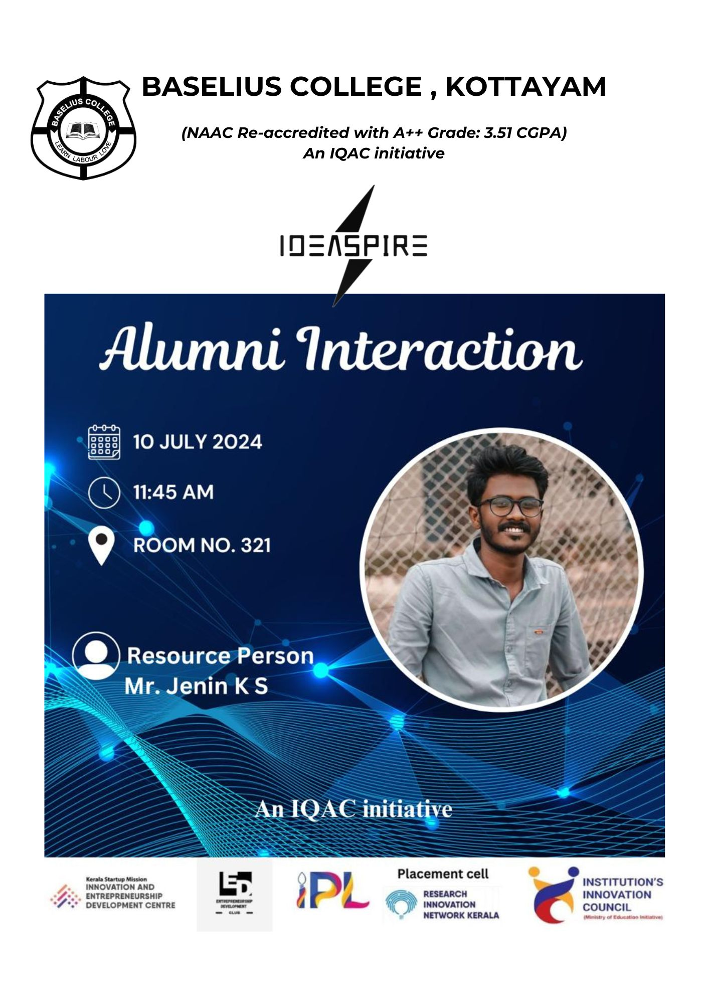
- Photograph of the event - Stage

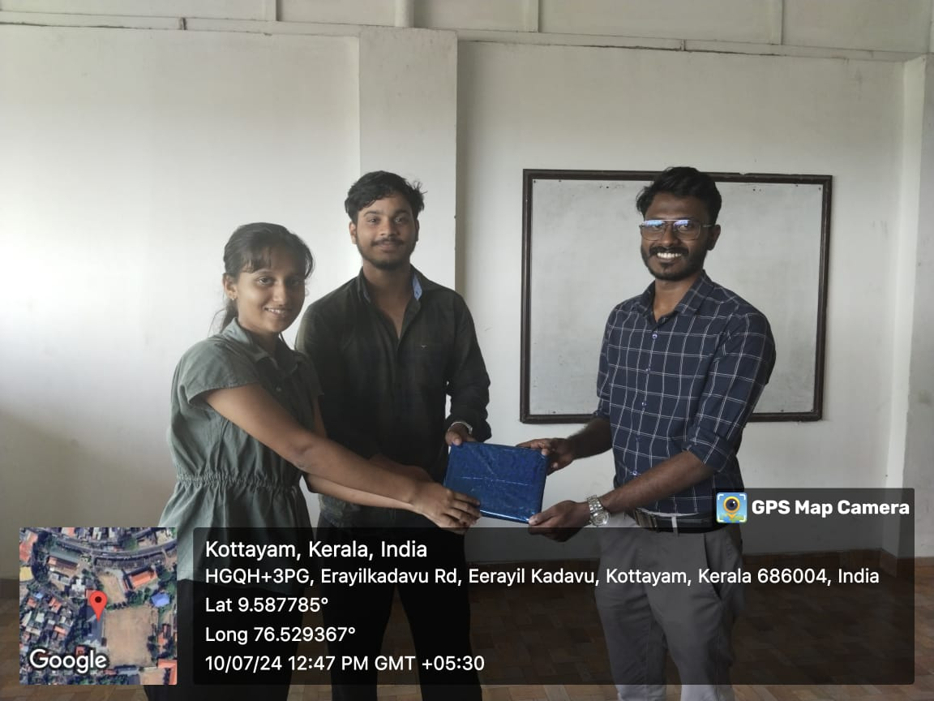

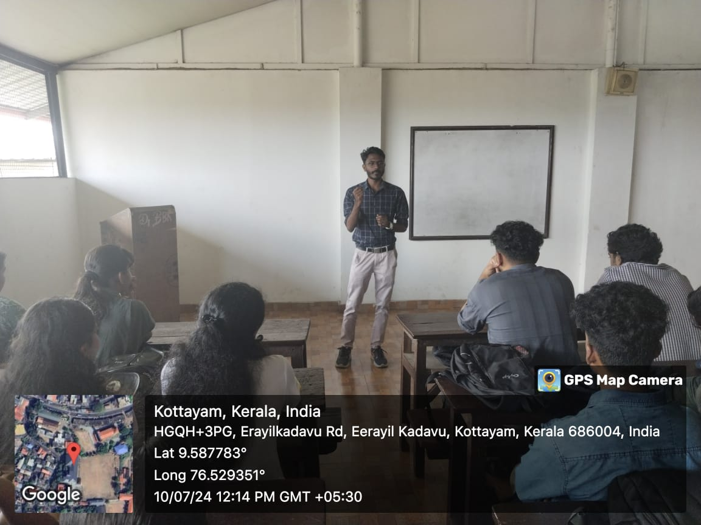
- Photograph of the event - Audience

- Photograph of the event - Group Photo

- Other photographs if any
- Other Documents if any (Schedule, Resource Person Details, ..)
Mr. Jenin K S

Innovation & Entrepreneurship Development Centre
An initiative of Kerala Startup Mission

- Name of Event | Alumni Interaction
- Name of Institute | : Baselius College
- Name of Nodal Officer | : Dr Aparna Thankappan
- Email Address | : aparnathankappan@baselius.ac.in
- Contact Number | : 9747620918
- Event participant type | : participants only from the institution
- Total number of participants | : 19
- Total number of women participants | : 11
- Track of Event | Entrepreneurship
- Event category | Alumni Engagement
- Sector | Other- capacity buiding
- Date from | 6.7.24
- Date to | 6.7.241
- Total number of hours | 1
- Details of IEDCs Collaborated | -
- Details of Communities or Clubs collaborated with | IEDC,IIC,ED,Rink,placement cell & BBA
- Detailed report of the event (Min 200 words) | On July 6, 2024, Baselius College hosted an engaging alumni interaction session with Mr. Sherry Abraham at 9:30 am. Organized by the Institution's Innovation Council (IIC), Institution Innovation and Entrepreneurship Development Centre (IEDC), Entrepreneurship Development (ED) Cell, Placement Cell, and the BBA Department, the event attracted nineteen enthusiastic students.  Mr. Sherry Abraham, a distinguished alumnus, shared his professional journey and insights with the participants. During the one-hour session, he highlighted the key experiences and challenges that shaped his career, offering invaluable advice on navigating the professional world. His anecdotes and practical tips resonated with the students, providing them with a clearer understanding of what to expect in their future careers.  The interaction was highly interactive, with students actively engaging and asking questions. Mr. Sherry's responses were insightful and encouraging, addressing various aspects of career development, networking, and personal growth. The session concluded with a sense of motivation and inspiration, as the students left with a renewed confidence to pursue their career aspirations. The event was well-received, with organizers commended for facilitating a meaningful and impactful interaction.
- Creatives created for the event (Max 10nos)

- 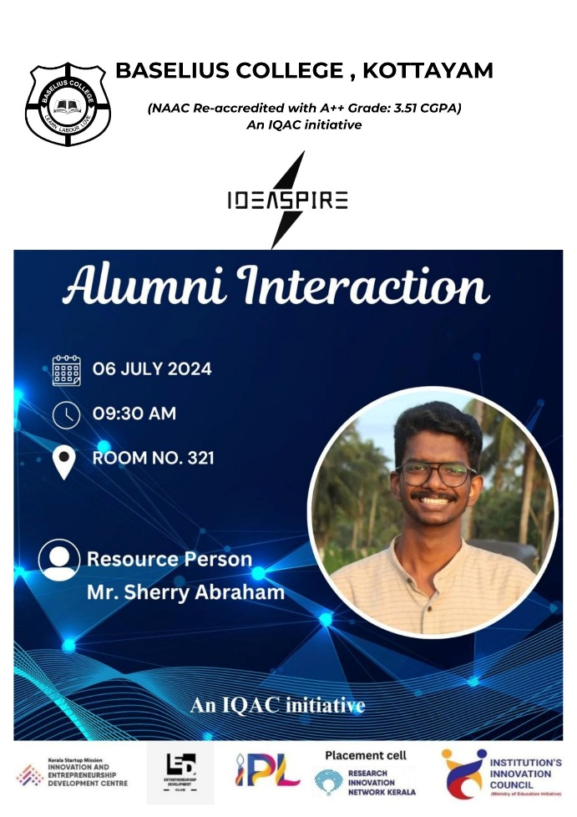P

- hotograph of the event - Stage

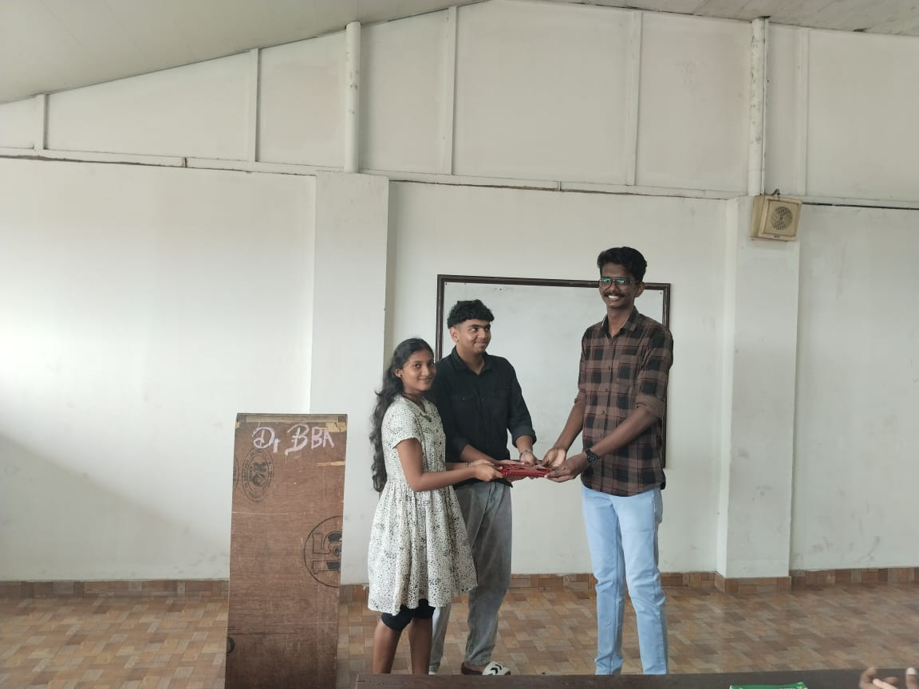

- Photograph of the event - Audience
- Photograph of the event - Group Photo

- Other photographs if any
- Other Documents if any (Schedule, Resource Person Details, ..)

Mr. Sherry Abraham
- Participant list in prescribed format

Innovation & Entrepreneurship Development Centre
An initiative of Kerala Startup Mission

- Name of Event | Graduate attributes and goal setting
- Name of Institute | : Baselius College
- Name of Nodal Officer | : Dr Aparna Thankappan
- Email Address | : aparnathankappan@baselius.ac.in
- Contact Number | : 9747620918
- Event participant type | : participants only from the institution
- Total number of participants | : 18
- Total number of women participants | : 11
- Track of Event | Entrepreneurship
- Event category | Mentoring Programme
- Sector | Graduate attributes
- Date from | 8.7.24
- Date to | 8.7.24
- Total number of hours | 1
- Details of IEDCs Collaborated | -
- Details of Communities or Clubs collaborated with | IEDC,IIC,ED,RINK, Placement cell,BBA
- Detailed report of the event (Min 200 words) | On July 8, 2024, Baselius College hosted an enlightening session on "Graduate Attributes and Goal Setting," led by Dr. Thomas Kuruvilla from the Department of Malayalam. The event was organized by IEDC, IIC, RINK, ED, Placement Cell, and BBA, reflecting a collaborative effort to equip students with essential skills and guidance for their future careers. Dr. Kuruvilla's expertise and engaging delivery made the session highly impactful, providing students with valuable insights into developing key graduate attributes and setting achievable career goals.  Dr. Kuruvilla emphasized the importance of cultivating attributes such as critical thinking, effective communication, and teamwork, which are crucial for professional success. He also highlighted the significance of setting clear, realistic goals and devising strategic plans to achieve them. Through interactive discussions and practical exercises, students were encouraged to reflect on their personal strengths and aspirations, fostering a proactive approach to their academic and professional journeys. The session concluded with a Q&A segment, where students actively participated, seeking advice and clarification, making the event a highly enriching experience.
- Creatives created for the event (Max 10nos)

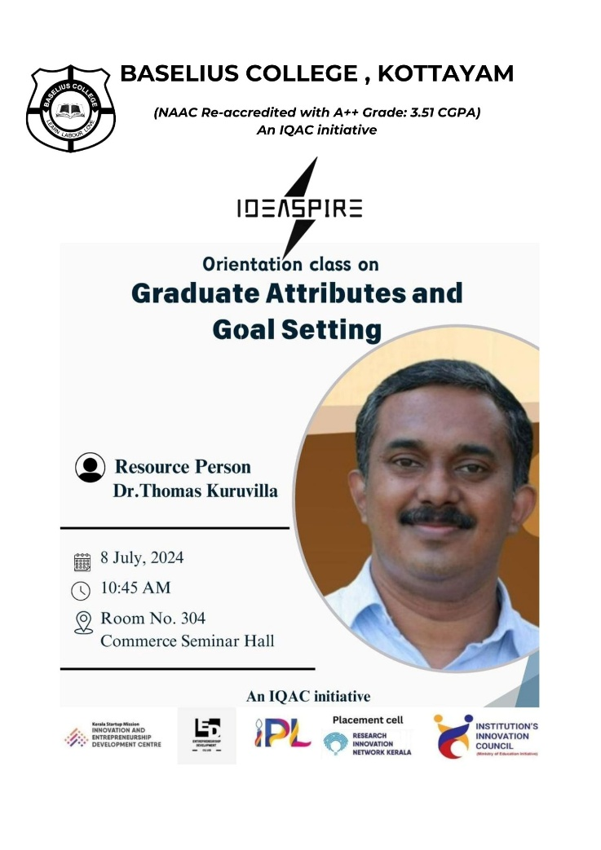
- Photograph of the event - Stage 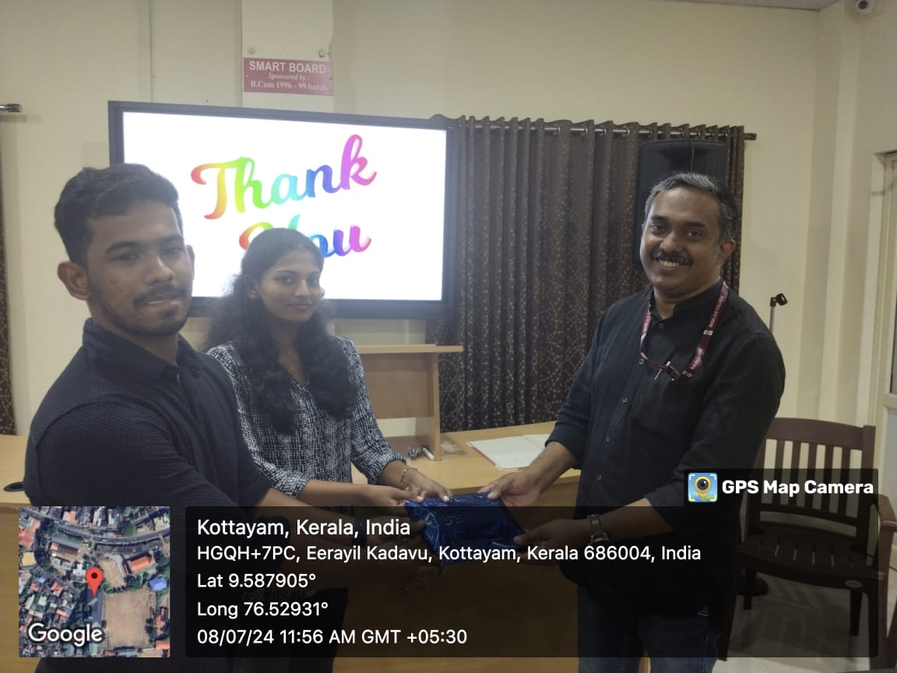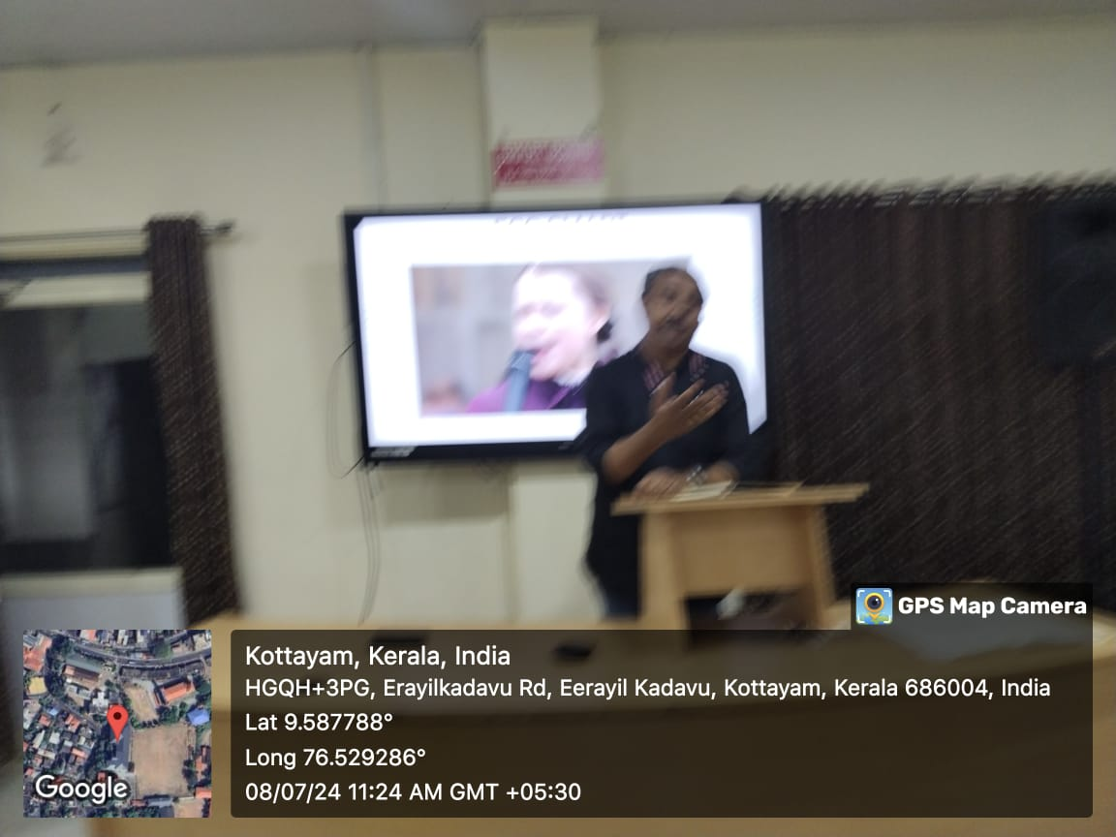

- Photograph of the event - Audience

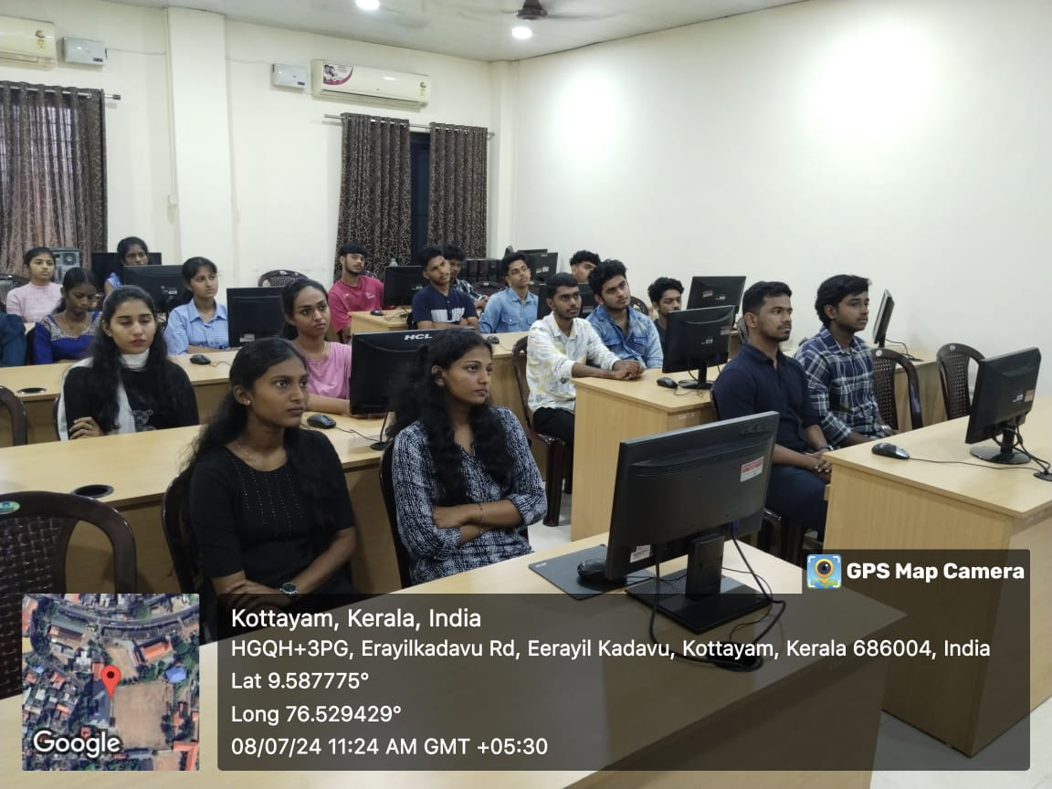
- Photograph of the event - Group Photo

- Other photographs if any
- Other Documents if any (Schedule, Resource Person Details, ..)

Dr Thomas Kuruvilla, Department of Malayalam

- Participant list in prescribed format
Innovation & Entrepreneurship Development Centre
An initiative of Kerala Startup Mission

- Name of Event | Seminar and expo on AR/VR Technologies
- Name of Institute | : Baselius College
- Name of Nodal Officer | : Dr Aparna Thankappan
- Email Address | : aparnathankappan@baselius.ac.in
- Contact Number | : 9747620918
- Event participant type | : participants only from the institution
- Total number of participants | : 96
- Total number of women participants | : 63
- Track of Event | Technology
- Event category | Technology Talk Sessions: Basics of AR/VR, Programmer/3D artist etc.
- Sector | AI, ML & IoT
- Date from | 2.8.2024
- Date to | 2.8.2024
- Total number of hours | 4
- Details of IEDCs Collaborated | Baselius College, KE College & Amal Jyothi Engineering College
- Details of Communities or Clubs collaborated with | IIC, IEDC, Department of physics
- Detailed report of the event (Min 200 words) | Innovation and Entrepreneurship Development Center (IEDC) in collaboration with the and Institution's Innovation Council (IIC) and the Department of Physics, of Baselius College, organized a Seminar and Expo on AR/VR technologies. This event, held in partnership with KE College and Amal Jyothi Engineering College, attracted the participation of 96 students. Attendees had the opportunity to experience the latest advancements in Virtual and Augmented Reality technologies, providing them with hands-on exposure to these cutting-edge tools. This seminar provided a platform for students to gain practical insights and hands-on exposure to these emerging technologies, which are rapidly shaping the future of education, entertainment, and industry.  The seminar was led by Mr. Abhijith S, a distinguished STEM.org certified Mechatronics engineer and Senior Robotics and AI Trainer, who has over 6.5 years of experience in the field. Mr. Abhijith has an impressive track record, having trained and inspired more than 25,000 students across India, in cities such as Mumbai, Delhi, Haryana, Gujarat, Bangalore, Tamil Nadu, and Kerala. His expertise was evident as he guided the participants through various AR and VR applications, showcasing their practical uses and potential impact. Mr. Abhijith has also played a pivotal role in major technological events, including co-leading India’s largest AI competition, CODEAVOUR 5.0 in Kerala, and being an organizing team member for the NASA Space Apps Challenge 2023 in Thrissur, recognized as the largest local event globally. His engaging presentation and interactive sessions made the event a resounding success, leaving students inspired and better equipped to engage with AR/VR technologies in their future endeavors.
- Creatives created for the event (Max 10nos)
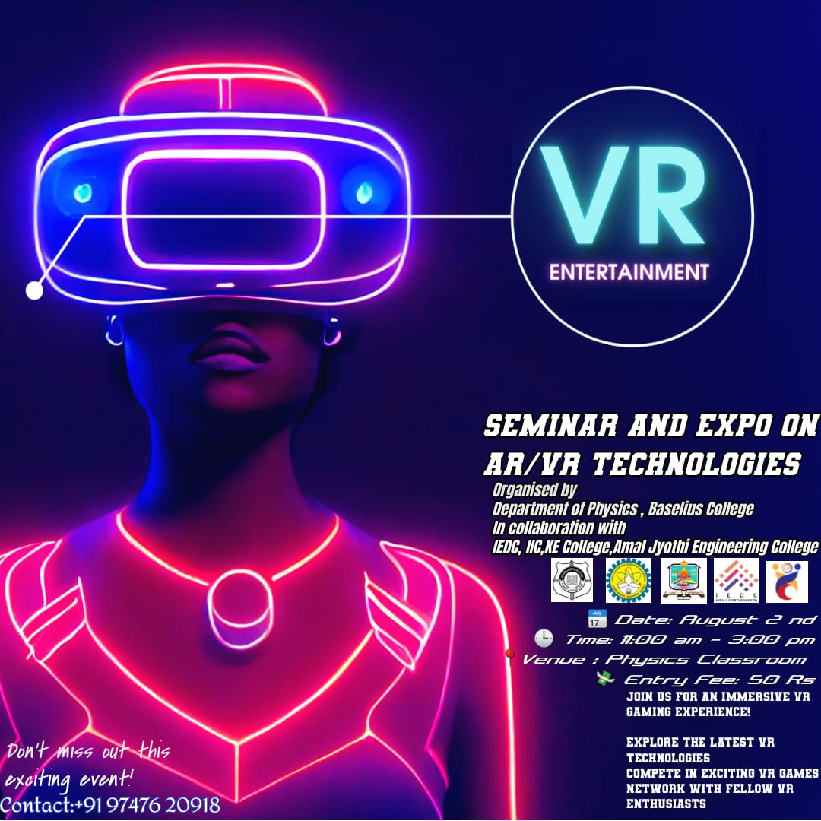

- Photograph of the event - Stage

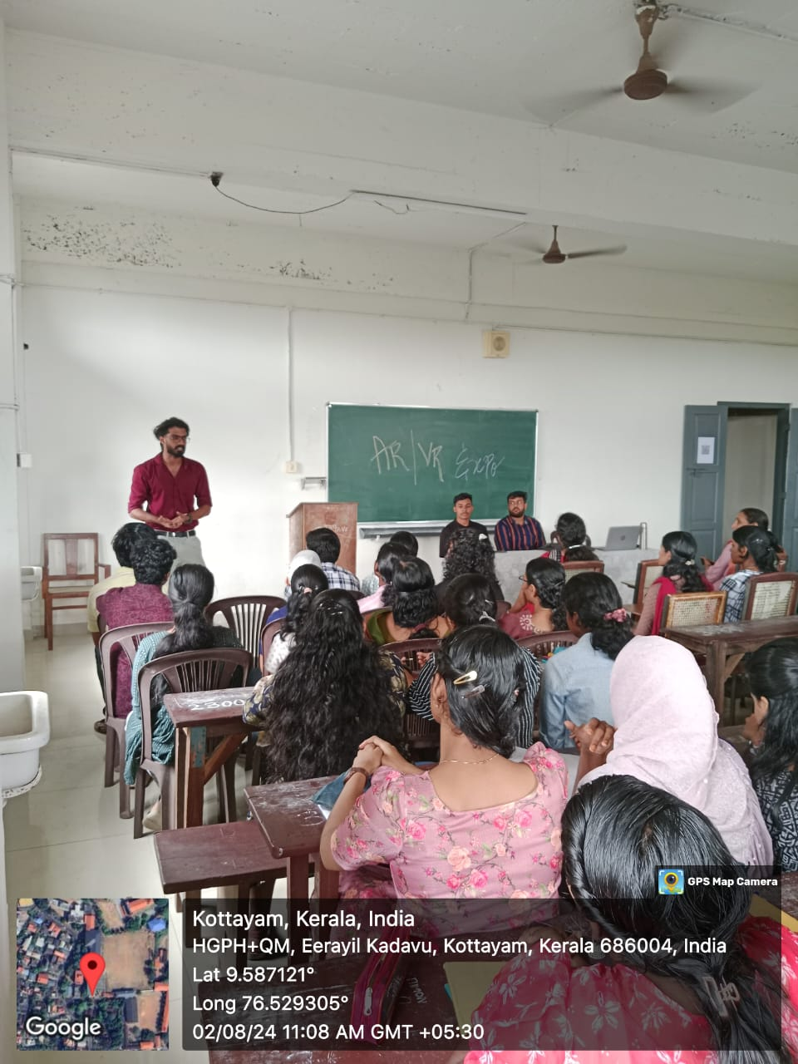

- Photograph of the event - Audience

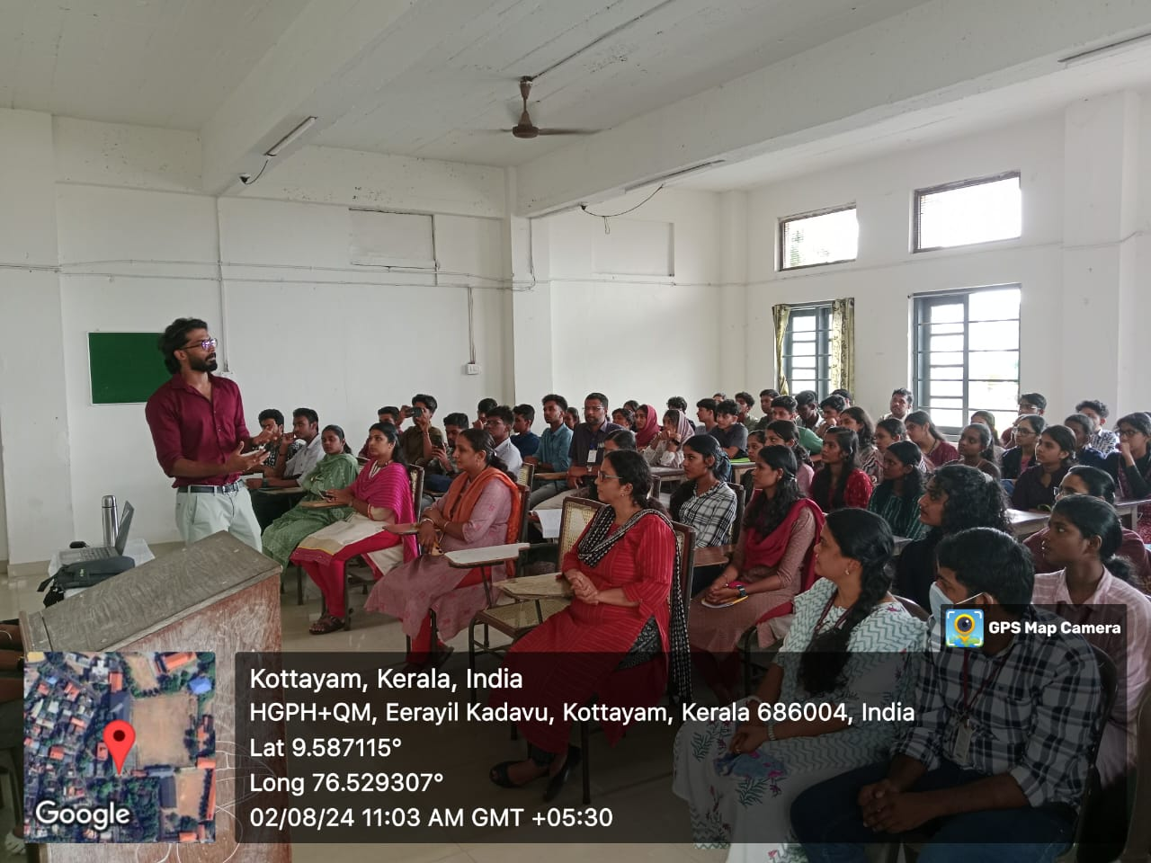

- Photograph of the event - Group Photo

- Other photographs if any
- Other Documents if any (Schedule, Resource Person Details, ..)

Mr. Abhijith S, STEM.org certified Mechatronics engineer and Senior Robotics and AI Trainer, Amal Jyothi Engineering College
- Participant list in prescribed format
Innovation & Entrepreneurship Development Centre
An initiative of Kerala Startup Mission

- Name of Event | Alumni Interaction
- Name of Institute | : Baselius College
- Name of Nodal Officer | : Dr Aparna Thankappan
- Email Address | : aparnathankappan@baselius.ac.in
- Contact Number | : 9747620918
- Event participant type | : participants only from the institution
- Total number of participants | : 18
- Total number of women participants | : 8
- Track of Event | Entrepreneurship
- Event category | Alumni Engagement
- Sector | Alumni Engagement
- Date from | 8.9.2024
- Date to | 8.9.2024
- Total number of hours | 1
- Details of IEDCs Collaborated | -
- Details of Communities or Clubs collaborated with | IEDC,IIC,ED,RINK,Placement cell, &BBA
- Detailed report of the event (Min 200 words) | On September 8, 2024, an engaging session was held at Baselius College as part of the ongoing efforts to strengthen alumni connections and provide valuable insights to current students. The event, organized jointly by the Innovation and Entrepreneurship Development Centre (IEDC), Institution's Innovation Council (IIC), Entrepreneurship Development (ED) cell, Placement Cell, RINK, and the Department of Business Administration (BBA), featured Mr. Aravind V, a distinguished alumnus of the BBA program, as the resource person.  The session, which took place from 8:30 am to 9:30 am, was attended by BBA students eager to learn from the experiences of their predecessor. Mr. Aravind V, who has made significant strides in his professional career since graduating from Baselius College, shared his journey, highlighting the challenges he faced and the strategies he employed to overcome them.  His talk provided a blend of practical advice and motivational anecdotes, inspiring students to focus on their goals while remaining adaptable to the dynamic business environment. The session also included an interactive segment, where students posed questions about career planning, entrepreneurship, and the importance of continuous learning.  This alumni engagement initiative not only offered valuable learning opportunities but also reinforced the strong bond between the college and its alumni. The event was well-received by the students, who left with a renewed sense of purpose and a deeper understanding of the professional world.

- Creatives created for the event (Max 10nos)

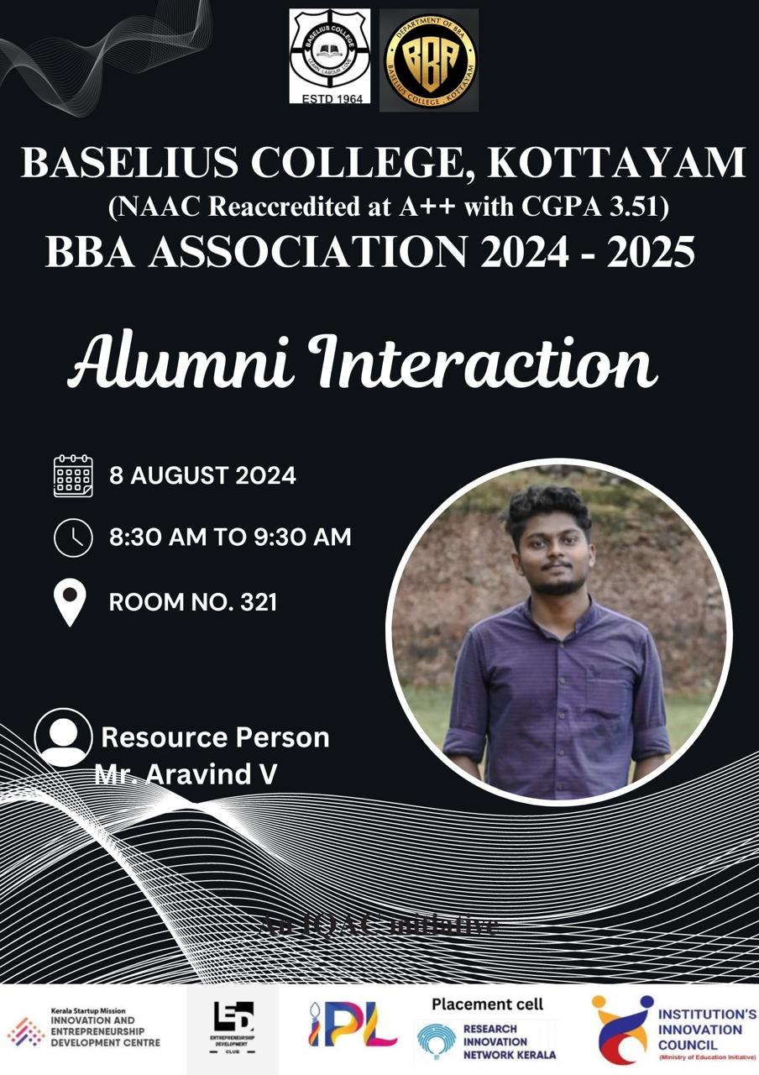
- Photograph of the event - Stage

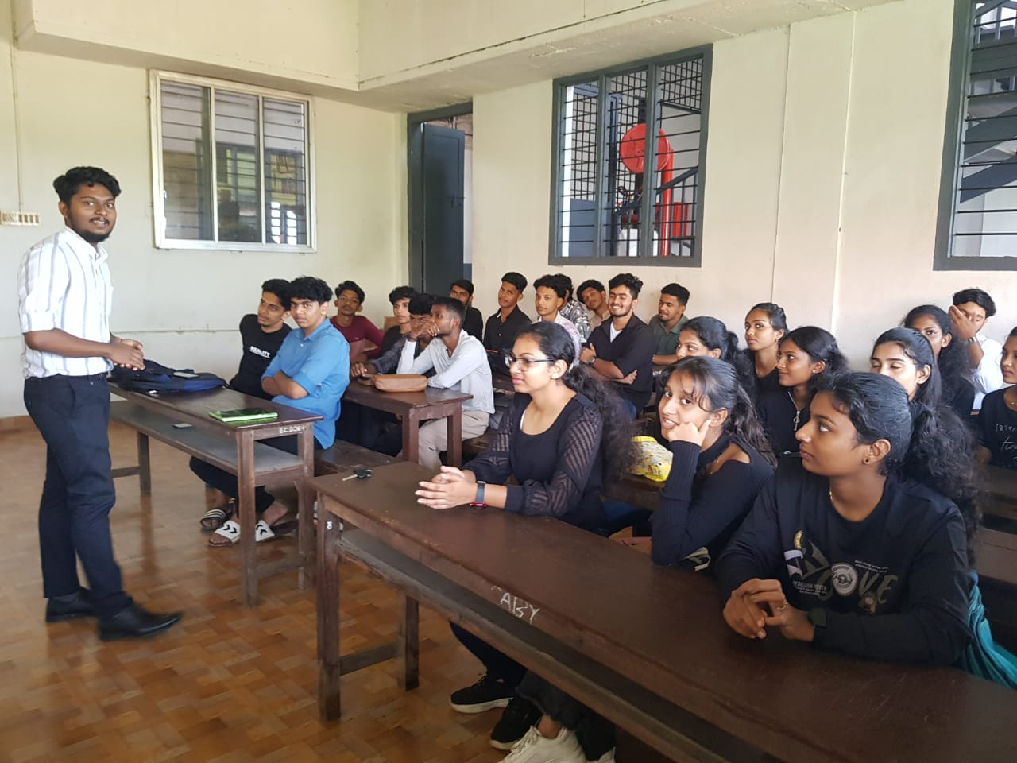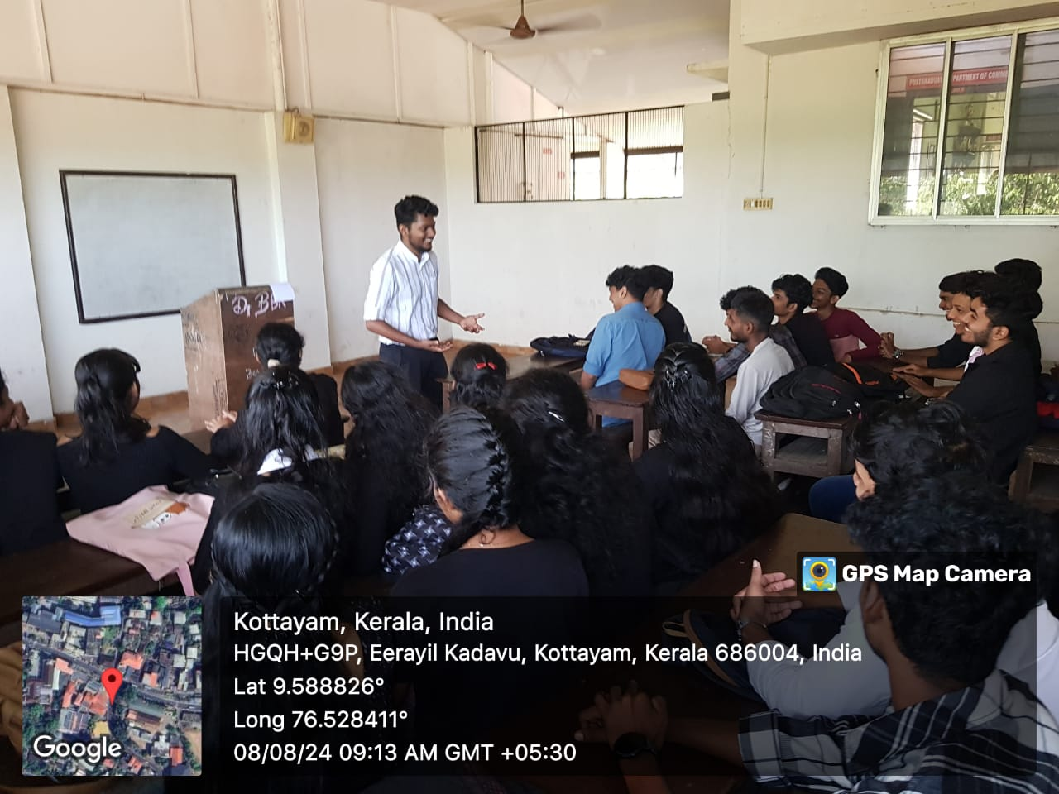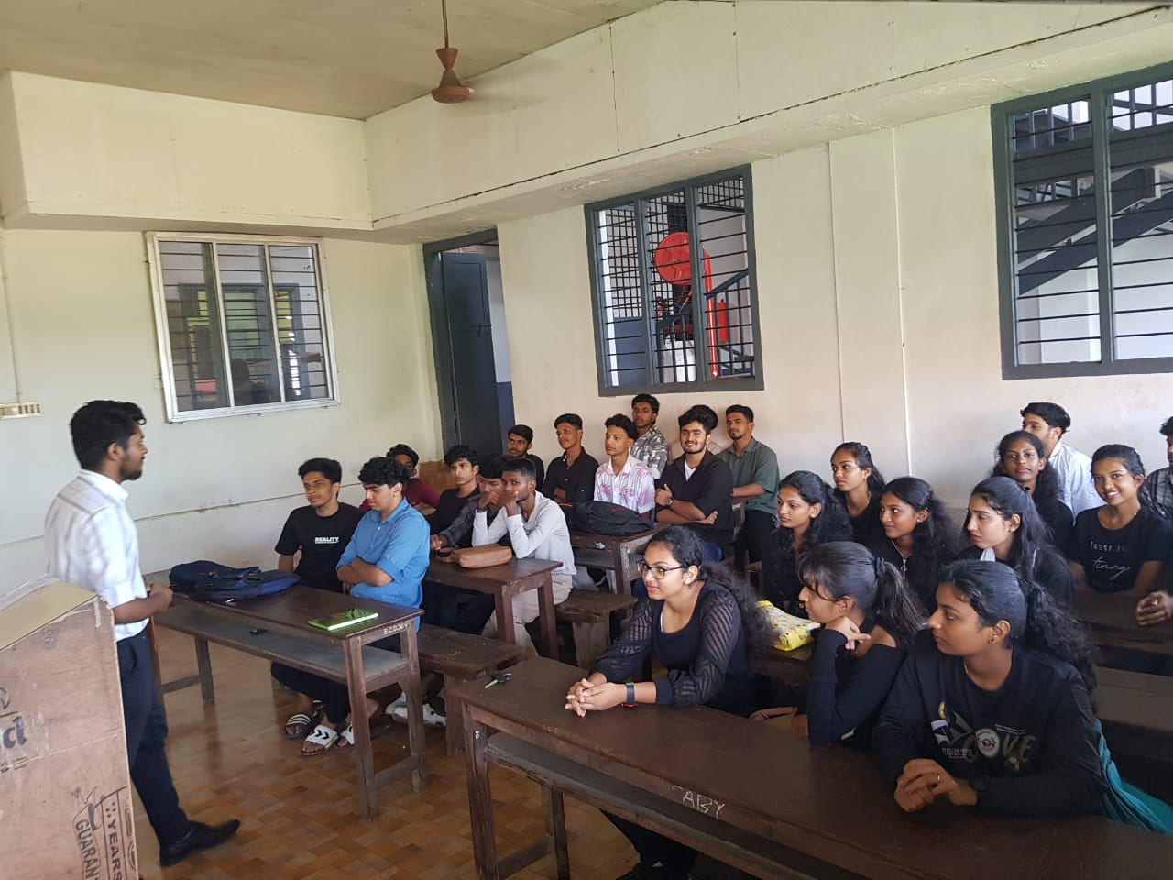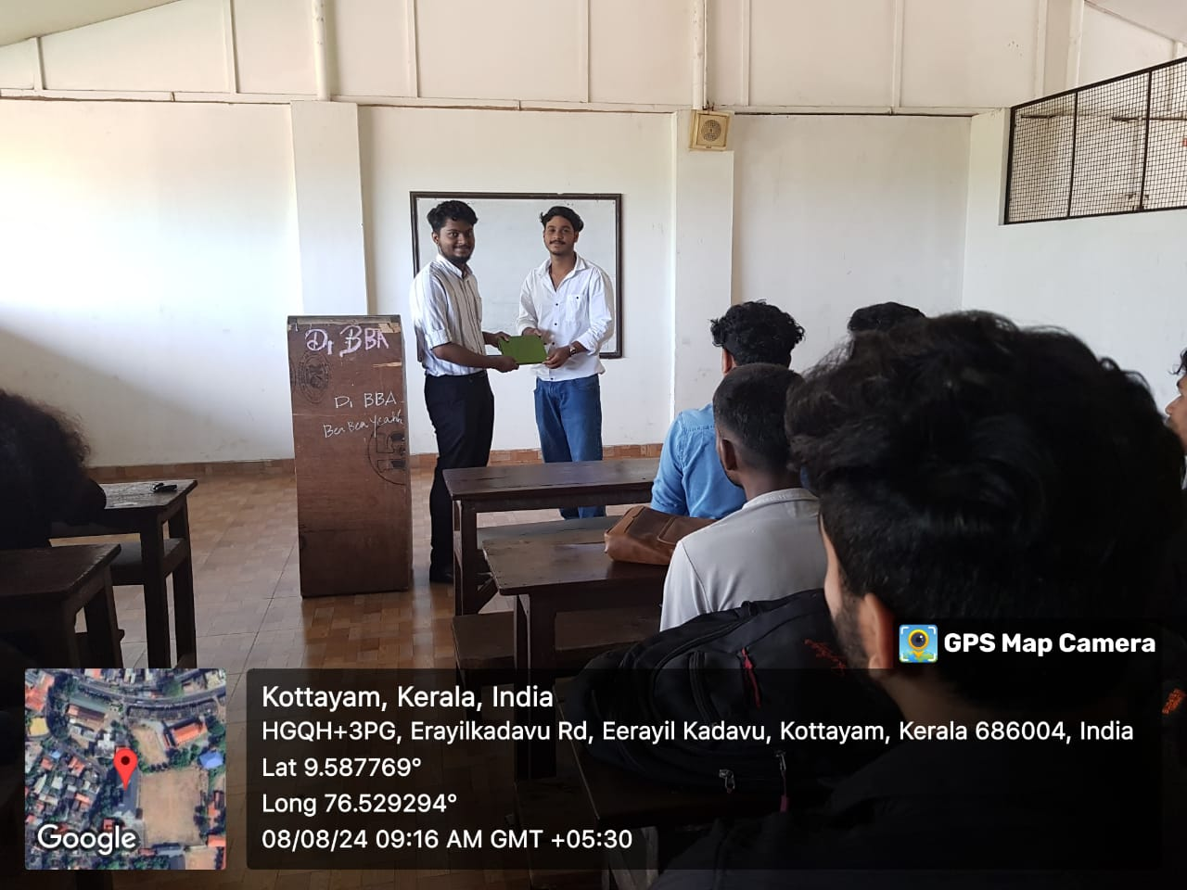

- Photograph of the event - Audience
- Photograph of the event - Group Photo
- Other photographs if any
- Other Documents if any (Schedule, Resource Person Details, ..)

Participant list in prescribed format
Innovation & Entrepreneurship Development Centre
An initiative of Kerala Startup Mission

- Name of Event | Hands-On with Smart Learn Kits
- Name of Institute | : Baselius College
- Name of Nodal Officer | : Dr Aparna Thankappan
- Email Address | : aparnathankappan@baselius.ac.in
- Contact Number | : 9747620918
- Event participant type | : participants only from the institution
- Total number of participants | : 8
- Total number of women participants | : 8
- Track of Event | Innovation
- Event category | Innovation - "Demo Day" (Student Innovators with showcase their Product/Prototype to corporates, investors, stake holders, MSMEs etc.)
- Sector | Industry 4.0 & Advanced Manufacturing
- Date from | 9.9.24
- Date to | 9.9.24
- Total number of hours | 2
- Details of IEDCs Collaborated | -
- Details of Communities or Clubs collaborated with | -
- Detailed report of the event (Min 200 words) | The Innovation and Entrepreneurship Development Centre (IEDC) of Baselius College organized a hands-on training workshop on Smart Learn Kits, aimed at fostering practical learning through innovative educational tools. The workshop witnessed the active participation of 8 students, who engaged in assembling and experimenting with smart learning equipment.  The primary focus of the workshop was on creating two experimental setups: a Force Table and a Laser Triangulation system. These setups are designed to enhance interactive learning and provide students with a deeper understanding of fundamental physics concepts.  At the conclusion of the workshop, the completed experimental setups were formally handed over to Dr. Linju Ann Jacob, Head of the Department of Physics, by the Vice Principal of Baselius College, Dr. Jyothi Mol. The successful creation of these setups marks a significant achievement for the participating students and highlights the potential of smart learning kits in improving the learning experience.  The workshop was part of IEDC’s ongoing efforts to integrate innovative technologies into education and provide students with opportunities for practical, hands-on learning.

- Creatives created for the event (Max 10nos)

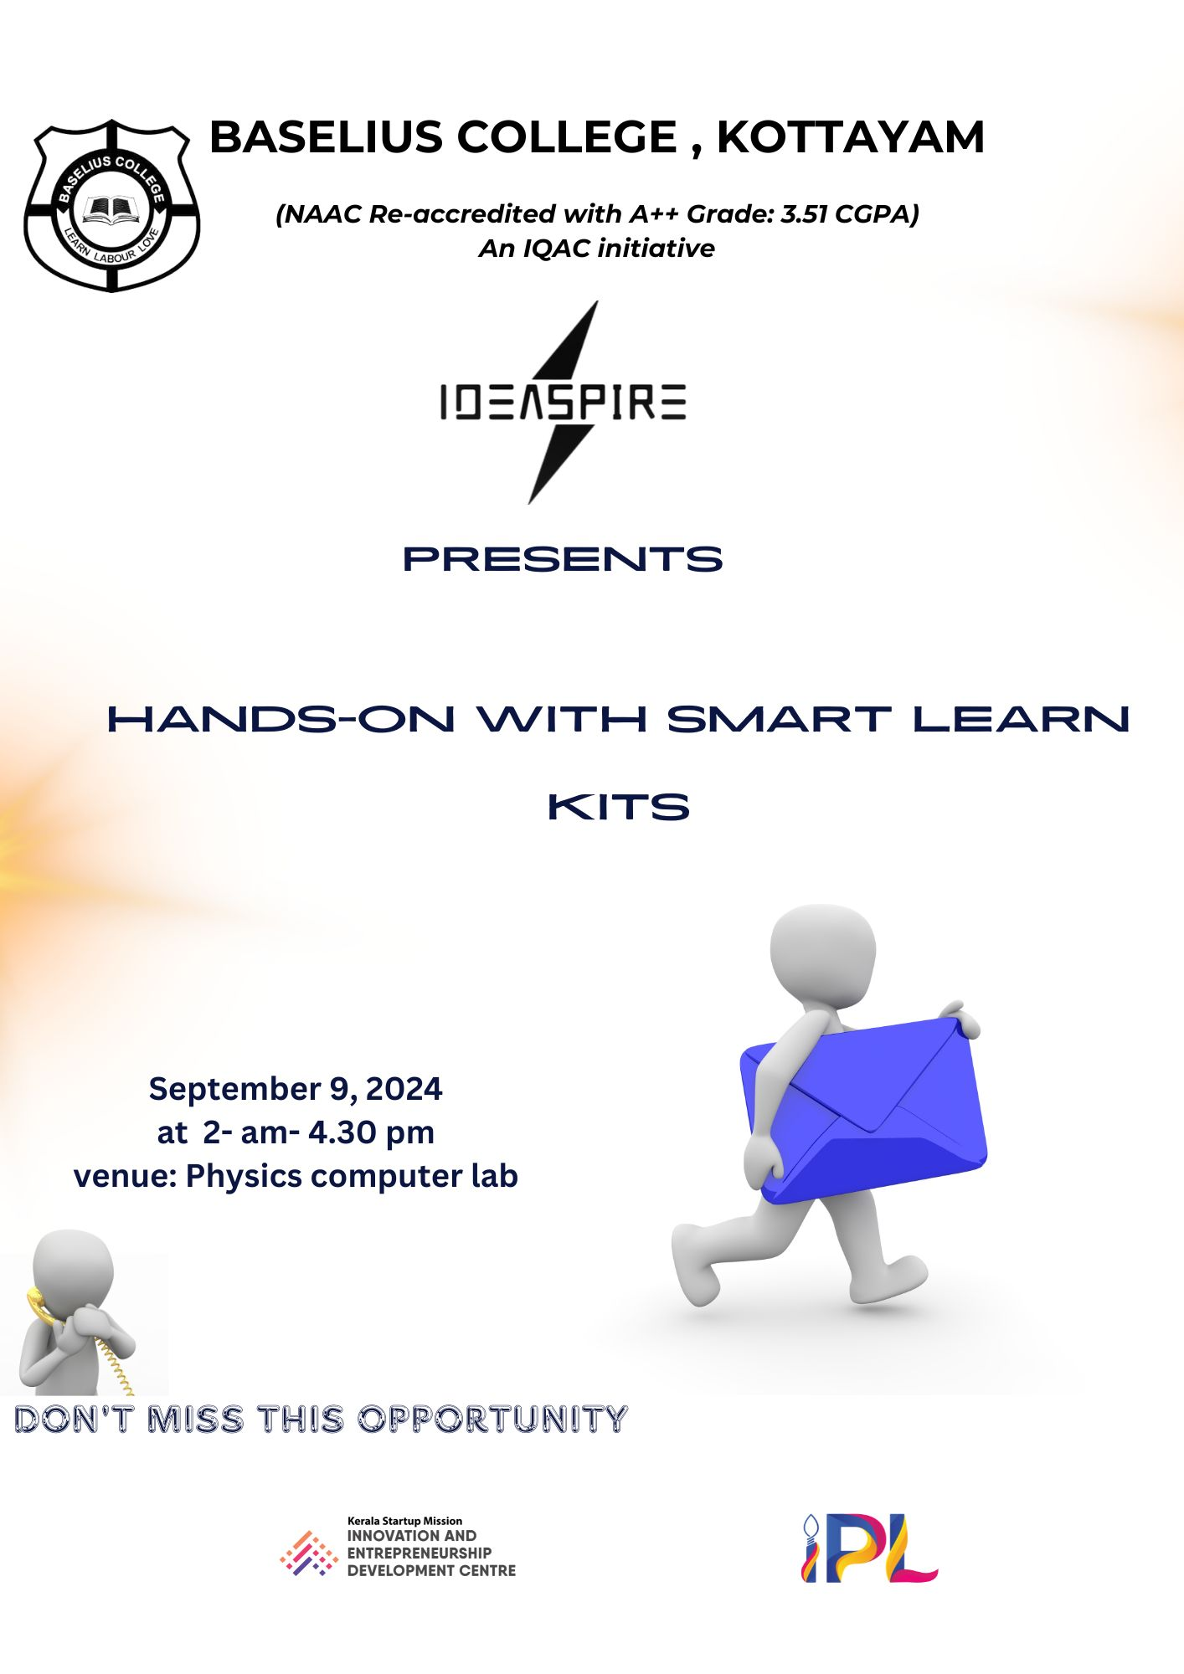
- Photograph of the event - Stage

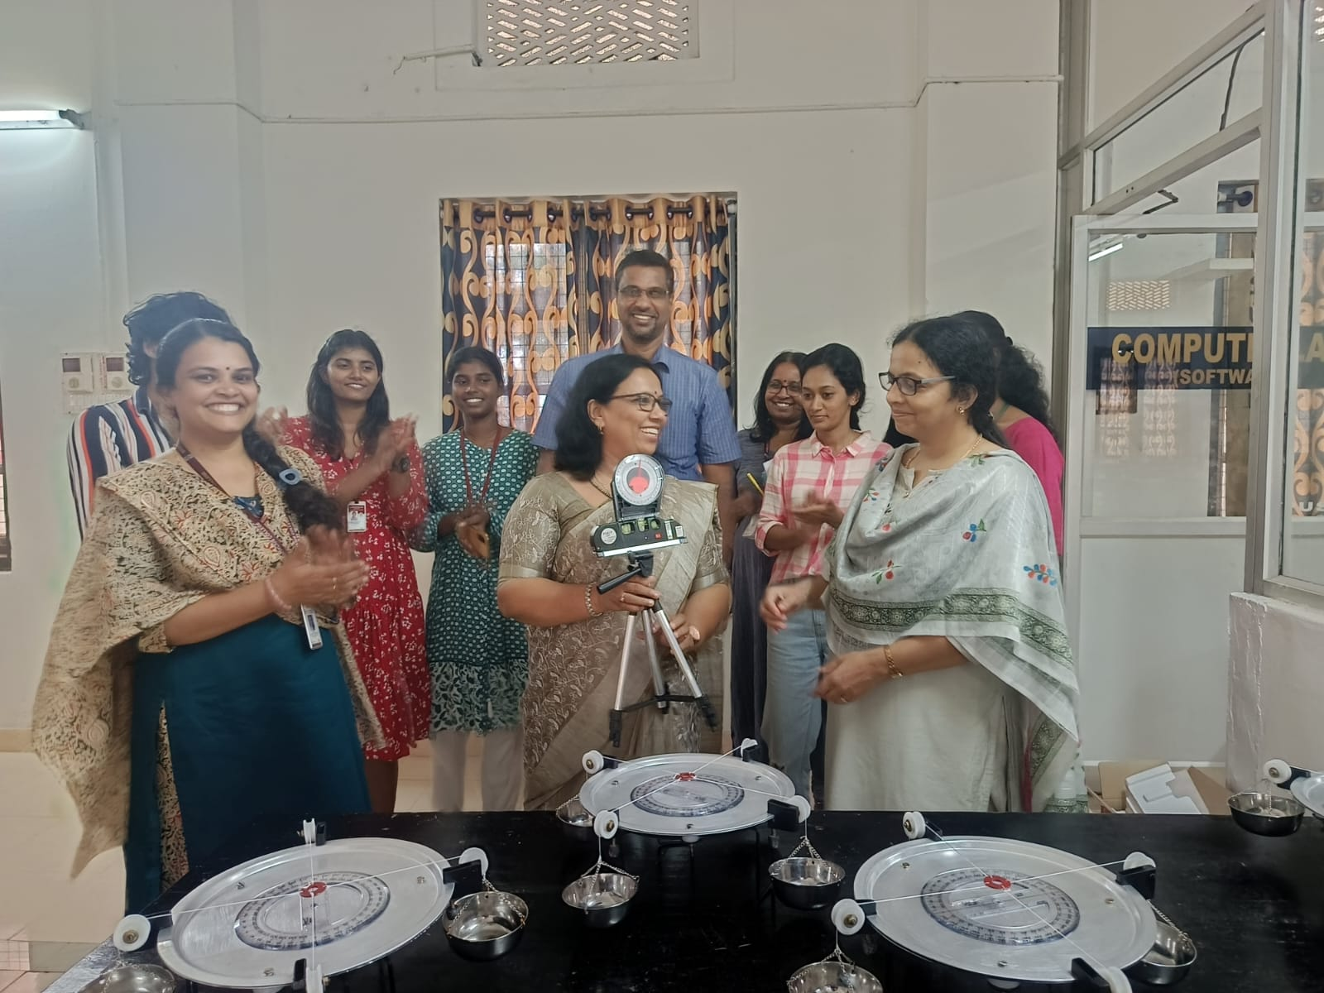

- Photograph of the event - Audience

- Photograph of the event - Group Photo

- Other photographs if any
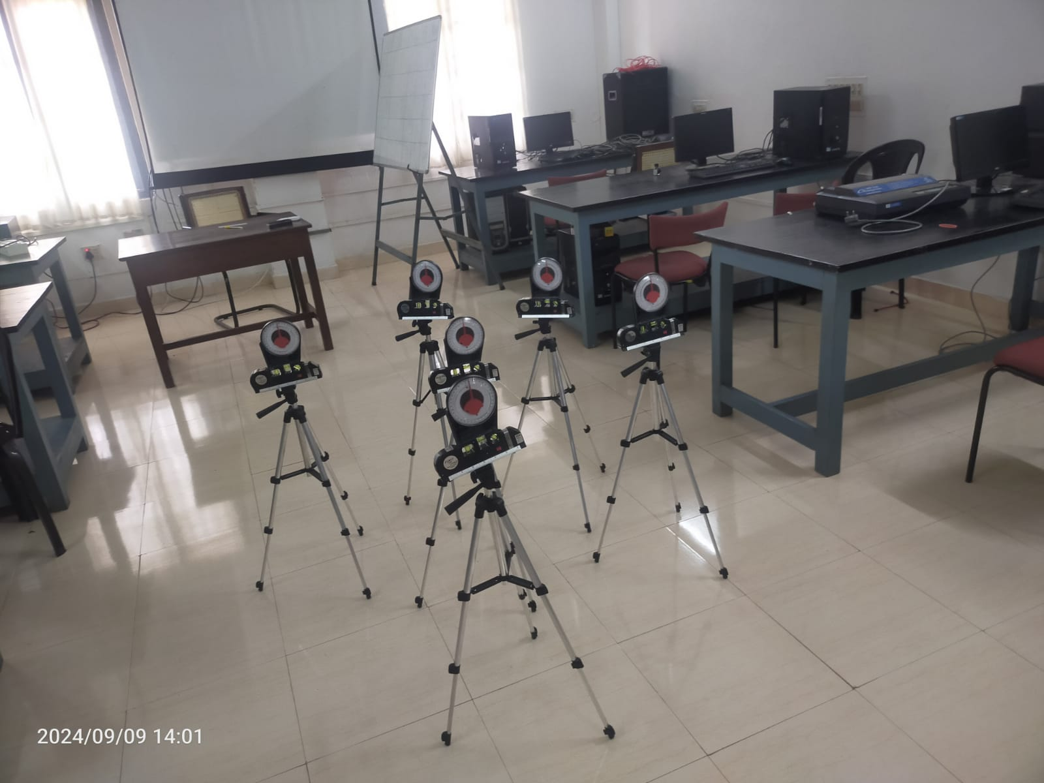
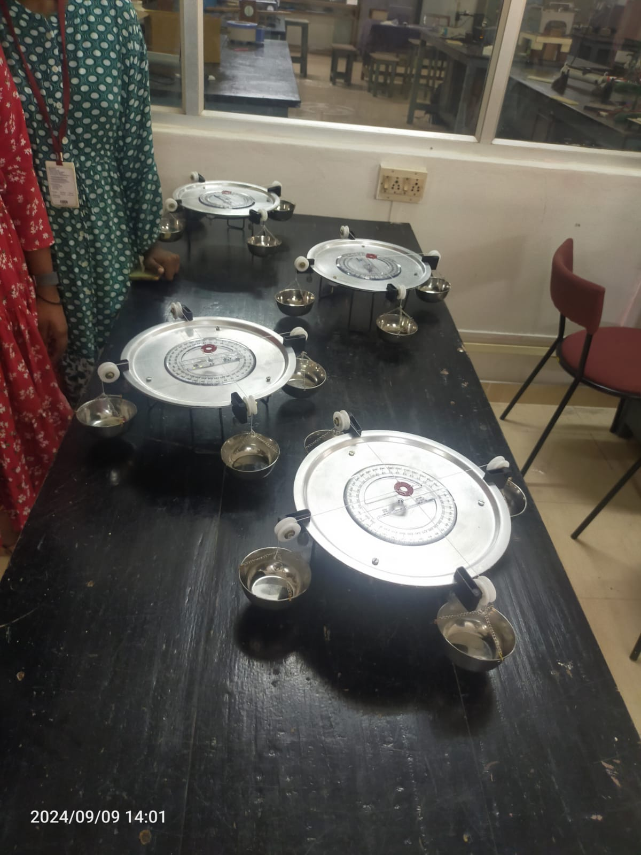
- Other Documents if any (Schedule, Resource Person Details, ..)
Dr Jyothi Mol P, Vice principal Baselius College

- Participant list in prescribed format

Innovation & Entrepreneurship Development Centre
An initiative of Kerala Startup Mission

- Name of Event | I Talks
- Name of Institute | : Baselius College
- Name of Nodal Officer | : Dr Aparna Thankappan
- Email Address | : aparnathankappan@baselius.ac.in
- Contact Number | : 9747620918
- Event participant type | : participants only from the institution
- Total number of participants | : 76
- Total number of women participants | : 51
- Track of Event | Innovation
- Event category | Innovation - "iTalk, Failure Friday,Campus Innovator Talk, Meet the Founder/Innovator"
- Sector | Social Impact, Rural Livelihood & Sustainability
- Date from | 8.10 24
- Date to | 8.10.24
- Total number of hours | 2 hrs 30 min
- Details of IEDCs Collaborated
- Details of Communities or Clubs collaborated with | IIC, Department of Physics, Department of chemistry
- Detailed report of the event (Min 200 words) | On October 8, 2024, a collaborative "I Talk" session was organized by IEDC, IIC, the Department of Physics, and the Department of Chemistry at Baselius College. The event, held at Mrs. Mammen Mappilai Hall, showcased the achievements and experiences of Baselius College students who participated in the prestigious NASA Space Apps Challenge. The session featured insights from award-winning students Gayathri Nair (MSc Physics), Aparna Thilakan (MSc Physics), Nidarsh S (BSc Physics), Aivin Jinu (BSc Physics)  , and A Surya Kumar (BSc Physics). As one of the teams awarded the Local Impact Award, hosted by Amal Jyothi Engineering College, the students shared their innovative ideas and project experiences, inspiring the 78 students in attendance.  Their presentations reflected the creativity and collaboration required in tackling real-world challenges, emphasizing the significance of interdisciplinary approaches. The session provided a platform for learning, networking, and fostering a culture of innovation among aspiring scientists and technologists at Baselius College.
- Creatives created for the event (Max 10nos)

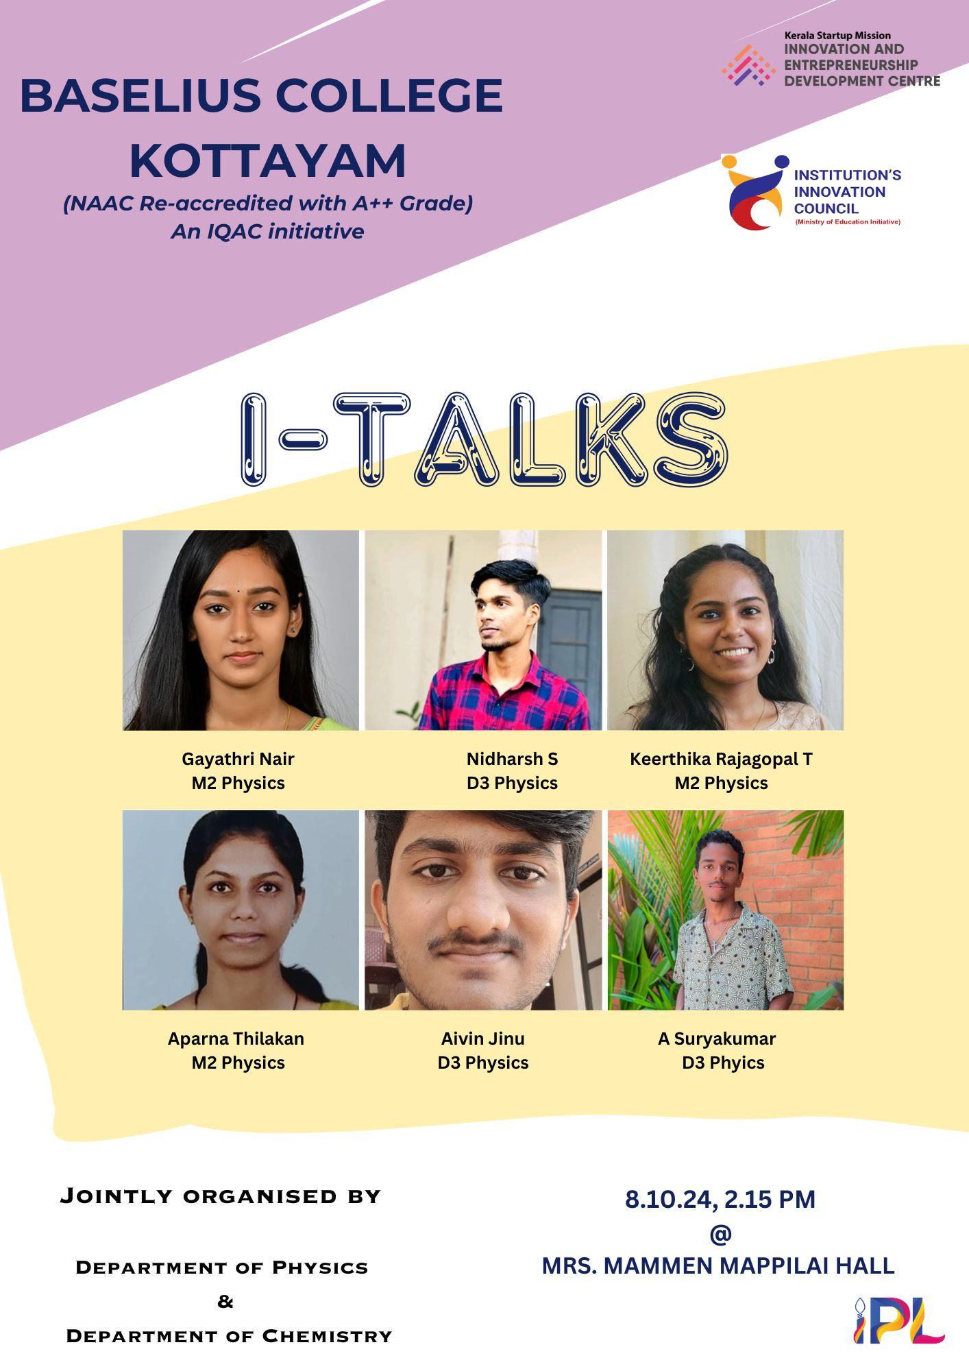
- Photograph of the event - Stage

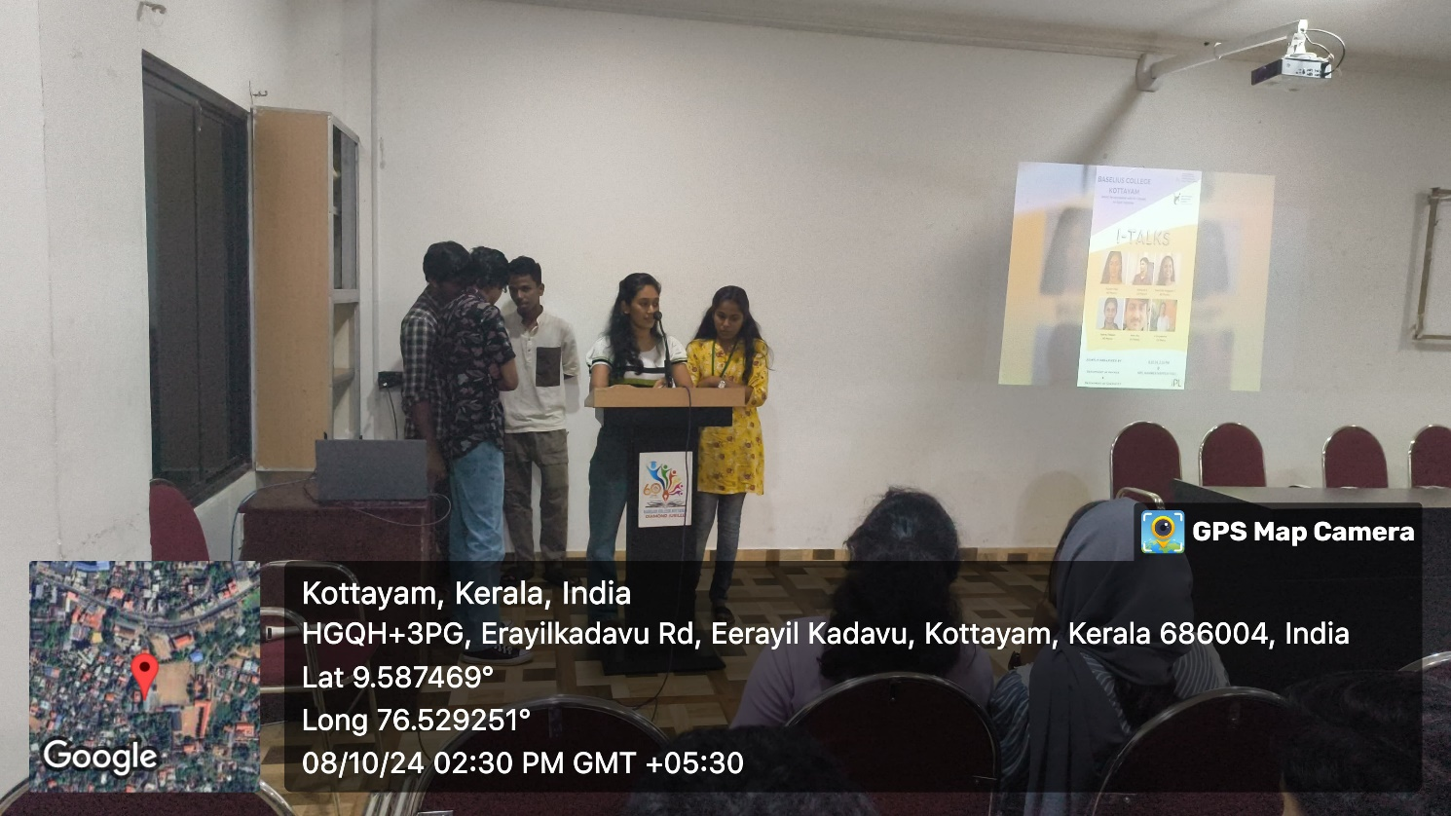

- Photograph of the event - Audience

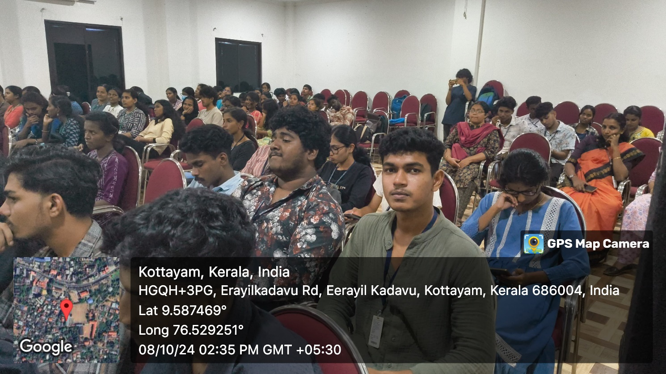
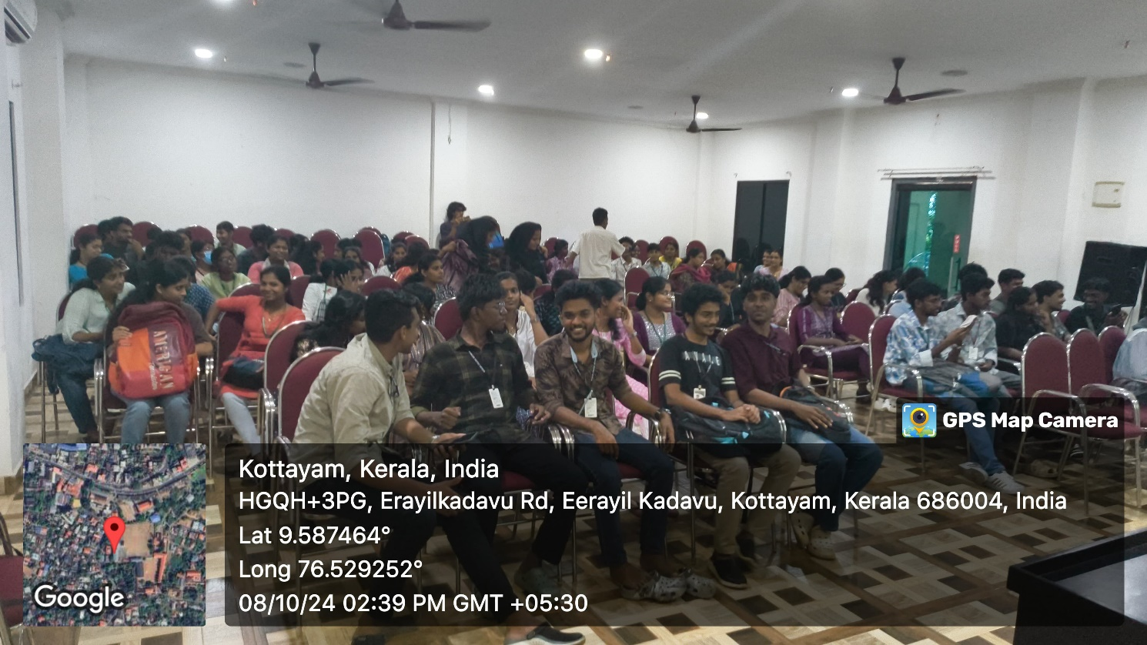

- Photograph of the event - Group Photo

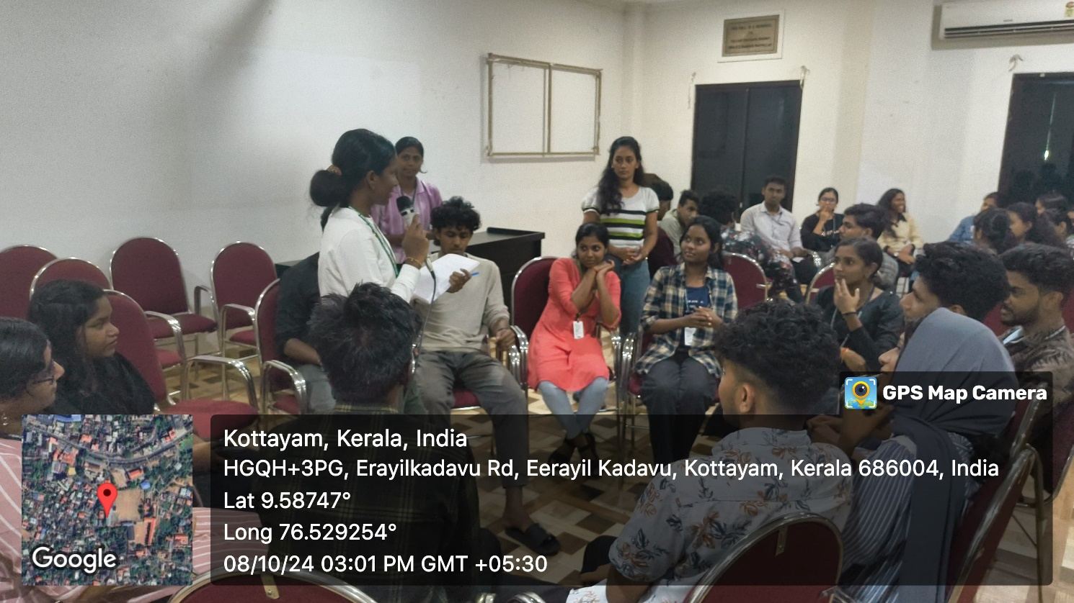
- Other photographs if any
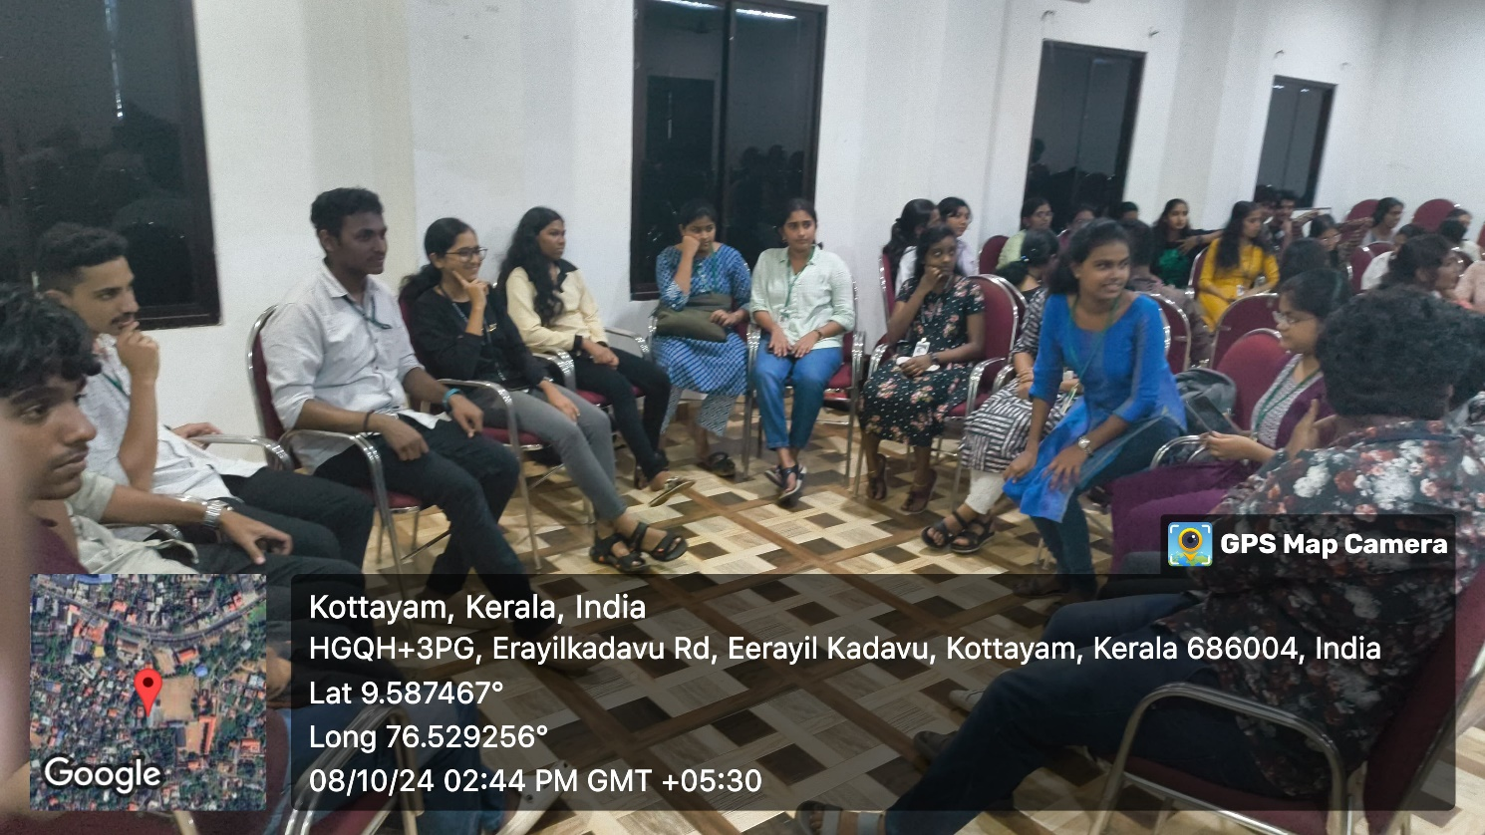
- Other Documents if any (Schedule, Resource Person Details, ..)

Gayathri Nair (MSc Physics), Aparna Thilakan (MSc Physics), Nidarsh S (BSc Physics), Aivin Jinu (BSc Physics) , and A Surya Kumar (BSc Physics)
- Participant list in prescribed format
Innovation & Entrepreneurship Development Centre
An initiative of Kerala Startup Mission

- Name of Event | Workshop on startup launchpad- from idea to reality
- Name of Institute | : Baselius College
- Name of Nodal Officer | : Dr Aparna Thankappan
- Email Address | : aparnathankappan@baselius.ac.in
- Contact Number | : 9747620918
- Event participant type | : participants only from the institution
- Total number of participants | : 30
- Total number of women participants | : 18
- Track of Event | Entrepreneurship
- Event category | Entrepreneurship - Boot camps/Workshops - Business model Canvas Workshop, How to build a startup etc.
- Sector | Agriculture & FoodTech
- Date from | 30.9.24
- Date to | 1.10.24
- Total number of hours | 6 hrs
- Details of IEDCs Collaborated | nil
- Details of Communities or Clubs collaborated with | IIC
- Detailed report of the event (Min 200 words) | A two-day workshop titled "Startup Launchpad - From Idea to Reality" was successfully conducted from September 30 to October 1, 2024. This event, jointly organized by IEDC and IIC at Baselius College, provided a comprehensive introduction to the fundamentals of launching a startup. The workshop took place in Mrs. Mammen Mappilai Hall, with 30 enthusiastic students participating.  The sessions were led by resource persons Dr. Anju Linda Varghese, IIC Nodal Officer; Dr. Aparna Thankappan, IEDC Nodal Officer; and Dr. Nibu A. George, also an IEDC Nodal Officer. Each brought valuable insights and practical strategies for startup development, from ideation to implementation. Students engaged actively, discussing innovative ideas and receiving guidance on developing their concepts into viable business models.  This interactive program inspired students to think entrepreneurially and equipped them with foundational skills to transform their ideas into real-world startups, fostering a spirit of innovation and creativity within Baselius College.
- Creatives created for the event (Max 10nos)

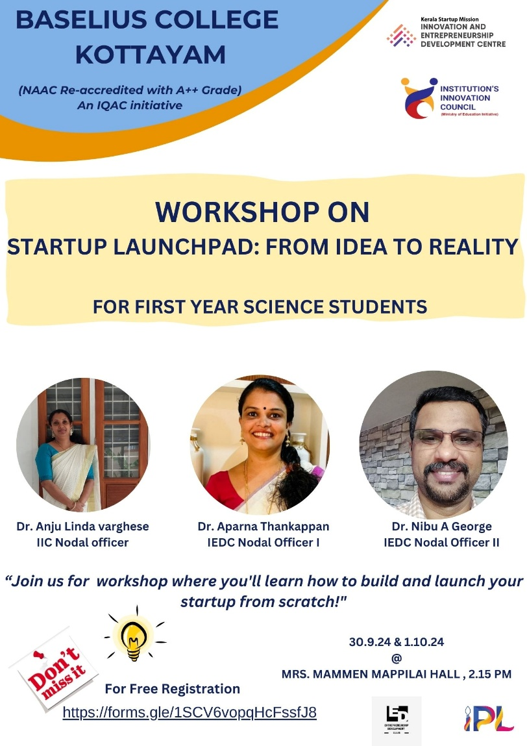
- Photograph of the event - Stage

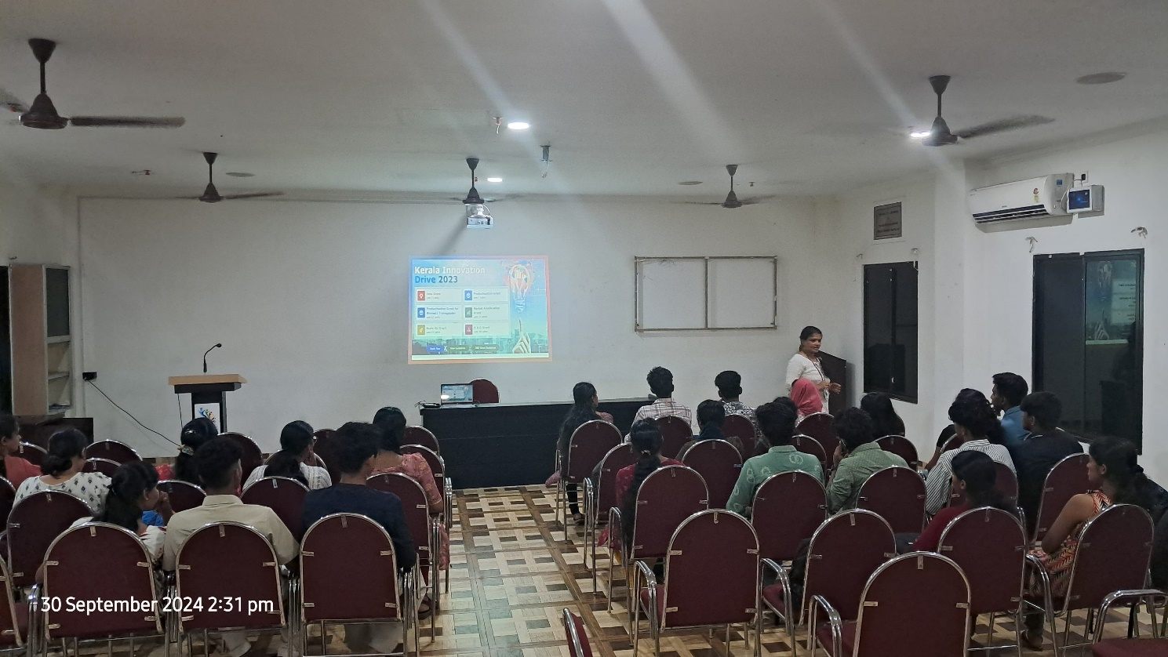

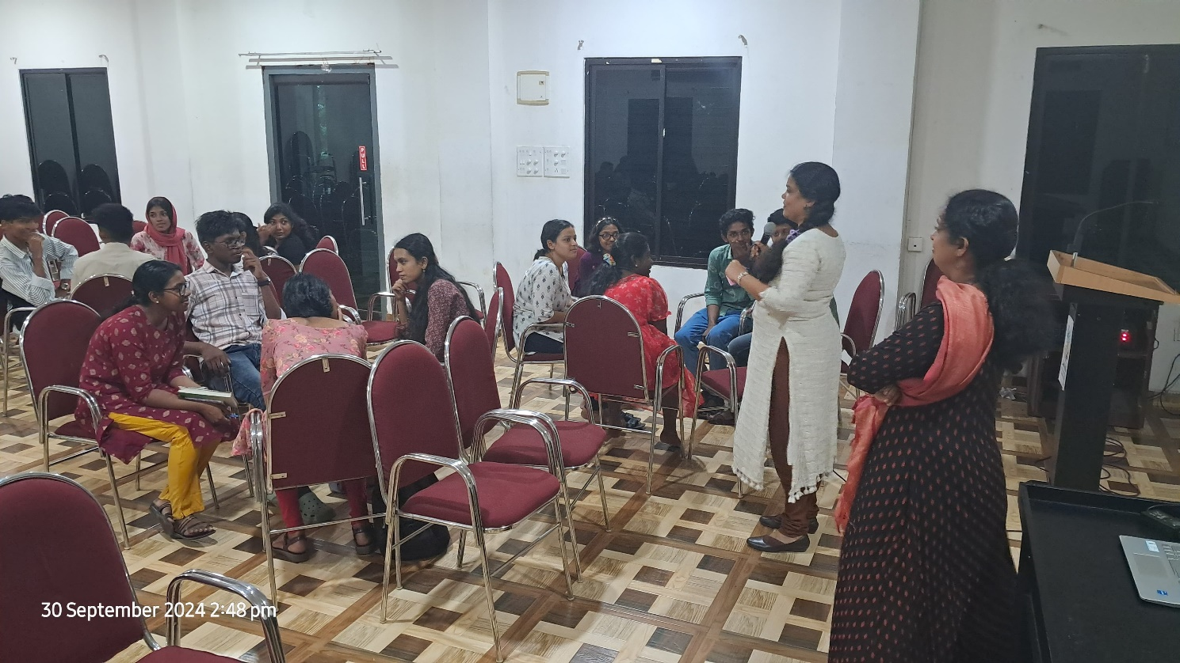

- Photograph of the event - Audience

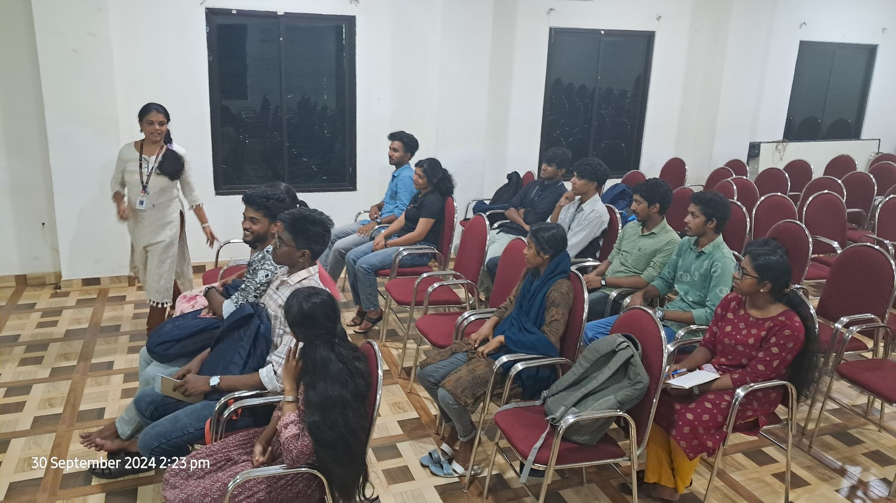

- Photograph of the event - Group Photo

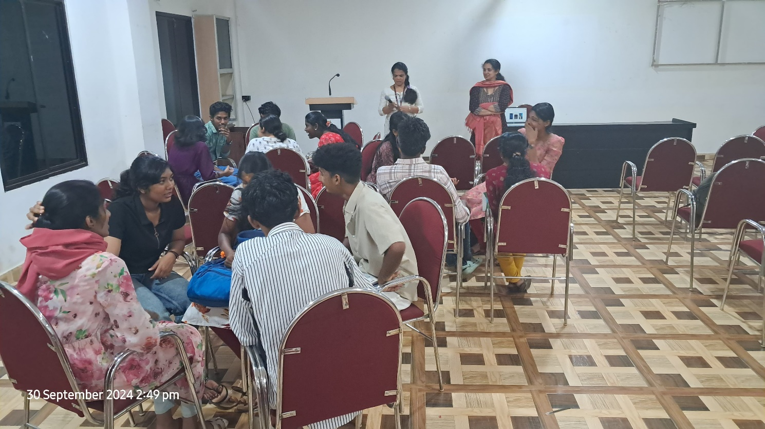

- Other photographs if any
- Other Documents if any (Schedule, Resource Person Details, ..)
Dr. Anju Linda Varghese, IIC Nodal Officer
Dr. Aparna Thankappan, IEDC Nodal Officer
Dr. Nibu A. George, also an IEDC Nodal Officer

- Participant list in prescribed format
Innovation & Entrepreneurship Development Centre
An initiative of Kerala Startup Mission

- Name of Event | Idea at Baselius
- Name of Institute | : Baselius College
- Name of Nodal Officer | : Dr Aparna Thankappan
- Email Address | : aparnathankappan@baselius.ac.in
- Contact Number | : 9747620918
- Event participant type | : participants only from the institution
- Total number of participants | : 30
- Total number of women participants | : 18
- Track of Event | Innovation
- Event category | Innovation - Workshops - Innovation Orientation, Ideation etc.
- Sector | Agriculture & FoodTech
- Date from | 15.10.24
- Date to | 15.10.24
- Total number of hours | 2 hrs
- Details of IEDCs Collaborated
- Details of Communities or Clubs collaborated with | IEDC,IIC,ED,Placement cell,YIP
- Detailed report of the event (Min 200 words) | On October 15, 2024, Baselius College celebrated Innovation Day, an event that brought together aspiring student entrepreneurs to present their innovative ideas, cultivated through the "Startup Launchpad - From Idea to Reality" workshop held from September 30 to October 1, 2024. This follow-up event was jointly organized by IEDC, IIC, the Entrepreneurship Development (ED) Cell, the Placement Cell, and the Young Innovators Programme (YIP), further supporting students in their journey from ideation to action.  The event took place in Mrs. Mammen Mappilai Hall, where students showcased the concepts they had developed during the workshop. These presentations were the culmination of intensive brainstorming, hands-on sessions, and mentorship from workshop leaders Dr. Anju Linda Varghese, Dr. Aparna Thankappan, and Dr. Nibu A. George. By the time of Innovation Day, students were ready to pitch their refined ideas, demonstrating the potential of their projects and the entrepreneurial skills they had acquired.  The day’s program was graced by chief guest Nibu B. Thomas from the Department of Electronics, who encouraged students to pursue innovation with dedication and creativity. He highlighted the importance of technical proficiency and market understanding in transforming ideas into impactful solutions. Dr. Viju Kurian, YIP Coordinator from the Department of English, also addressed the audience, stressing the value of interdisciplinary collaboration in today’s startup landscape. His insights on the Young Innovators Programme encouraged students to think beyond the local community and aim for broader societal impact.  Throughout the event, students engaged actively, receiving constructive feedback from faculty and peers on further developing their ideas. This event served as a milestone in nurturing a culture of innovation at Baselius College, empowering students to move confidently from idea generation to potential startup ventures.

- Creatives created for the event (Max 10nos)

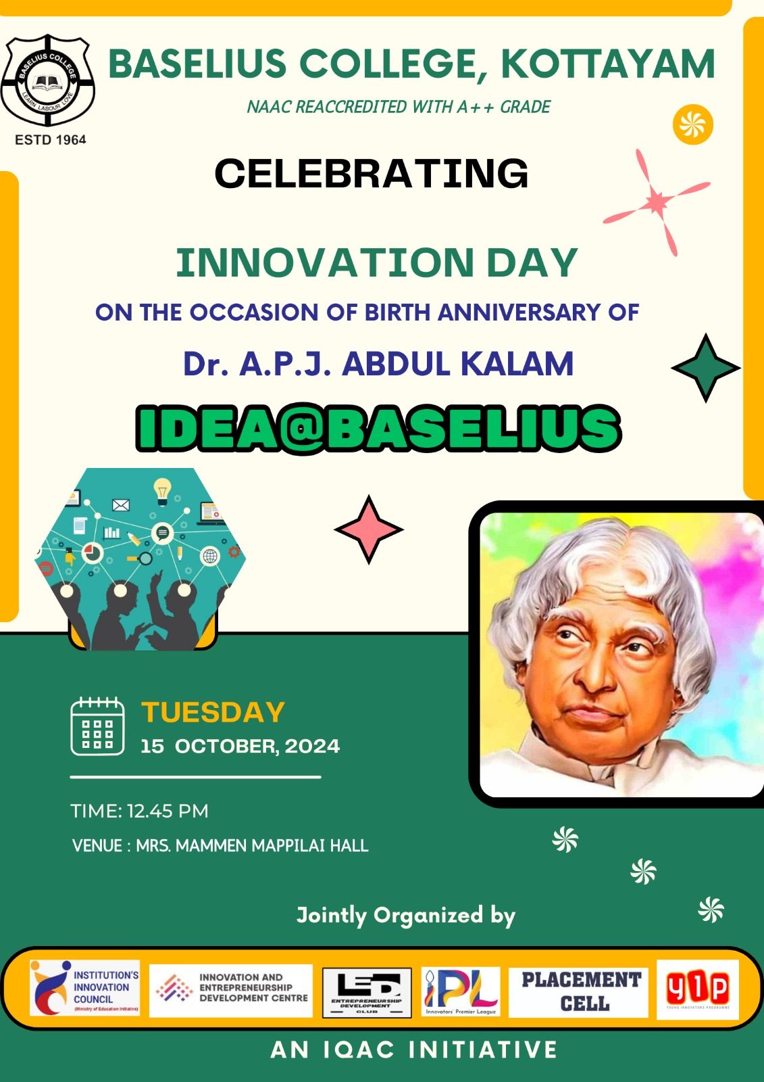
- Photograph of the event - Stage
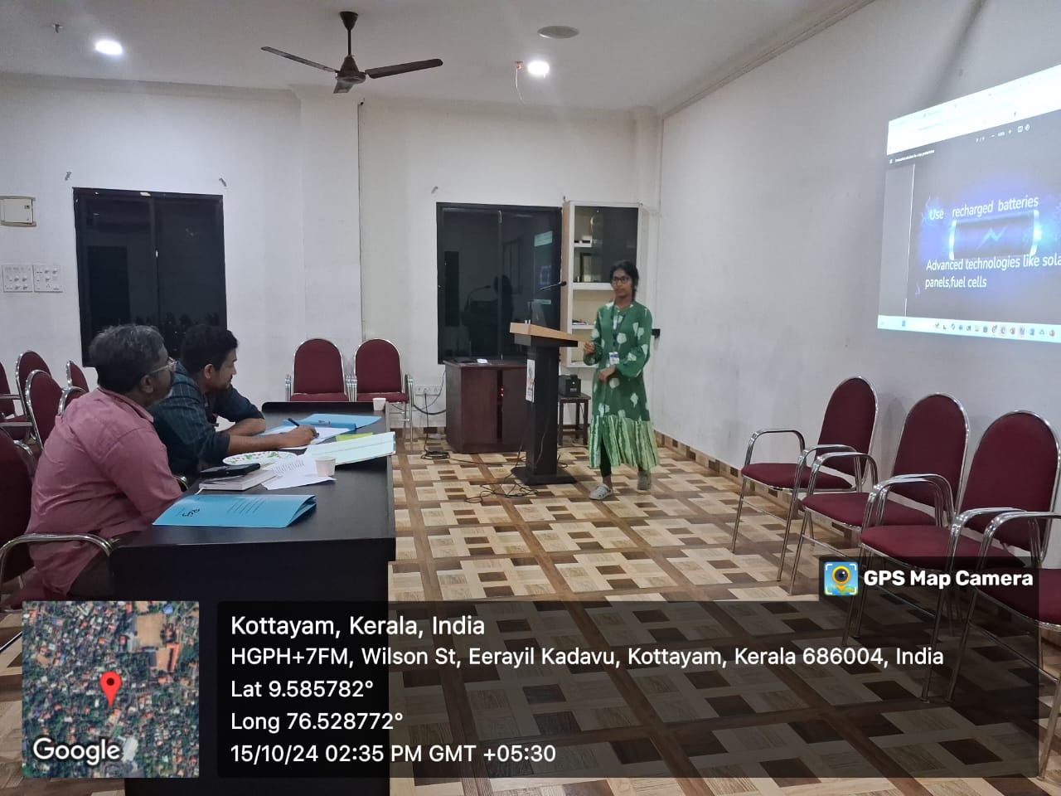
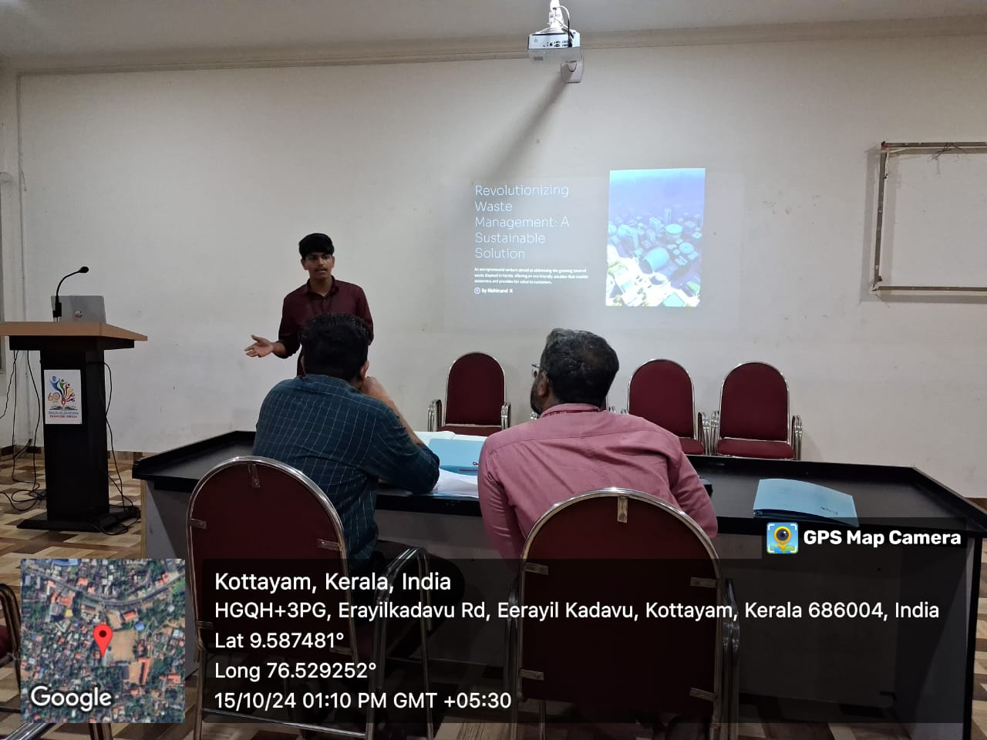

- Photograph of the event - Audience
- Photograph of the event - Group Photo
- Other photographs if any
- Other Documents if any (Schedule, Resource Person Details, ..)

Nibu B. Thomas, Department of Electronics
Dr. Viju Kurian, YIP Coordinator, Department of English
- Participant list in prescribed format
Innovation & Entrepreneurship Development Centre
An initiative of Kerala Startup Mission

- Name of Event | Workshop on igniting your idea
- Name of Institute | : Baselius College
- Name of Nodal Officer | : Dr Aparna Thankappan
- Email Address | : aparnathankappan@baselius.ac.in
- Contact Number | : 9747620918
- Event participant type | : participants only from the institution
- Total number of participants | : 32
- Total number of women participants | : 16
- Track of Event | Innovation
- Event category | Innovation - Workshops - Innovation Orientation, Ideation etc.
- Sector | MarketingTech & MICE
- Date from | 14.10.24
- Date to | 14.10.24
- Total number of hours | 2 hrs
- Details of IEDCs Collaborated
- Details of Communities or Clubs collaborated with | IIC,ED club,Placement cell,BBA department,RINK
- Detailed report of the event (Min 200 words) | The IEDC, IIC, ED, BBA Department, and RINK of Baselius College jointly organized a workshop titled "Igniting Your Idea" on October 14, 2024. The workshop aimed to inspire students to identify and develop innovative ideas into actionable plans. The resource person for the session was Mr. Lorance Mathew, Assistant District Industries Officer at the District Industries Centre, Kottayam. Mr. Mathew shared valuable insights into the processes of ideation, validation, and execution, highlighting real-world examples to make the concepts relatable and practical for the participants.  The workshop witnessed the active participation of 32 students, who engaged enthusiastically in discussions and brainstorming activities. Mr. Mathew emphasized the importance of leveraging available resources and aligning ideas with market needs to create impactful entrepreneurial ventures. The event provided a stimulating platform for students to explore their creativity and refine their entrepreneurial mindset. The organizing departments successfully created an inspiring and informative experience for the participants, fostering a spirit of innovation within the college community.
- Creatives created for the event (Max 10nos)
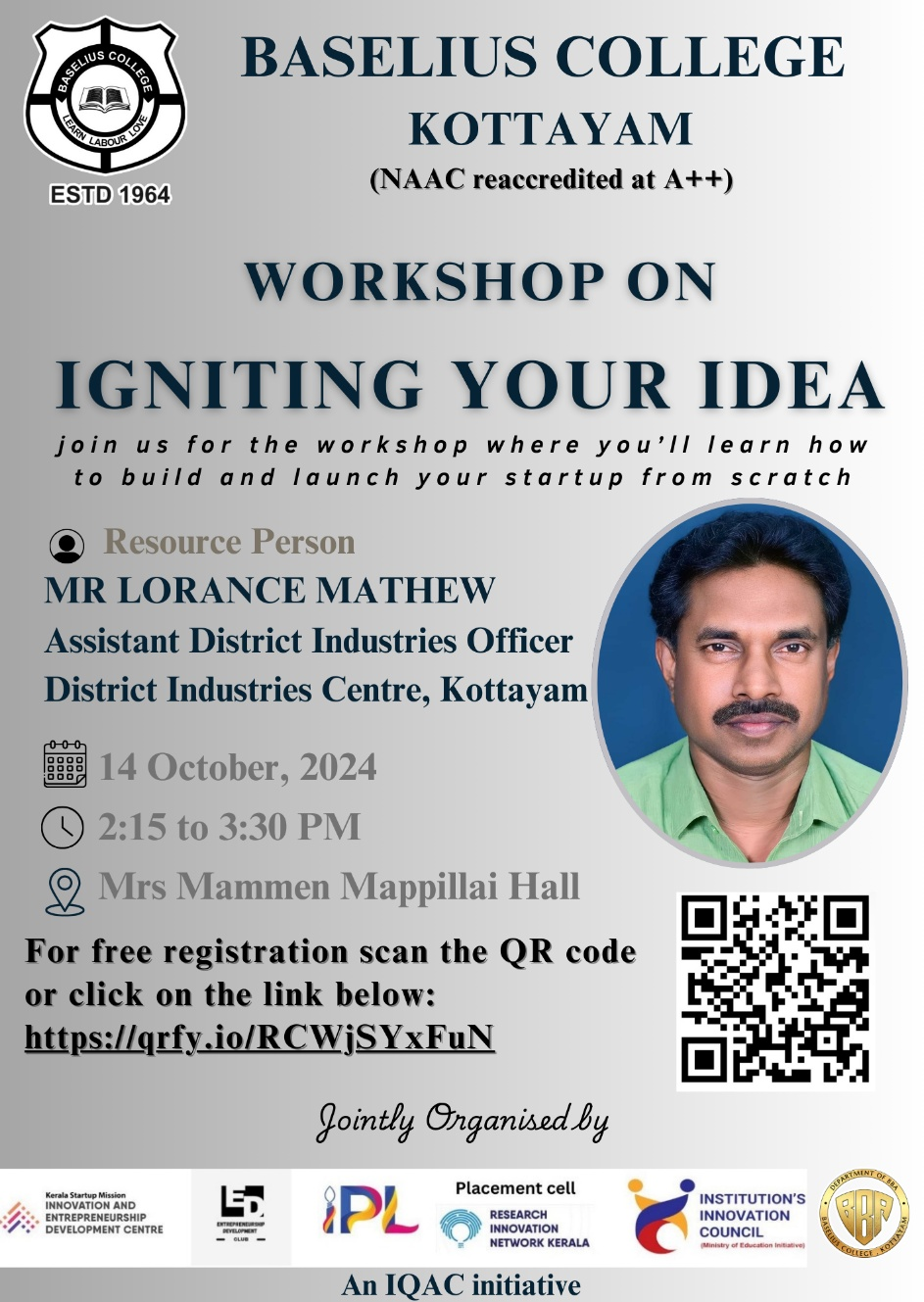

- Photograph of the event - Stage

- Photograph of the event - Audience

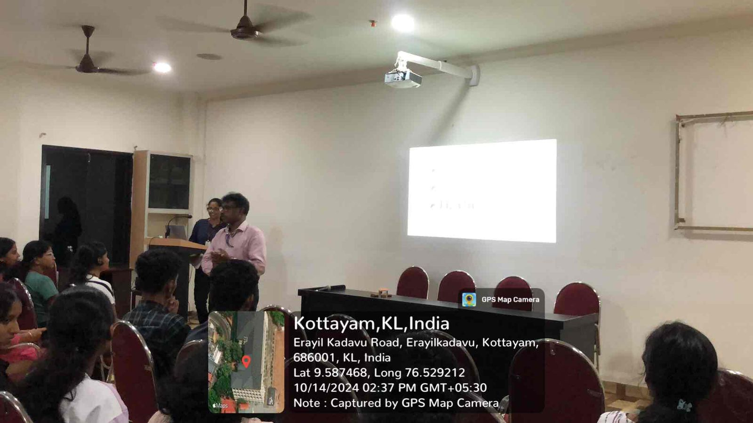

- Photograph of the event - Group Photo

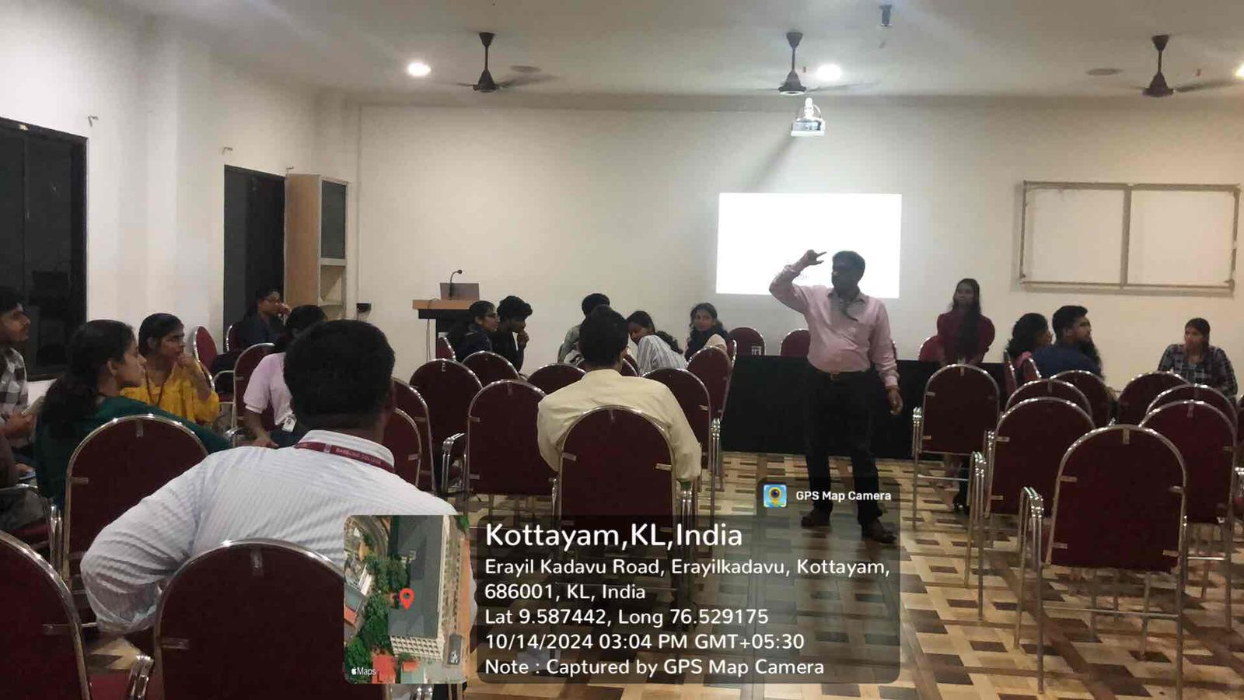

- Other photographs if any
- Other Documents if any (Schedule, Resource Person Details, ..)
Mr. Lorance Mathew, assistant district industries officer, district industries centre, Kottayam.

Participant list in prescribed format
Innovation & Entrepreneurship Development Centre
An initiative of Kerala Startup Mission

- Name of Event | Workshop on app developing
- Name of Institute | : Baselius College
- Name of Nodal Officer | : Dr Aparna Thankappan
- Email Address | : aparnathankappan@baselius.ac.in
- Contact Number | : 9747620918
- Event participant type | : participants only from the institution
- Total number of participants | : 40
- Total number of women participants | : 27
- Track of Event | Technology
- Event category | Technology - Boot Camp/Hands-On Workshop - AR/VR, Mobile/Web Development, Artificial Intelligence, Hardware, Other Future Technologies etc.
- Sector | Aerospace, Defence & SpaceTech
- Date from | 15.10.24
- Date to | 15.10.24
- Total number of hours | 3 hrs
- Details of IEDCs Collaborated | KE College
- Details of Communities or Clubs collaborated with | IIC
- Detailed report of the event (Min 200 words) | On October 15, 2024, IEDC Baselius College partnered with KE College to host an engaging App Development Program, held at KE College. This collaborative initiative aimed to equip students with practical app development skills, enhance their technical knowledge, and promote peer-led learning. The program featured an impressive lineup of resource persons from Baselius College, including Aparna Thilakan, Gayathri Nair, Keerithika Rajagopal, Surya Kumar, Aivin Jinu, and Nidarsh S. These student leaders, experienced in coding and app design, guided participants through the essentials of app development, including planning, coding, and user interface design.  With a participation of 40 students, the session was structured to be highly interactive, offering hands-on exercises that allowed students to apply concepts in real-time. Each resource person shared insights from their experiences, including tips on tackling challenges in app development, optimizing performance, and considering user experience. Through guided activities, participants gained familiarity with development tools, explored common programming languages for app development, and collaborated to build prototype apps. The program emphasized problem-solving, creativity, and teamwork, essential skills for the tech-driven landscape.  Feedback from participants highlighted the value of learning from peers and the approachable format of the session. This collaboration between Baselius College and KE College fostered a unique opportunity for knowledge exchange and laid the groundwork for further intercollegiate programs in technology and innovation.

- Creatives created for the event (Max 10nos)
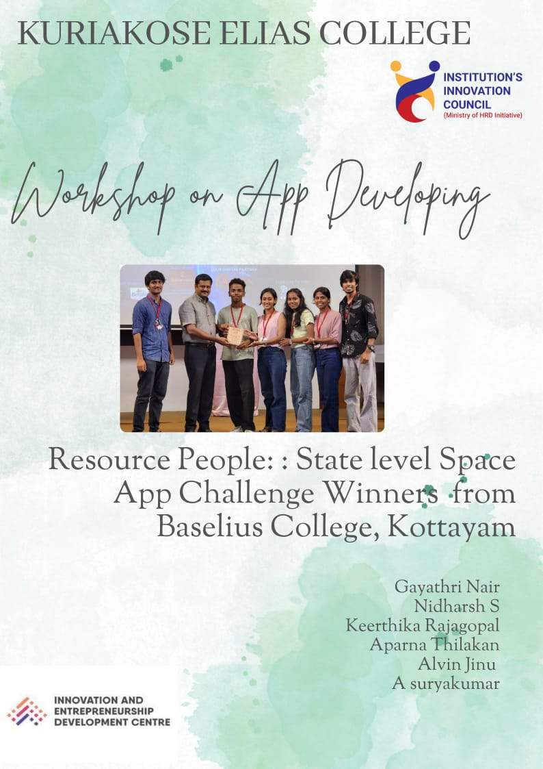

- Photograph of the event - Stage

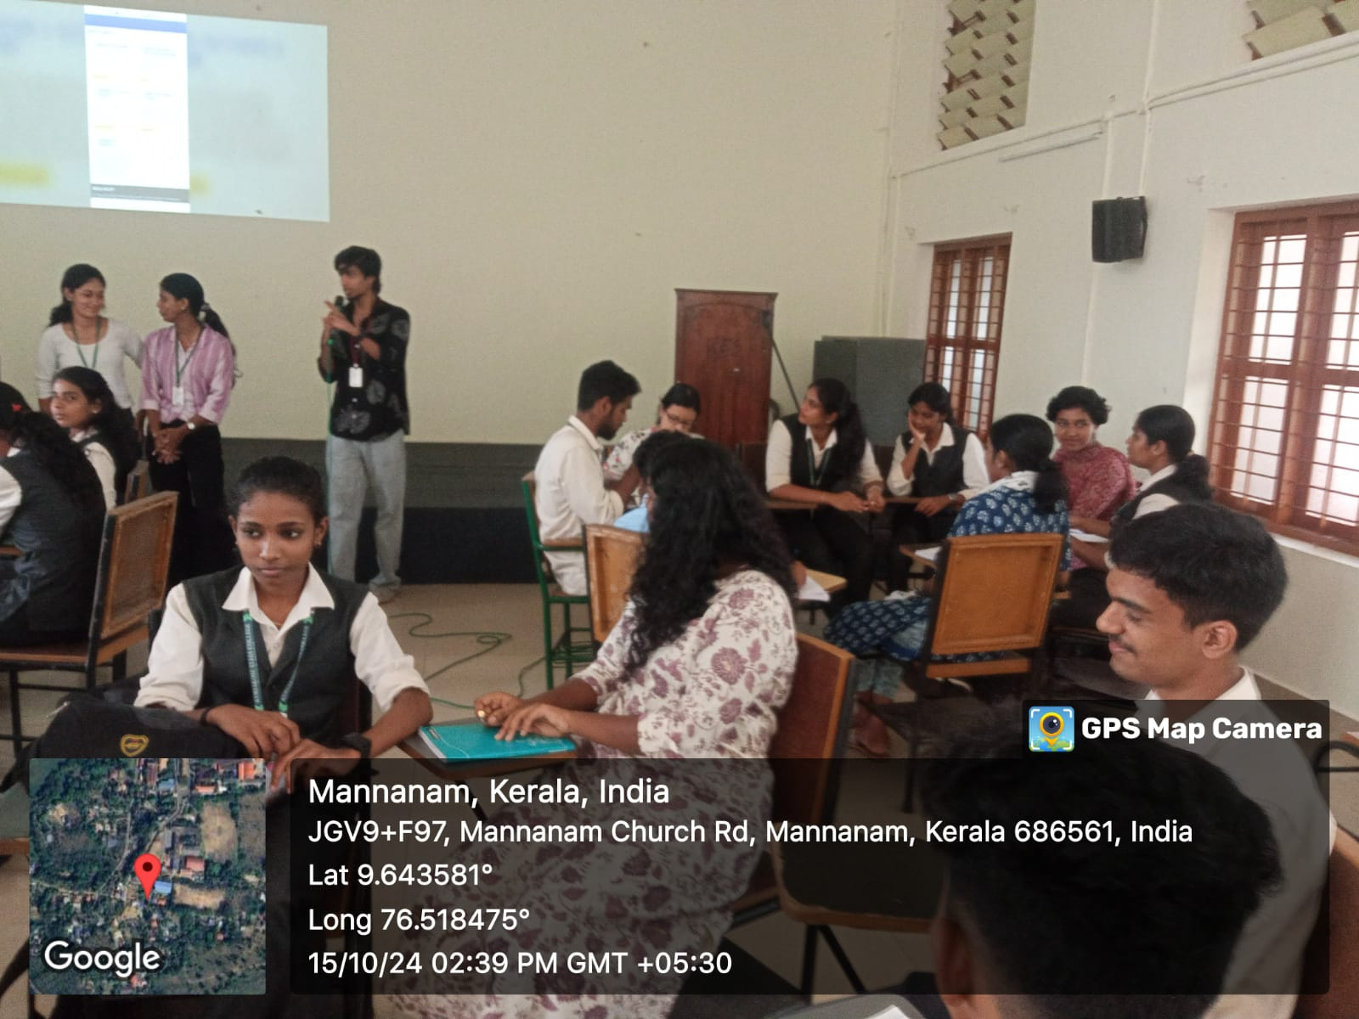

- Photograph of the event - Audience

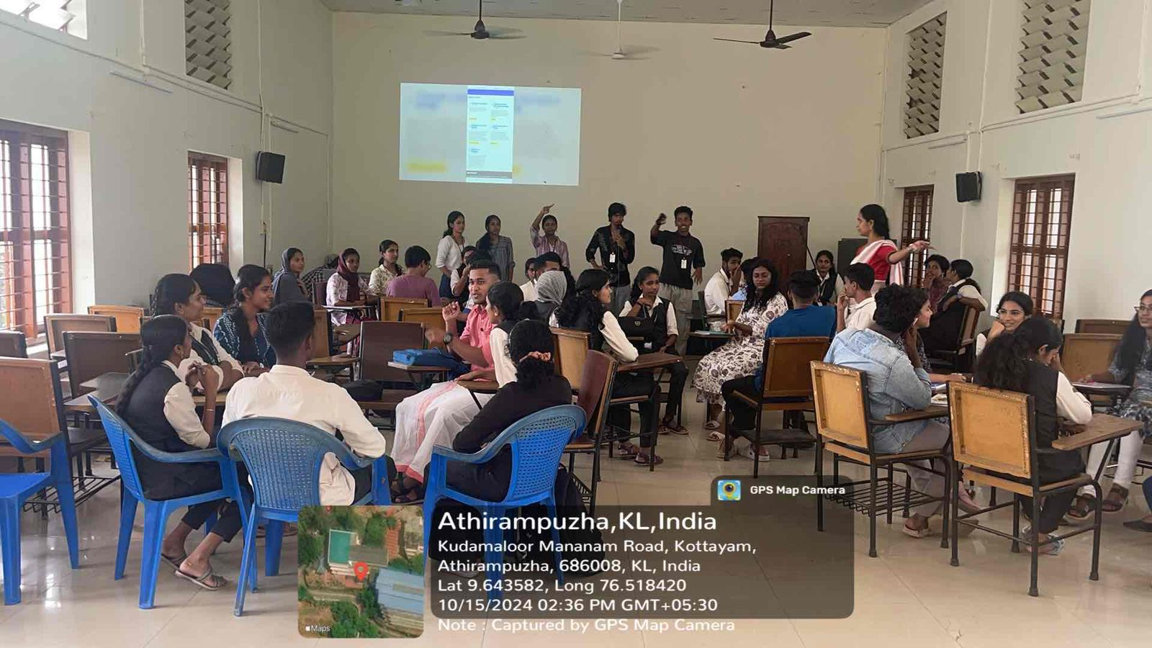
- Photograph of the event - Group Photo

- Other photographs if any
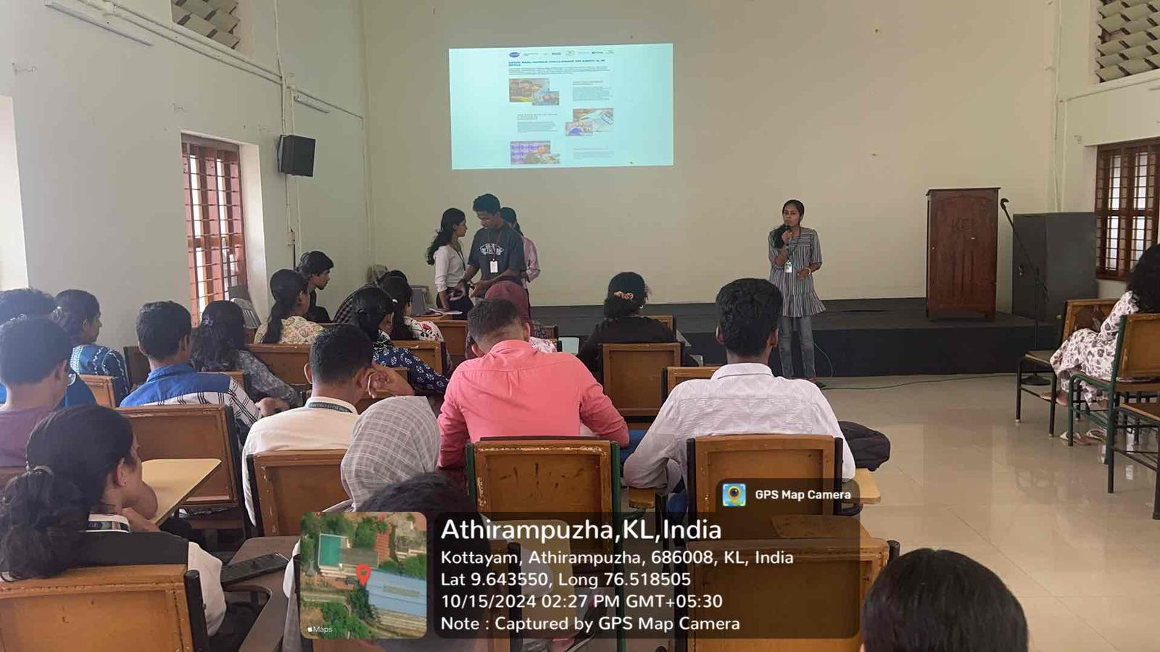
- Other Documents if any (Schedule, Resource Person Details, ..)
Aparna Thilakan- MSc.Physics, Baselius College
Gayathri Nair- MSc.Physics, Baselius College
Keerithika Rajagopal- MSc.Physics, Baselius College
Surya Kumar A- BSc.Physics, Baselius College
Aivin Jinu, - BSc.Physics, Baselius College
Nidarsh S- BSc.Physics, Baselius College

- Participant list in prescribed format

Innovation & Entrepreneurship Development Centre
An initiative of Kerala Startup Mission

- Name of Event | Building Intelligent Systems: Fundamentals of Machine Learning & Deep Learning
- Name of Institute | : Baselius College
- Name of Nodal Officer | : Dr Aparna Thankappan
- Email Address | : aparnathankappan@baselius.ac.in
- Contact Number | : 9747620918
- Event participant type | : participants only from the institution
- Total number of participants | : 19
- Total number of women participants | : 11
- Track of Event | Technology
- Event category | Technology - Boot Camp/Hands-On Workshop - AR/VR, Mobile/Web Development, Artificial Intelligence, Hardware, Other Future Technologies etc.
- Sector | AI, ML & IoT
- Date from | 15.10.24
- Date to | 19.10.24
- Total number of hours | 10
- Details of IEDCs Collaborated
- Details of Communities or Clubs collaborated with | IIC,ED,Placement cell, RINK
- Detailed report of the event (Min 200 words) | A five day workshop titled "Building Intelligent Systems: Fundamentals of Machine Learning & Deep Learning" was organized by IEDC, IIC, ED Club, Placement Cell, and RINK from October 15 to 19, 2024, at Baselius College. The sessions, led by Mr. Athul Gopalakrishnan, a freelance data analyst, provided an introductory yet comprehensive understanding of machine learning (ML) and deep learning (DL) principles. Nineteen students participated, gaining insights into the core concepts of artificial intelligence, including supervised and unsupervised learning, neural networks, and practical applications of ML and DL in building intelligent systems.  Mr. Gopalakrishnan’s interactive approach included hands-on coding exercises and real-world case studies, ensuring participants could connect theoretical knowledge with practical implementation. The workshop also explored the role of intelligent systems in modern industries, empowering students to envision innovative solutions leveraging ML and DL technologies. Feedback from attendees reflected their enthusiasm and appreciation for the resource person’s clarity and expertise. The program concluded with a Q&A session, fostering further curiosity and motivation to explore advanced topics in artificial intelligence.
- Creatives created for the event (Max 10nos)

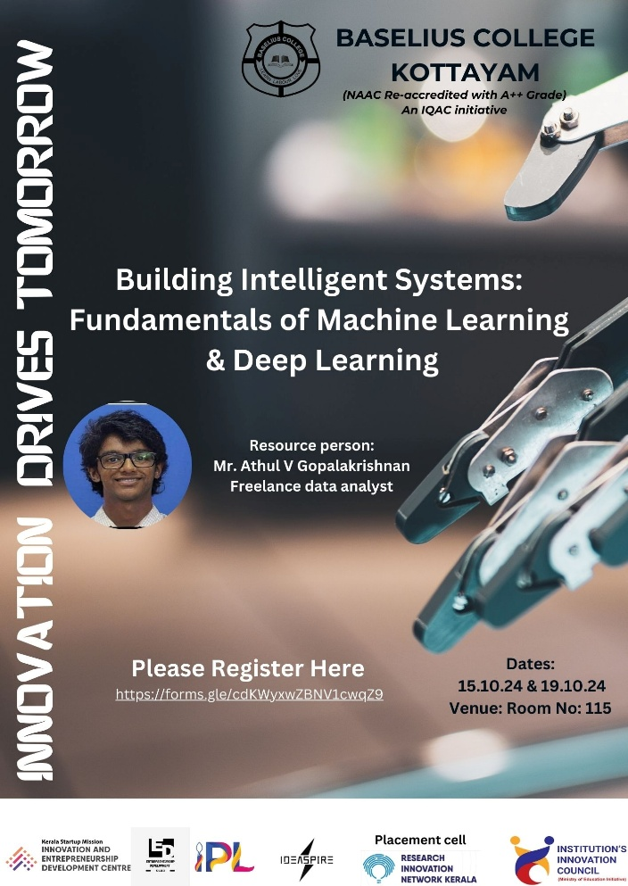
- Photograph of the event - Stage

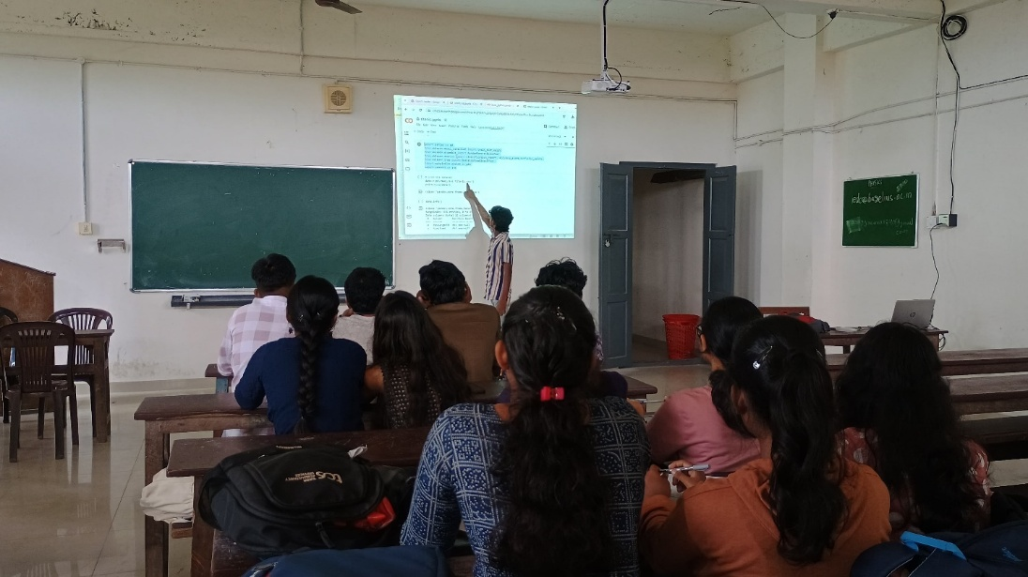

- Photograph of the event - Audience

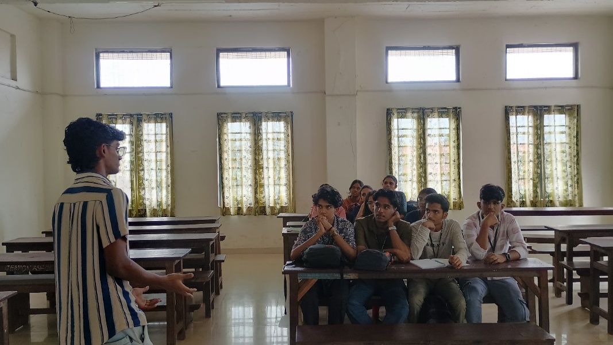

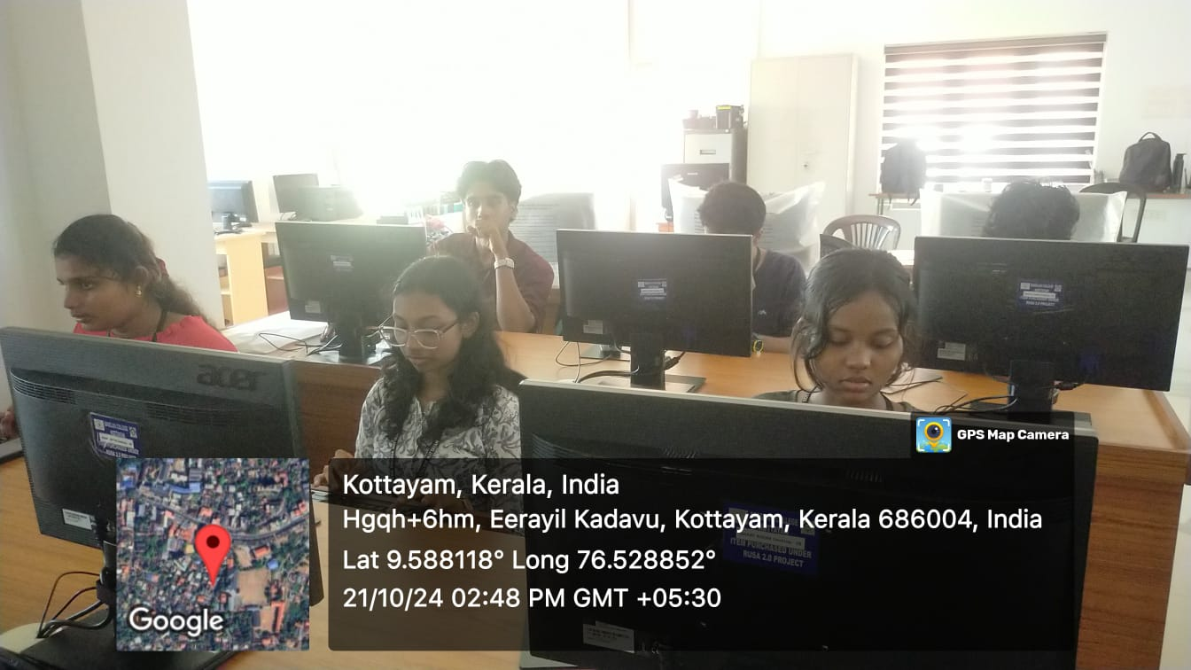
- Photograph of the event - Group Photo

- Other photographs if any

- Other Documents if any (Schedule, Resource Person Details, ..)

Mr. Athul V Gopalakrishnan
Freelance data analyst.

- Participant list in prescribed format
Innovation & Entrepreneurship Development Centre
An initiative of Kerala Startup Mission

- Name of Event | Idea to Impact: A Case Study Analysis
- Name of Institute | : Baselius College
- Name of Nodal Officer | : Dr Aparna Thankappan
- Email Address | : aparnathankappan@baselius.ac.in
- Contact Number | : 9747620918
- Event participant type | : participants only from the institution
- Total number of participants | : 77
- Total number of women participants | : 58
- Track of Event | entrepreneurship
- Event category | Entrepreneurship - Boot camps/Workshops - Business model Canvas Workshop, How to build a startup etc.
- Sector | Smart Cities & E-Governance
- Date from | 4.10.24
- Date to | 4.10.24
- Total number of hours
- Details of IEDCs Collaborated
- Details of Communities or Clubs collaborated with | IIC, ED, placement cell, RINK, BBA
- Detailed report of the event (Min 200 words) | A workshop titled "Idea to Impact: A Case Study Analysis" was conducted on 4.10.24 at Baselius College, organized by IEDC, IIC, ED Club, Placement Cell, and the Department of BBA. The session aimed to guide students in transforming innovative ideas into impactful solutions, focusing on real-world applications and entrepreneurial strategies. Dr. Resmi Annie Thomas, Assistant Professor in the Department of Commerce, served as the resource person, offering her expertise in business development and innovation. The event witnessed the enthusiastic participation of 77 students.  Dr. Resmi Annie Thomas shared detailed case studies that highlighted the journey from ideation to successful implementation, emphasizing problem-solving, market analysis, and value creation. The interactive nature of the session encouraged students to engage in discussions, share their perspectives, and explore pathways to bring their ideas to life. Participants found the workshop inspiring and relevant, equipping them with practical knowledge and tools to navigate their entrepreneurial aspirations. The event concluded with a vibrant Q&A session, leaving attendees motivated to pursue innovative projects and impactful ventures.
- Creatives created for the event (Max 10nos)

- Photograph of the event - Stage

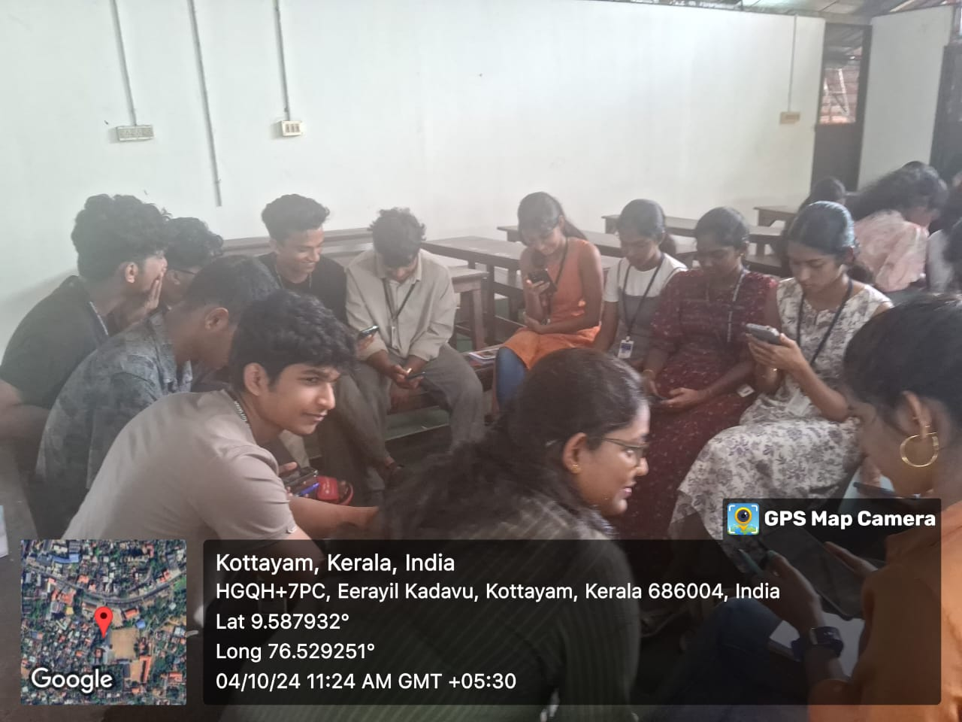
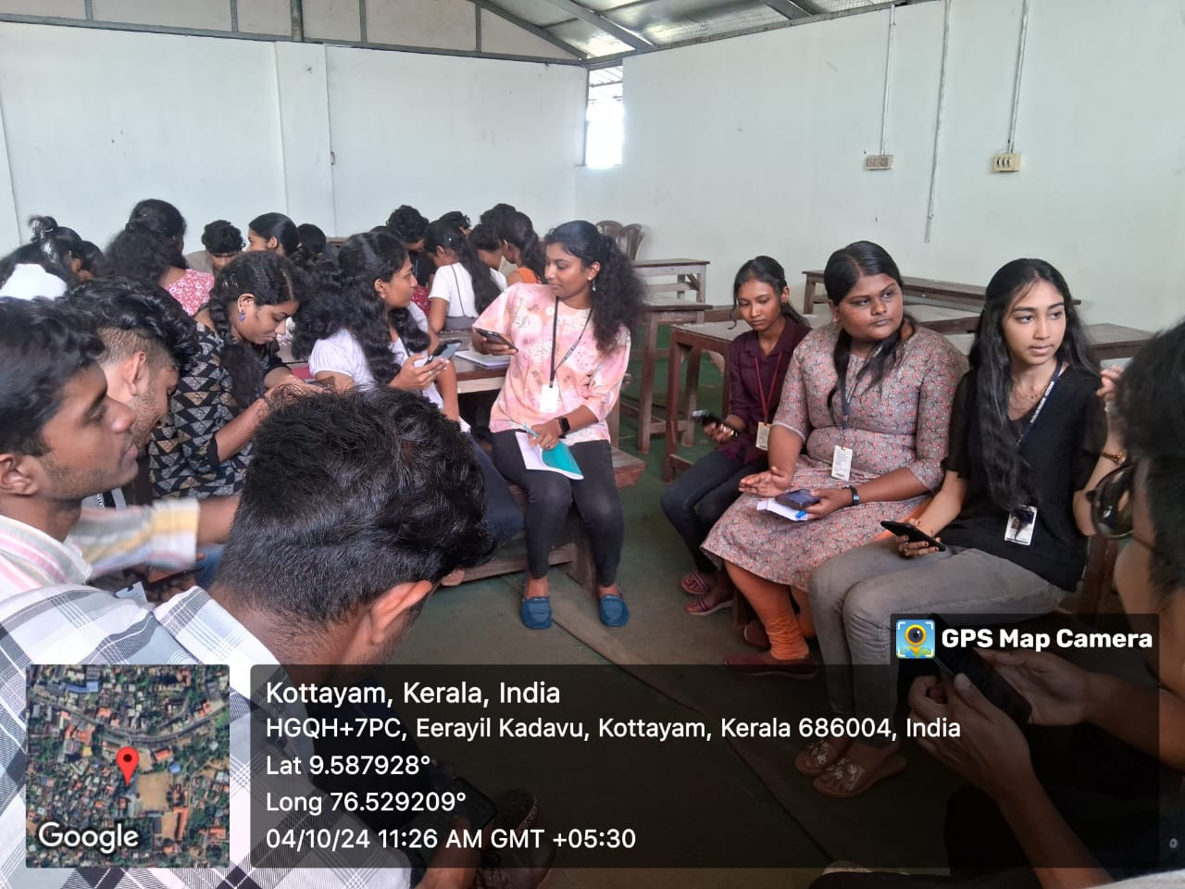
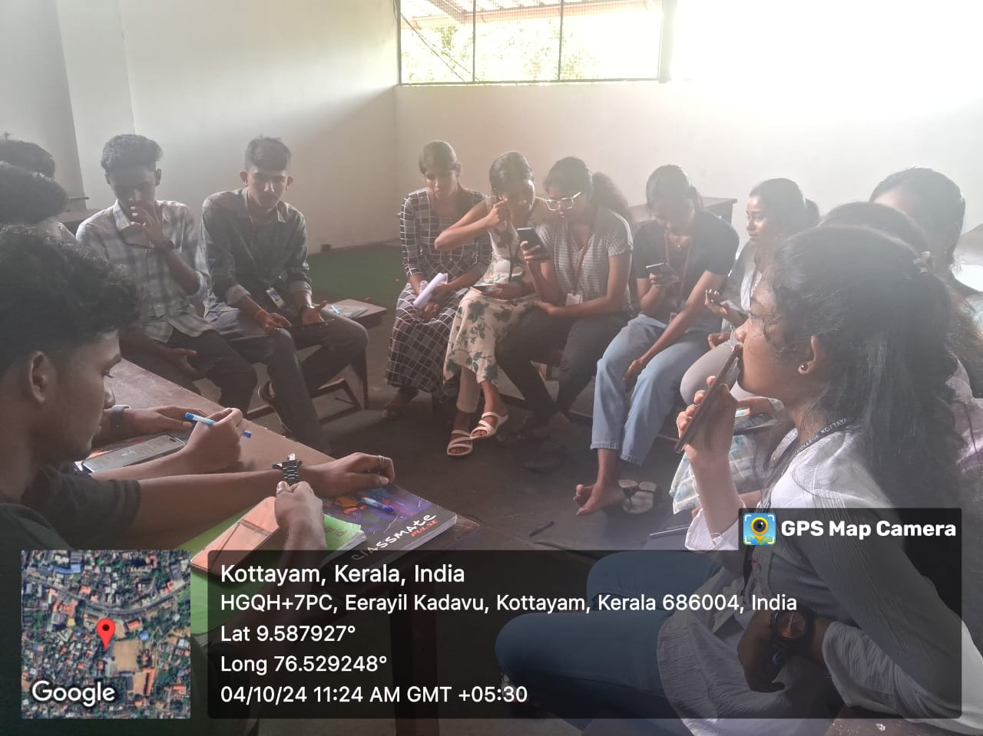
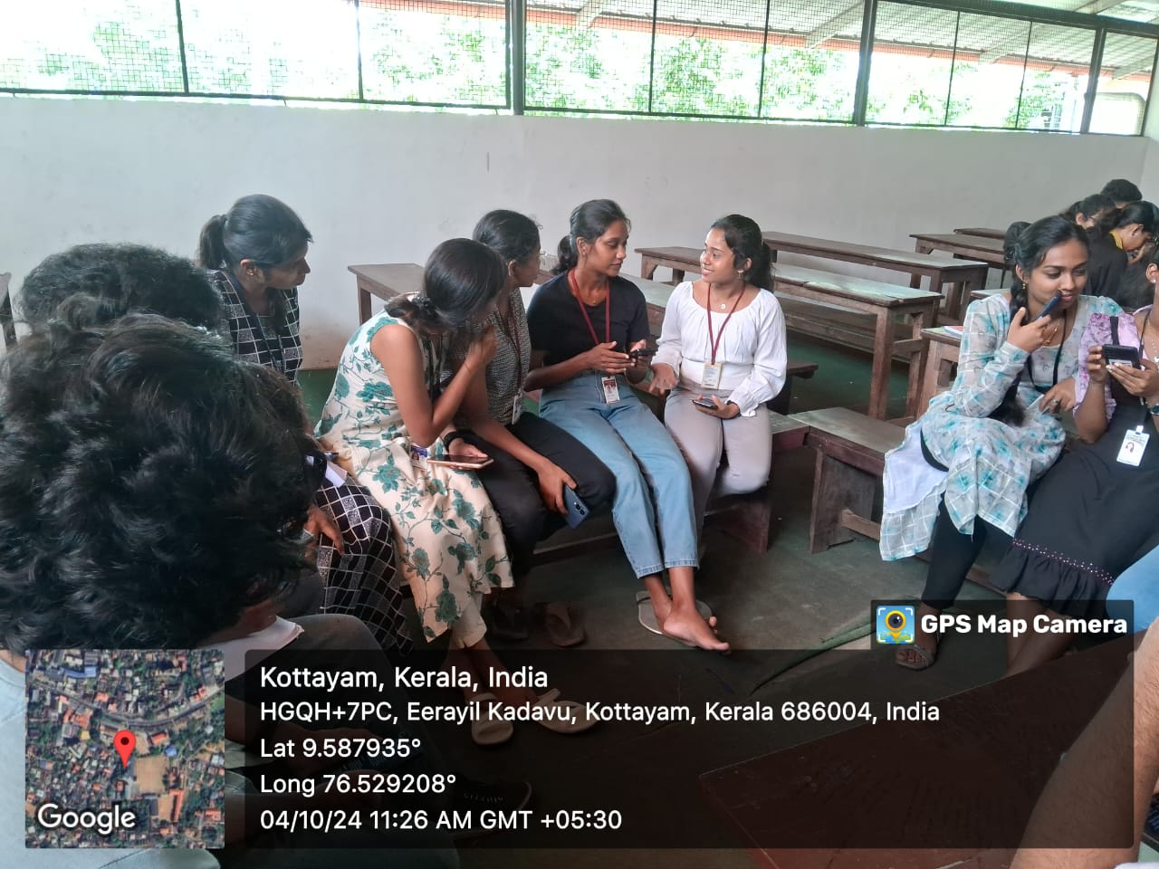

- Photograph of the event - Audience

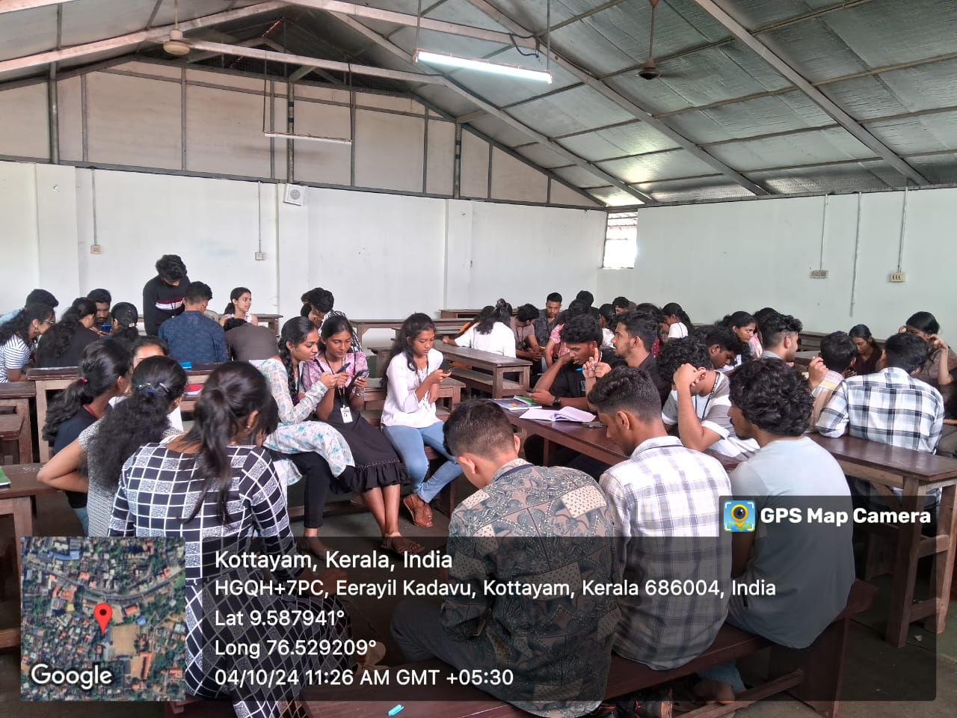
- Photograph of the event - Group Photo

- Other photographs if any
- Other Documents if any (Schedule, Resource Person Details, ..)

Participant list in prescribed format
Innovation & Entrepreneurship Development Centre
An initiative of Kerala Startup Mission

- Name of Event | Build and Innovate: Hands-on Electronics Workshop for school students-@ MD School ,Kottayam
- Name of Institute | : Baselius College
- Name of Nodal Officer | : Dr Aparna Thankappan
- Email Address | : aparnathankappan@baselius.ac.in
- Contact Number | : 9747620918
- Event participant type | : participants only from the institution
- Total number of participants | : 35
- Total number of women participants | : 35
- Track of Event | Technology
- Event category | Technology - Boot Camp/Hands-On Workshop - AR/VR, Mobile/Web Development, Artificial Intelligence, Hardware, Other Future Technologies etc.
- Sector | ClimateTech & Clean Energy
- Date from | 13.11.24
- Date to | 13.11.24
- Total number of hours | 2
- Details of IEDCs Collaborated | -
- Details of Communities or Clubs collaborated with | IIC, MD school , Kottayam
- Detailed report of the event (Min 200 words) | On November 13, 2024, IEDC Baselius College conducted an engaging hands-on electronics workshop for 7th-grade students at MD School, Kottayam. This workshop was specially designed to introduce young learners to the fundamentals of electronics, sparking curiosity and encouraging hands-on experimentation with basic electronic components. Thirty-five enthusiastic 7th-grade students participated, making it a memorable experience for everyone involved.  The workshop was led by a team from Baselius College, including Dr. Nibu A. George, Assistant Professor of Physics;; Dr. Aparna Thankappan, Assistant Professor of Physics; and Vivek K M and Arjun Haridas , M. Sc Students from the Department of Physics. Each contributed their expertise to create a rich learning experience, combining theoretical knowledge with practical application.  Following the lecture, students transitioned into the hands-on portion, where they worked on assembling simple circuits and creating LED bulbs. Each student was provided with a beginner’s kit containing batteries, wires, resistors, switches, and LED components. This collaborative initiative by IEDC Baselius College not only gave students hands-on experience but also fostered a lasting interest in STEM fields, inspiring them to explore more projects in the future.

- Creatives created for the event (Max 10nos)

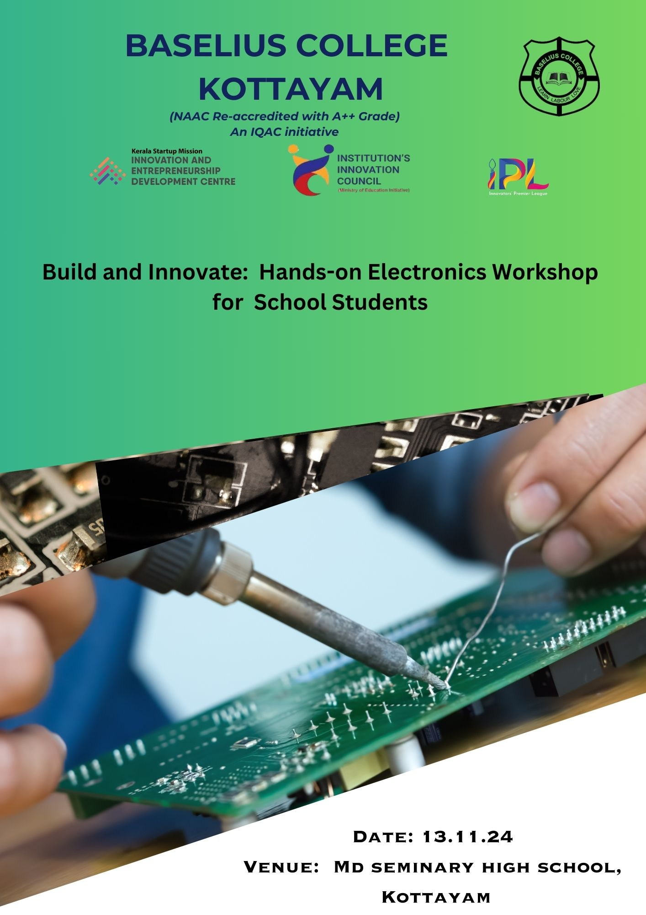
- Photograph of the event - Stage

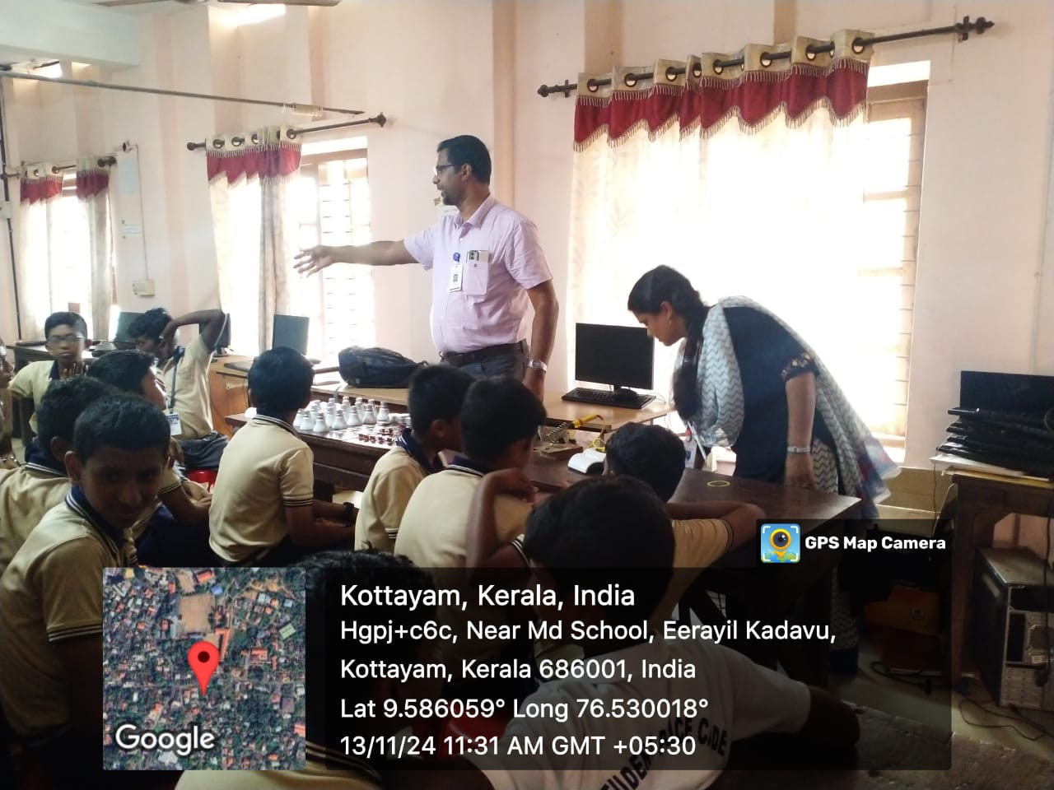

- Photograph of the event - Audience

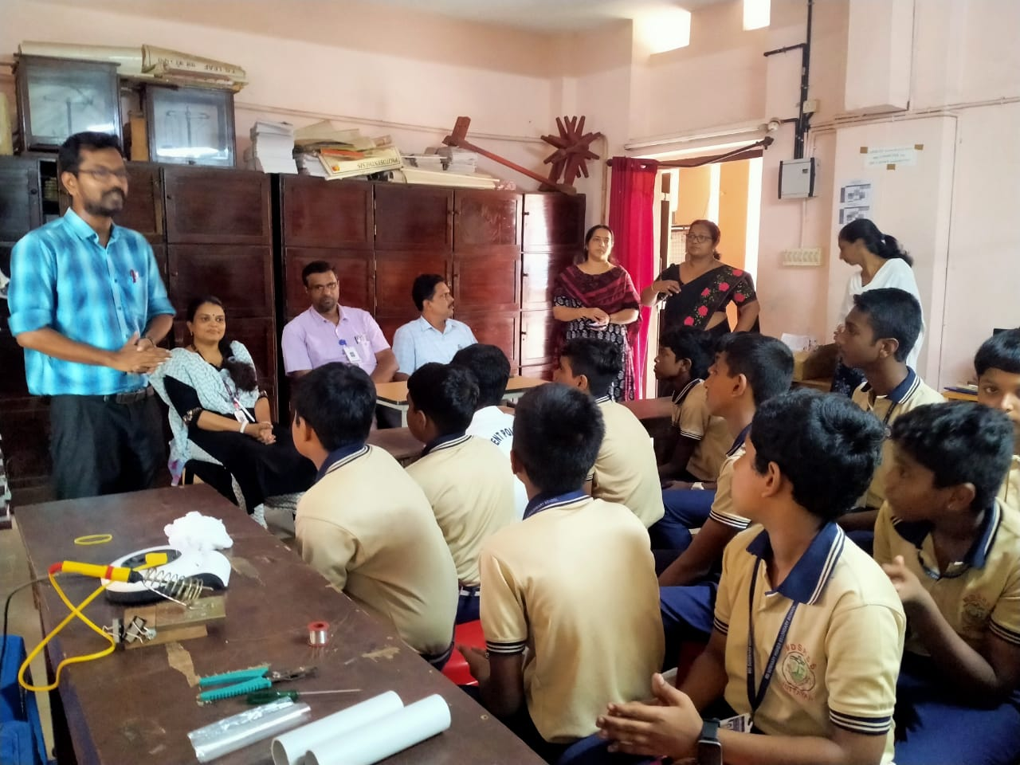

- Photograph of the event - Group Photo

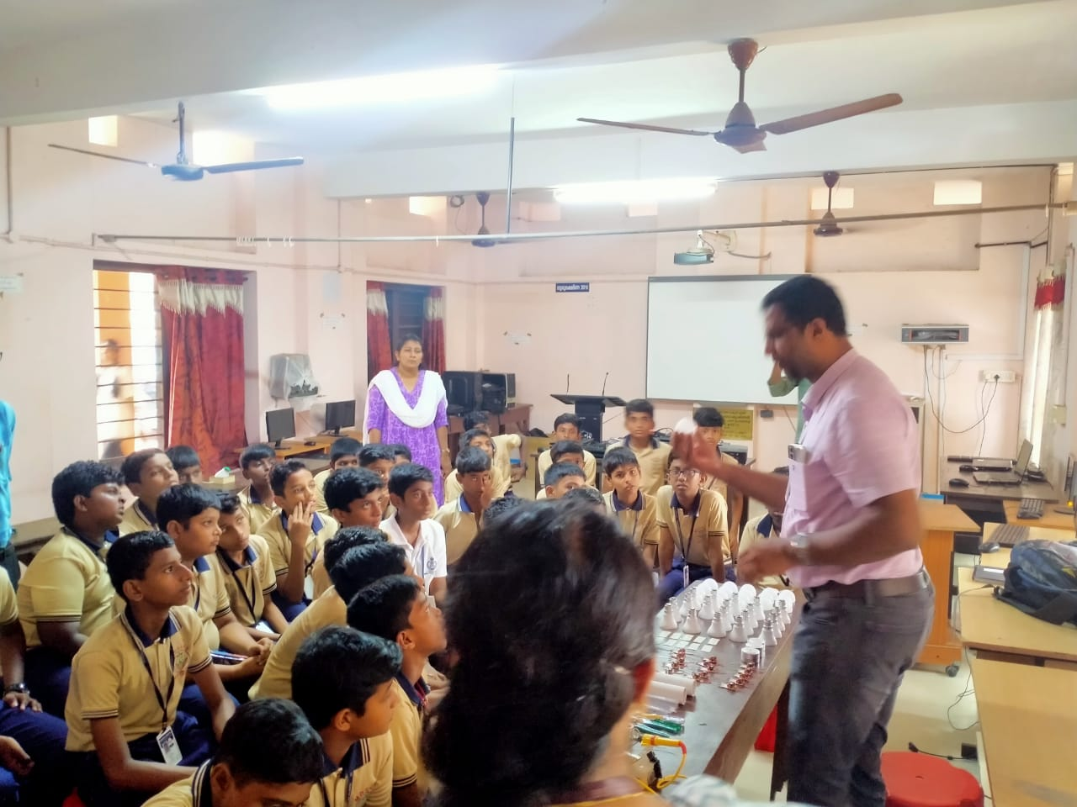
- Other photographs if any

- Other Documents if any (Schedule, Resource Person Details, ..)

Dr. Nibu A. George, Assistant Professor of Physics, Baselius College
Dr. Aparna Thankappan, Assistant Professor of Physics, Baselius College
Vivek K M. M.Sc Physics, Baselius College
Arjun Haridas, M.Sc Physics,Baselius College
- Participant list in prescribed format
Innovation & Entrepreneurship Development Centre
An initiative of Kerala Startup Mission

- Name of Event | Build and Innovate: Hands-on Electronics Workshop for school students-@ St Anne’s School ,Kottayam
- Name of Institute | : Baselius College
- Name of Nodal Officer | : Dr Aparna Thankappan
- Email Address | : aparnathankappan@baselius.ac.in
- Contact Number | : 9747620918
- Event participant type | : participants only from the institution
- Total number of participants | : 65
- Total number of women participants | : 65
- Track of Event | Technology
- Event category | Technology - Boot Camp/Hands-On Workshop - AR/VR, Mobile/Web Development, Artificial Intelligence, Hardware, Other Future Technologies etc.
- Sector | ClimateTech & Clean Energy
- Date from | 8.11.24
- Date to | 8.11.24
- Total number of hours | 2
- Details of IEDCs Collaborated | -
- Details of Communities or Clubs collaborated with | IIC, St Anne’s H S school , Kottayam
- Detailed report of the event (Min 200 words) | On November 8, 2024, IEDC Baselius College conducted an engaging hands-on electronics workshop for 7th-grade students at St. Anne's Girls High School, Kottayam. This workshop was specially designed to introduce young learners to the fundamentals of electronics, sparking curiosity and encouraging hands-on experimentation with basic electronic components. Sixty-five enthusiastic 7th-grade students participated, making it a memorable experience for everyone involved.  The workshop was led by a team from Baselius College, including Dr. Nibu A. George, Assistant Professor of Physics; Nibu B. Thomas, Assistant Professor of Electronics; Dr. Aparna Thankappan, Assistant Professor of Physics; and Ms. Lakshmi P. Kumar, a research scholar from the Department of Physics. Each contributed their expertise to create a rich learning experience, combining theoretical knowledge with practical application.  Following the lecture, students transitioned into the hands-on portion, where they worked on assembling simple circuits and creating LED bulbs. Each student was provided with a beginner’s kit containing batteries, wires, resistors, switches, and LED components. This collaborative initiative by IEDC Baselius College not only gave students hands-on experience but also fostered a lasting interest in STEM fields, inspiring them to explore more projects in the future.
- Creatives created for the event (Max 10nos)

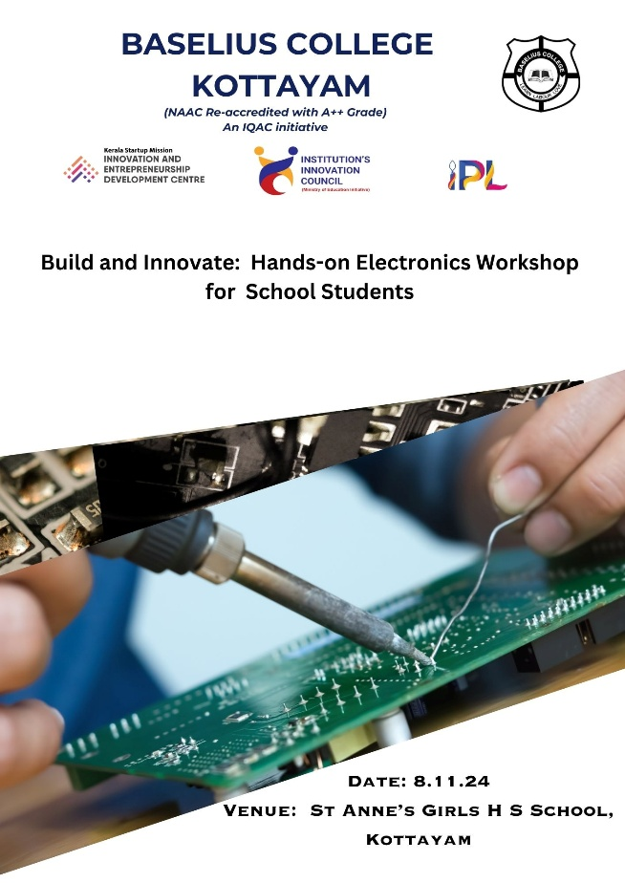
- Photograph of the event - Stage

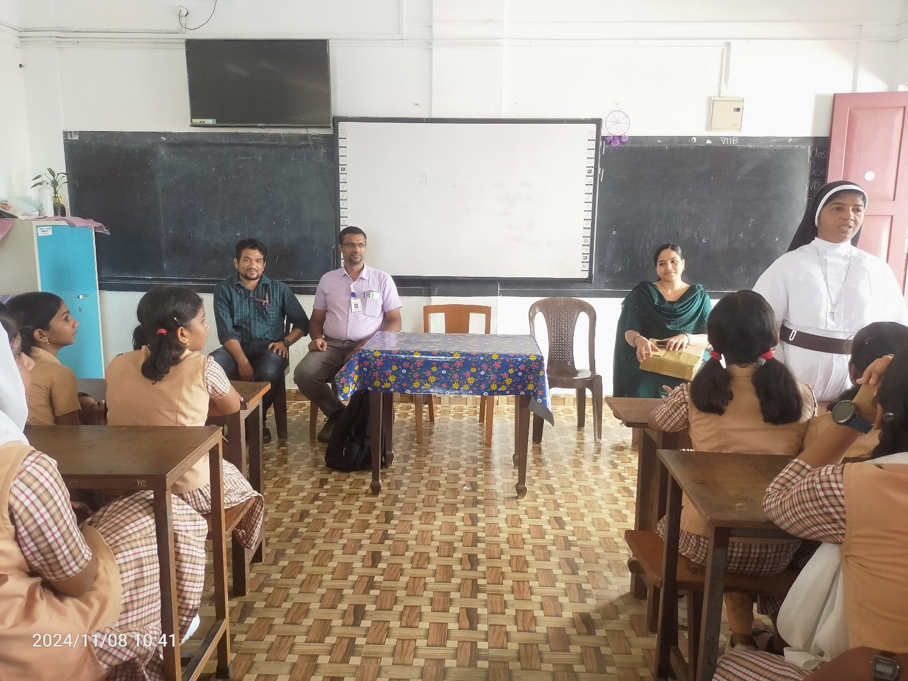

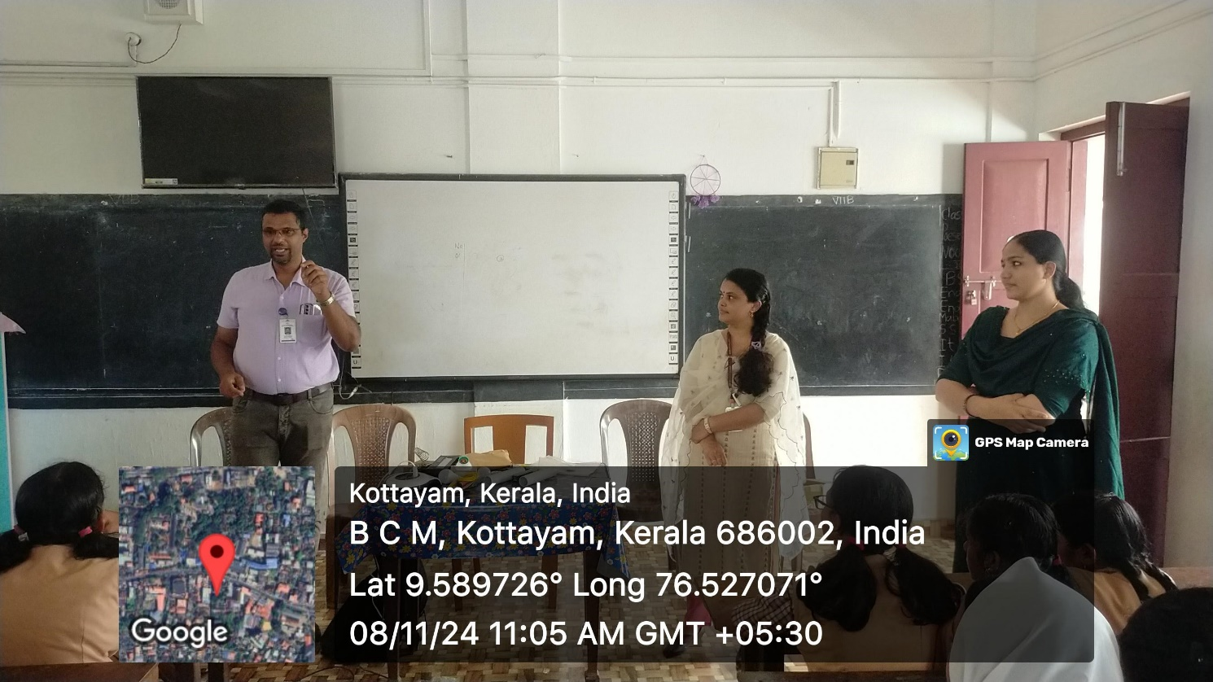

- Photograph of the event - Audience
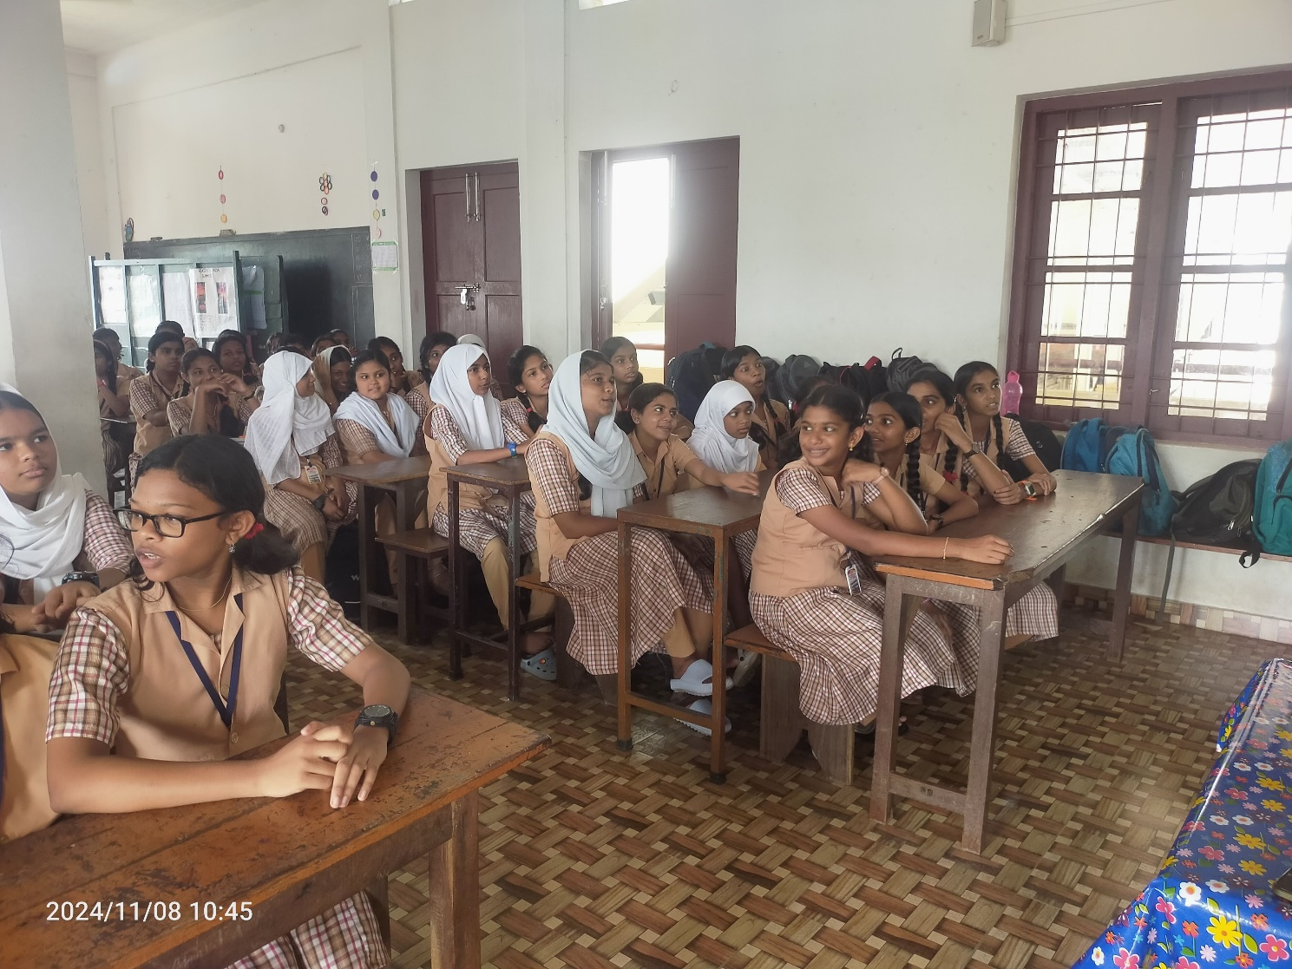
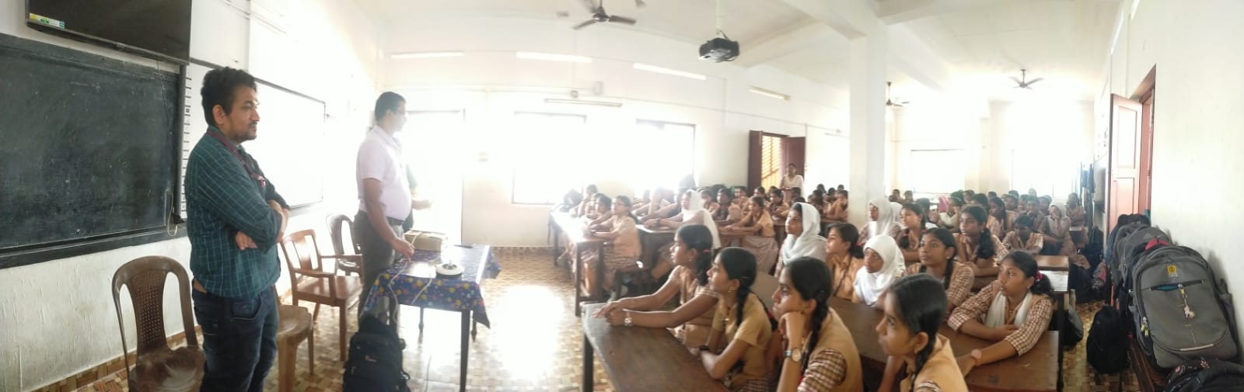

- Photograph of the event - Group Photo

- Other photographs if any
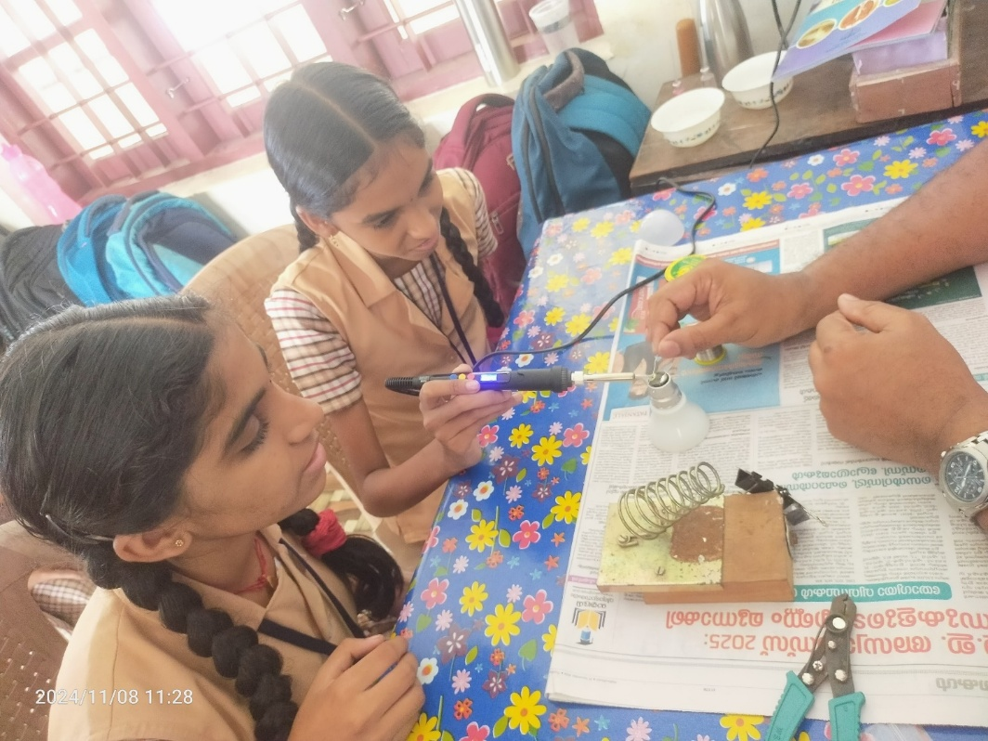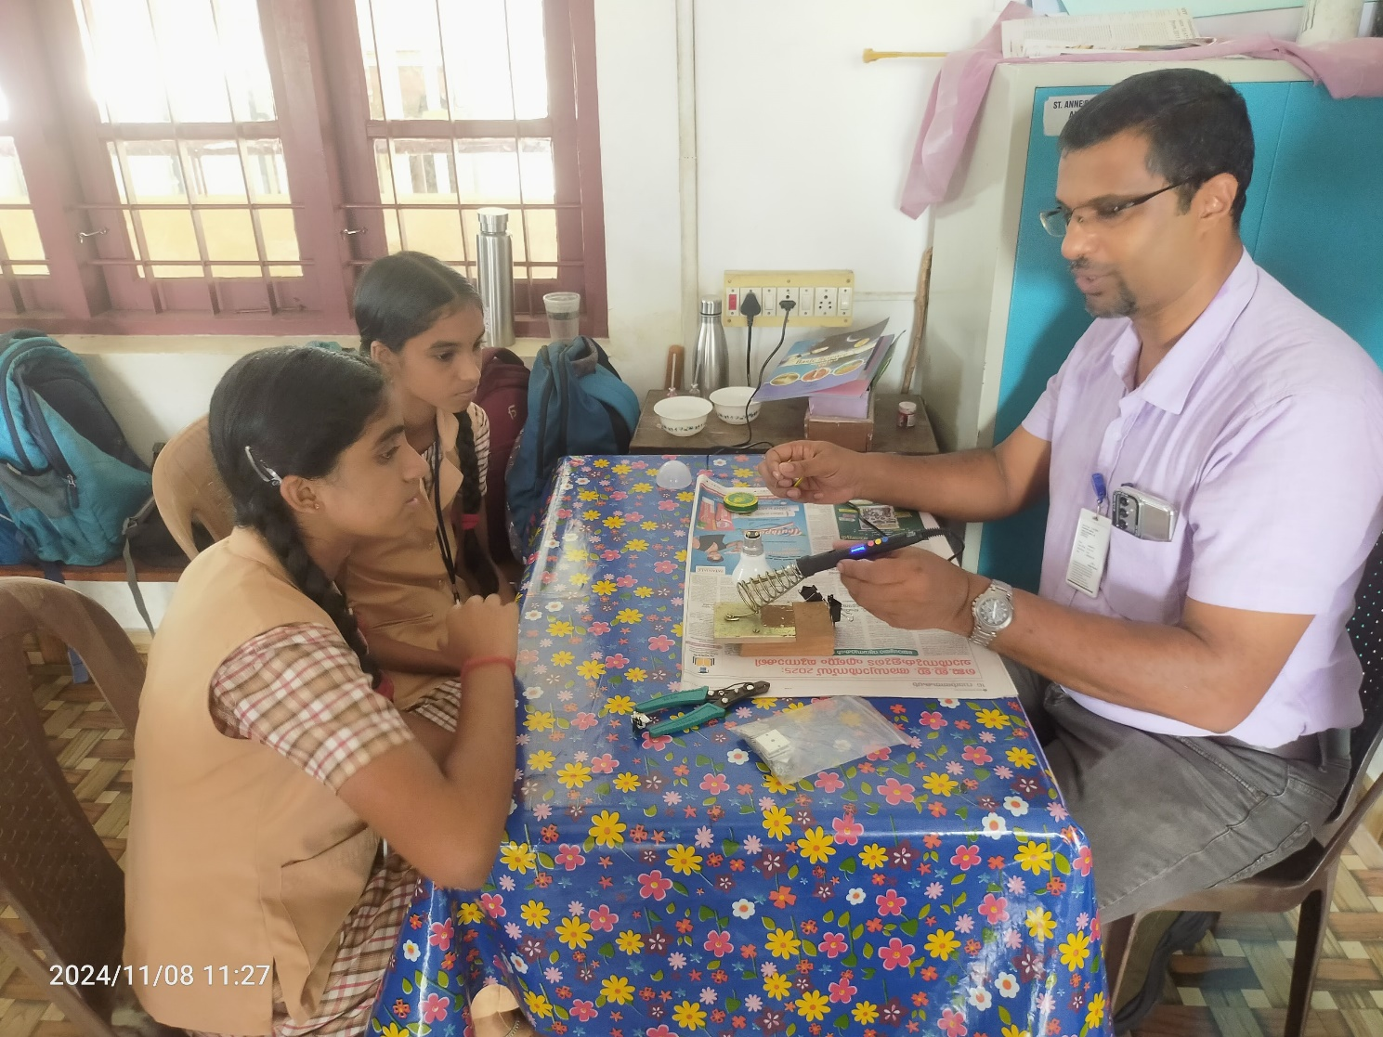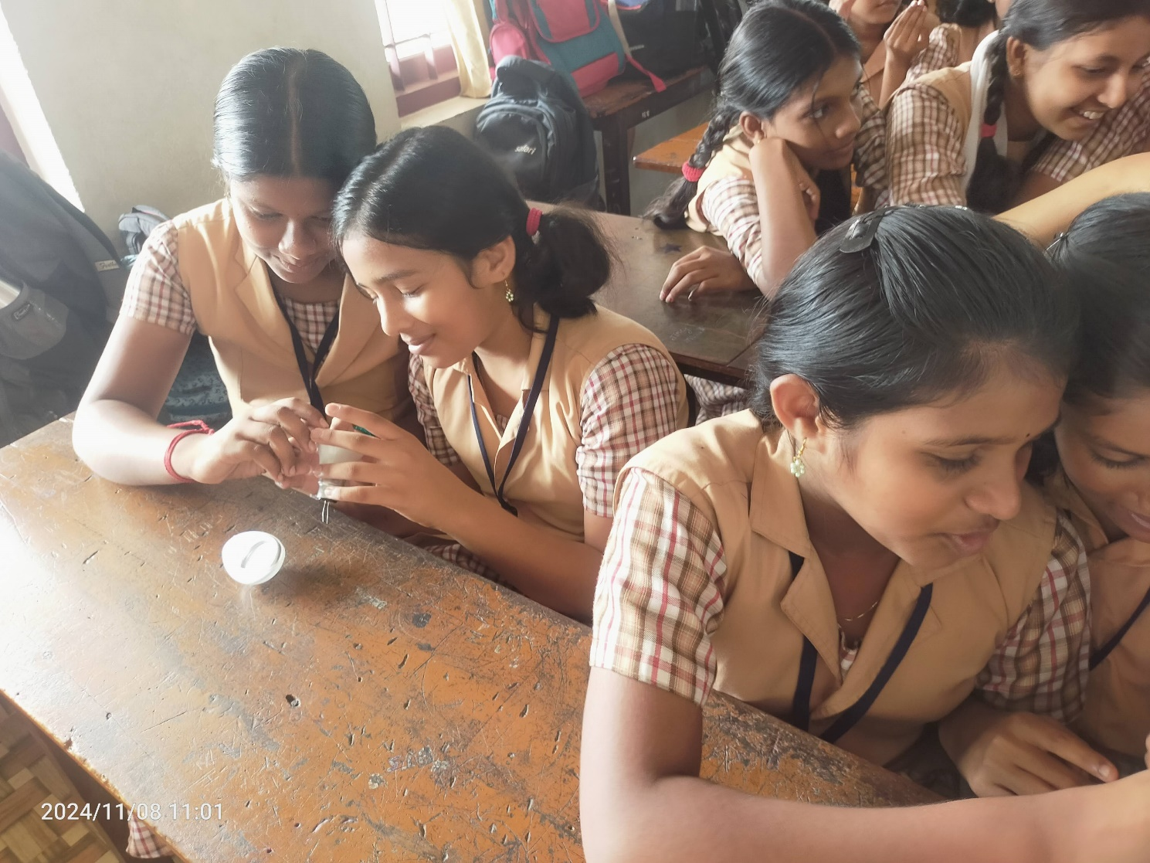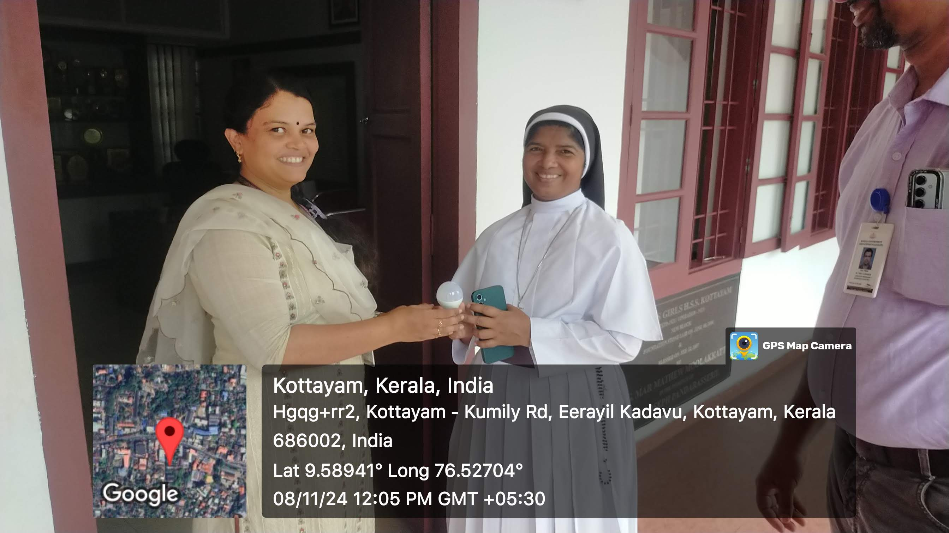
- Other Documents if any (Schedule, Resource Person Details, ..)

Dr. Nibu A. George, Assistant Professor of Physics, Baselius College
Nibu B. Thomas, Assistant Professor of Electronics, Baselius College
Dr. Aparna Thankappan, Assistant Professor of Physics, Baselius College
Ms. Lakashmi P Kumar, Research scholar, Department of physics, Baselius college

Innovation & Entrepreneurship Development Centre
An initiative of Kerala Startup Mission

- Name of Event | One-Day Workshop on Apiculture and Paper Bag Making
- Name of Institute | : Baselius College
- Name of Nodal Officer | : Dr Aparna Thankappan
- Email Address | : aparnathankappan@baselius.ac.in
- Contact Number | : 9747620918
- Event participant type | : participants only from the institution
- Total number of participants | :
- Total number of women participants | :
- Track of Event | Entrepreneurship
- Event category | Entrepreneurship - Boot camps/Workshops - Business model Canvas Workshop, How to build a startup etc.
- Sector
- Date from | 28.1.25
- Date to | 28.1.25
- Total number of hours | 5
- Details of IEDCs Collaborated | Nil
- Details of Communities or Clubs collaborated with | IIC,IEDC
- Detailed report of the event (Min 200 words) | Objective  - The workshop aimed to educate students on the fundamentals of apiculture and paper bag making, highlighting their economic and environmental significance while providing hands-on training to enhance skill development.  Outcome  - Participants gained practical knowledge in beekeeping and paper bag production, equipping them with entrepreneurial insights and sustainable practices that could be implemented for self-employment or community-based projects.  The Department of Zoology, Baselius College, Kottayam, in association with IQAC, IIC, and IEDC, organized a one-day workshop on apiculture and paper bag making on January 28, 2025. The event was conducted in collaboration with the Kerala Khadi and Village Industries Commission (Khadi Gramodyog Vidyalaya, Mallappally) to promote skill-based learning among students. The workshop featured two resource persons: Mr. James Dominic, a retired Beekeeping Fieldman and former Principal of KGV Mallappally, and Smt. Usha Jose, Senior Technical Instructor at KGV Mallappally. Their expertise provided participants with both theoretical and practical insights into these sustainable practices.  The session on apiculture covered the importance of beekeeping in biodiversity conservation, hive management techniques, honey extraction processes, and the economic potential of apiculture. Mr. James Dominic explained the life cycle of bees, colony maintenance, and the challenges faced by beekeepers. Students actively engaged in demonstrations, learning how to handle bee colonies and extract honey safely. The second session on paper bag making was led by Smt. Usha Jose, who emphasized the need to reduce plastic waste and adopt eco-friendly alternatives. She demonstrated various paper bag designs, folding techniques, and methods to enhance durability. Participants were encouraged to create their own paper bags, which provided them with hands-on experience and an understanding of the market potential for handmade paper products.
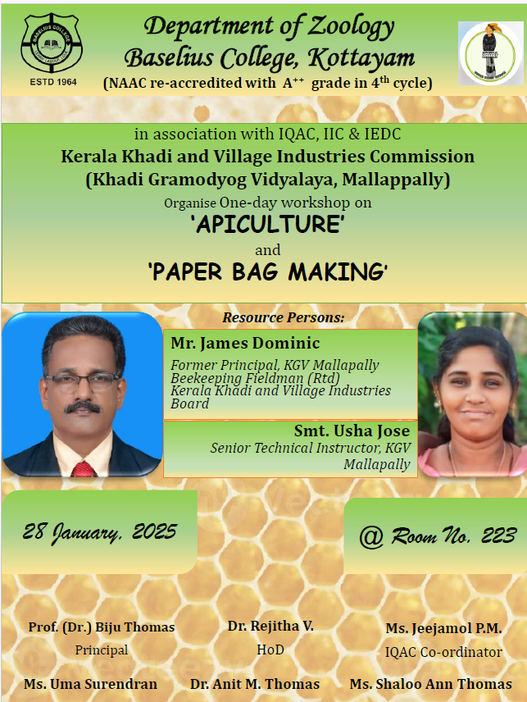
- Creatives created for the event (Max 10nos)

- Photograph of the event - Stage

- Photograph of the event - Audience

- Photograph of the event - Group Photo

- Other photographs if any
- Other Documents if any (Schedule, Resource Person Details, ..)
Mr. James Dominic, a retired Beekeeping Fieldman and former Principal of KGV Mallappally, and Smt. Usha Jose, Senior Technical Instructor at KGV Mallappally

Participant list in prescribed format
Innovation & Entrepreneurship Development Centre
An initiative of Kerala Startup Mission

- Name of Event | Skill Development Workshop on Cosmetics and Homecare Products Manufacturing
- Name of Institute | : Baselius College
- Name of Nodal Officer | : Dr Aparna Thankappan
- Email Address | : aparnathankappan@baselius.ac.in
- Contact Number | : 9747620918
- Event participant type | : participants only from the institution
- Total number of participants | :
- Total number of women participants | :
- Track of Event | Entrepreneurship
- Event category | Entrepreneurship - Boot camps/Workshops - Business model Canvas Workshop, How to build a startup etc.
- Sector | Healthcare & Life Sciences
- Date from | 28.1.25
- Date to | 28.1.25
- Total number of hours
- Details of IEDCs Collaborated
- Details of Communities or Clubs collaborated with
- Detailed report of the event (Min 200 words) | - Objective: To equip participants with practical skills in manufacturing cosmetics and homecare products, fostering entrepreneurship and innovation.  - Outcome: Participants will gain hands-on experience in product formulation, enhancing their ability to create market-ready homecare and cosmetic products.  The Department of Chemistry and Centre for Research at Baselius College, Kottayam, organized a Skill Development Workshop on Cosmetics and Homecare Products Manufacturing on January 28, 2025. The workshop was conducted as part of an IQAC initiative in collaboration with the Institution’s Innovation Council, Innovation and Entrepreneurship Development Centre, and Entrepreneurship Development Cell. Sri. Sreejith V.S., Director of the Science Centre, Kodungallur, served as the resource person for the session. The event aimed to provide students with hands-on training in the formulation and production of everyday consumer products. Participants were introduced to the fundamental principles of cosmetic chemistry and homecare product development. The session included demonstrations on preparing items such as soaps, detergents, and skincare products using safe 44  and sustainable ingredients.  Sri. Sreejith V.S. elaborated on the importance of quality control, regulatory standards, and market feasibility in product manufacturing. Students were encouraged to explore entrepreneurship opportunities by developing their own product lines. The workshop provided insights into cost-effective methods for small-scale production and the potential for commercialization. Participants actively engaged in discussions and practical exercises to understand ingredient interactions and formulation techniques. The event also emphasized the significance of innovation in product development to meet consumer demands. Feedback from attendees indicated a high level of satisfaction, with many expressing interest in further training on advanced formulations. The organizers ensured that the workshop was interactive and informative, catering to both beginners and those with prior knowledge of chemistry. By the end of the session, students had developed a deeper understanding of product formulation, fostering confidence in their ability to create homecare and cosmetic products. The workshop successfully bridged the gap between theoretical knowledge and practical application, aligning with the institution’s goal of promoting skill-based education

- Creatives created for the event (Max 10nos)

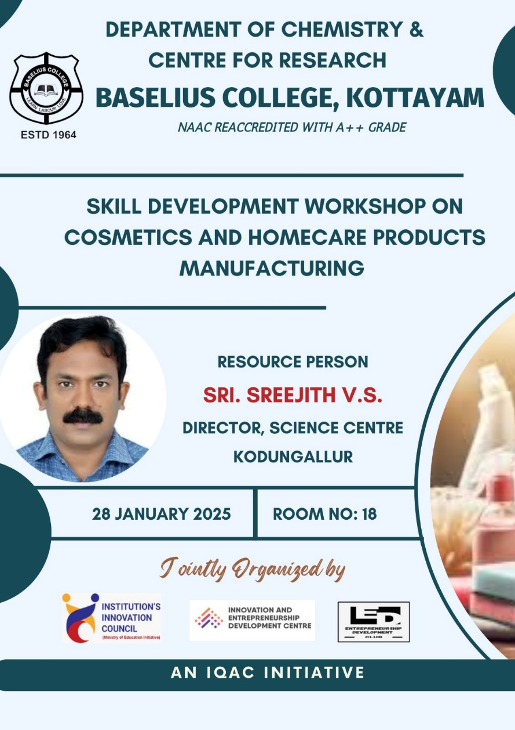

- Photograph of the event - Stage

- Photograph of the event - Audience

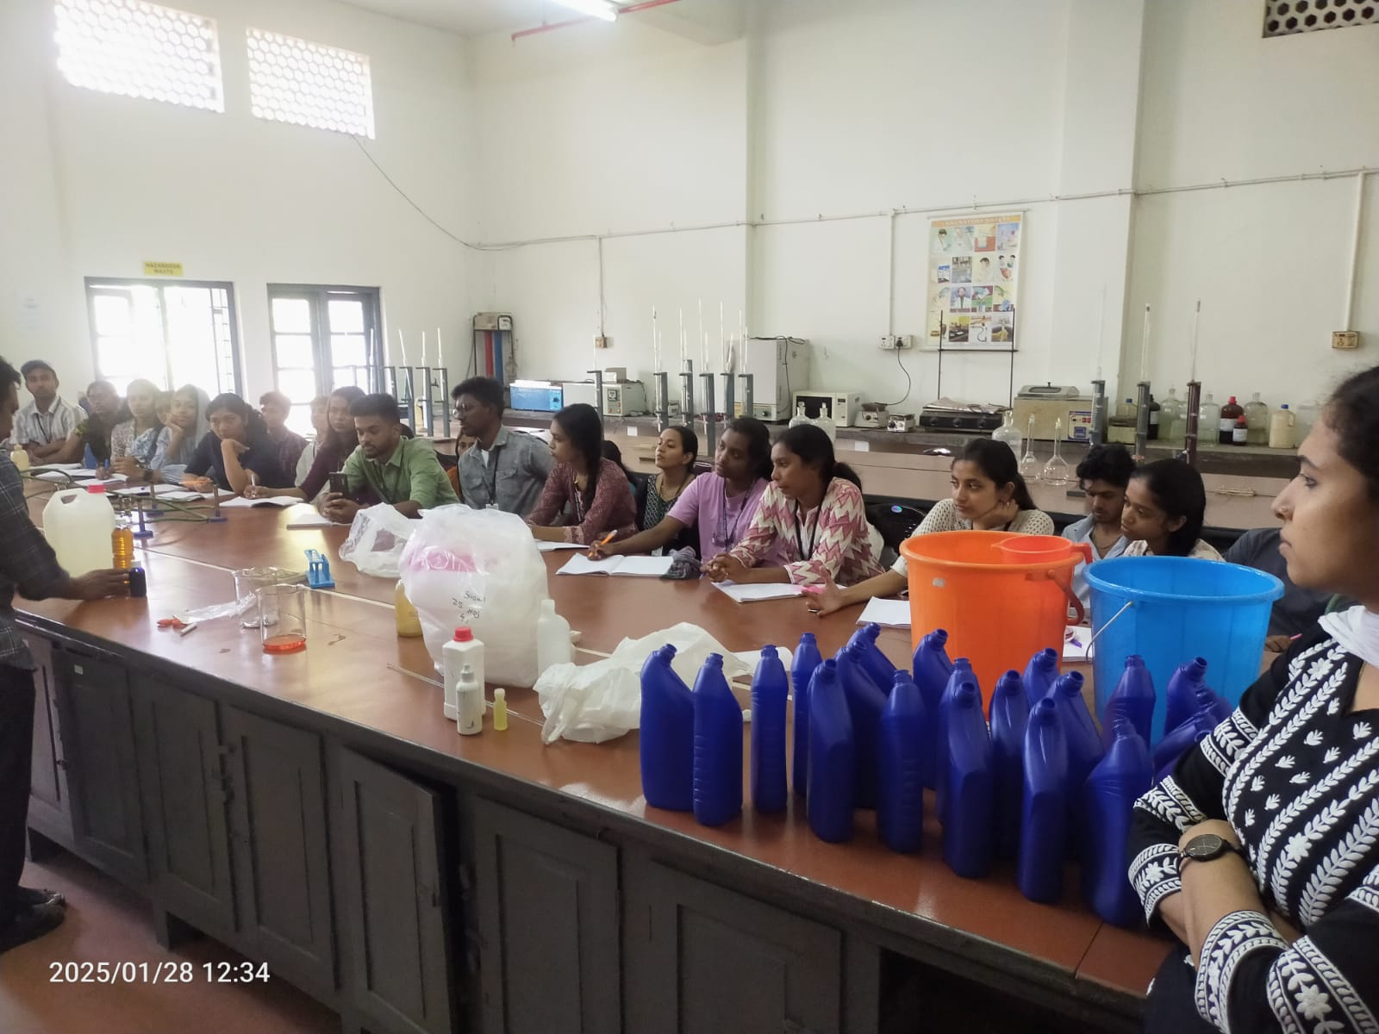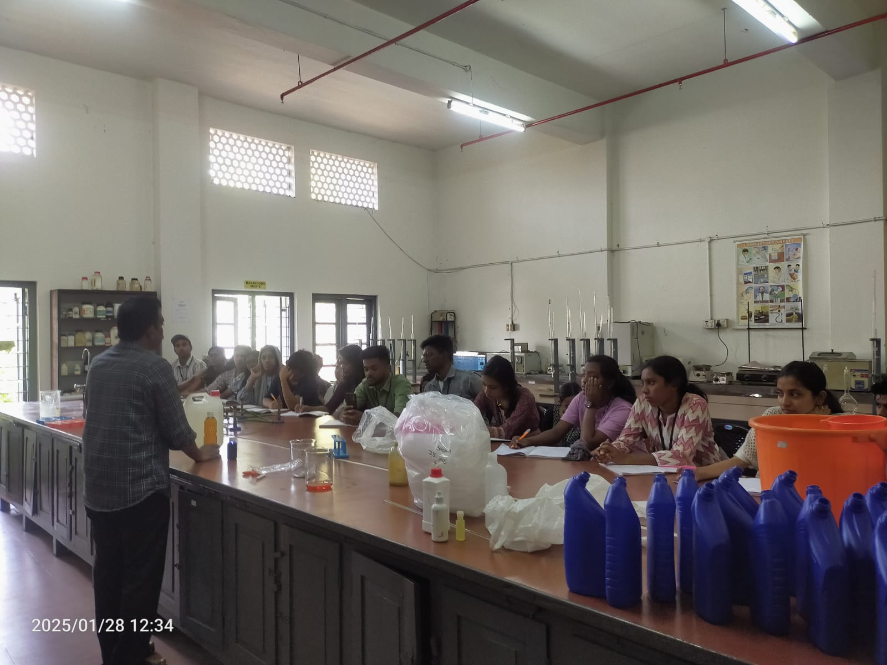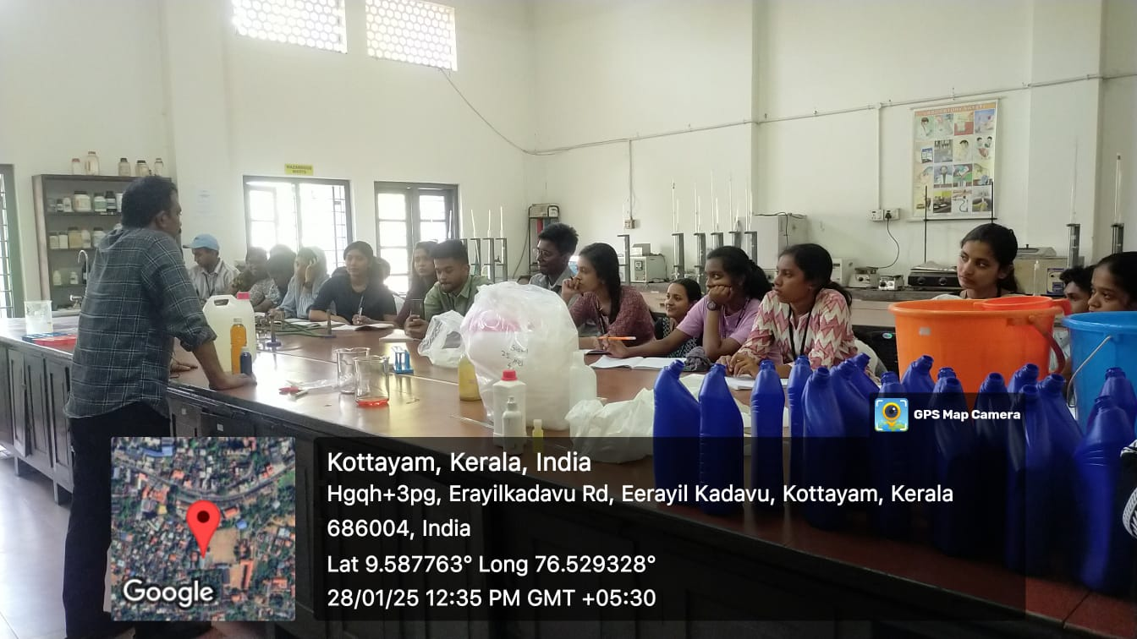
- Photograph of the event - Group Photo

- Other photographs if any
- Other Documents if any (Schedule, Resource Person Details, ..)

Sri. Sreejith V.S., Director of the Science Centre, Kodungallur

Innovation & Entrepreneurship Development Centre
An initiative of Kerala Startup Mission

- Name of Event | Inside a film
- Name of Institute | : Baselius College
- Name of Nodal Officer | : Dr Aparna Thankappan
- Email Address | : aparnathankappan@baselius.ac.in
- Contact Number | : 9747620918
- Event participant type | : participants only from the institution
- Total number of participants | :
- Total number of women participants | :
- Track of Event | Technology
- Event category | Other technology related events
- Sector | Media & Entertainment
- Date from | 11.2.25
- Date to | 11.2.25
- Total number of hours | 1.30
- Details of IEDCs Collaborated
- Details of Communities or Clubs collaborated with | IIC,ED. Department of BBA
- Detailed report of the event (Min 200 words) | The event "Inside A Film" was organized by IDEASPIRE at Baselius College, Kottayam. It was conducted on February 11, 2025, from 2:15 PM to 3:15 PM in Room No. 307. The session was led by Robin Dev from D2 Physics, along with team members Anandhu Krishnan N S, Bedhovan P Binumon, Abhi Krishna, Kochumon, and Aswini Krishna S. The program was jointly organized by the Department of BBA, the Entrepreneurship Development Club, the Institution’s Innovation Council, and the Innovation and Entrepreneurship Development Centre. The event aimed to educate students about the different stages of filmmaking. The session began with an introduction to scriptwriting, where participants learned how to structure a compelling narrative. It then covered cinematography techniques, explaining camera angles, lighting, and framing. Editing was discussed in detail, focusing on how transitions and effects enhance storytelling. The role of sound design and background scores in evoking emotions was also explored. Participants engaged in an interactive discussion, sharing their thoughts on famous films and their techniques. The event concluded with a short analysis of a popular movie scene, breaking down its technical aspects. The session provided a new perspective on the art and science of filmmaking. It successfully sparked interest among students in exploring the field further. Overall, it was an informative and engaging session, benefiting all attendees.
- Creatives created for the event (Max 10nos)
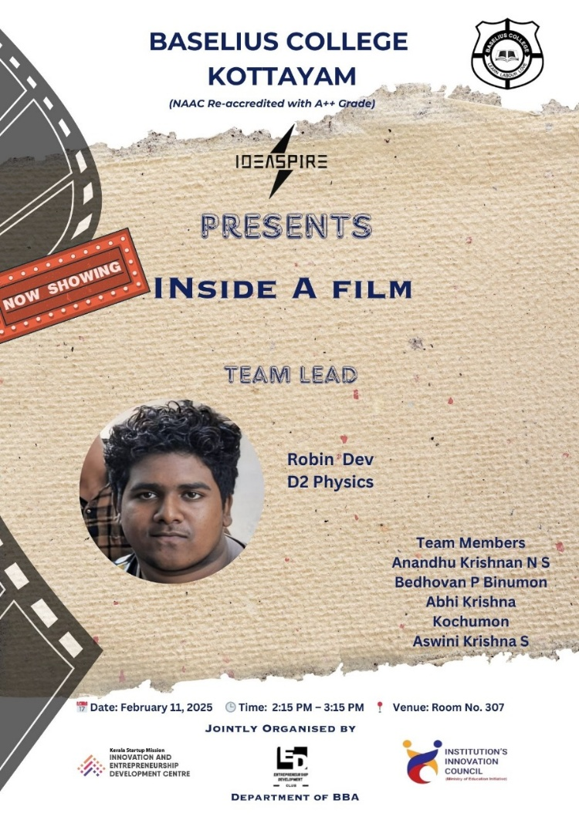

- Photograph of the event - Stage

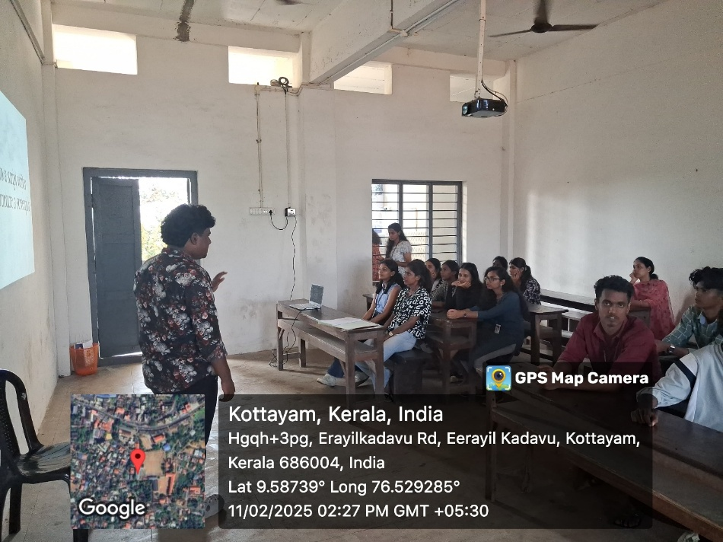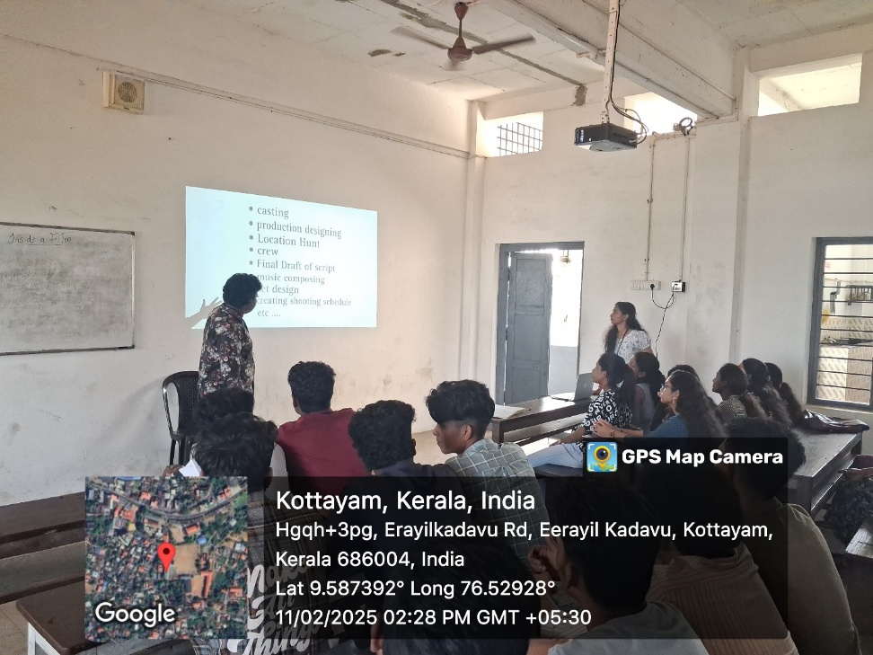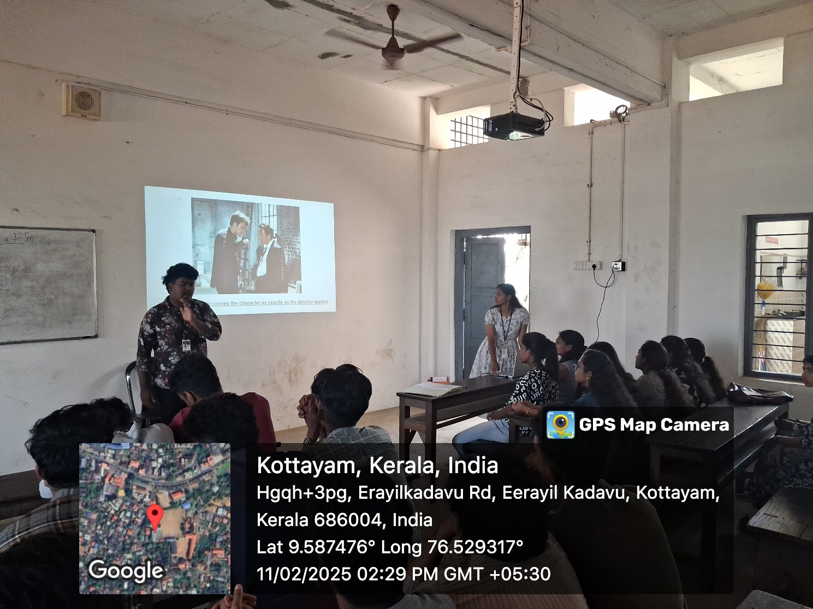

- Photograph of the event - Audience

- Photograph of the event - Group Photo

- Other photographs if any
- Other Documents if any (Schedule, Resource Person Details, ..)
Robin Dev from D2 Physics

- Participant list in prescribed format
Innovation & Entrepreneurship Development Centre
An initiative of Kerala Startup Mission

- Name of Event | Youth Ideathon in agriculture sector
- Name of Institute | : Baselius College
- Name of Nodal Officer | : Dr Aparna Thankappan
- Email Address | : aparnathankappan@baselius.ac.in
- Contact Number | : 9747620918
- Event participant type | : participants only from the institution
- Total number of participants | : 20
- Total number of women participants | : 11
- Track of Event | Innovation
- Event category | Innovation - Workshops - Innovation Orientation, Ideation etc.
- Sector | Agriculture & FoodTech
- Date from | 10.12.24
- Date to | 10.12.24
- Total number of hours | 2
- Details of IEDCs Collaborated | Nil
- Details of Communities or Clubs collaborated with | IIC
- Detailed report of the event (Min 200 words) | Baselius College Innovation and Entrepreneurship Development Centre (IEDC), in association with the Institution's Innovation Council (IIC), successfully organized a Youth Ideathon focused on the agriculture sector on 10th December 2024. The event aimed to inspire innovative thinking among young minds and encourage sustainable and tech-driven solutions in agriculture.  A total of 20 students enthusiastically participated in the ideathon, showcasing a variety of innovative ideas addressing key issues in agriculture such as irrigation, crop monitoring, smart farming, and sustainable practices. The event served as a platform for students to pitch their solutions, receive expert feedback, and refine their ideas for future development.  Mentors from the academic and agricultural industries were present to guide the participants, fostering a collaborative learning environment. The ideathon not only highlighted the students' creativity and problem-solving skills but also reinforced the importance of youth involvement in transforming the agricultural landscape.  The event concluded with a brief feedback session and appreciation from the organizers, encouraging students to pursue further development of their ideas through IEDC support channels.
- Creatives created for the event (Max 10nos)
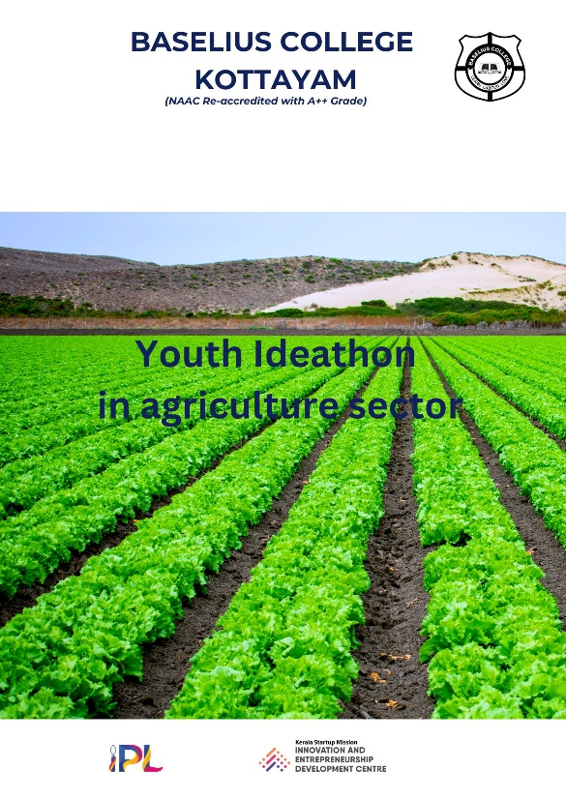

- Photograph of the event - Stage

- Photograph of the event - Audience

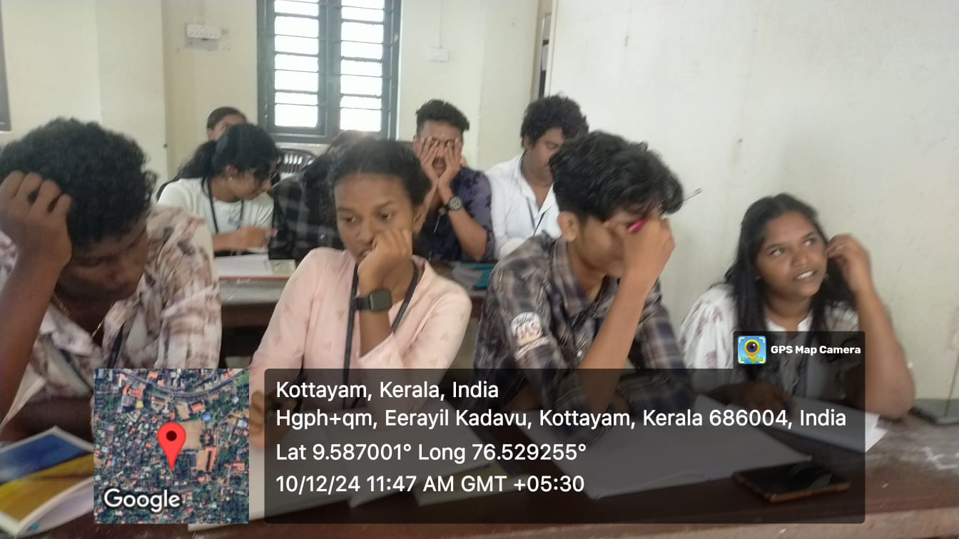

- Photograph of the event - Group Photo

- Other photographs if any

- Other Documents if any (Schedule, Resource Person Details, ..)

- Participant list in prescribed format
Innovation & Entrepreneurship Development Centre
An initiative of Kerala Startup Mission

- Name of Event | Evolving AI
- Name of Institute | : Baselius College
- Name of Nodal Officer | : Dr Aparna Thankappan
- Email Address | : aparnathankappan@baselius.ac.in
- Contact Number | : 9747620918
- Event participant type | : participants only from the institution
- Total number of participants | : 114
- Total number of women participants | : 65
- Track of Event | Technology
- Event category | Technology - Boot Camp/Hands-On Workshop - AR/VR, Mobile/Web Development, Artificial Intelligence, Hardware, Other Future Technologies etc.
- Sector | AI, ML & IoT
- Date from | 27.1.25
- Date to | 27.1.25
- Total number of hours | 2
- Details of IEDCs Collaborated | Nil
- Details of Communities or Clubs collaborated with | IIC, ED, Placement cell, NSDC(National skill development corporation), Image (creative education, Kottayam)
- Detailed report of the event (Min 200 words) | On 27th January 2025, Baselius College hosted an impactful seminar titled “Evolving AI”, jointly organized by the Institution’s Innovation Council (IIC), the Entrepreneurship Development (ED) Cell, the Placement Cell, the National Skill Development Corporation (NSDC), and IMAGE – Creative Education, Kottayam. The event drew an impressive participation of 114 students, reflecting a strong interest in the growing significance of artificial intelligence across various sectors.  The seminar focused on the rapid evolution of AI technologies and their transformative impact on industries, employment, and entrepreneurship. Experts from the AI and tech sectors shared valuable insights on current trends, ethical considerations, AI-driven innovations, and future career opportunities. Interactive sessions allowed students to engage directly with the resource persons, fostering curiosity and practical understanding of AI applications.  The program also highlighted how AI is reshaping traditional skill sets and underlined the importance of upskilling through platforms supported by NSDC and IMAGE. The session encouraged students to think critically about the role of AI in shaping future economies and motivated them to explore careers and ventures in the technology domain.  The event concluded on a positive note, with participants expressing appreciation for the knowledge gained and organizers reiterating their commitment to providing such forward-looking opportunities for students.

- Creatives created for the event (Max 10nos)

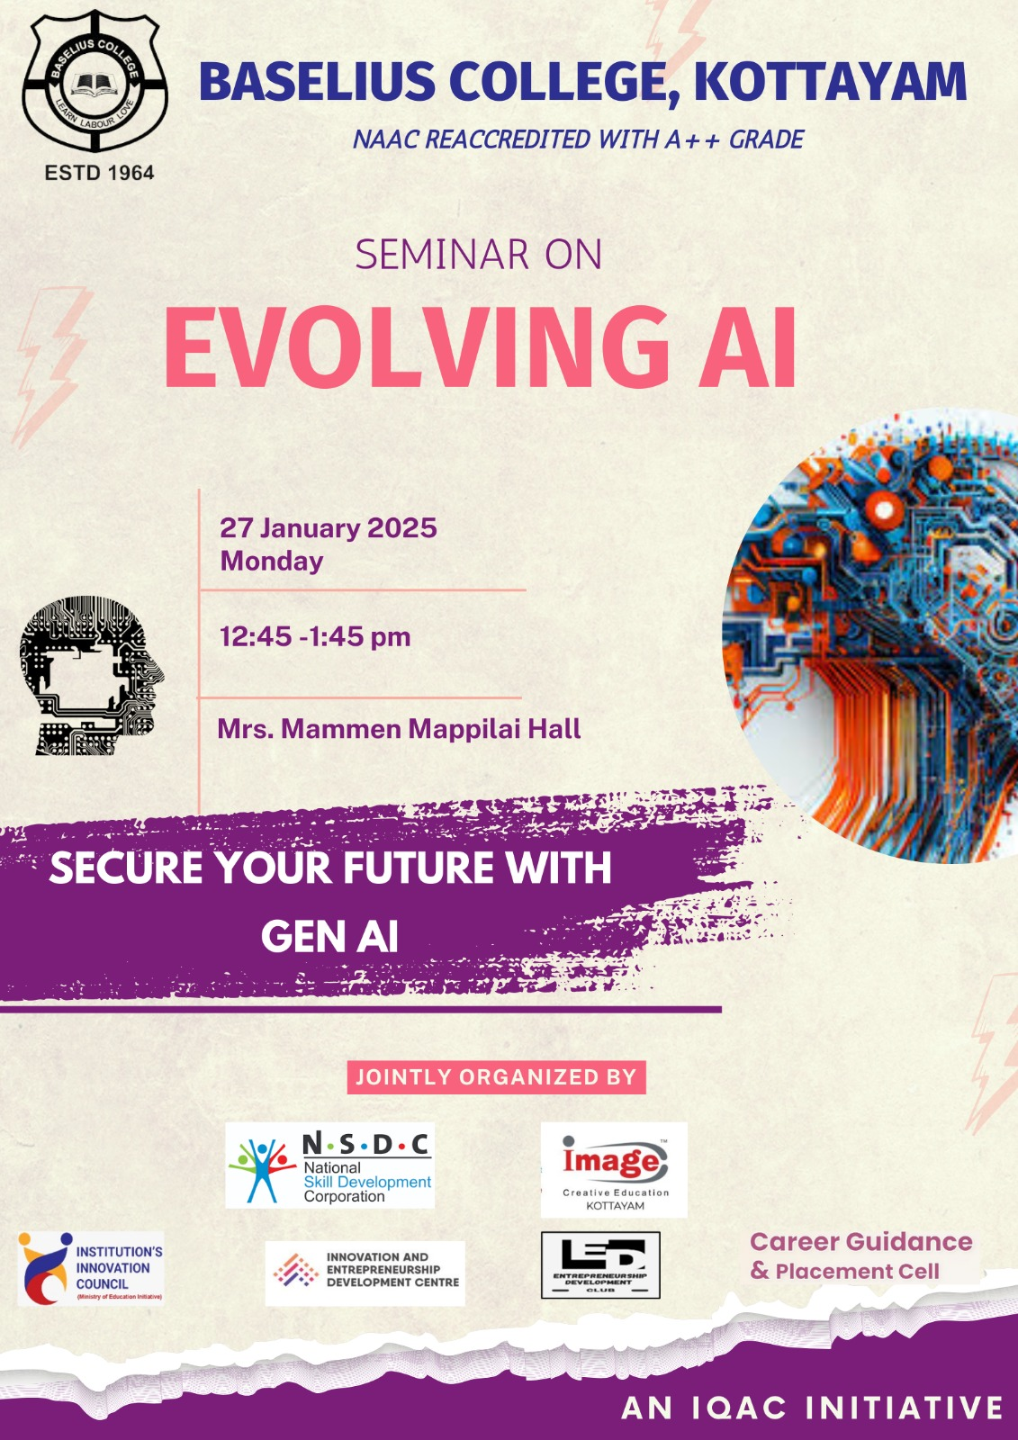

- Photograph of the event - Stage

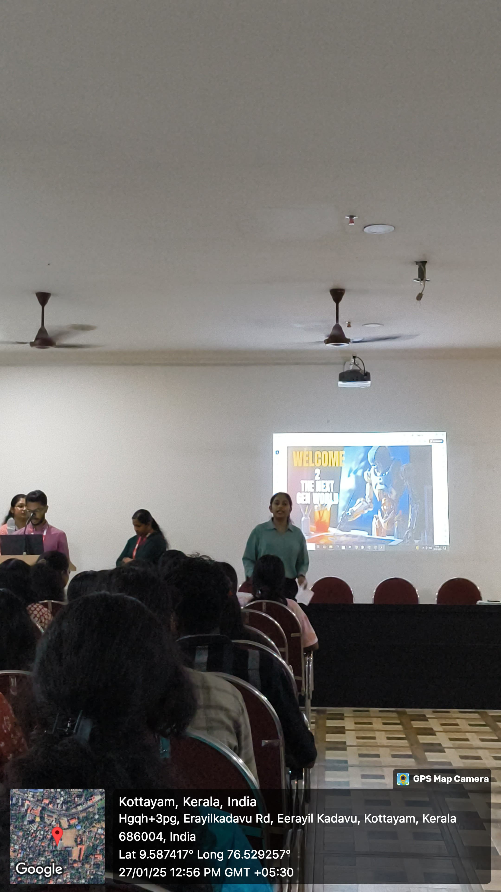

- Photograph of the event - Audience

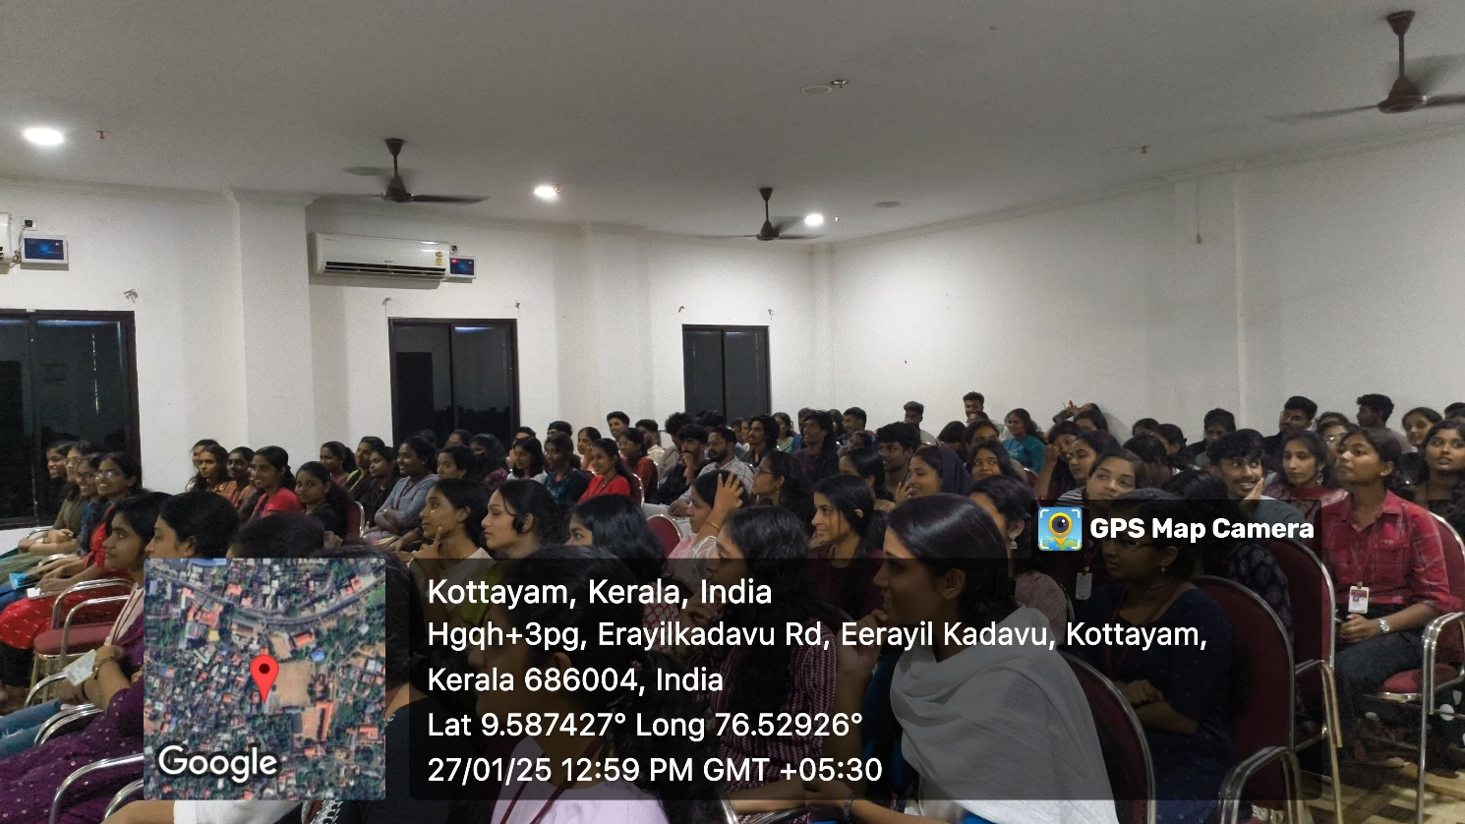

- Photograph of the event - Group Photo

- Other photographs if any

- Other Documents if any (Schedule, Resource Person Details, ..)

- Participant list in prescribed format
Innovation & Entrepreneurship Development Centre
An initiative of Kerala Startup Mission

- Name of Event | She lights the way: LED bulb making program
- Name of Institute | : Baselius College
- Name of Nodal Officer | : Dr Aparna Thankappan
- Email Address | : aparnathankappan@baselius.ac.in
- Contact Number | : 9747620918
- Event participant type | : participants only from the institution
- Total number of participants | : 14
- Total number of women participants | : 11
- Track of Event | technology
- Event category | Technology - Boot Camp/Hands-On Workshop - AR/VR, Mobile/Web Development, Artificial Intelligence, Hardware, Other Future Technologies etc.
- Sector | ClimateTech & Clean Energy
- Date from | 7.12.24
- Date to | 7.12.24
- Total number of hours | 3
- Details of IEDCs Collaborated | Nil
- Details of Communities or Clubs collaborated with | IIC, ED, Kudumbasree Kottayam
- Detailed report of the event (Min 200 words) | On December 7, 2024, a hands-on workshop titled "She Lights the Way: LED Bulb Making Program" was organized jointly by the IEDC, IIC, ED Club, and Kudumbashree, Kottayam. The program, aimed at empowering Kudumbashree women through skill development, took place at Baselius College. The workshop witnessed active participation from 12 Kudumbashree members representing various units in Kottayam.  The three-hour workshop was inaugurated by Dr. Nibu A George and Dr. Aparna Thankappan, IEDC Nodal Officers of Baselius College, who shared insights on the importance of technological literacy and entrepreneurship for women. The program was meticulously monitored and guided by Mr. Arjun Haridas and Mr. Vivek K Anil, both MSc Physics students of Baselius College, ensuring an interactive and engaging learning experience.  Participants were introduced to the fundamentals of LED bulb assembly, covering topics such as circuit design, soldering techniques, and quality control. Each participant successfully assembled LED bulbs during the session, marking a significant step toward acquiring practical skills that could be further developed for entrepreneurial ventures.  The workshop concluded with positive feedback from the participants, who expressed gratitude for the opportunity to learn a new skill that has the potential to supplement their income while contributing to sustainable practices.  This initiative highlights Baselius College's commitment to fostering community empowerment through education, innovation, and entrepreneurship.

- Creatives created for the event (Max 10nos)

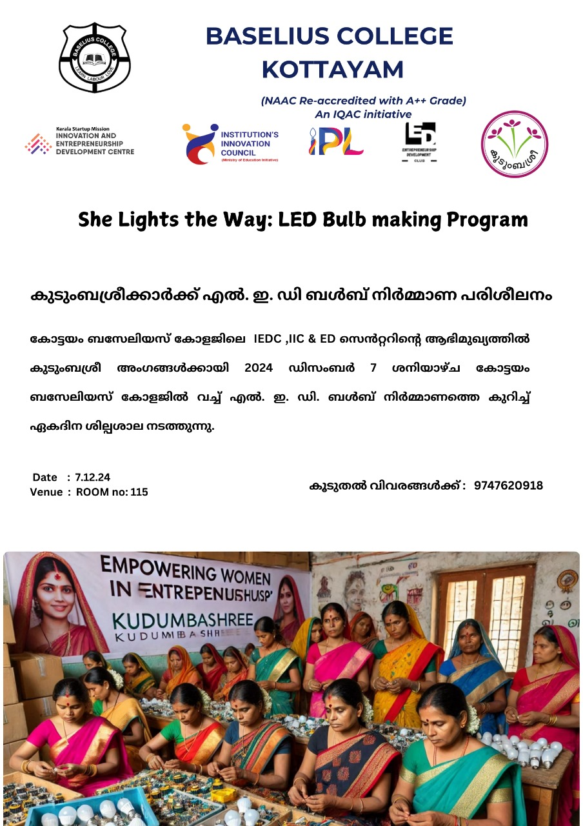

- Photograph of the event - Stage
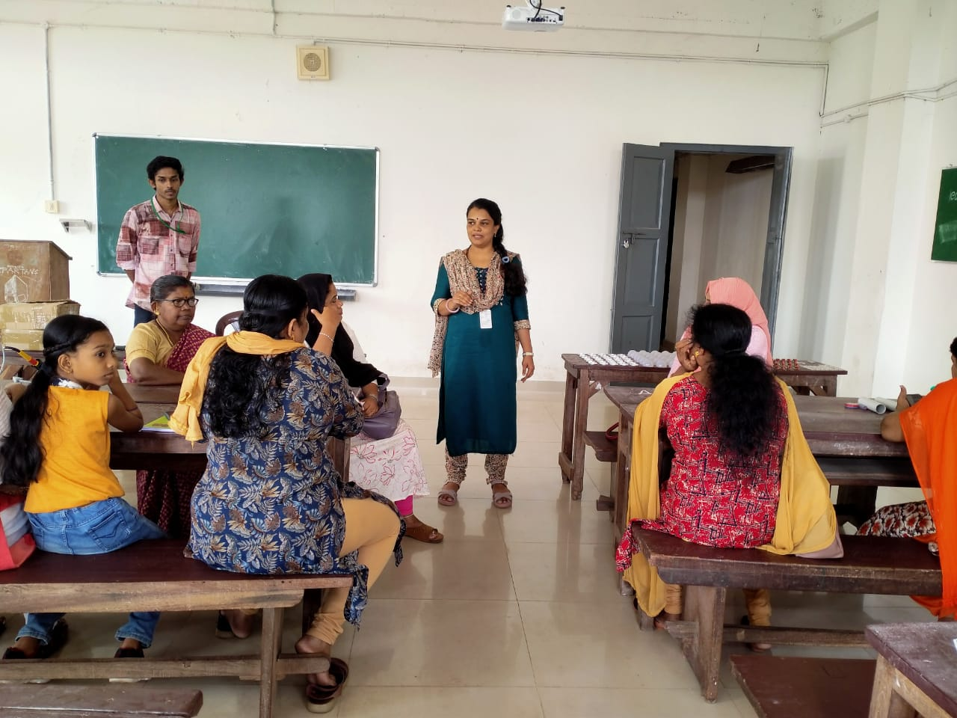

- Photograph of the event - Audience

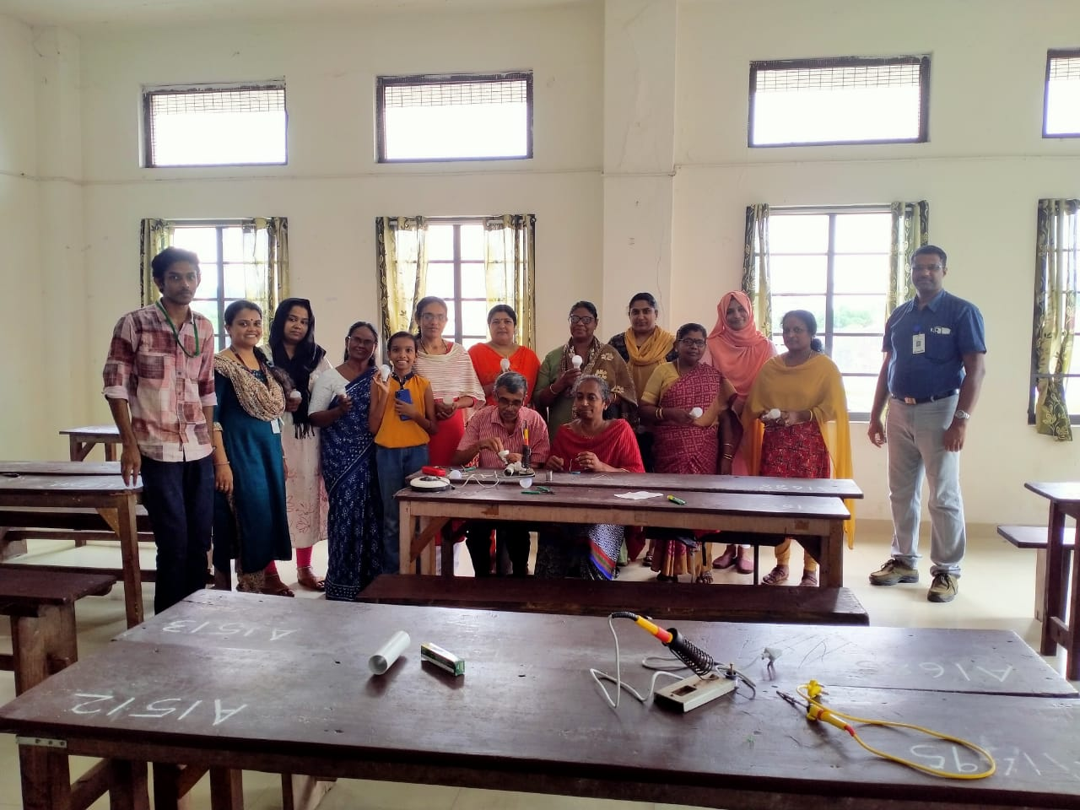

- Photograph of the event - Group Photo

- Other photographs if any

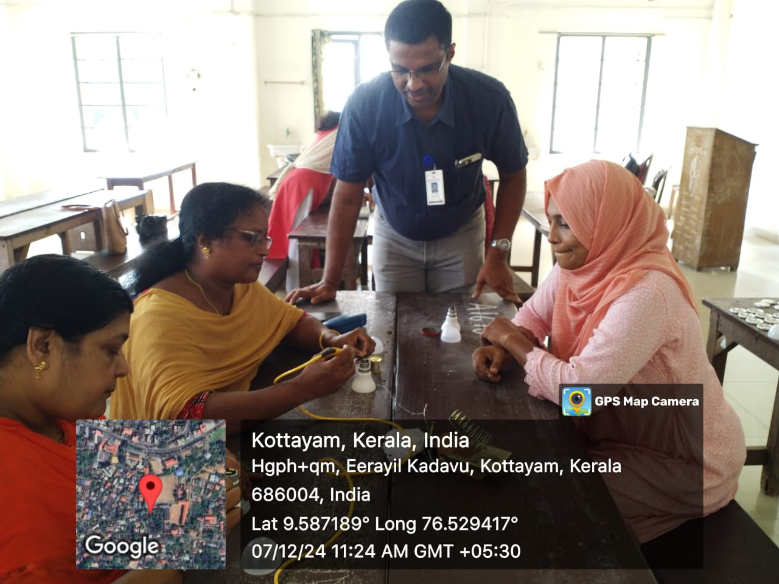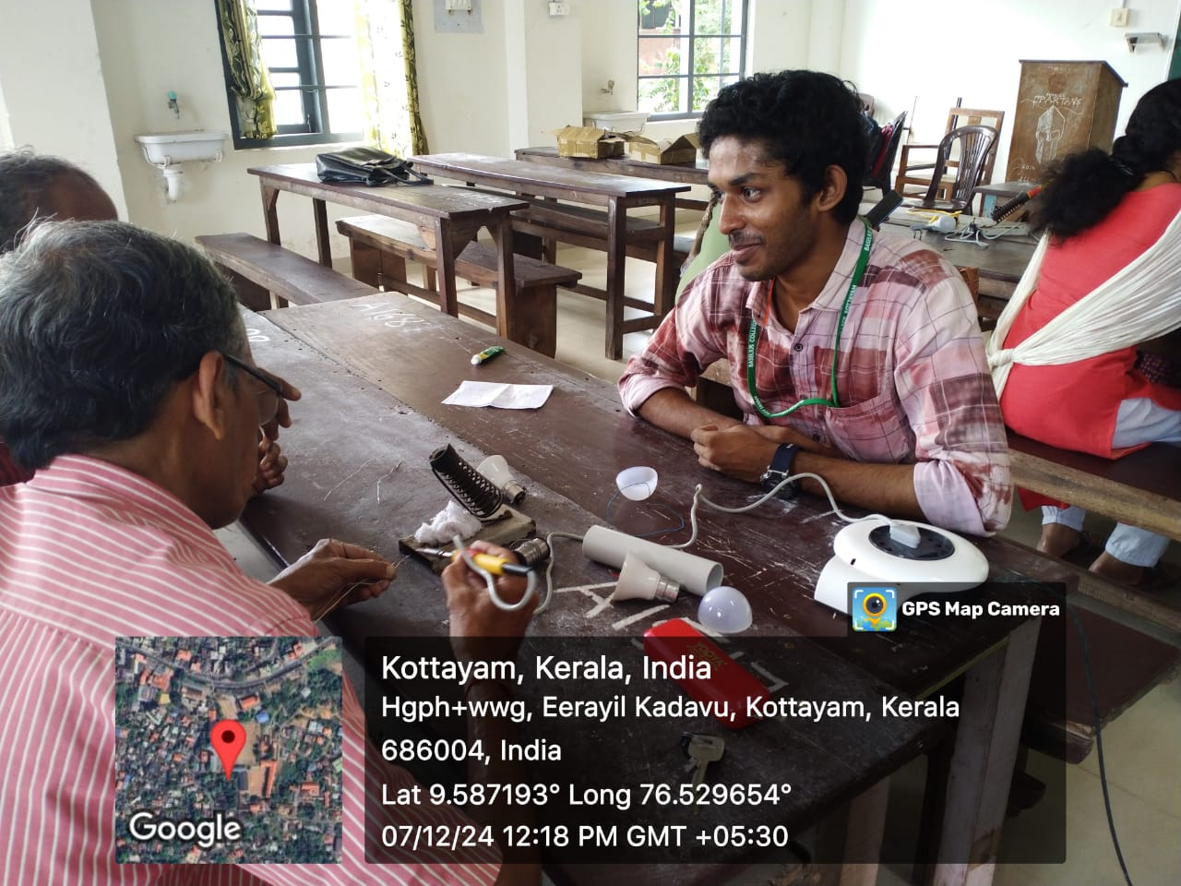
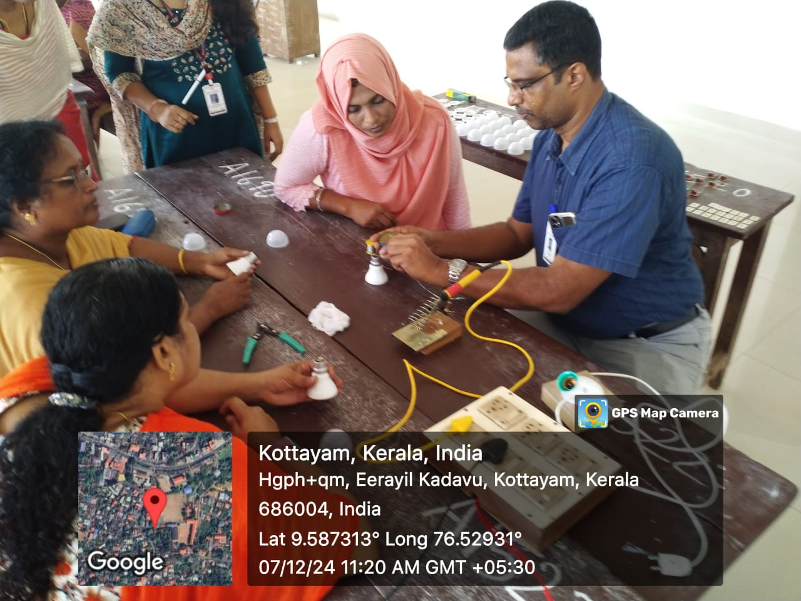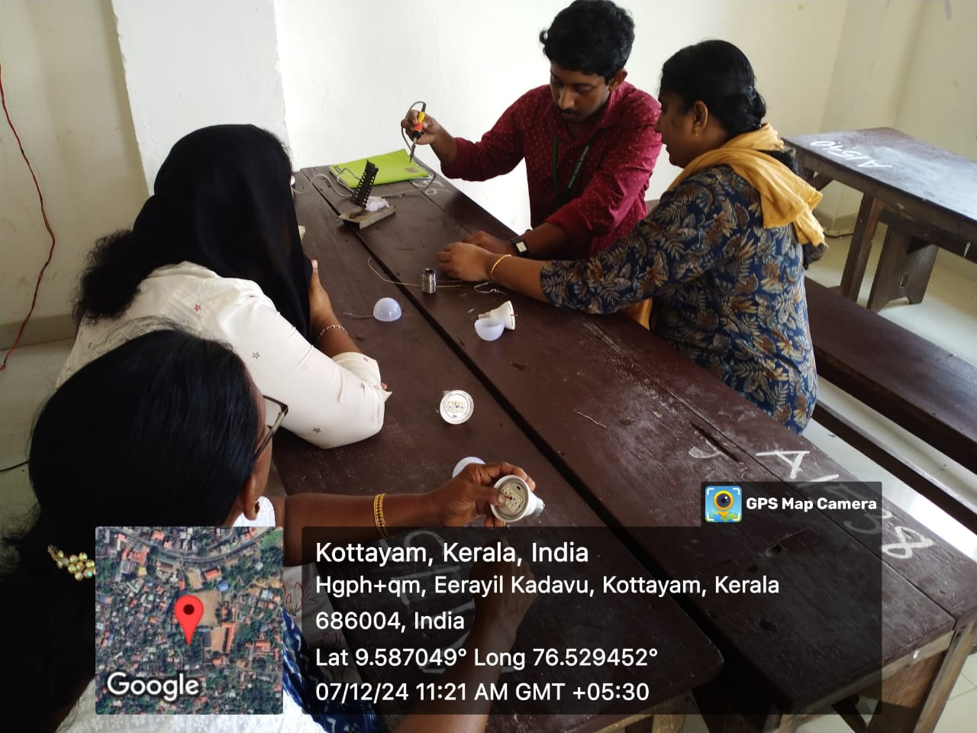
- Other Documents if any (Schedule, Resource Person Details, ..)
Dr. Nibu A George , IEDC Nodal Officer, Baselius College
Dr. Aparna Thankappan, IEDC Nodal Officer, Baselius College
Mr. Arjun Haridas, MSc Physics, Baselius College
Mr. Vivek K Anil, MSc Physics, Baselius College

- Participant list in prescribed format
Innovation & Entrepreneurship Development Centre
An initiative of Kerala Startup Mission

- Name of Event | Grassroots
- Name of Institute | : Baselius College
- Name of Nodal Officer | : Dr Aparna Thankappan
- Email Address | : aparnathankappan@baselius.ac.in
- Contact Number | : 9747620918
- Event participant type | : participants only from the institution
- Total number of participants | : 14
- Total number of women participants | : 11
- Track of Event | Entrepreneurship
- Event category | Entrepreneurship - Startup Pitch or Business Plan Competition or Ideathon
- Sector | MarketingTech & MICE
- Date from | 7.12.24
- Date to | 7.12.24
- Total number of hours | 3
- Details of IEDCs Collaborated | Nil
- Details of Communities or Clubs collaborated with | IIC, Department of English, Kudumbasree Kottayam
- Detailed report of the event (Min 200 words) | English Literature Association along with IEDC and IIC conducted an extension program "Grassroots 1" for the Kudumbasree unit of Kottayam Zone. It was an interactive session meant to arm the ladies of the Unit with confidence by helping them to shed stage fear and inhibitions of speaking in front of an audience.  The session began at 1.15 with a short message from the Vice Principal Jyothimol .P .The Head of the Department, Mr. Steve Vincent and ELITA coordinator Dr. Kavitha Gopalakrishnan too spoke on the occassion.  The students from D3 and D2 English led the session well  A total of 8 members participated in it. The first session dealt with famaliarizing them with the basic introduction in English. Each participant was given a chance to come forward and introduce themselves.The students actively joined them in polishing their English.  The second session was a fun module in which word game was played.The members were divided into groups and made to create stories based on certain key words.  It brought out their creative side.  The third session dealt with the basic English words to be used while promoting the products they make. Their ideas of convincing the customers were also shared.  The sessions were well received by the participants and it was a spirited and an informative experience for both the participants and the student volunteers.

- Creatives created for the event (Max 10nos)

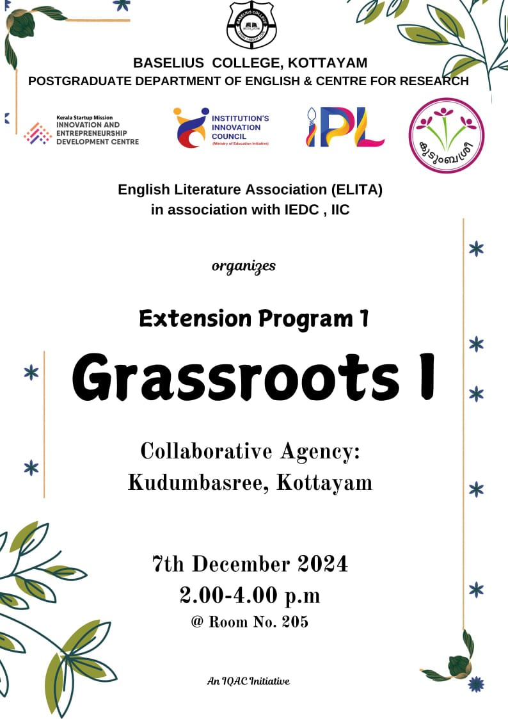

- Photograph of the event - Stage

- Photograph of the event - Audience

- Photograph of the event - Group Photo

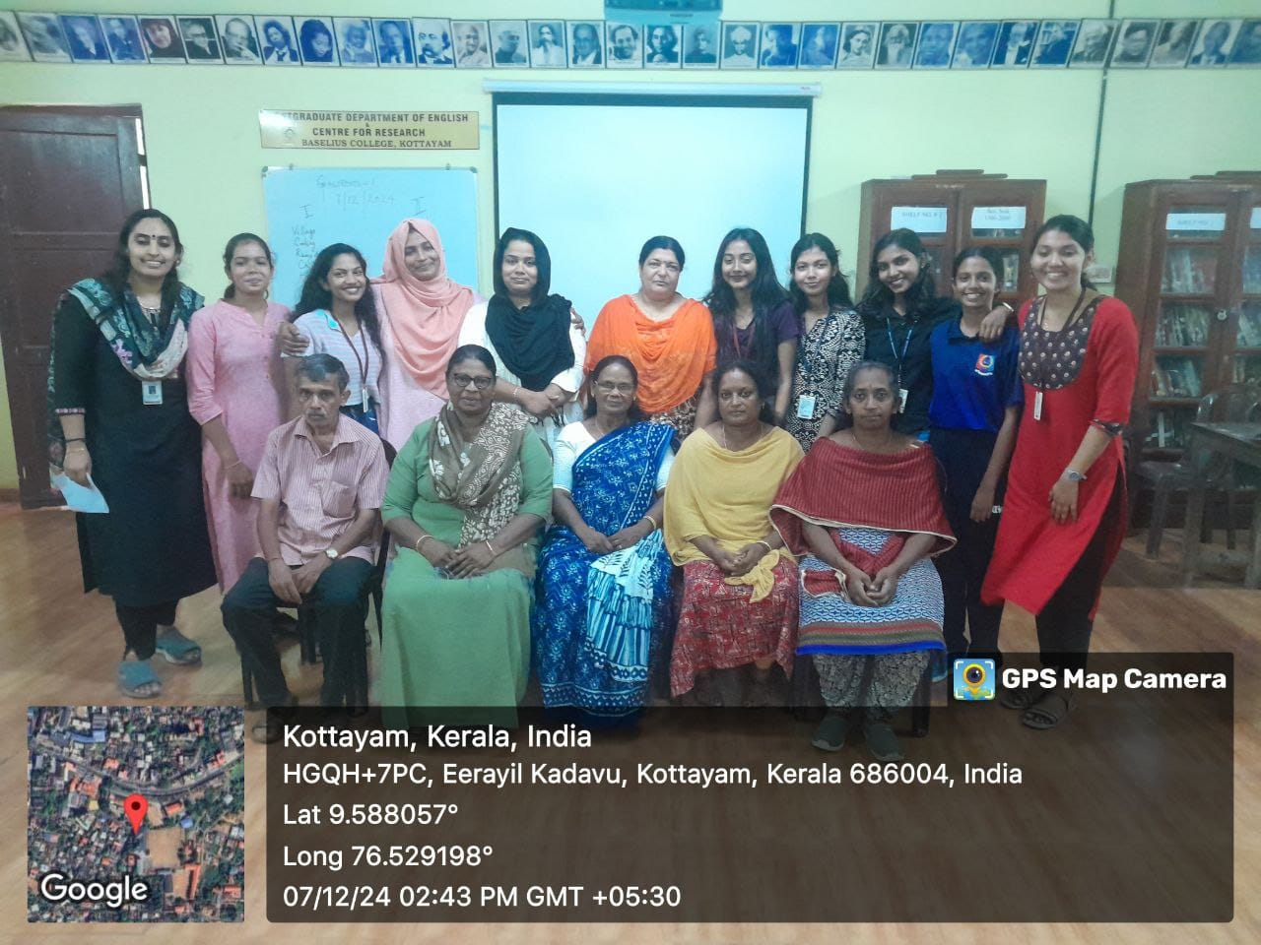

- Other photographs if any

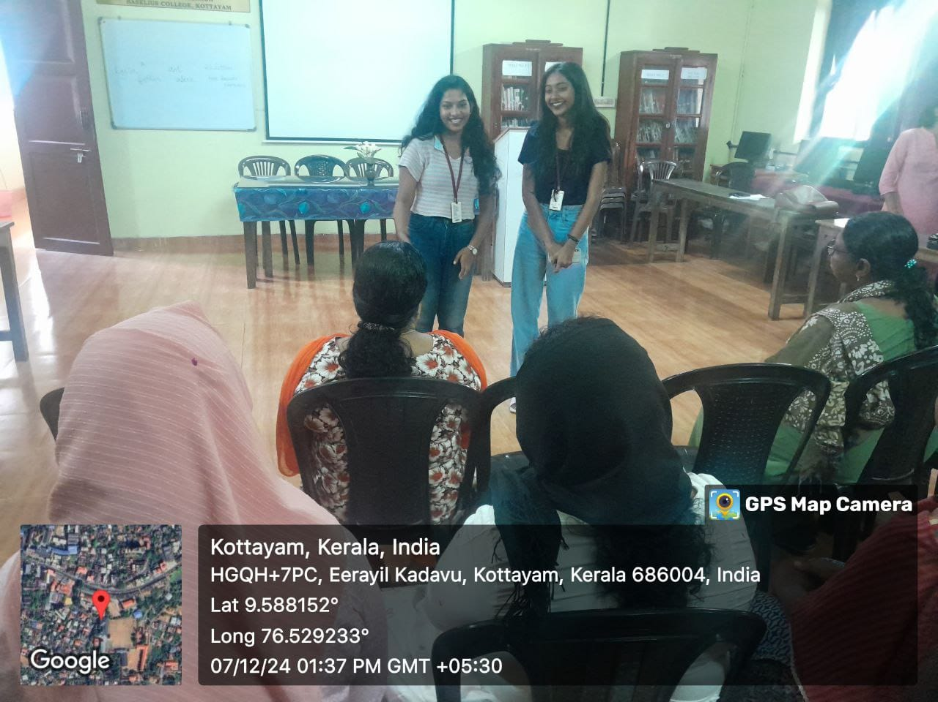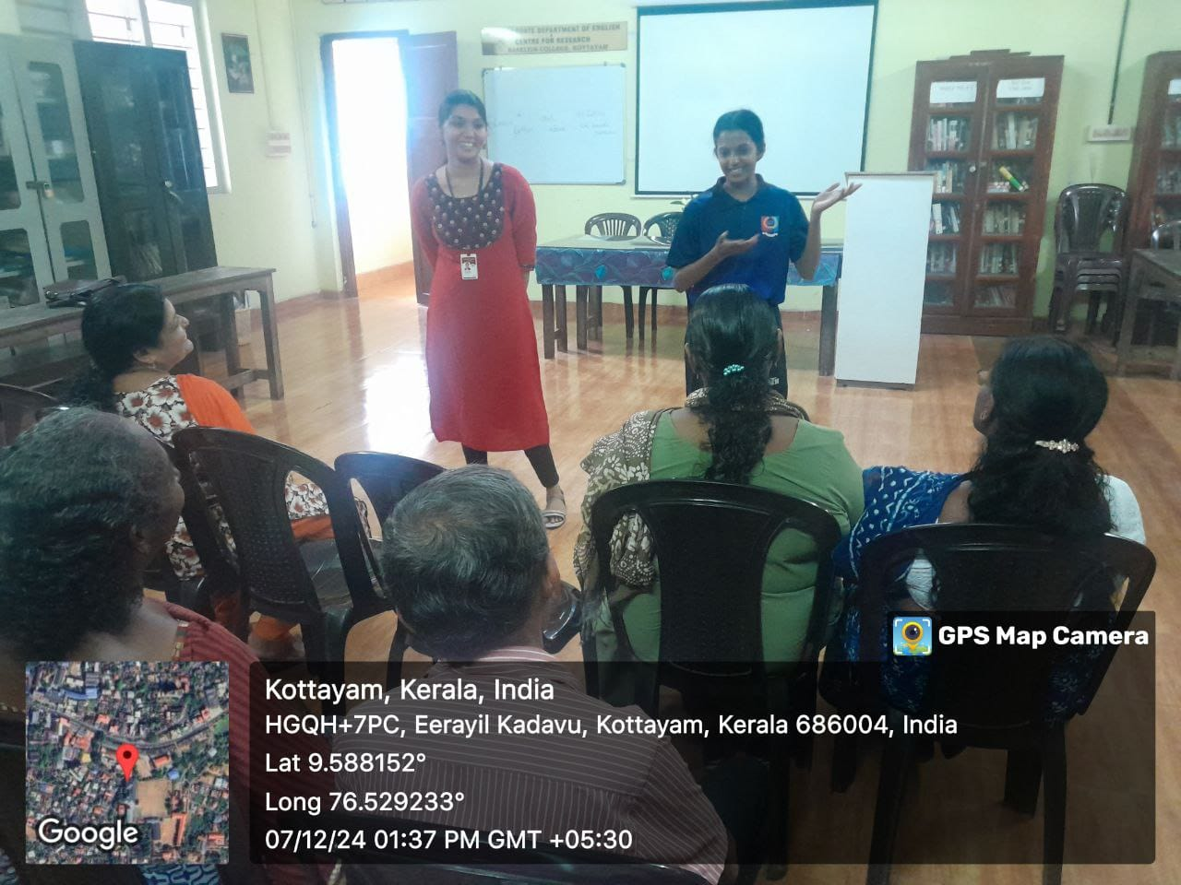

- Other Documents if any (Schedule, Resource Person Details, ..)
- Participant list in prescribed format
Innovation & Entrepreneurship Development Centre
An initiative of Kerala Startup Mission

- Name of Event | Ignite Innovation: Orientation for NASA Space Apps Challenge
- Name of Institute | : Baselius College
- Name of Nodal Officer | : Dr Aparna Thankappan
- Email Address | : aparnathankappan@baselius.ac.in
- Contact Number | : 9747620918
- Event participant type | : participants only from the institution
- Total number of participants | :21
- Total number of women participants | : 11
- Track of Event | Innovation
- Event category | Innovation - Workshops - Innovation Orientation, Ideation etc.
- Sector | Aerospace, Defence & SpaceTech
- Date from | 4.10.24
- Date to | 4.10.24
- Total number of hours | 2
- Details of IEDCs Collaborated
- Details of Communities or Clubs collaborated with
- Detailed report of the event (Min 200 words) | An orientation session titled "Ignite Innovation: Orientation for NASA Space Apps Challenge" was held on 4.10.24 at Baselius College to prepare students for the prestigious global hackathon hosted by NASA. The session was led by Nissy Sara Prince, a second-year BSc Mathematics student and the campus ambassador for the NASA Space Apps Challenge. With 21 students in attendance, the session aimed to familiarize participants with the themes, problem statements, and collaborative framework of the competition, while inspiring them to tackle real-world challenges with innovative solutions.  As the campus ambassador, Nissy Sara Prince shared her experiences and provided practical tips on effective participation in the challenge. She emphasized the importance of teamwork, creativity, and leveraging the resources available on the Space Apps platform. Her insightful guidance motivated students to explore interdisciplinary approaches and take bold steps toward developing impactful projects. The session concluded with an engaging Q&A segment, leaving the participants eager to contribute to this global innovation platform.
- Creatives created for the event (Max 10nos)

- Photograph of the event - Stage

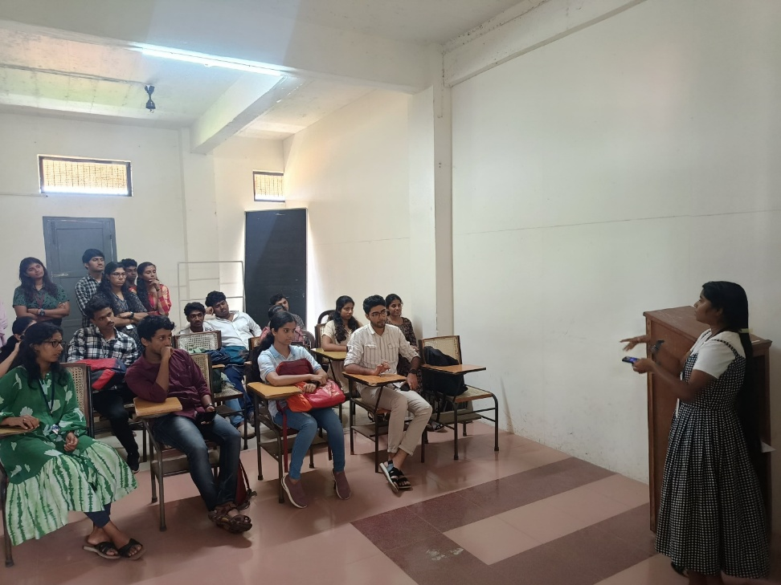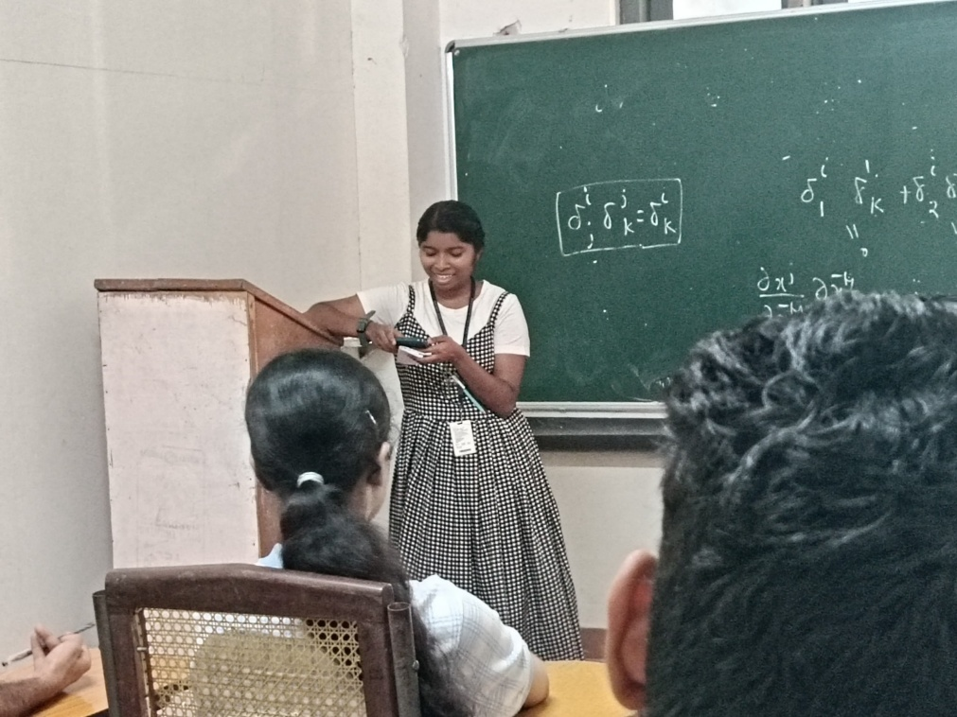

- Photograph of the event - Audience

- Photograph of the event - Group Photo

- Other photographs if any
- Other Documents if any (Schedule, Resource Person Details, ..)

Innovation & Entrepreneurship Development Centre
An initiative of Kerala Startup Mission

- Name of Event | From pages to binding- hands on workshop
- Name of Institute | : Baselius College
- Name of Nodal Officer | : Dr Aparna Thankappan
- Email Address | : aparnathankappan@baselius.ac.in
- Contact Number | : 9747620918
- Event participant type | : District level Event (Participants from various institutes)
- Total number of participants | :62
- Total number of women participants | :43
- Track of Event | Entrepreneurship
- Event category | Entrepreneurship - Boot camps/Workshops - Business model Canvas Workshop, How to build a startup etc.
- Sector | Social Impact, Rural Livelihood & Sustainability
- Date from | 29.1.25
- Date to | 29.1.25
- Total number of hours | 2
- Details of IEDCs Collaborated | Nil
- Details of Communities or Clubs collaborated with | IIC
- Detailed report of the event (Min 200 words) | On 29th January 2025, the Innovation and Entrepreneurship Development Centre (IEDC) and the Institution’s Innovation Council (IIC) of Baselius College jointly organized a hands-on workshop titled “From Pages to Binding” for school students at CMS School, Kottayam. The workshop aimed to introduce young students to the basics of bookbinding and foster creativity through practical engagement.  The session was led by two enthusiastic student resource persons—Nissy Sara Prince (Second Year B.Sc. Mathematics) and Anshida P V (First Year B.Sc. Zoology)—who effectively guided participants through each step of the bookbinding process. Their clear instructions and interactive approach helped make the learning experience both educational and enjoyable for the school students.  The workshop provided participants with a unique opportunity to learn a valuable craft, understand the importance of manual skills, and explore the creative process involved in transforming loose pages into a finished product. The students participated with great interest, gaining hands-on experience and developing an appreciation for the effort and artistry behind book making.  The event was well-received by both students and school faculty, who appreciated the initiative taken by Baselius College in promoting skill-based learning at the school level. The program concluded with a vote of thanks and words of encouragement from the organizers, inspiring students to further explore their creative and practical abilities.

- Creatives created for the event (Max 10nos)

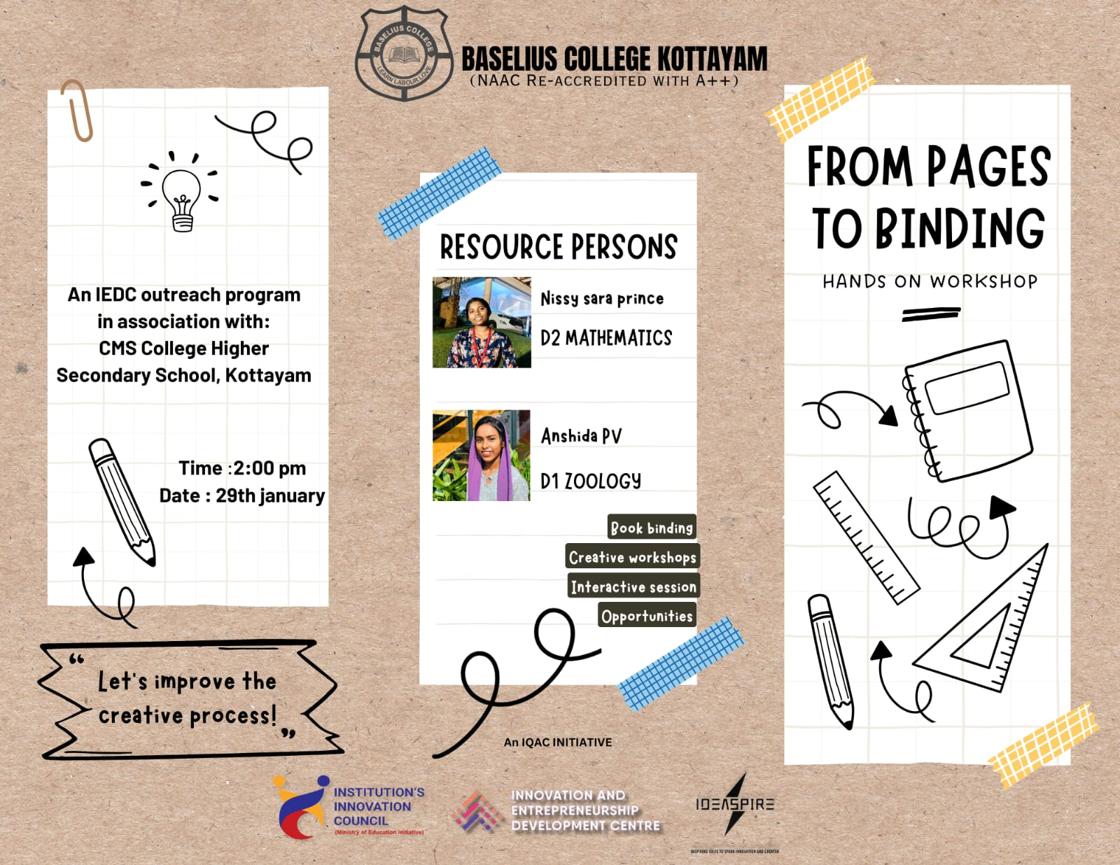
- Photograph of the event - Stage

- Photograph of the event - Audience

- Photograph of the event - Group Photo

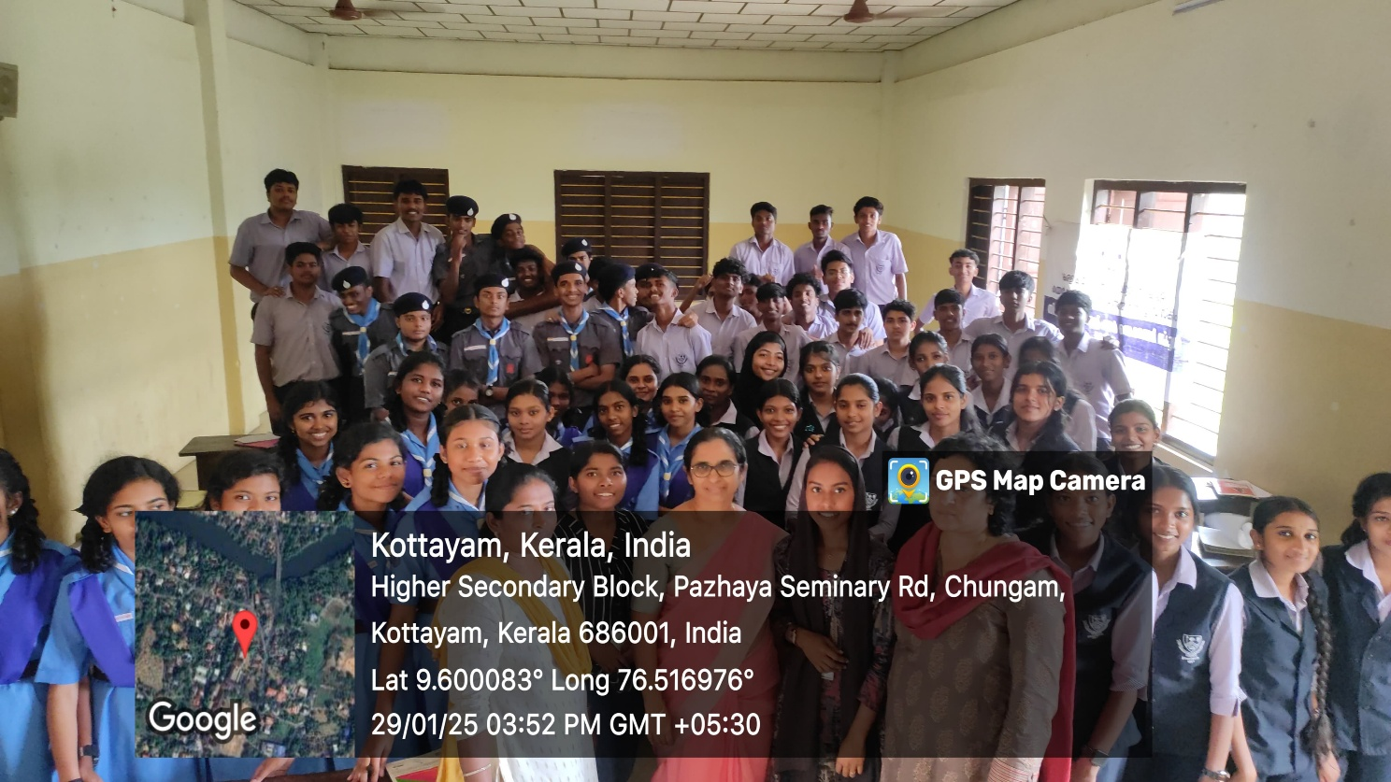

- Other photographs if any

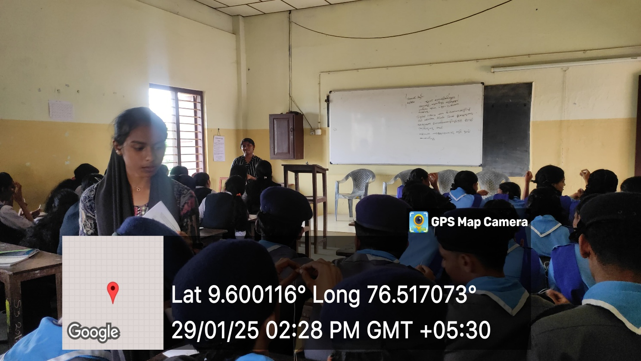
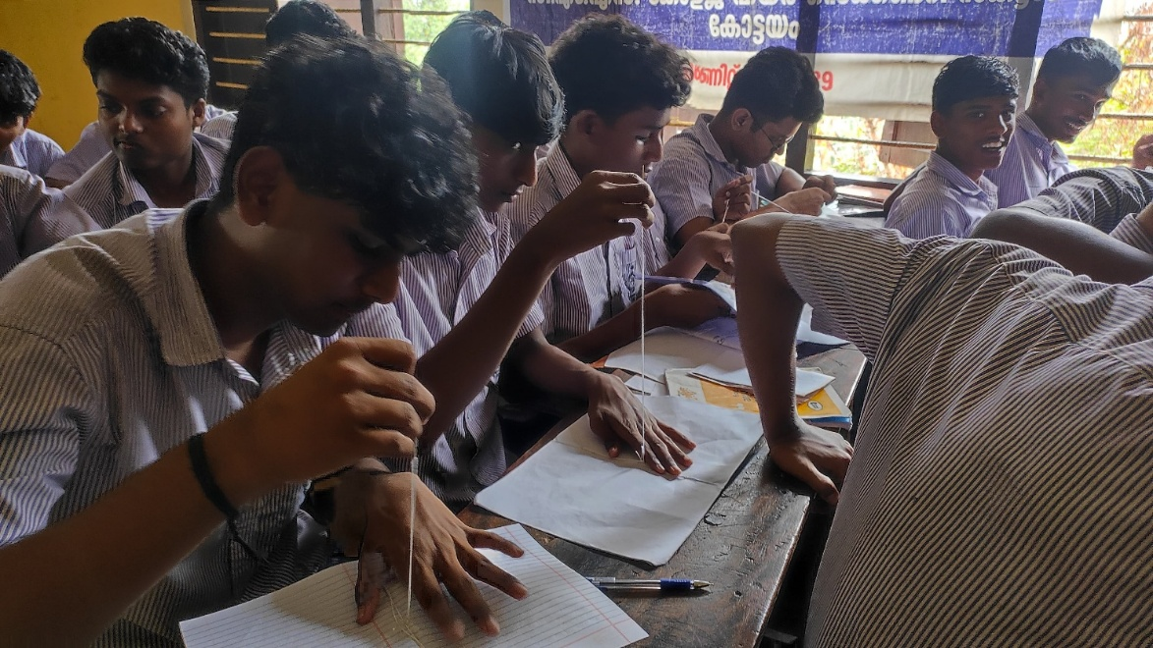
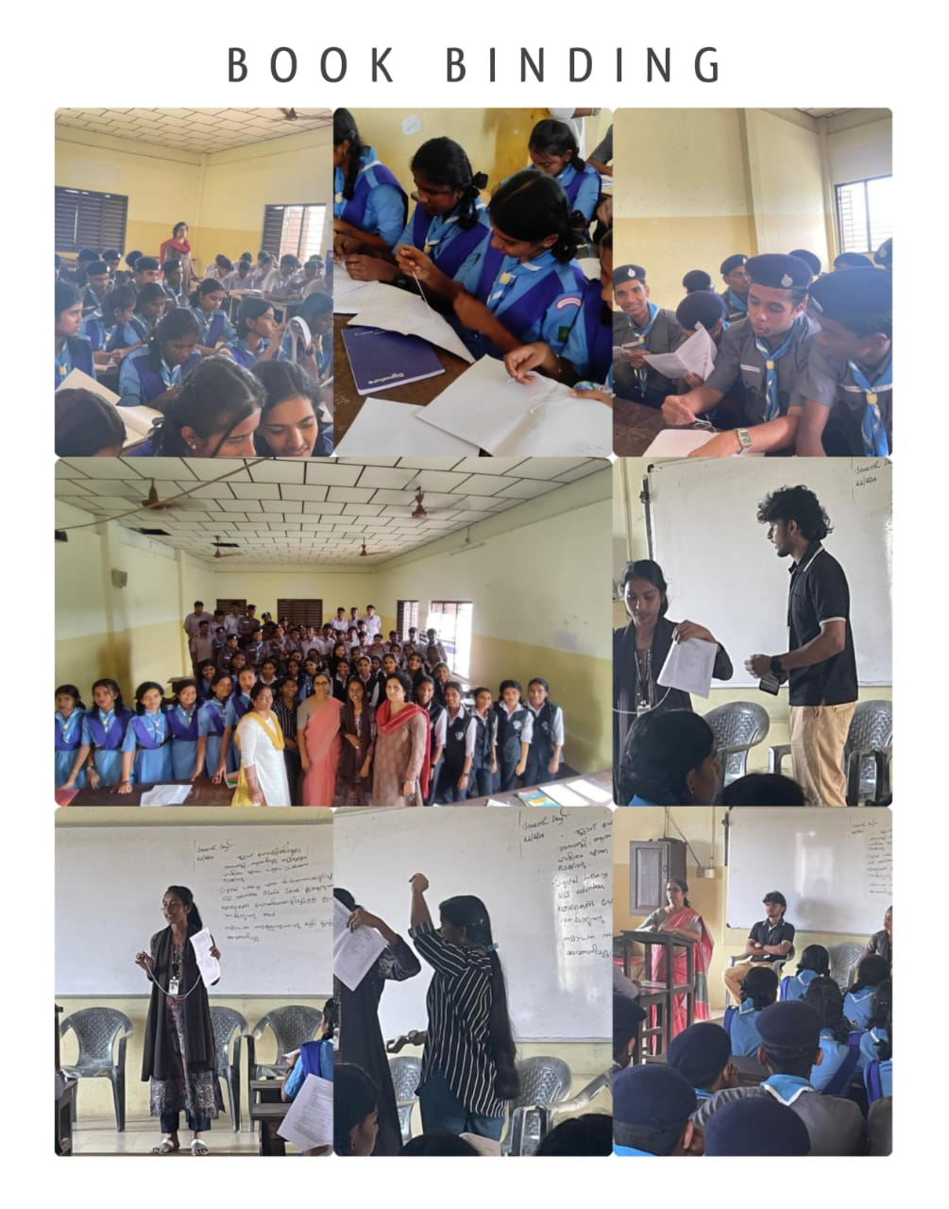
- Other Documents if any (Schedule, Resource Person Details, ..)
Nissy Sara prince. D2 Mathematics
Anshida P V , D1 Zoology

Innovation & Entrepreneurship Development Centre
An initiative of Kerala Startup Mission

- Name of Event | Think, create, innovate: using hackathons to solve real world problems
- Name of Institute | : Baselius College
- Name of Nodal Officer | : Dr Aparna Thankappan
- Email Address | : aparnathankappan@baselius.ac.in
- Contact Number | : 9747620918
- Event participant type | : Participant only from the Institution
- Total number of participants | :18
- Total number of women participants | :15
- Track of Event | Innovation
- Event category | Innovation - Workshops - Innovation Orientation, Ideation etc.
- Sector | Social Impact, Rural Livelihood & Sustainability
- Date from | 28.1.25
- Date to | 28.1.25
- Total number of hours | 1
- Details of IEDCs Collaborated | Nil
- Details of Communities or Clubs collaborated with | IIC
- Detailed report of the event (Min 200 words) | On 28th January 2025, the Innovation and Entrepreneurship Development Centre (IEDC) and the Institution’s Innovation Council (IIC) of Baselius College organized an engaging workshop titled “Think, Create, Innovate: Using Hackathons to Solve Real-World Problems”. The session was specially designed for students from the Botany and Zoology departments, with the aim of introducing them to the concept of hackathons as powerful tools for innovation and interdisciplinary problem-solving.  The workshop was led by six dynamic and knowledgeable student resource persons—Arun Hari, Aswini Krishna S, Mariya Sara Sunil, Uthara Vinu, Jenu B Bijoy, and Jewel Mariam Jose—who brought valuable insights from their own hackathon experiences. Through interactive presentations and group activities, they guided participants on how to identify real-world issues, ideate solutions, form teams, and develop practical prototypes within a limited timeframe.  Participants were encouraged to think creatively and collaboratively, blending their knowledge of biological sciences with problem-solving techniques typically used in innovation challenges. The session also emphasized the importance of teamwork, time management, and presentation skills—key elements in any successful hackathon.  The workshop was met with enthusiastic participation and positive feedback. It succeeded in planting the seeds of innovation among students from non-technical backgrounds and demonstrated how hackathons can serve as inclusive platforms for developing impactful solutions across disciplines.

- Creatives created for the event (Max 10nos)

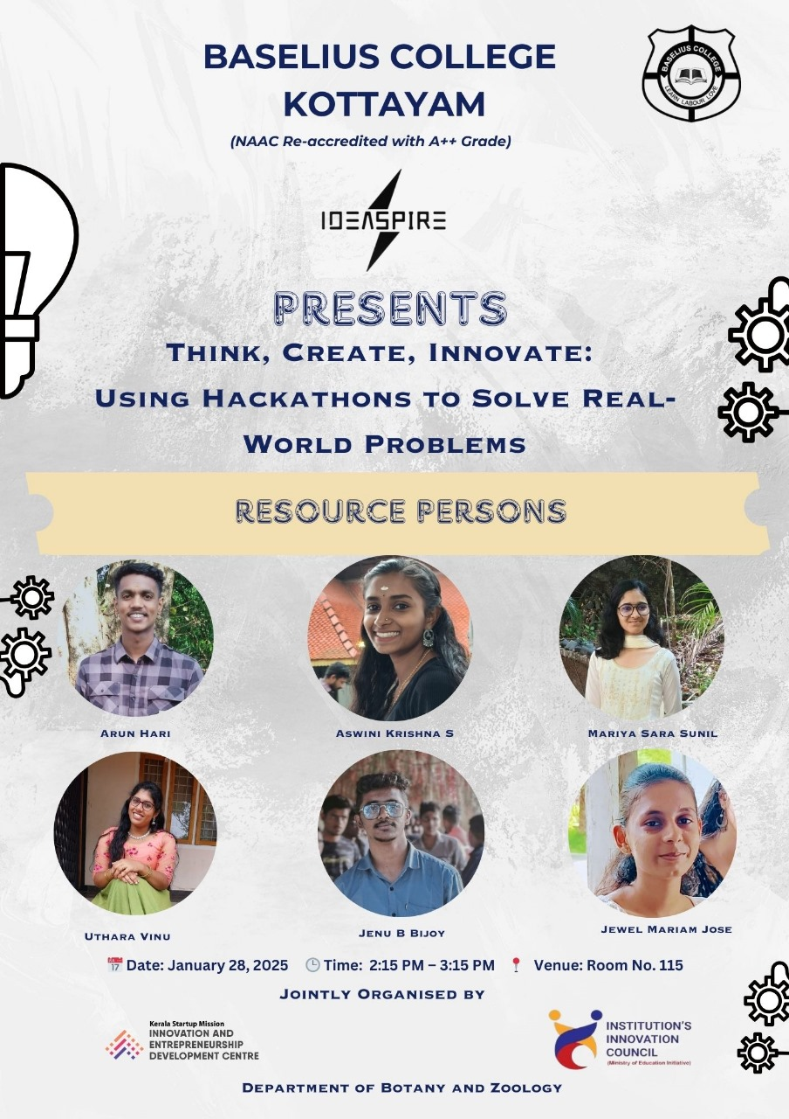

- Photograph of the event - Stage

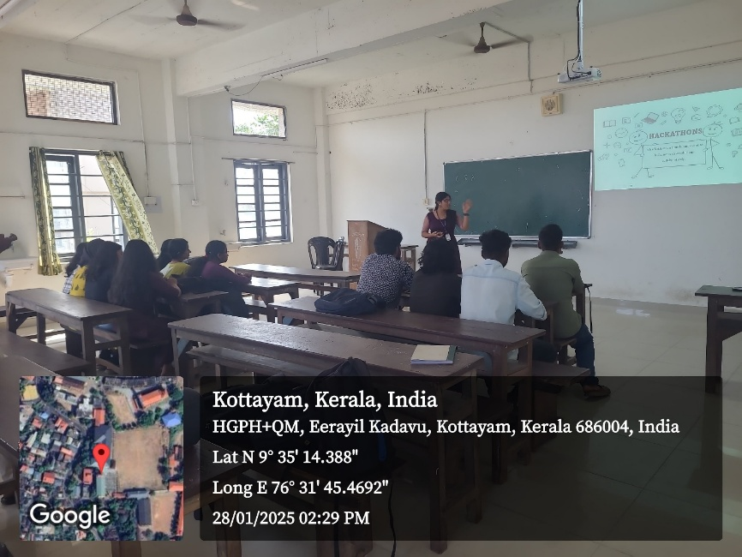

- Photograph of the event - Audience

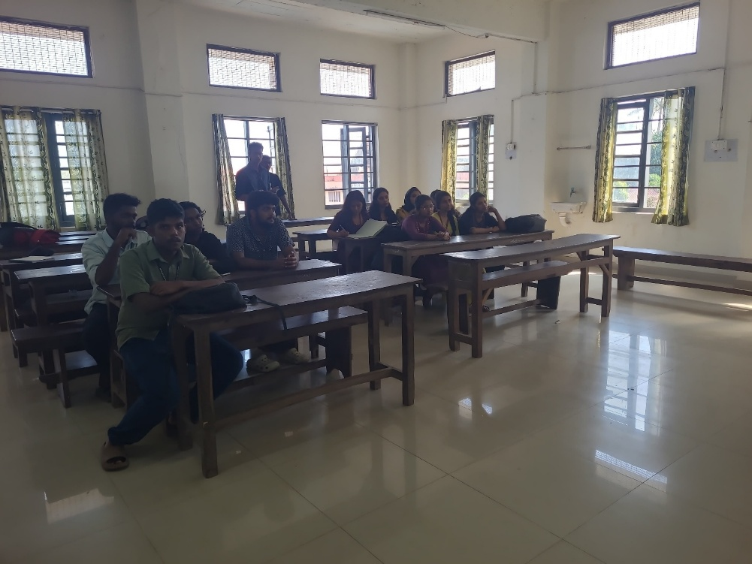

- Photograph of the event - Group Photo

- Other photographs if any

- Other Documents if any (Schedule, Resource Person Details, ..)

Resource Persons:
- Arun Hari-D2 Physics
- Aswini Krishna S- D2 Physics
- Mariya Sara Sunil- D2 Physics
- Uthara Vinu- D2 Physics
- Jenu B Bijoy- D2 Chemistry
- Jewel Mariam Jose- D2 Physics

Participant list in prescribed format
Innovation & Entrepreneurship Development Centre
An initiative of Kerala Startup Mission

- Name of Event | Leadership Training Programme
- Name of Institute | : Baselius College
- Name of Nodal Officer | : Dr Aparna Thankappan
- Email Address | : aparnathankappan@baselius.ac.in
- Contact Number | : 9747620918
- Event participant type | : participants only from the institution
- Total number of participants | : 230
- Total number of women participants | :
- Track of Event
- Event category | Mentoring Programme
- Sector | Leadership
- Date from | 29.1.25
- Date to | 31.1.25
- Total number of hours | 15
- Details of IEDCs Collaborated
- Details of Communities or Clubs collaborated with | Institution's Innovation Council (IIC), Innovation, Entrepreneurship Development Centre (IEDC), Placement Cell, PTA of Baselius College, Kottayam
- Detailed report of the event (Min 200 words) | The Leadership Training Programme is designed for first-year undergraduate students to help them develop key leadership qualities and basic manners essential for success in both academic and social settings. The programme aims to equip students with the skills to be effective leaders, improve interpersonal communication, and practice proper etiquette in daily interactions. It fosters confidence, responsibility, and respect. In today’s fast-paced world, leadership is not only about academic excellence but also about strong interpersonal skills and good manners. Early development of these qualities helps students navigate university life and prepares them for future professional success. This programme is intended for first-year undergraduate students who wish to enhance their leadership skills and refine their social manners for personal and academic growth.  The Programme was organised by PTA in association with Institution’s Innovation Council (IIC), Innovation and Entrepreneurship Development Centre (IEDC) and Career Guidance and Placement Cell from 29.01.2025 to 31.01.2025 in Self-financing Seminar Hall from 8.30 am to 1.45 pm on Wednesday and Thursday and from 8.30 am to 11.15 on Friday as 5 sessions. Sri. Sanju P. Cherian, certified trainer and leadership consultant was the resource person of the sessions. 230 students attended the programme.
- Creatives created for the event (Max 10nos)

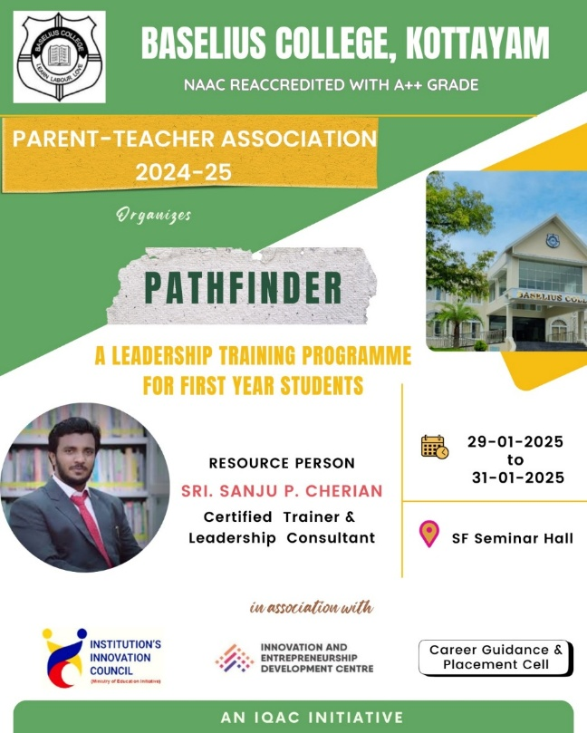
- Photograph of the event - Stage

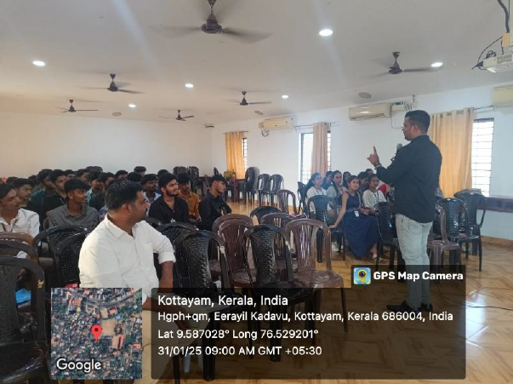

- Photograph of the event - Audience

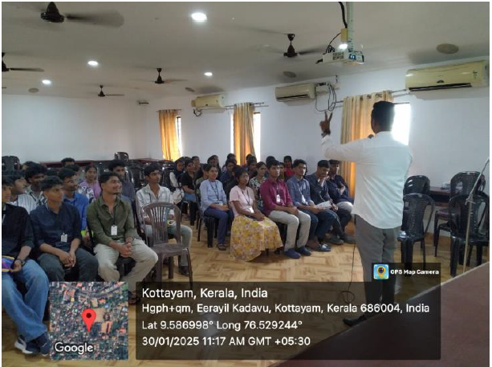
- Photograph of the event - Group Photo

- Other photographs if any
- Other Documents if any (Schedule, Resource Person Details, ..)
Sri. Sanju P. Cherian, Certified trainer and Leadership Consultant

Participant list in prescribed format
Innovation & Entrepreneurship Development Centre
An initiative of Kerala Startup Mission

- Name of Event | Transforming Trash to Treasure: A Scrap-to-Craft Workshop
- Name of Institute | : Baselius College
- Name of Nodal Officer | : Dr Aparna Thankappan
- Email Address | : aparnathankappan@baselius.ac.in
- Contact Number | : 9747620918
- Event participant type | : participants only from the institution
- Total number of participants | :
- Total number of women participants | :
- Track of Event | Innovation
- Event category | Innovation - Workshops - Innovation Orientation, Ideation etc.
- Sector | Art, Culture & Architecture
- Date from | 31.1.25
- Date to | 31.1.25
- Total number of hours | 2
- Details of IEDCs Collaborated
- Details of Communities or Clubs collaborated with | IIC IEDC
- Detailed report of the event (Min 200 words) | Objective  - To encourage creative upcycling by transforming waste materials into useful and artistic crafts, promoting sustainability and innovation.  Outcome:  - Participants will develop hands-on skills in recycling and crafting, fostering an eco-conscious mindset and entrepreneurial thinking.  The Commerce Association of Baselius College, Kottayam, organized a workshop titled "Transforming Trash to Treasure: A Scrap-to-Craft Workshop." The event was held on January 31, 2025, at 2:00 PM in Room No. 302. The session was led by Bhavya N.A. and Shilpa Shibu, both from D3 B.Com. This workshop was an initiative to promote sustainability through creative reuse of waste materials. The participants explored different techniques to convert discarded items into decorative and functional crafts. The event emphasized the importance of reducing waste and adopting eco-friendly practices. Students actively engaged in hands-on crafting, applying innovative ideas to repurpose materials. The workshop also highlighted the potential of upcycled crafts in entrepreneurial ventures. Through interactive discussions, participants learned about market opportunities for sustainable products. The event fostered creativity, problem-solving skills, and environmental awareness among students. The Institution’s Innovation Council and Innovation and Entrepreneurship Development Centre collaborated to make the event impactful. The session concluded with participants showcasing their creations and sharing their experiences.

- Creatives created for the event (Max 10nos)

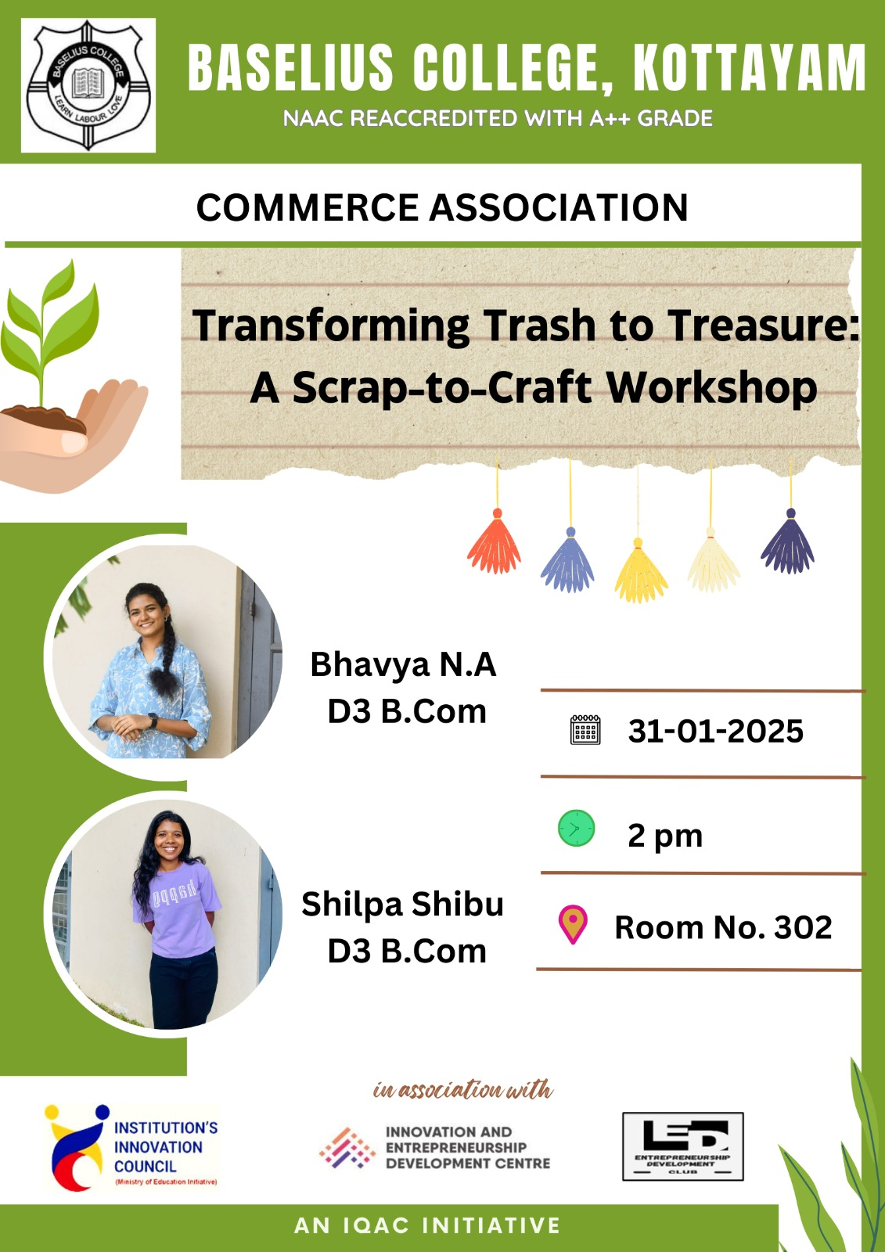

- Photograph of the event - Stage

- Photograph of the event - Audience
- Photograph of the event - Group Photo
- Other photographs if any
- Other Documents if any (Schedule, Resource Person Details, ..)

Bhavya N.A. and Shilpa Shibu,D3 B.Com
Participant list in prescribed format
Innovation & Entrepreneurship Development Centre
An initiative of Kerala Startup Mission

- Name of Event | Handmade Dreams : Art of Creative Crafting
- Name of Institute | : Baselius College
- Name of Nodal Officer | : Dr Aparna Thankappan
- Email Address | : aparnathankappan@baselius.ac.in
- Contact Number | : 9747620918
- Event participant type | : participants only from the institution
- Total number of participants | :
- Total number of women participants | :
- Track of Event | Innovation
- Event category | Innovation - "Demo Day" (Student Innovators with showcase their Product/Prototype to corporates, investors, stake holders, MSMEs etc.)
- Sector | Art, Culture & Architecture
- Date from | 25.4.25
- Date to | 25.4.25
- Total number of hours | 1.30hrs
- Details of IEDCs Collaborated | Nil
- Details of Communities or Clubs collaborated with | IIC,ED
- Detailed report of the event (Min 200 words) | Objective  - To inspire young minds towards creative crafting and entrepreneurship  Outcome  - Participants gained insights into the art of crafting, branding, and marketing handmade gifts, encouraging them to explore creative business opportunities.  The masterclass titled 'Handmade Dreams: The Art of Creative Crafting' was organized on 25th April 2025 at Baselius College, Kottayam, under the Prabodhan programme. This initiative, aimed at high school and higher secondary school students, focused on fostering creativity and entrepreneurial thinking through practical and interactive sessions. The event commenced at 12:30 pm and was organized by the Institution’s Innovation Council (IIC), Innovation and Entrepreneurship Development Centre (IEDC), and the Entrepreneurship Development Club. The resource person for the session was Ms. Riya Aji, CEO of IEDC and Founder of 'With Love Gifts and Hampers.'  Riya Aji shared her journey from ideation to establishing a successful brand in the handmade gifts sector. She emphasized the importance of finding a niche in the market and using creativity as a tool for differentiation. Her narrative was not only inspiring but also educational, as she highlighted the steps involved in conceptualizing, designing, and marketing handmade products. Participants were actively engaged in a hands-on crafting session where they created personalized gift items under Riya's guidance. This practical approach helped them understand the intricacies of crafting and the potential of turning creative skills into profitable ventures.

- Creatives created for the event (Max 10nos)

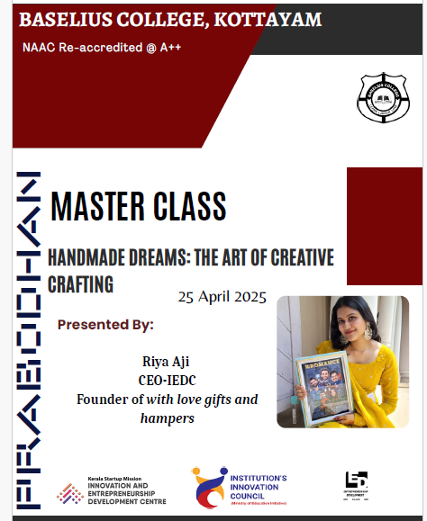
- Photograph of the event - Stage

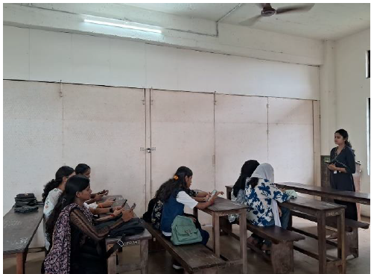

- Photograph of the event - Audience

- Photograph of the event - Group Photo

- Other photographs if any
- Other Documents if any (Schedule, Resource Person Details, ..)

- Participant list in prescribed format
Innovation & Entrepreneurship Development Centre
An initiative of Kerala Startup Mission

- Name of Event | C++ for Beginners
- Name of Institute | : Baselius College
- Name of Nodal Officer | : Dr Aparna Thankappan
- Email Address | : aparnathankappan@baselius.ac.in
- Contact Number | : 9747620918
- Event participant type | : participants only from the institution
- Total number of participants | :
- Total number of women participants | :
- Track of Event | Technology
- Event category | Technology - Boot Camp/Hands-On Workshop - AR/VR, Mobile/Web Development, Artificial Intelligence, Hardware, Other Future Technologies etc.
- Sector
- Date from
- Date to
- Total number of hours
- Details of IEDCs Collaborated
- Details of Communities or Clubs collaborated with
- Detailed report of the event (Min 200 words) | Objective  - To provide a foundational understanding of C++ programming for beginners, focusing on basic syntax, data structures, and problem-solving techniques.  Outcome  - Participants acquired basic programming skills in C++ and gained confidence to pursue further learning in coding.  As part of the 'Prabodhan' programme, a masterclass titled 'C++ for Beginners' was conducted on 25th April 2025 at Baselius College, Kottayam. The session was aimed at introducing high school and higher secondary school students to the basics of C++ programming. The session, organized by the Institution’s Innovation Council (IIC), Innovation and Entrepreneurship Development Centre (IEDC), and the Entrepreneurship Development Club, commenced at 1:30 pm. The resource person was Amit Krishna, a member of the IEDC EXECOM.  Amit Krishna began the session by explaining the fundamentals of C++, including variables, data types, loops, and conditional statements. He emphasized the importance of logical thinking in programming and how C++ serves as a strong foundation for learning other programming languages.During the practical segment, participants were provided with simple programming tasks to implement the concepts discussed. Amit guided the students in writing basic programs, troubleshooting errors, and optimizing code. He also demonstrated how to set up a C++ programming environment and shared key online resources for beginners to practice coding effectively.

- Creatives created for the event (Max 10nos)

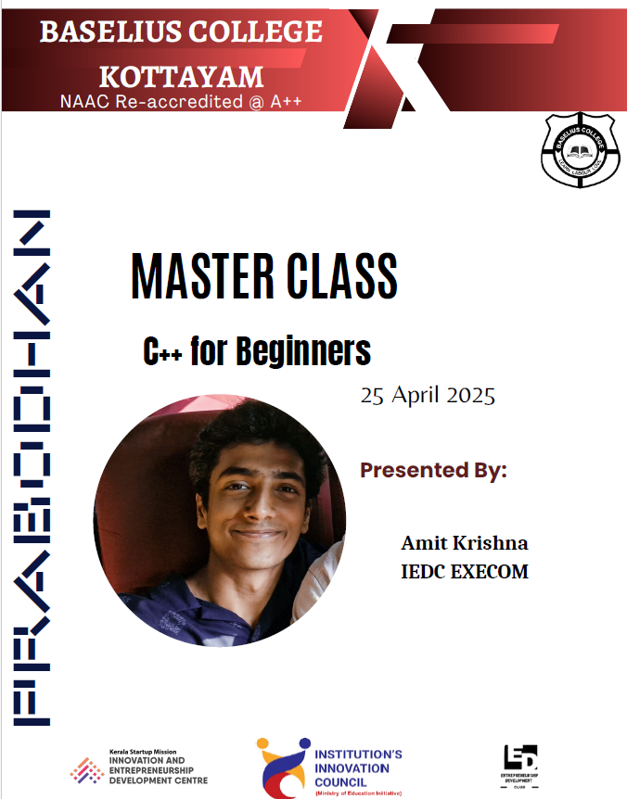

- Photograph of the event - Stage

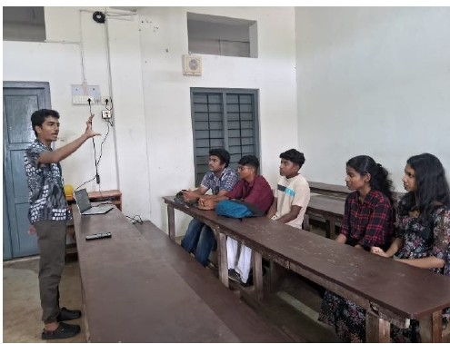

- Photograph of the event - Audience
- Photograph of the event - Group Photo
- Other photographs if any
- Other Documents if any (Schedule, Resource Person Details, ..)

- Participant list in prescribed format
Innovation & Entrepreneurship Development Centre
An initiative of Kerala Startup Mission

- Name of Event | Weaving Narrations
- Name of Institute | : Baselius College
- Name of Nodal Officer | : Dr Aparna Thankappan
- Email Address | : aparnathankappan@baselius.ac.in
- Contact Number | : 9747620918
- Event participant type | : participants only from the institution
- Total number of participants | :
- Total number of women participants | :
- Track of Event
- Event category
- Sector
- Date from | 25.4.25
- Date to | 25.4.25
- Total number of hours | 1.30 hrs
- Details of IEDCs Collaborated
- Details of Communities or Clubs collaborated with | IIC,ED
- Detailed report of the event (Min 200 words) | Objective  - To introduce high school and higher secondary school students to the fundamentals of narrative construction, emphasizing techniques for effective storytelling across various genres.  Outcome  - Participants gained insights into the art of storytelling, learning how to craft compelling narratives using character development, plot structuring, and thematic exploration.  The session titled "Weaving Narrations" was held on 25th April 2025 as part of the 'Prabodhan' programme, aimed at enhancing creative and narrative skills among high school and higher secondary school students. The event was organized by the Institution's Innovation Council (IIC), Innovation and Entrepreneurship Development Centre (IEDC), and the Entrepreneurship Development Club of Baselius College, Kottayam. The resource person, Jithin John, Assistant Professor of English, led the session, sharing his expertise in storytelling techniques and narrative construction. The workshop began with an engaging discussion on the power of storytelling and its impact across various media. Jithin John introduced key narrative elements such as plot structure, character development, conflict, and resolution, using literary and cinematic examples to illustrate each concept. Participants were encouraged to share their own storytelling experiences, creating an interactive learning atmosphere. The importance of tone, voice, and perspective in shaping narratives was also emphasized. The session concluded with a discussion on how effective storytelling can be used in academic, personal, and professional contexts.

- Creatives created for the event (Max 10nos)

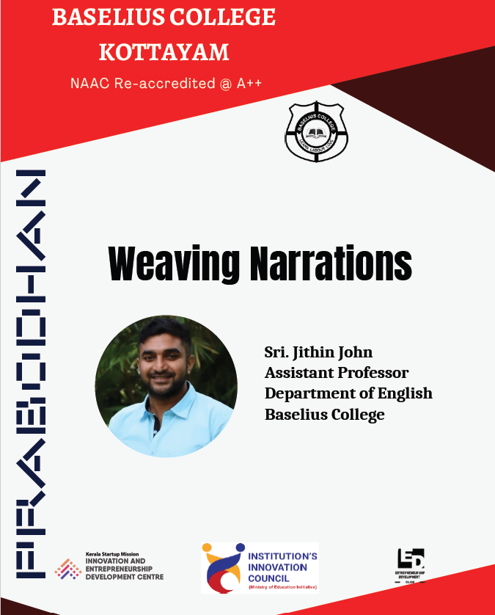

- Photograph of the event - Stage

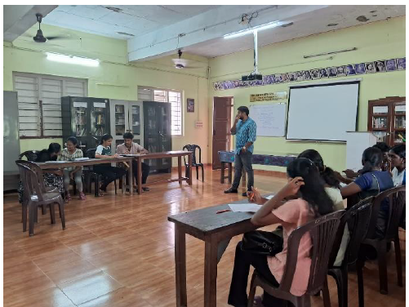

- Photograph of the event - Audience

- Photograph of the event - Group Photo
- Other photographs if any
- Other Documents if any (Schedule, Resource Person Details, ..)

- Participant list in prescribed format
Innovation & Entrepreneurship Development Centre
An initiative of Kerala Startup Mission

- Name of Event | From Code to Motion: The Magic of Robotics
- Name of Institute | : Baselius College
- Name of Nodal Officer | : Dr Aparna Thankappan
- Email Address | : aparnathankappan@baselius.ac.in
- Contact Number | : 9747620918
- Event participant type | : participants only from the institution
- Total number of participants | :
- Total number of women participants | :
- Track of Event
- Event category
- Sector
- Date from | 25.4.25
- Date to
- Total number of hours
- Details of IEDCs Collaborated
- Details of Communities or Clubs collaborated with
- Detailed report of the event (Min 200 words) | Objective  - To introduce high school and higher secondary students to the fundamentals of robotics and how coding can be utilized to bring machines to life.  Outcome  - Participants gained basic insights into robotics, including programming concepts and practical applications in creating robotic movements.  As part of the 'Prabodhan' initiative organized by the Institution’s Innovation Council (IIC), IEDC, and the Entrepreneurship Development Club of Baselius College, Kottayam, a Master Class titled “From Code to Motion: The Magic of Robotics” was held on the 25th of April 2025. The session aimed to introduce high school and higher secondary students to the fascinating world of robotics and its integration with coding. Mr. Nibu B Thomas, Assistant Professor in the Department of Electronics, served as the resource person for the session. He began with an engaging introduction to the evolution of robotics and its relevance in today’s technological landscape. The focus was on how coding acts as a bridge to transform instructions into robotic actions.The practical segment included a demonstration of a basic robotic arm that responded to coded commands. The students were given an opportunity to observe how specific instructions translated into precise mechanical movements, making the concept more tangible and relatable.

- Creatives created for the event (Max 10nos)

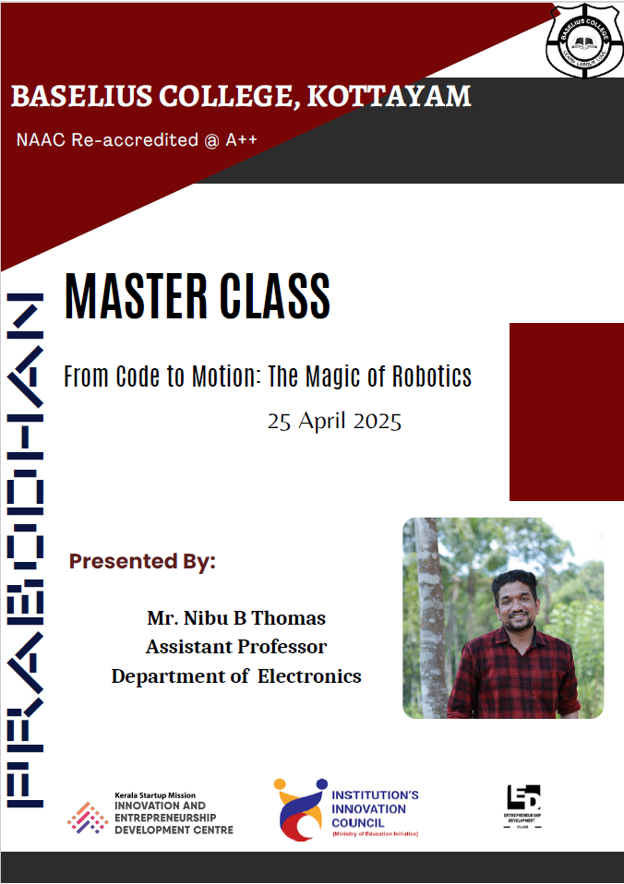
- Photograph of the event - Stage

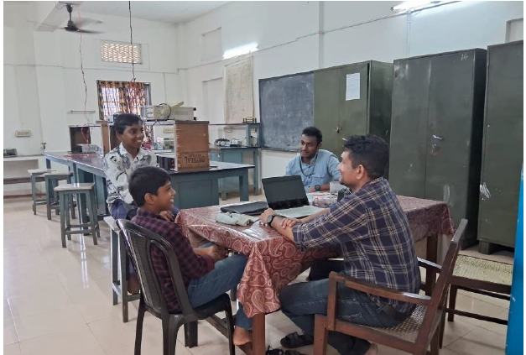

- Photograph of the event - Audience

- Photograph of the event - Group Photo
- Other photographs if any
- Other Documents if any (Schedule, Resource Person Details, ..)

Innovation & Entrepreneurship Development Centre
An initiative of Kerala Startup Mission

- Name of Event | The Magic Behind the Scenes: Video Editing Basics
- Name of Institute | : Baselius College
- Name of Nodal Officer | : Dr Aparna Thankappan
- Email Address | : aparnathankappan@baselius.ac.in
- Contact Number | : 9747620918
- Event participant type | : participants only from the institution
- Total number of participants | :
- Total number of women participants | :
- Track of Event
- Event category
- Sector
- Date from
- Date to
- Total number of hours
- Details of IEDCs Collaborated
- Details of Communities or Clubs collaborated with
- Detailed report of the event (Min 200 words) | Objective  - To introduce high school and higher secondary school students to the basics of video editing, including essential tools, techniques, and storytelling principles to effectively convey messages through visual content.  Outcome  - Participants gained hands-on experience with video editing software, enabling them to create simple video projects and understand the impact of editing on storytelling and audience engagement.  The workshop titled "The Magic Behind the Scenes: Video Editing Basics" was conducted on 25th April 2025 as part of the 'Prabodhan' programme for high school and higher secondary school students. Organized by the Institution's Innovation Council (IIC), Innovation and Entrepreneurship Development Centre (IEDC), and the Entrepreneurship Development Club of Baselius College, Kottayam, the session aimed to foster creativity and technical skills in young learners. The resource person, Nidharsh S., a former IEDC EXECOM member, guided the participants through the fundamentals of video editing. The workshop began with an introduction to the importance of video editing in storytelling and its applications in various fields. Basic editing tools, such as cutting, trimming, and adding transitions, were demonstrated using industry-standard software.

- Creatives created for the event (Max 10nos)

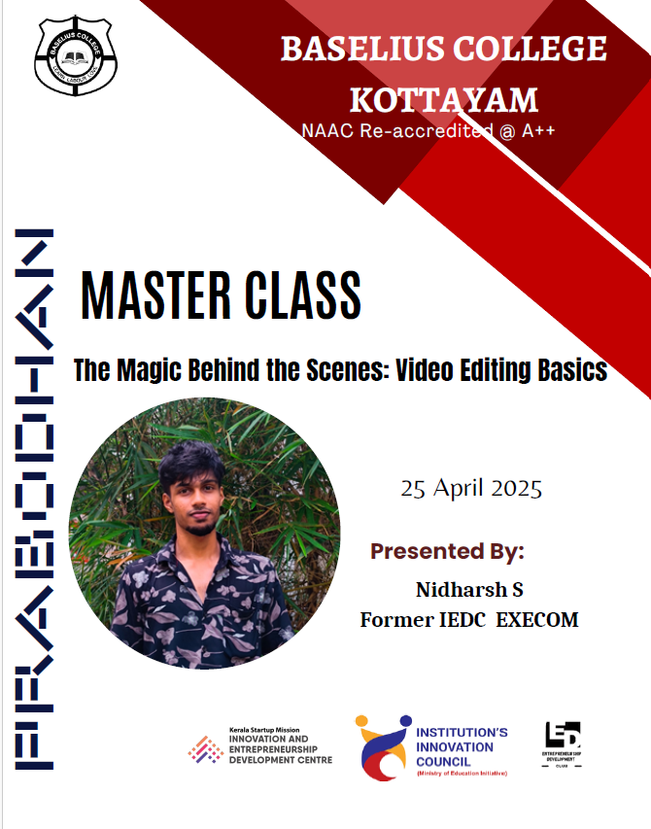

- Photograph of the event - Stage

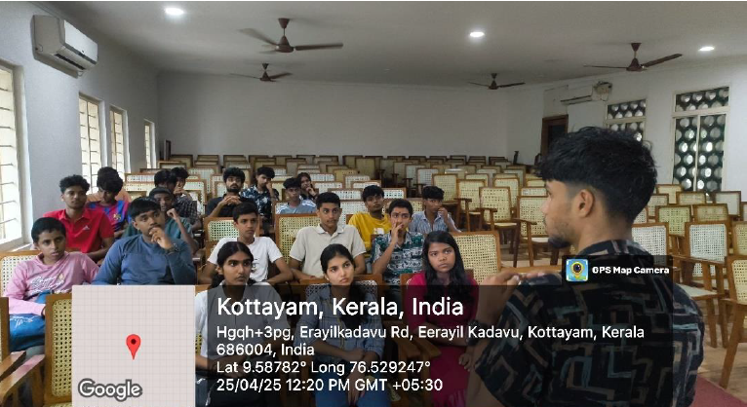

- Photograph of the event - Audience

- Photograph of the event - Group Photo

- Other photographs if any
- Other Documents if any (Schedule, Resource Person Details, ..)

- Participant list in prescribed format

